**Python Contents**

* **Introduction to Python**
* **Applications of Python**
* **IDEs**
* **Introduction to Python Interpreter**
* **Indentations & Comments**
* **Keywords**
* **Variables - Identifiers**
* **Built-in Types**
* **Assigning Values to Variables**
* **Input & Output Statements**
* **Operators**
* **Control Structures**
* **Math & Random Modules**
* **List**
* **Tuple**
* **Strings**
* **Set**
* **Dictionary**
* **Functions**
* **Files**
* **Libraries in Python**

**Introduction to Python** (Why Python, Features of Python & Difference between C, C++, Java & Python):

* Simple Syntax & Simple to Learn
* Open Source & Length of Code is very small
* Portability & Complex problems can be solved easily
* High-Level Interpreter - Memory Management
* Object Oriented
* Standard Libraries

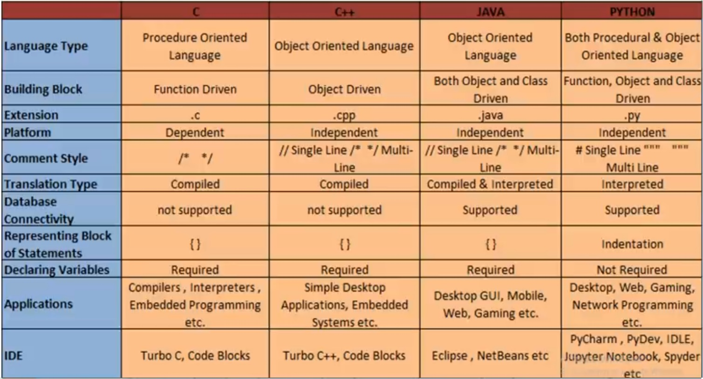

**Applications of Python:**

* Web & Internet Development
* Artificial Intelligence
* Machine Learning
* Image Processing Applications
* Business Applications
* Games & 3D Graphics
* Network Programming
* Databases Access

**Integrated Development Environments (IDEs)**

* IDLE
* Jupyter
* Anaconda
* PyCharm
* eRic
* SpyDER

**Introduction to Python Interpreter:**

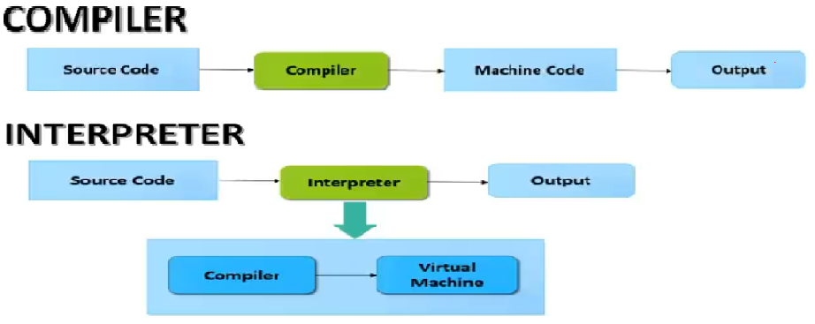

**Indentation & Comments:**

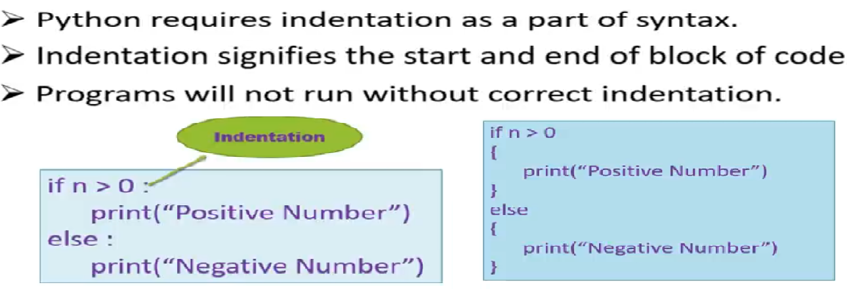



**Keywords:** Keywords are reserved words which have predefined meanings and functionality.

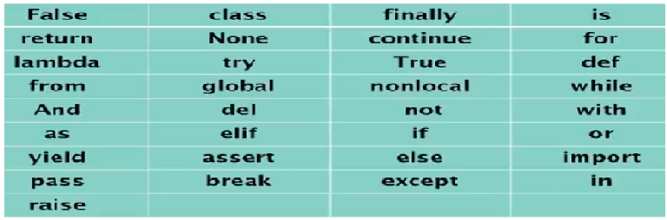

**Variables:**

Variables are identifiers. A Variable is defined as an alternative name for a memory location and can have a short name or a more descriptive name.

**Rules for Python Variables:**

* A Variables name must start with a letter or the underscore character
* A Variable name cannot start with a number
* A Variable name can only have alpha-numeric characters and underscores (A-z, 0-9, and _)
* Variable names are case-sensitive. (name, Name and NAME are three different variables.
* Variable name should not match with keywords.

**Built-in Types**

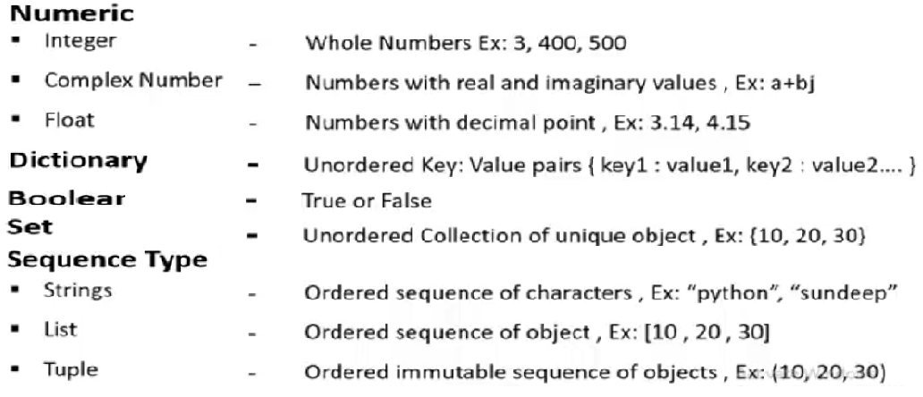

**Assigning Values to Variables**

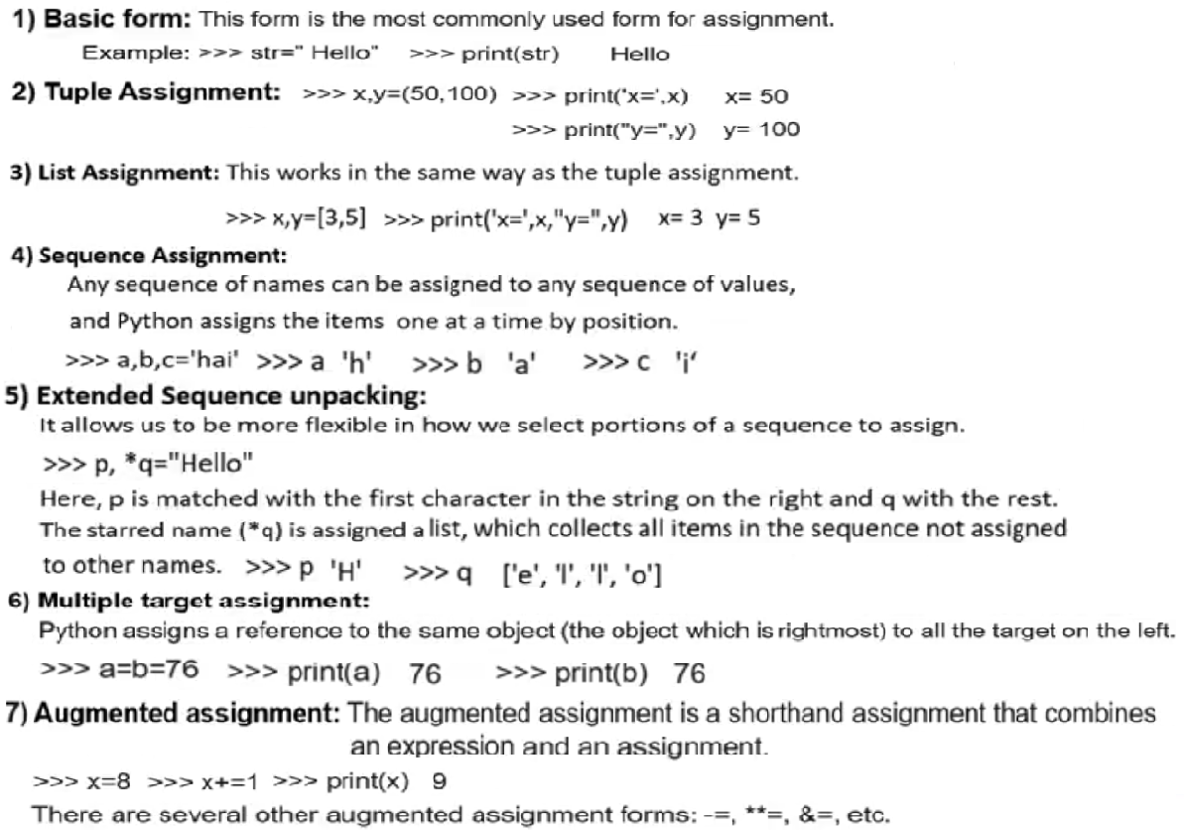

**

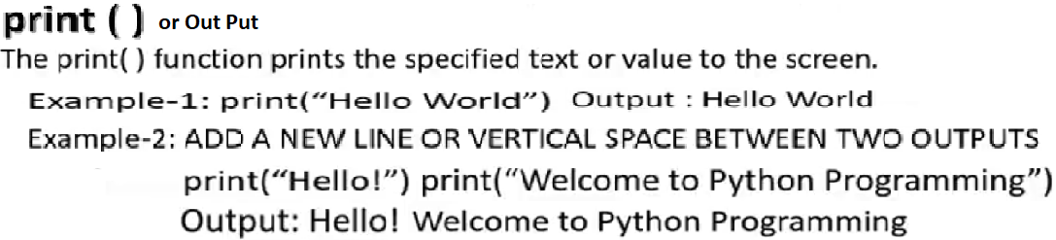

**Operators:**

**Control Structures:**

