**AwesomeDigitalClocks**

**Objectives**

* To practice HTML5, CSS3, Javascript.

**Overview**

For this project you will write HTML,CSS, and JavaScript that supports a web portal providing different kinds of Digital Clocks. Fivedigital clocks are to be design and shown proper timings

**User stories**

* Create a navigation bar to the right with 5 styles , an option to set time and set to default.
* To the center, display the different styles for time.
* Give a header and footer of your own logo and copyrights.

**JavaScript Programs**

* Get time with hours, minutes, seconds
* Get date with year, month, day

**Requirements**

* You must use good indentation.
* Your html files must be implemented using HTML5(Strict) and must validate accordingly.
* Your css must validate according to the <http://jigsaw.w3.org/css-validator/> validator.
* You may use any authoring tool (e.g., sublime,webstorm, etc.)
* You must implement this project by yourself.
* To the head section of each html file add <meta> tags that identify the author, copyright, keywords, description. Feel free to use any values for each of them (for an example, see the html source for this document).
* Make sure you view your code using Google Chrome (that is the environment we will use to grade your project).
* You cannot use &nbsp; in your html files.
* Your css file must define and use at least one id selector.
* Your css file must define and use at least one class selector.
* You do not need to provide any pseudocode.
* You must use good variable names and good indentation in your JavaScript code

**ScreenShot**

Screen -1

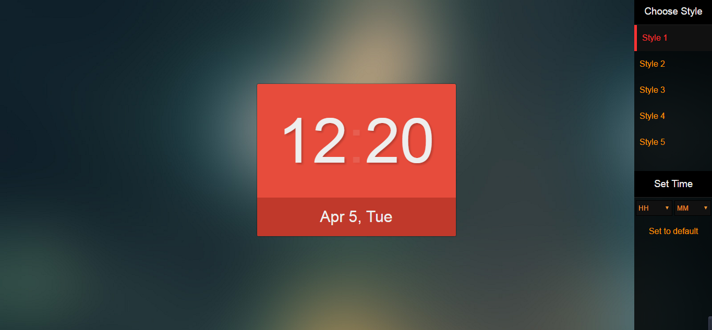

Screen-2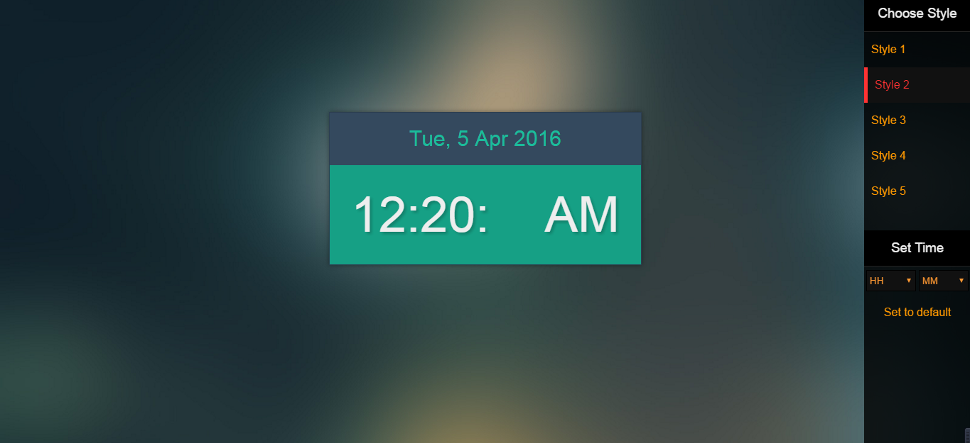

Screen-3

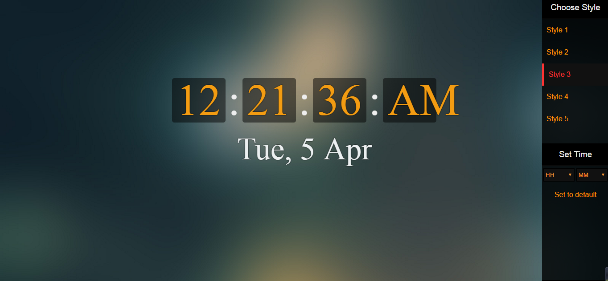

Screen-4

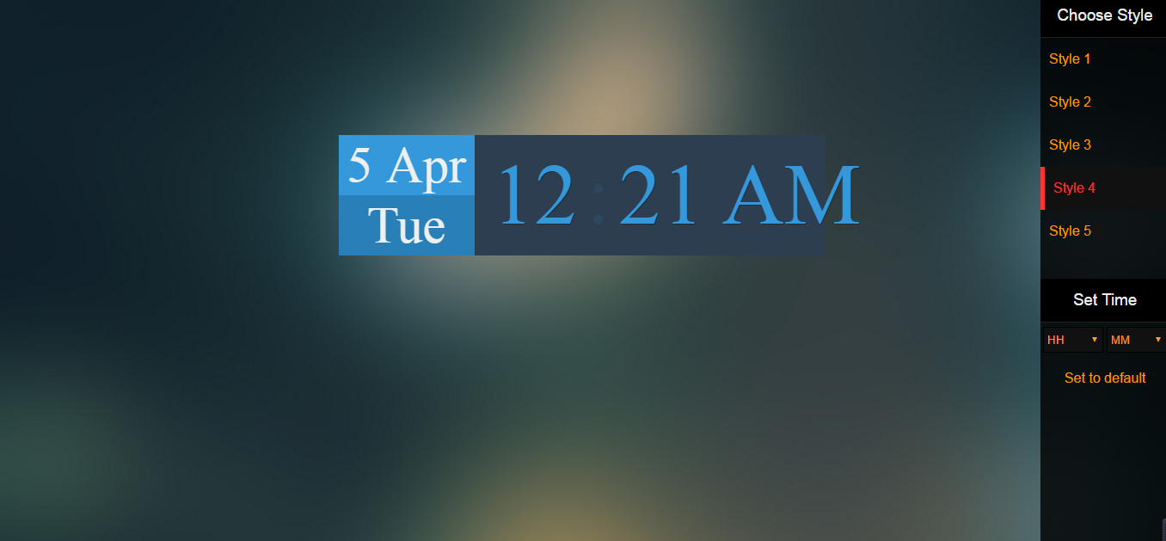

Screen-5

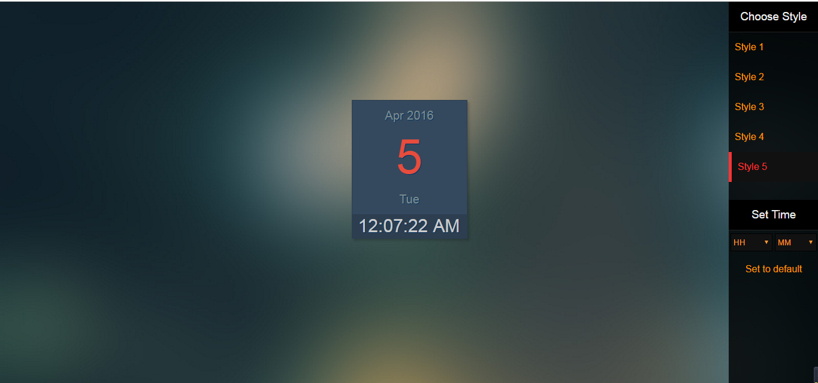

Background