Azure AKS High-Concurrency Scaling Strategy
Infrastructure Architecture to Support 15,000 Concurrent Users (Q125 Requirement)

1. The Concurrency Requirement
RFP Question 125 exactly states: 'Need to support high-concurrency real-time transactions (15,000 users concurrently, running 60 to 70 simulations at the same time).' To guarantee this without massive idle infrastructure costs, JA BizTown 3.0 will leverage a Two-Tier Elastic Scaling architecture utilizing Azure Kubernetes Service (AKS).

2. Two-Tier Scaling Architecture

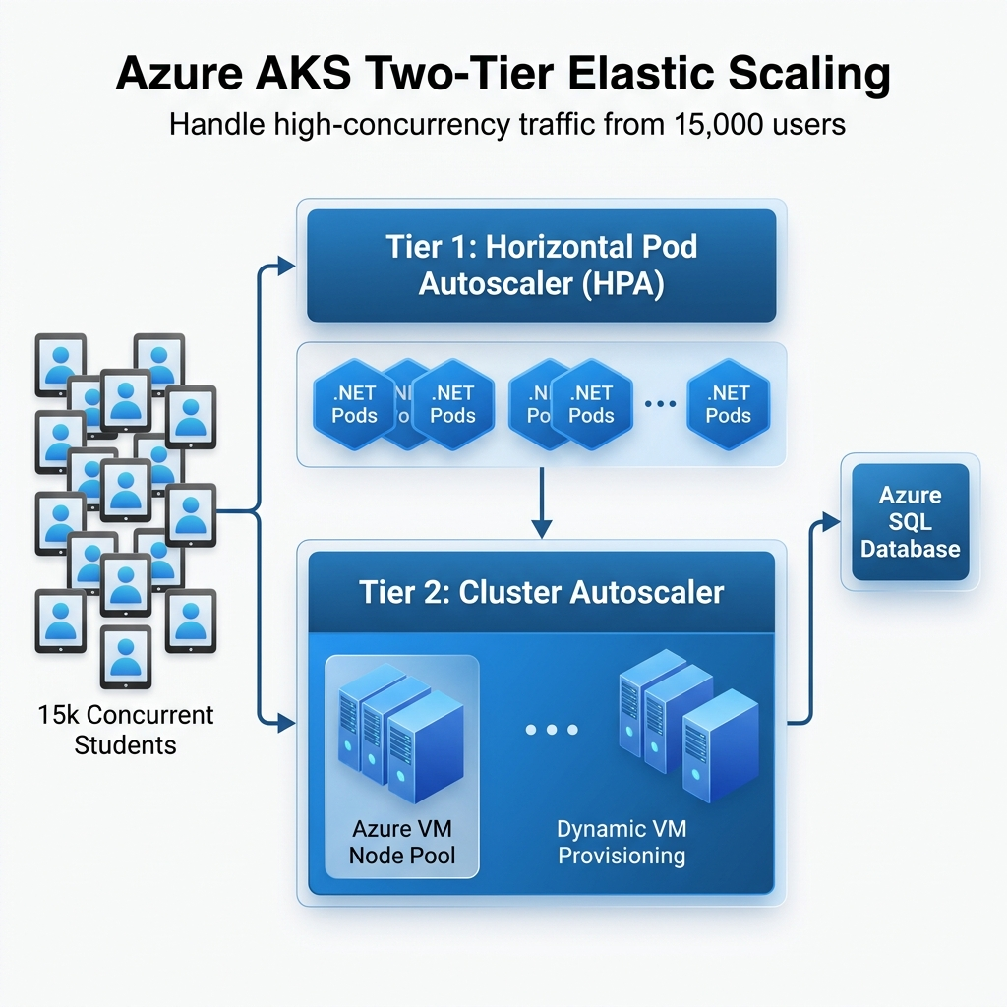

Tier 1: Horizontal Pod Autoscaler (HPA)
The HPA operates at the application level. As real-time simulation traffic hits the .NET APIs, the HPA monitors CPU thresholds (e.g., Target CPU Utilization > 70%). If the threshold is breached, the HPA instantly spins up additional .NET Pod (container) replicas to distribute the load.

Tier 2: Cluster Autoscaler (CA)
The Cluster Autoscaler operates at the hardware level. If the HPA tries to spin up 50 new .NET Pods, but the underlying Azure Virtual Machines (Node Pool) are full, the Cluster Autoscaler tells Azure to dynamically provision brand new Virtual Machines and attach them to the AKS cluster within 60-90 seconds.

3. Azure Configuration & Integration Steps
- Step 1 (Requests & Limits): Configure hard CPU/Memory limits on the .NET container deployment yaml so the HPA can accurately calculate threshold metrics.
- Step 2 (HPA Thresholds): Deploy the `HorizontalPodAutoscaler` yaml to AKS targeting `minReplicas: 3` and `maxReplicas: 50` against the .NET Deployment.
- Step 3 (KEDA Integration): We recommend installing KEDA (Kubernetes Event-driven Autoscaling) to scale pods based on actual concurrent user load (measured via Azure Service Bus or Redis Queues) rather than just CPU strain.

4. Required Terraform Code Updates
To automate this deployment, the existing infrastructure-as-code must be updated. The primary modification is enabling the `auto_scaler_profile` within the generic AKS block, and establishing a bounded `node_pool` range.
Expected Terraform Modificaton (azurerm_kubernetes_cluster):
default_node_pool {
name = "simpool"
vm_size = "Standard_D4s_v4"
enable_auto_scaling = true
min_count = 3 # Baseline capability
max_count = 25 # Maximum hardware scale for 15k users
}
auto_scaler_profile {
scale_down_delay_after_add = "5m"
scan_interval = "10s"
}

5. The ROI for JA
By enforcing this configuration in Terraform, JA BizTown will only pay for massive infrastructure during the exact business hours when 70 simulations are running. Overnight and on weekends, the Cluster Autoscaler will automatically terminate unused Virtual Machines, drastically reducing the monthly Azure computing burn rate.

