Double Diamond Design Thinking Methodology
UX/UI Strategy for JA BizTown 3.0

1. Executive Overview
To ensure the JA BizTown 3.0 platform is highly intuitive for all key personas (Students, Teachers, Volunteers, and JA Admin Staff), our team actively employs the Double Diamond Design Thinking framework. This human-centered design methodology ensures we solve the right problems and deliver a gamified, stress-free simulation experience. The process oscillates between 'Divergent Thinking' (exploring wide possibilities) and 'Convergent Thinking' (narrowing down to specific solutions).
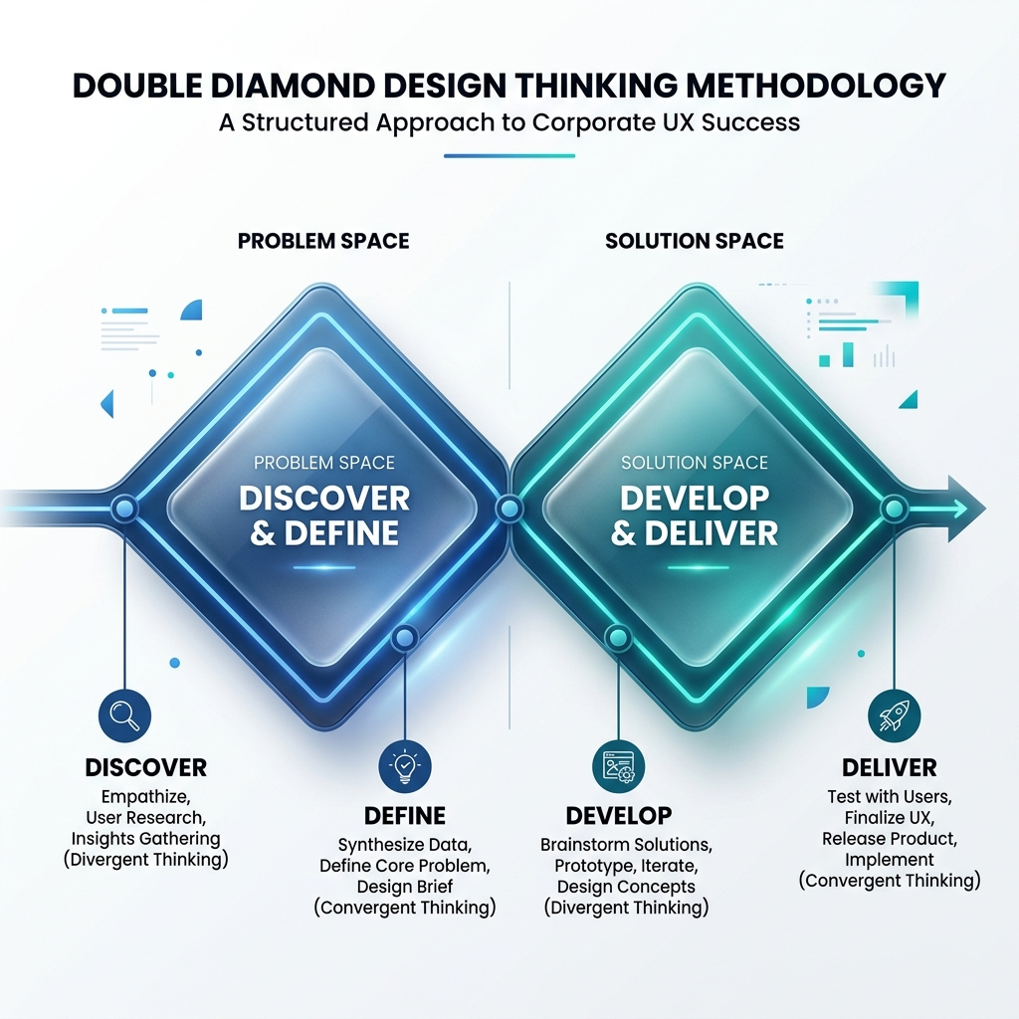

2. The Four Phases of Development

Diamond 1: Finding the Right Problem (Research & Synthesis)

Phase 1: Discover (Divergent)
- Goal: Understand the physical and digital realities of the JA BizTown simulation environment.
- Activities for JA BizTown:
• Shadowing existing simulation runs to observe tablet/device pain points (e.g., student login friction, connection drops).
• Interviewing JA Staff regarding National-to-State data inheritance burdens.
• Gathering accessibility (WCAG) requirements for diverse student populations.

Phase 2: Define (Convergent)
- Goal: Synthesize findings into actionable problem statements and personas.
- Activities for JA BizTown:
• Formalizing the 4 Key Personas: The Citizen (Student), The Oversser (Teacher), The Facilitator (Volunteer), and The Manager (JA Staff).
• Defining the 'Optimistic Offline Sync' technical requirement based on discovered Wi-Fi dead-zone pain points.
• Locking in exact User Journeys (e.g., 'The Shopping Break Flow').

Diamond 2: Finding the Right Solution (Ideation & Execution)

Phase 3: Develop (Divergent)
- Goal: Brainstorm and prototype multiple solutions for the defined problems.
- Activities for JA BizTown:
• Wireframing modern, game-like UIs for the student tablets to increase engagement.
• Prototyping data-dense dashboards for JA Admins using the Headless CMS architecture.
• Conducting 'Wizard of Oz' testing with paper or lo-fi prototypes with volunteers to test workflow speed.

Phase 4: Deliver (Convergent)
- Goal: Build, test, and release the finalized product.
- Activities for JA BizTown:
• Generating High-Fidelity UI/UX screens.
• Development sprint execution (React Native / .NET).
• Strict QA testing ensuring COPPA compliance and offline resilience.
• Deployment to App Stores via MDM (Mobile Device Management) and launching V1.0.

3. Cognitive Differentiation (Multi-Age Support)
A singular User Interface cannot effectively serve both a 3rd Grade student and an 8th Grade student due to vastly different cognitive load capacities and reading levels. Our Design Thinking methodology specifically addresses multi-age support through Adaptive Profiling mechanics:
- Discover Phase: We actively shadow a wide spectrum of ages inside the simulation. We empirically map the reading comprehension, motor skills, and attention spans of a 3rd Grader versus older cohorts.
- Develop Phase: Rather than a 'one-size-fits-all' UI, we design 'Age-Adaptive Interfaces'. For a 3rd Grade student, the UI employs larger iconography, simplified terminology (e.g., 'Put Money In' instead of 'Deposit'), and heavier gamified visual cues.
- Deliver Phase: The Headless CMS stores the student's Grade Level profile, allowing the frontend React Native application to dynamically render the appropriate UI complexity the moment that student scans their NFC ID.

4. Generative AI Integration (Scaffolding Student Creativity)
As highlighted in the RFP requirements, JA BizTown 3.0 will leverage secure Generative AI to assist students with creative tasks, specifically the generation of Business Slogans and Executive Speeches. Our Design Thinking methodology treats AI not as a replacement for student effort, but as an educational 'Cognitive Scaffold'.
- Discover Phase: We map how students currently experience writer's block during time-sensitive tasks. We define strict prompt-engineering constraints to ensure AI outputs match the student's specific assigned Grade Level vocabulary.
- Develop Phase: We design 'AI Co-Pilots' within the tablet UI. Rather than presenting a blank text box, a CEO student writing a Closing Speech receives contextual AI prompts (e.g., 'Do you want to sound confident or funny?'). For Slogans, the Marketing Team inputs three keywords, and the Azure OpenAI integration returns three distinct options they can edit and adopt.
- Deliver Phase: All AI requests are routed through a secured backend API (Azure OpenAI Services), ensuring strict COPPA compliance, zero PII transmission, and absolute profanity/content filtering before any AI-generated text reaches a student's tablet.

5. The Value to Junior Achievement
By strictly adhering to the Double Diamond approach, JA BizTown avoids the costly mistake of 'feature factory' development. We do not assume we know exactly how a 5th grader interacts with a PoS terminal; we Discover, Define, Develop, and Deliver based on empirical evidence and active end-user feedback. This guarantees a highly successful adoption rate across all national facilities.

