JA BizTown 3.0: Functional Requirements
This document outlines the core functional requirements for the JA BizTown 3.0 simulation environment.

1. System Architecture Overview
The platform utilizes a modern Azure-native cloud backend with React Native frontends, ensuring real-time synchronization across high-concurrency environments.
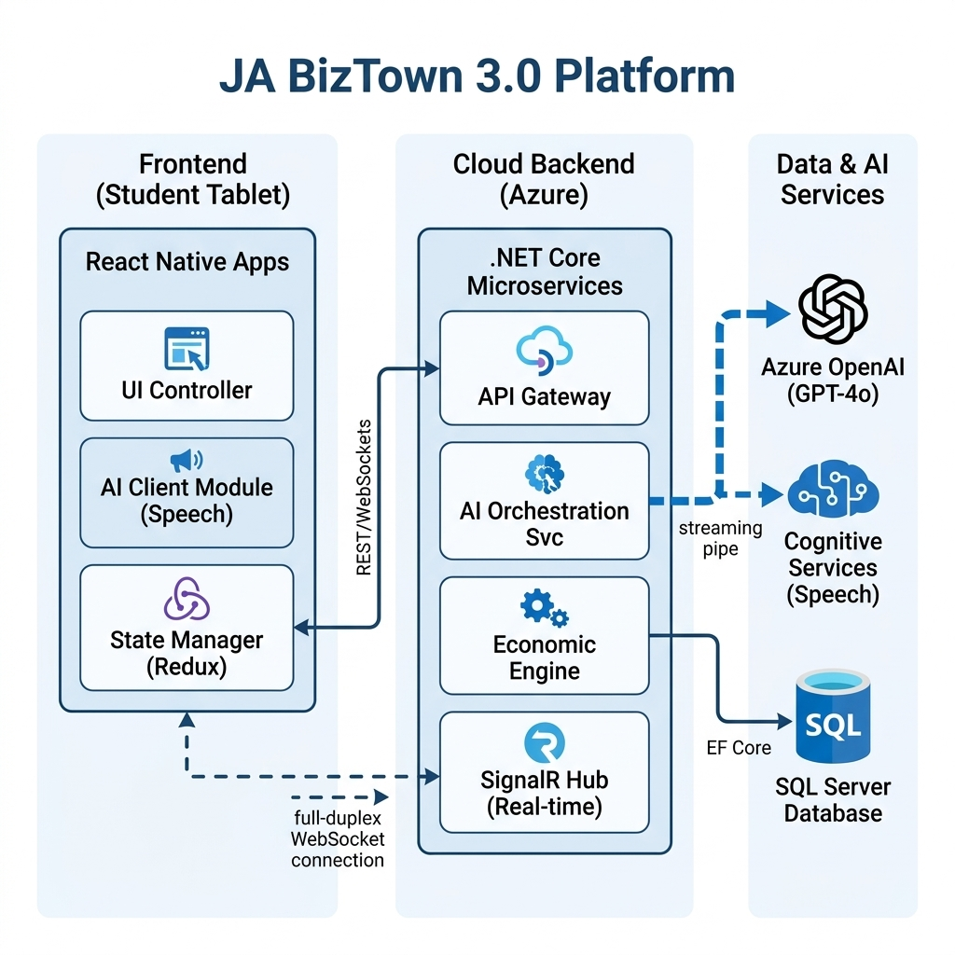
Figure 1: High Level Technical Architecture [RFP L66]

2. Core Functional Modules

2.1 Point of Sale (POS) & Payments
Students utilize a one-device-per-user model to conduct transactions within the storefront economy.
Requirements: QR Code payments, localized pricing, profit/loss sliders, and optional debit/NFC support.
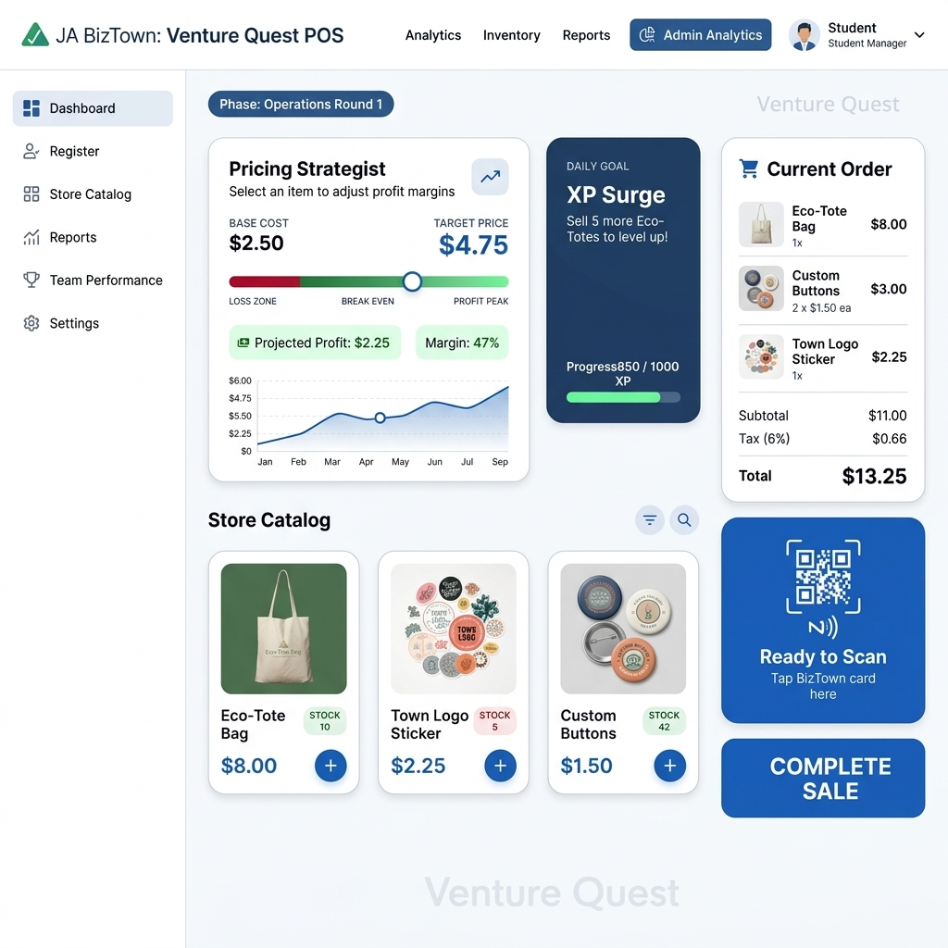
Figure 2: Venture Quest POS Mockup [RFP L182]
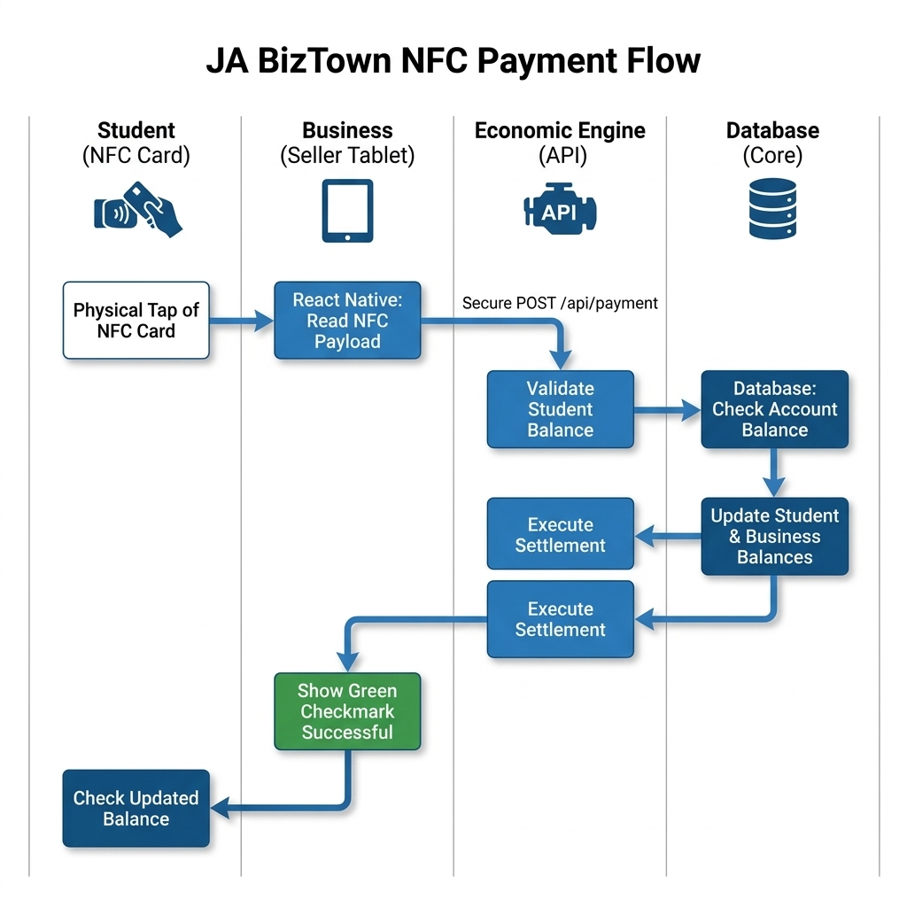
Figure 3: Secure Payment Processing Flow [QA Q7, Q19]

2.2 Banking, Payroll & Finance
Functional entities include personal student bank accounts, business loan applications, and automated payroll systems.
Requirements: Digital loan applications, direct deposit payroll, real-time balance updates, and B2B billing.

2.3 Digital Marketing & Media
A guided design experience (Canva-like) for creating business ads and slogans.
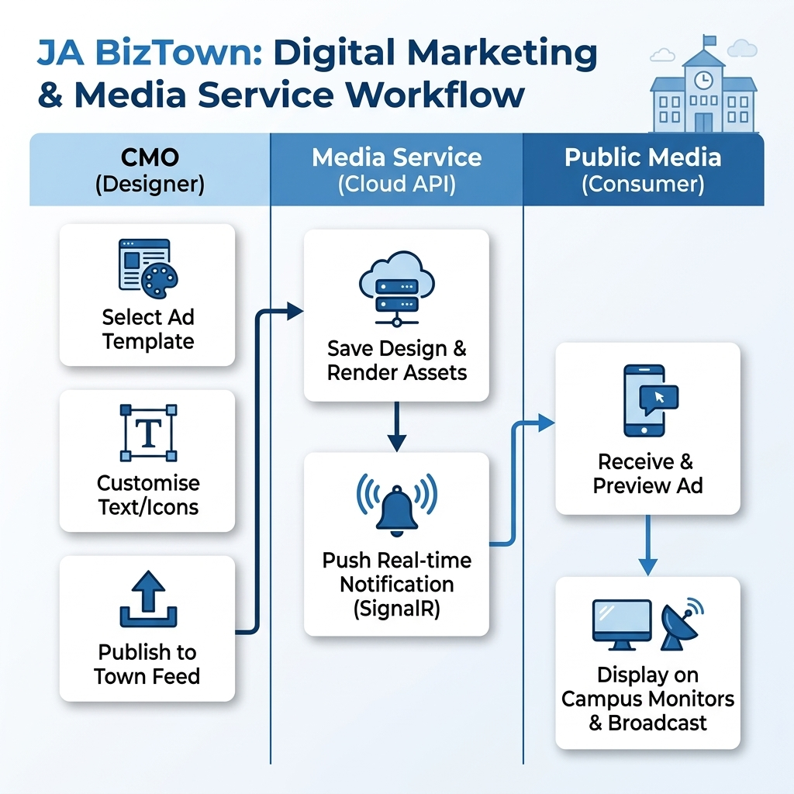
Figure 4: Digital Marketing & Publication Workflow [RFP L667]

3. Engagement & Gamification
Success is tracked via Experience Points (XPs) rather than just revenue, focusing on character education and social responsibility.
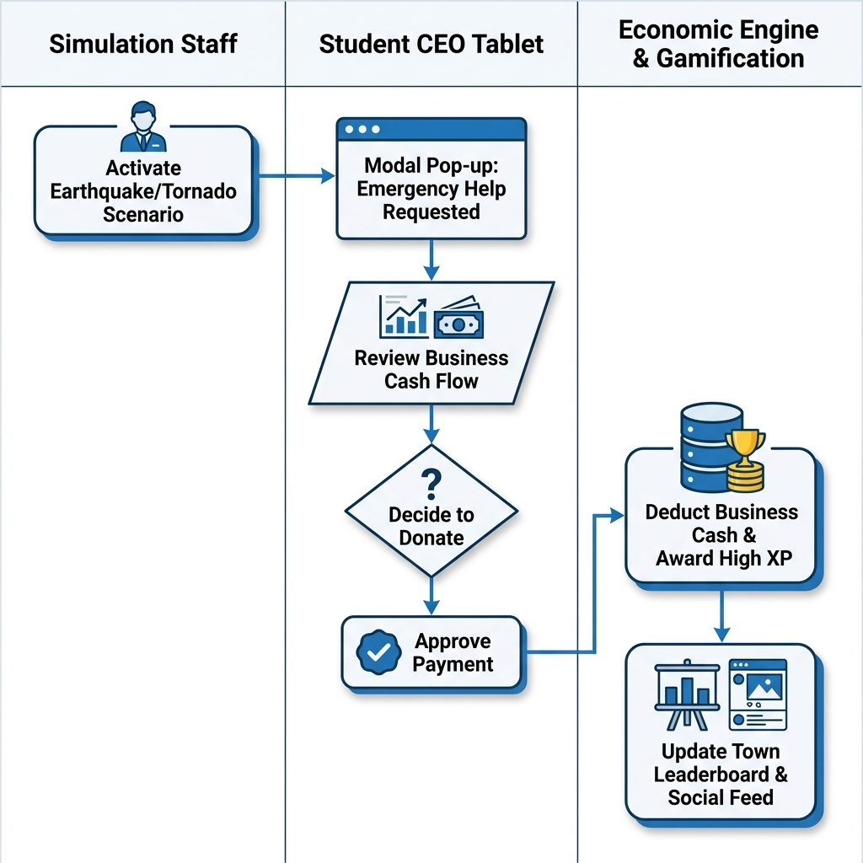
Figure 5: Ethical Dilemma / Donation Scenario [RFP L682]

4. Simulation Lifecycle
The simulation follows a 13-segment workflow, alternating between strategy sessions, business operations, and civic activity.
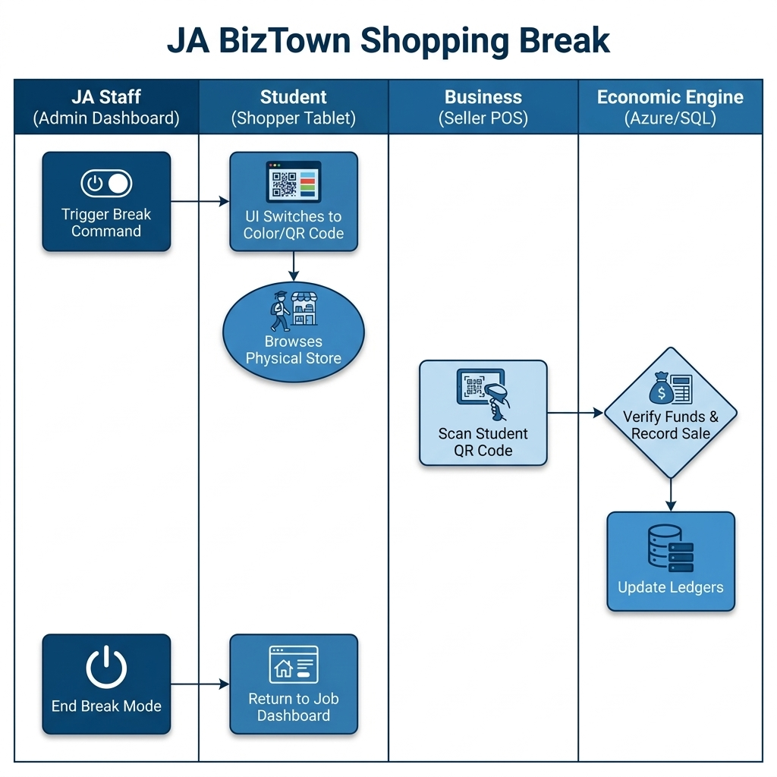
Figure 6: Standard Shopping Break Transition [RFP L583]

