JA BizTown 3.0: Key Functional Requirements
Exhaustive Functional Specification Mapping for Redevelopment
Date: April 8, 2026

1. Project Vision and Scope
The JA BizTown 3.0 redevelopment aims to modernize the hands-on simulation experience, providing a digital platform that reflects contemporary work concepts like digital marketing, real-time financial tools, and AI augmentation. The system is designed for a 'one-device-per-student' model across Tablet and Laptop platforms [RFP L138, QA Q23].
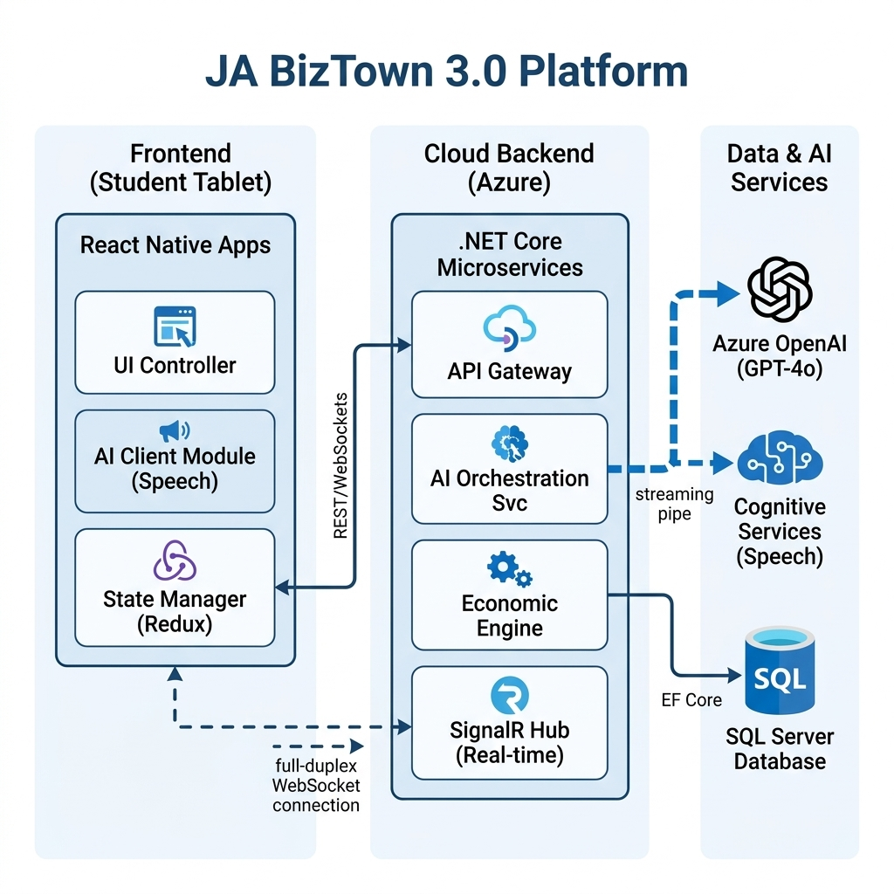
Figure 1: High Level Technical Architecture [RFP L66]

2. Administrative & Configuration Platform (CMS)
The CMS serves as the master administrative backend for national and local operations. It must support a scale of 100+ facilities with unique configuration requirements [RFP L917].

2.1 Master Template & Inheritance
The system must support a 'National Master Template' that provides global definitions (e.g., locked survey questions). Local site administrators can apply customization layers (sponsors, job titles, salary rates) that inherit from the national template without being overwritten by national updates [RFP L978, QA Q6].

2.2 Role-Based Access Control (RBAC)
Role | Key Capabilities
National Super-Admin | Global template control, push updates to all areas, audit log access, rollbacks.
Local Area Admin | Configure sponsors/logos, bulk upload jobs/tasks, clone localized CMS [RFP L943, QA Q6].
Simulation Manager | Simulation setup/activation, real-time storefront changes, student swapping [RFP L814].
Educator/Teacher | Access student/business performance reports via QR or login [RFP L723].
Volunteer | Real-time visibility into business performance, guided discussion prompts [RFP L791].

3. Core Functional Modules

3.1 Point of Sale (POS) & Community Commerce
The POS system is the central interface for the town economy. Students must determine pricing using an interactive slider that calculates profit/loss against the business loan [RFP L656].
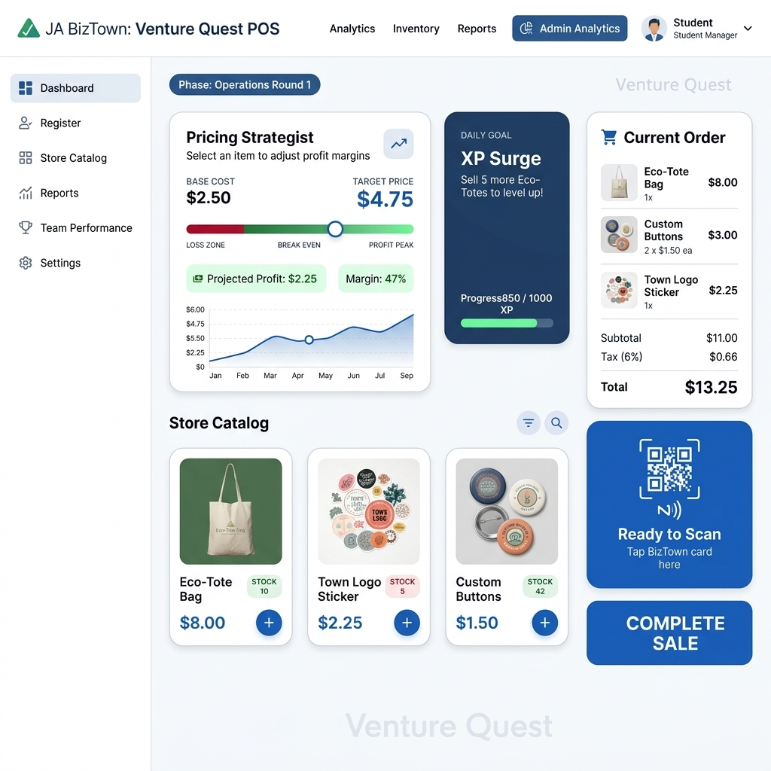
Figure 2: Venture Quest POS / Commerce Interface [RFP L182]
Payment Methods: QR Code scanning (Standard), Debit Card swiping, and exploration of NFC/Tap-to-pay [RFP L666, QA Q19]. Device Transition: Tablets automatically switch to a 'Payment QR' screen during student break segments [RFP L661].
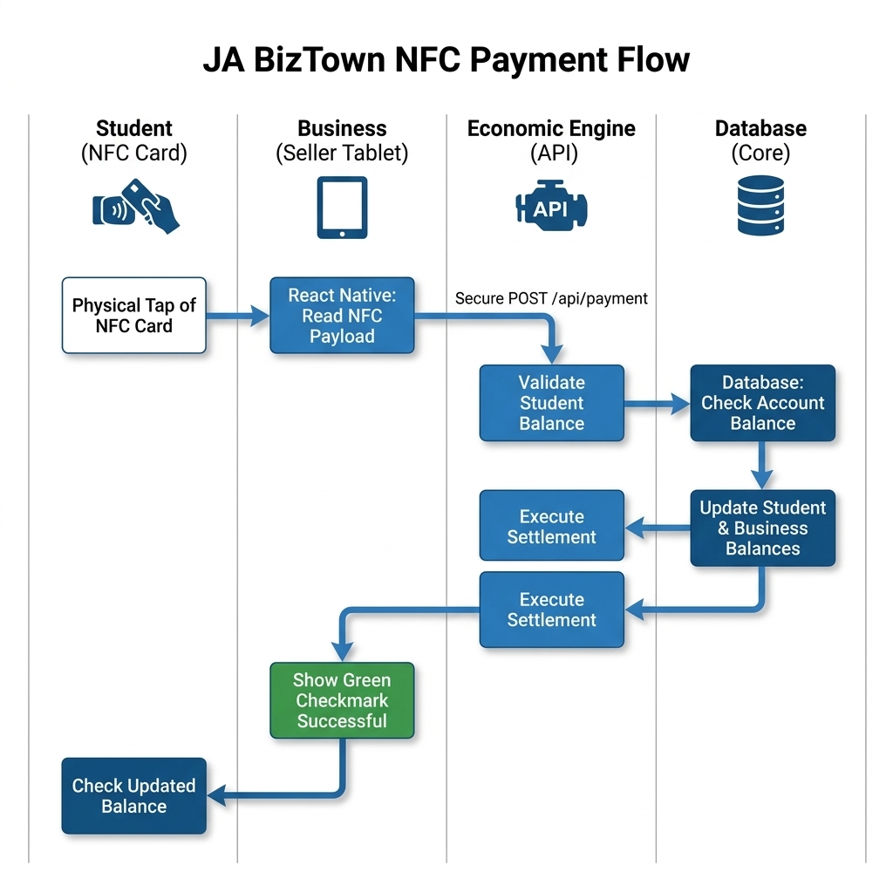
Figure 3: Secure Payment Processing Flow [QA Q7, Q19]

3.2 Banking, Payroll, and B2B Operations
Interconnected financial systems ensure real-time economic flow:
- Loan System: Digital application process. CFO device sharing allows team visibility [RFP L759, QA Q14].
- Payroll System: Direct deposit or printed checks. Support for W-2 verification and 'Spot Bonuses' [RFP L672].
- High-Accuracy Synchronization: Businesses must send/pay invoices to each other, tracked in real-time dashboards.

3.3 Digital Marketing Tool
A template-based 'design mission' guides students in building business advertisements. It includes text editing, slogan selection, and image asset selection from a curated library [QA Q13].
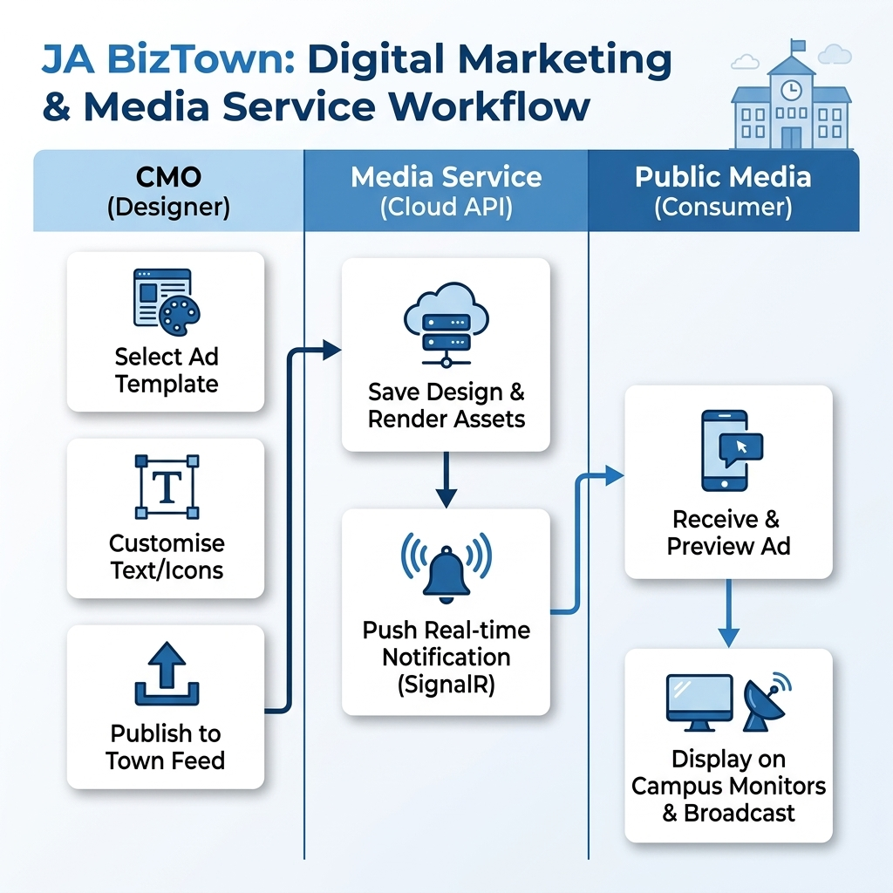
Figure 4: Digital Marketing Creation Workflow [RFP L667]

3.4 AI Integration & Guardrails
AI is utilized for task-specific enhancements with high guardrails [QA Q20]:
- Slogan Generator: Guided generation with a 'three-attempt' limit to prevent misuse.
- Transcription: Speech-to-text for CEO speeches; does not generate content.

4. Engagement & Gamification
Gamification focuses on learning milestones and accountability. Experience Points (XPs) are the primary metric [RFP L835].

4.1 Business Scenarios (Ethical Dilemmas)
Randomized scenarios (e.g., Tornado recovery repair) pop up, forcing team consensus. Donations result in cash deduction but significant XP gains. Selfish choices result in XP loss [RFP L685].
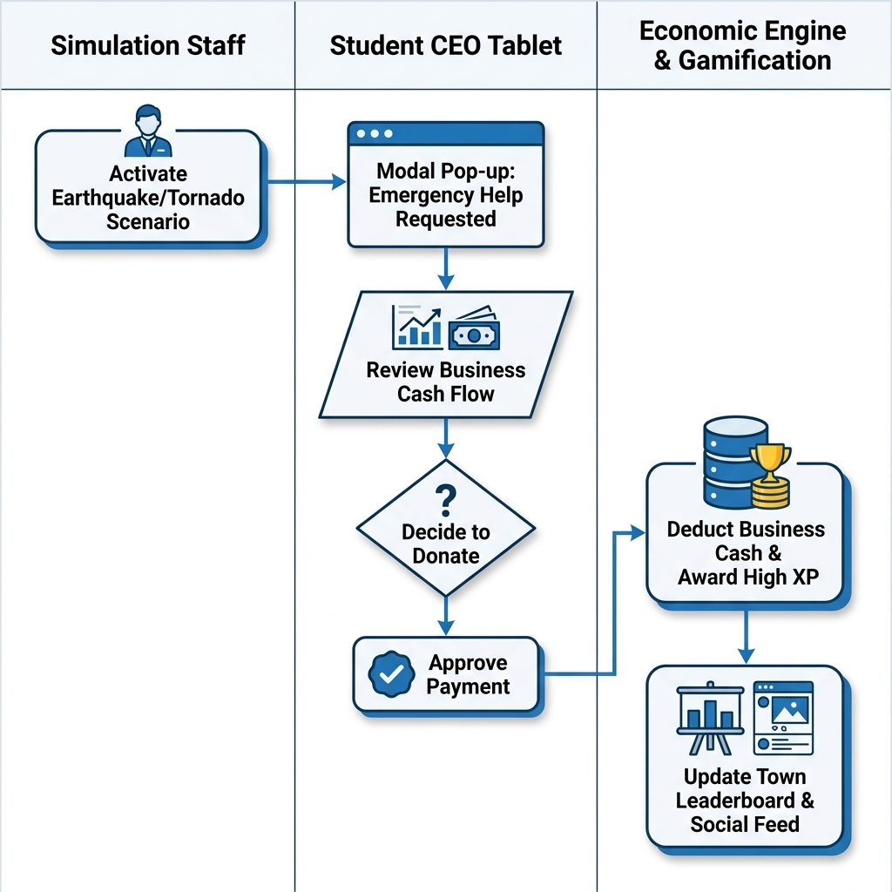
Figure 5: Community Incident & Donation Scenario [RFP L682]

4.2 Leaderboard & Performance Tips
A live town leaderboard combines Loan Payoff speed, Philanthropy, and Operational Efficiency. The dashboard provides real-time 'actionable tips' to help businesses improve their ranking [RFP L860, L889].

5. Operational Dashboards

5.1 Simulation Manager (Admin) Interface
A centralized 'Sim Manager' cockpit for overseeing 14-20 businesses. Capabilities include real-time incident response, editing student names/payroll after submission, and 'force-completing' segments [RFP L814].

5.2 Volunteer & Teacher Interfaces
Volunteers see a 'performance-at-a-glance' view. Intervention is non-prescriptive (judgment-based) based on data transparency rather than automated instructions [QA Q24].

6. Simulation Day Lifecycle
The 4.5-hour simulation day is segmented into 13 functional phases [RFP L421]:
Phase | Functional Activities
1. Arrival | Orientation & behavioral norms.
2. Opening Meeting | Civic pledge & leadership ceremony.
3. New Hire Orientation | Team building & mission review.
4. Trainings | Micro-trainings for Marketing/Leadership.
5. Business Opening | Loan approval & Payroll submission.
6. Lunch | Operational break.
7. Sales Strategy 1 | Goal setting & pricing strategy.
8. Operations 1 | Transactions, voting, B2B. Segmented into 10m intervals.
9. Sales Strategy 2 | Data analysis & ethical dilemmas.
10. Operations 2 | Refined strategy execution (Shorter 7m intervals).
11. Debrief | Quantitative performance analysis.
12. Closing | Organization care & checkout.
13. State of the Town | Leaderboard reveal & Civic awards.
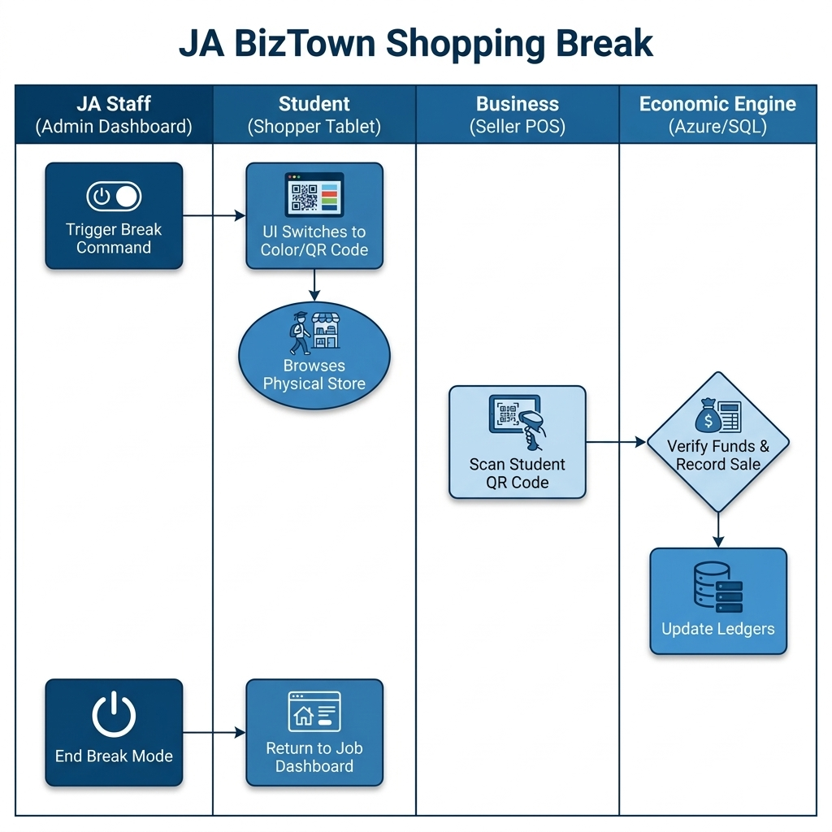
Figure 6: Standard Shopping Break Transition Protocol [RFP L583]
7. Critical Operational Requirements
The system must handle 150 students with ~500 transaction events in a 10-minute window. A cross-module 'Shared CFO View' must function over facility WiFi [QA Q7, Q14].

