**13.0 Prototypes**

**Sending Money to Friends/Family**

Screen 1: Home Screen

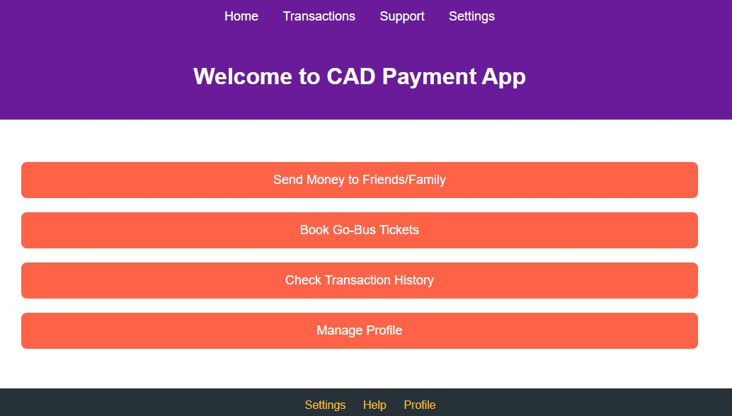

Fig:13.1 Sending Money to Friends/Family

Screen 2: Recipient Selection

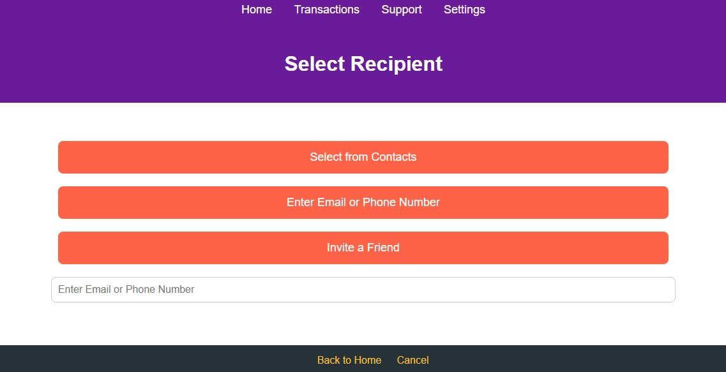

Fig:13.2 Recipient Selection

Screen 3: Enter Payment Details

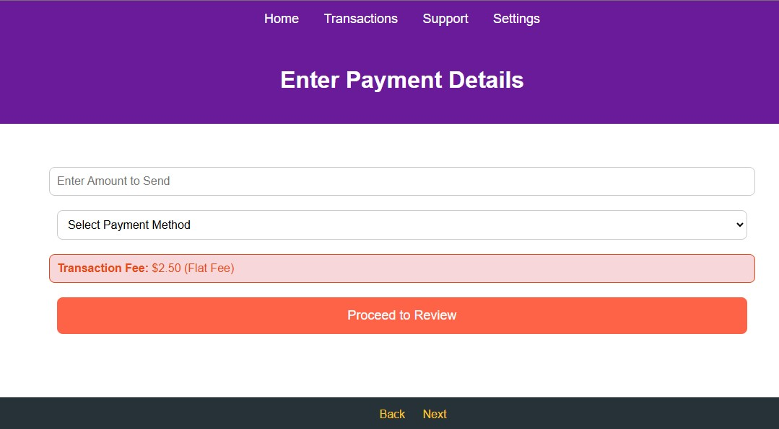

Fig:13.3 Enter Payment Details

Screen 4: Review Transaction

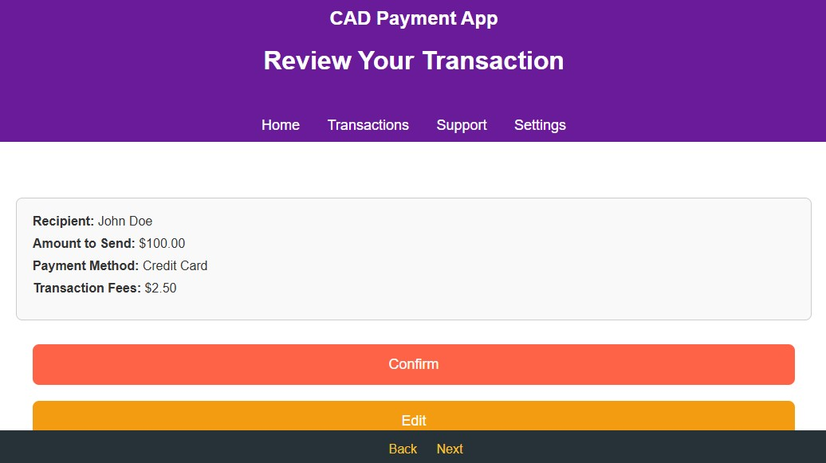

Fig:13.4 Review Transaction

Screen 5: Payment Processing  
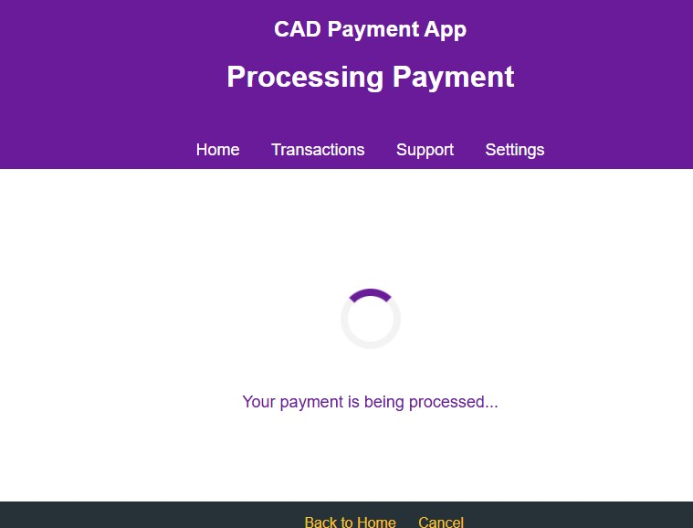

Fig:13.5 Payment Processing

Screen 6: Payment Confirmation

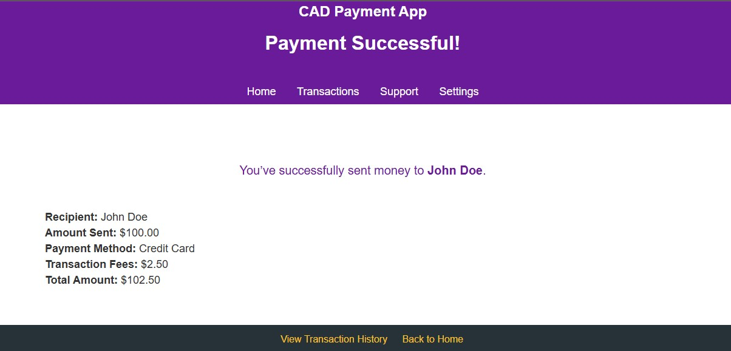

Fig:13.6 Payment Confirmation

Screen 7: Recipient Notification

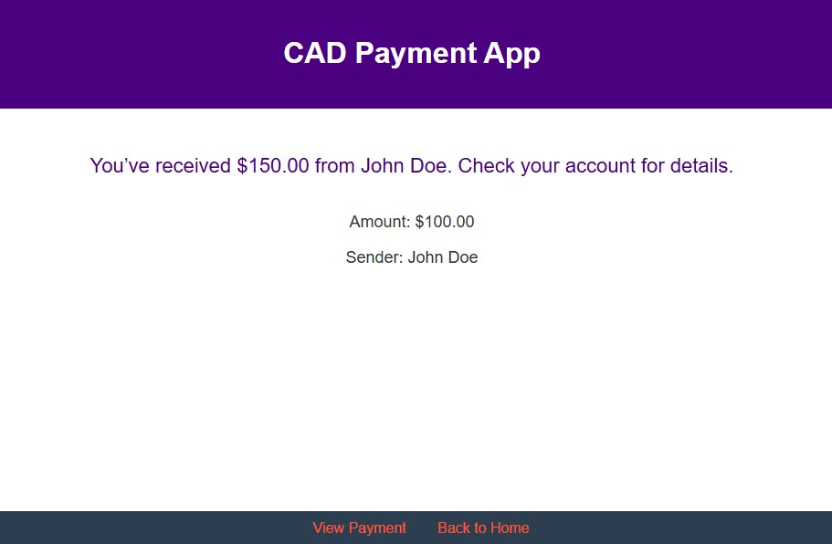

Fig:13.7 Recipient Notification

Screen 8: Alternative Flow- Recipient Not Found

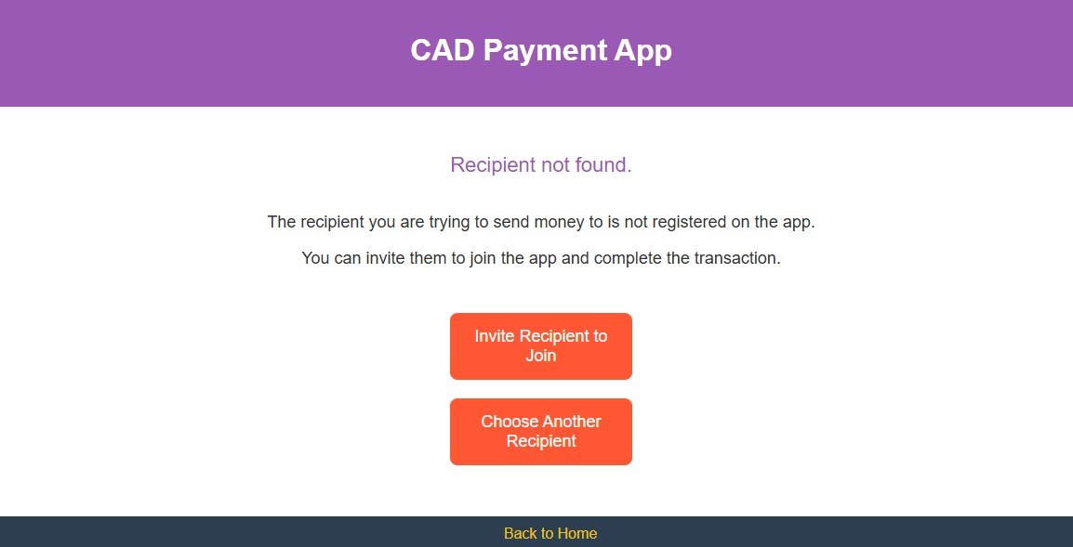

Fig:13.8 Recipient Not Found

**Admin Panel for Transaction Management**

Screen 1: Admin Dashboard

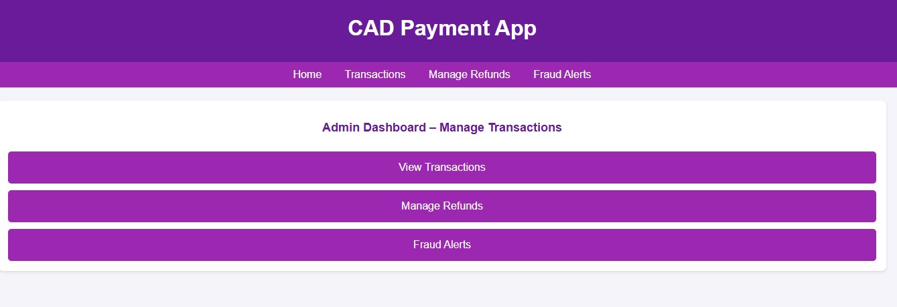

Fig:13.9 Admin Dashboard

Screen 2: Transaction Overview Page

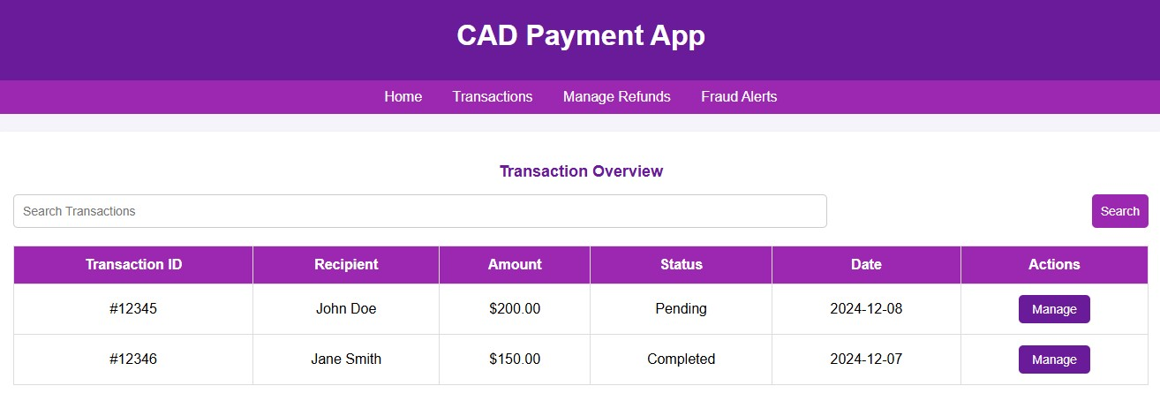

Fig:13.10 Transaction Overview Page

**Payment Setup**

Screen 1: Home Screen

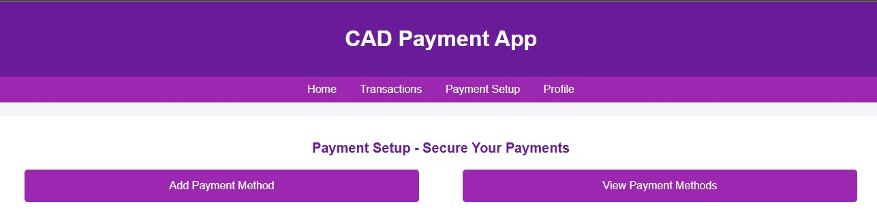

Fig:13.11 Payment Setup

Screen 2: Add Payment Method Page

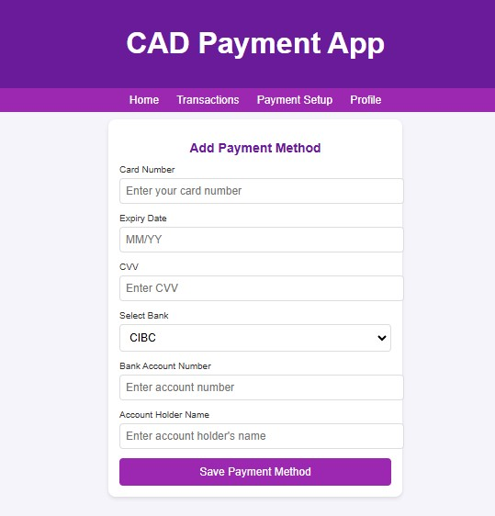

Fig:13.12 Add Payment Method Page

**Refund Request**

Screen 1: Home Screen

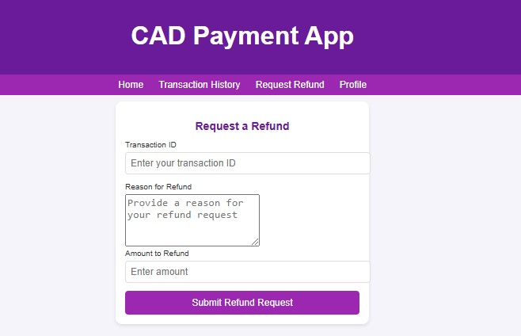

Fig:13.13 Refund Request

Screen 2: Refund Request Page

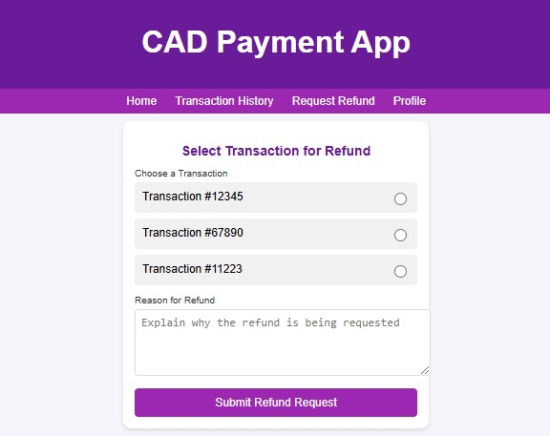

Fig:13.14 Refund Request Page

**Multi-currency Support**

Screen 1: Home Screen

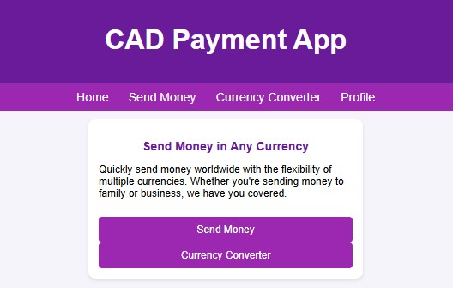

Fig:13.15 Multi-currency

Screen 2: Currency Selection Page

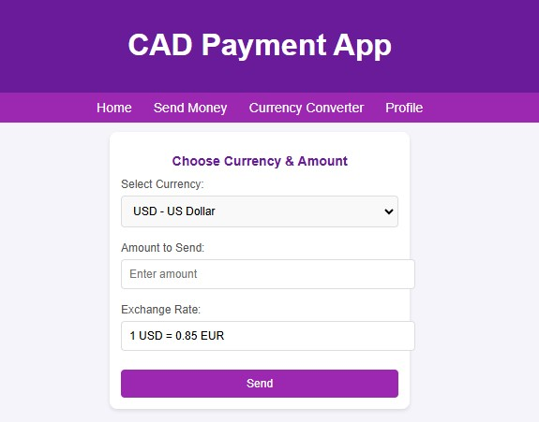

Fig:13.16 Currency Selection Page

**Cashback and Rewards**

Screen 1: Home Screen

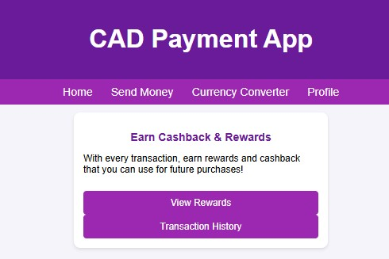

Fig:13.17 Cashback and Rewards

Screen 2: Rewards Page

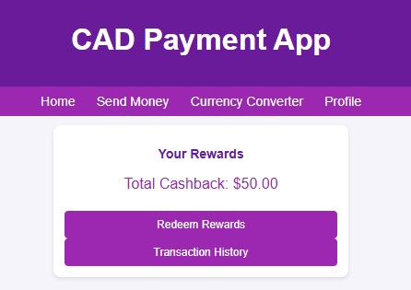

Fig:13.18 Rewards Page

**Booking Go-Bus Tickets**

Screen 1: Home Screen

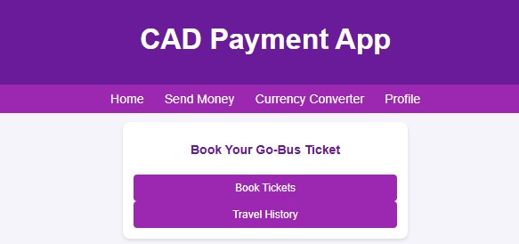

Fig:13.19 Booking Go-Bus Tickets

Screen 2: Bus Ticket Selection Page

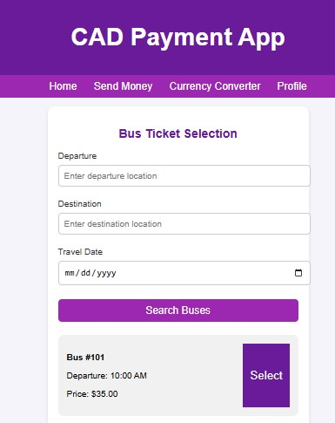

Fig:13.20 Bus Ticket Selection Page

**Add Funds to Account**

Screen 1: Home Screen

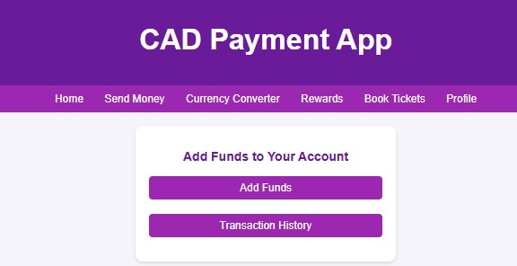

Fig:13.21 Add Funds to Account

Screen 2: Add Funds Page

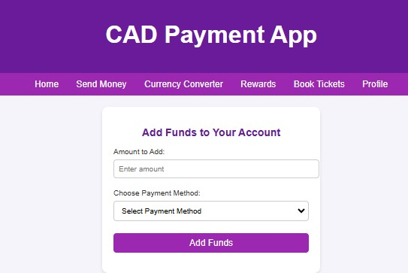

Fig:13.22 Add Funds Page

**Transaction Notification**

Screen 1: Home Screen

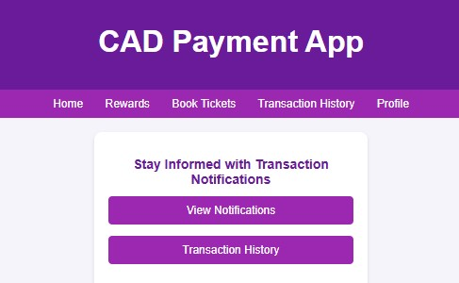

Fig:13.23 Transaction Notification

Screen 2: Notification Details Page

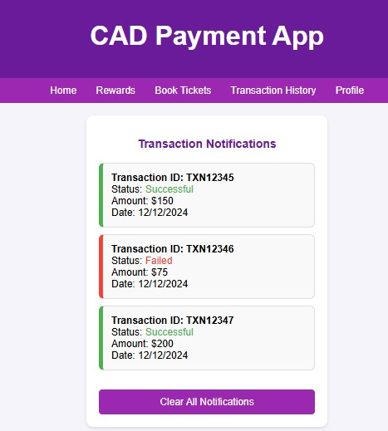

Fig:13.24 Notification Details Page

**Transaction Cancellation**

Screen 1: Home Screen

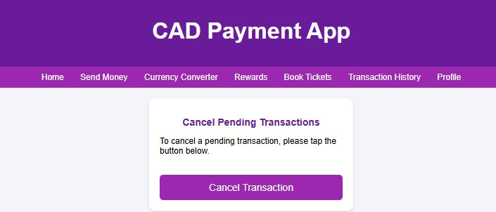

Fig:13.25 Transaction Cancellation

Screen 2: Cancel Transaction Page

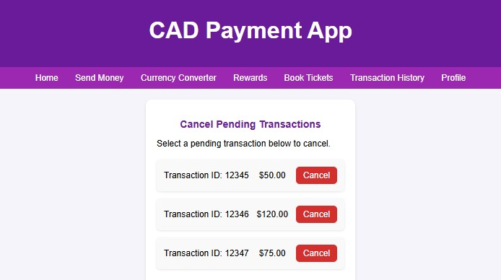

Fig:13.26 Cancel Transaction Page

**User Profile Management**

Screen 1: Home Screen

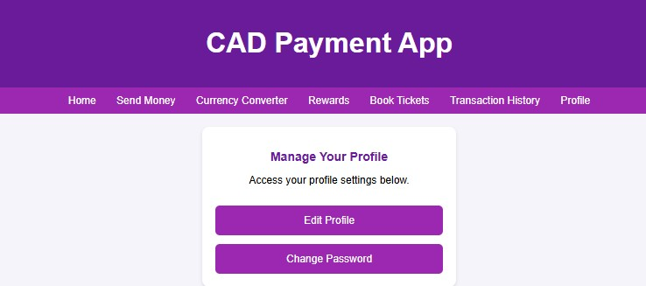

Fig:13.27 User Profile Management

Screen 2: Edit Profile Page

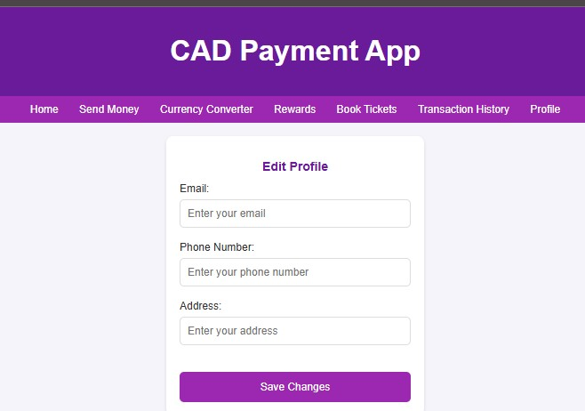

Fig:13.28 Edit Profile Page

**Booking Flights**

Screen 1: Home Screen



Fig:13.29 Booking Flights

Screen 2: Flight Booking Page

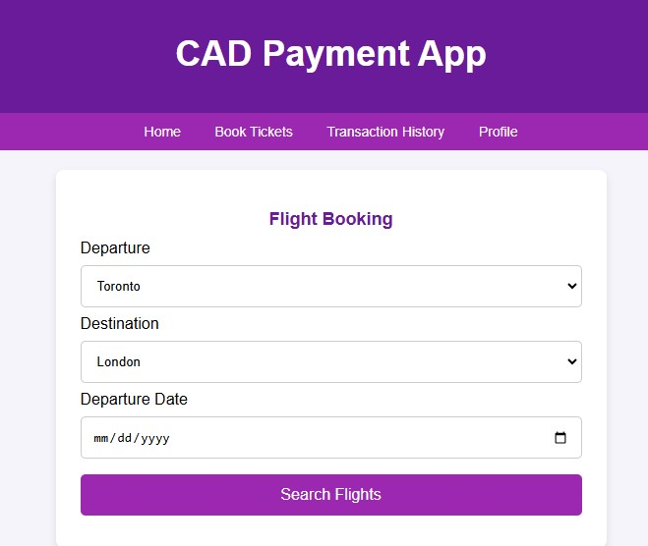

Fig:13.30 Flight Booking Page