Enter password: ****
Welcome to the MySQL monitor. Commands end with ; or \g.
Your MySQL connection id is 12
Server version: 8.0.43 MySQL Community Server - GPL
Copyright (c) 2000, 2025, Oracle and/or its affiliates.
Oracle is a registered trademark of Oracle Corporation and/or its
affiliates. Other names may be trademarks of their respective
owners.
Type 'help;' or '\h' for help. Type '\c' to clear the current input statement.

mysql> CREATE DATABASE CollegeEventDB;
Query OK, 1 row affected (0.02 sec)
mysql> USE CollegeEventDB;
Database changed
mysql> CREATE TABLE Department (
-> dept_id INT PRIMARY KEY,
-> dept_name VARCHAR(50)
-> );
Query OK, 0 rows affected (0.04 sec)

mysql> CREATE TABLE Student (
-> student_id INT PRIMARY KEY,
-> student_name VARCHAR(50),
-> dept_id INT,
-> year INT,
-> FOREIGN KEY (dept_id) REFERENCES Department(dept_id)
-> );
Query OK, 0 rows affected (0.07 sec)
mysql> CREATE TABLE Event (
-> event_id INT PRIMARY KEY,
-> event_name VARCHAR(100),
-> event_date DATE,
-> dept_id INT,
-> FOREIGN KEY (dept_id) REFERENCES Department(dept_id)
-> );
Query OK, 0 rows affected (0.07 sec)
mysql> CREATE TABLE Organizer (
-> organizer_id INT PRIMARY KEY,
-> organizer_name VARCHAR(50),
-> contact VARCHAR(15)
-> );
Query OK, 0 rows affected (0.04 sec)
mysql> CREATE TABLE Registration (
-> reg_id INT PRIMARY KEY,
-> student_id INT,
-> event_id INT,
-> organizer_id INT,
-> FOREIGN KEY (student_id) REFERENCES Student(student_id),
-> FOREIGN KEY (event_id) REFERENCES Event(event_id),
-> FOREIGN KEY (organizer_id) REFERENCES Organizer(organizer_id)
-> );
Query OK, 0 rows affected (0.09 sec)

mysql> DESC Student;
+--------------+-------------+------+-----+---------+-------+
| Field | Type | Null | Key | Default | Extra |
+--------------+-------------+------+-----+---------+-------+
| student_id | int | NO | PRI | NULL | |
| student_name | varchar(50) | YES | | NULL | |
| dept_id | int | YES | MUL | NULL | |
| year | int | YES | | NULL | |
+--------------+-------------+------+-----+---------+-------+
4 rows in set (0.01 sec)
mysql> DESC Department;
+-----------+-------------+------+-----+---------+-------+
| Field | Type | Null | Key | Default | Extra |
+-----------+-------------+------+-----+---------+-------+
| dept_id | int | NO | PRI | NULL | |
| dept_name | varchar(50) | YES | | NULL | |
+-----------+-------------+------+-----+---------+-------+
2 rows in set (0.00 sec)
mysql> DESC Event;
+------------+--------------+------+-----+---------+-------+
| Field | Type | Null | Key | Default | Extra |
+------------+--------------+------+-----+---------+-------+
| event_id | int | NO | PRI | NULL | |
| event_name | varchar(100) | YES | | NULL | |
| event_date | date | YES | | NULL | |
| dept_id | int | YES | MUL | NULL | |
+------------+--------------+------+-----+---------+-------+
4 rows in set (0.00 sec)
mysql> DESC Organizer;
+----------------+-------------+------+-----+---------+-------+
| Field | Type | Null | Key | Default | Extra |
+----------------+-------------+------+-----+---------+-------+
| organizer_id | int | NO | PRI | NULL | |
| organizer_name | varchar(50) | YES | | NULL | |
| contact | varchar(15) | YES | | NULL | |
+----------------+-------------+------+-----+---------+-------+
3 rows in set (0.00 sec)
mysql> DESC Registration;
+--------------+------+------+-----+---------+-------+
| Field | Type | Null | Key | Default | Extra |
+--------------+------+------+-----+---------+-------+
| reg_id | int | NO | PRI | NULL | |
| student_id | int | YES | MUL | NULL | |
| event_id | int | YES | MUL | NULL | |
| organizer_id | int | YES | MUL | NULL | |
+--------------+------+------+-----+---------+-------+
4 rows in set (0.00 sec)
mysql> INSERT INTO Department VALUES
-> (1, 'CSE'),
-> (2, 'ECE'),
-> (3, 'MECH');
Query OK, 3 rows affected (0.02 sec)
Records: 3 Duplicates: 0 Warnings: 0
mysql> INSERT INTO Student VALUES
-> (101, 'Ravi', 1, 3),
-> (102, 'Anita', 2, 2),
-> (103, 'Rahul', 1, 1),
-> (104, 'Neha', 3, 4);
Query OK, 4 rows affected (0.01 sec)
Records: 4 Duplicates: 0 Warnings: 0
mysql> INSERT INTO Event VALUES
-> (201, 'Tech Fest', '2026-02-10', 1),
-> (202, 'Cultural Fest', '2026-03-05', 2),
-> (203, 'Workshop', '2026-04-01', 1);
Query OK, 3 rows affected (0.02 sec)
Records: 3 Duplicates: 0 Warnings: 0
mysql> INSERT INTO Organizer VALUES
-> (301, 'Mr. Kumar', '9876543210'),
-> (302, 'Ms. Priya', '9123456780');
Query OK, 2 rows affected (0.02 sec)
Records: 2 Duplicates: 0 Warnings: 0
mysql> INSERT INTO Registration VALUES
-> (401, 101, 201, 301),
-> (402, 102, 202, 302),
-> (403, 103, 201, 301),
-> (404, 104, 203, 302);
Query OK, 4 rows affected (0.02 sec)
Records: 4 Duplicates: 0 Warnings: 0

mysql> START TRANSACTION;
Query OK, 0 rows affected (0.00 sec)
mysql> INSERT INTO Student VALUES (105, 'Amit', 2, 3);
Query OK, 1 row affected (0.00 sec)
mysql> SAVEPOINT sp1;
Query OK, 0 rows affected (0.00 sec)
mysql> INSERT INTO Student VALUES (106, 'Sneha', 1, 2);
Query OK, 1 row affected (0.00 sec)
mysql> ROLLBACK TO sp1;
Query OK, 0 rows affected (0.00 sec)

mysql> COMMIT;
Query OK, 0 rows affected (0.01 sec)
mysql> UPDATE Student
-> SET year = 4
-> WHERE student_id = 101;
Query OK, 1 row affected (0.01 sec)
Rows matched: 1 Changed: 1 Warnings: 0
mysql> DELETE FROM Student
-> WHERE student_id = 102;
ERROR 1451 (23000): Cannot delete or update a parent row: a foreign key constraint fails (`collegeeventdb`.`registration`, CONSTRAINT `registration_ibfk_1` FOREIGN KEY (`student_id`) REFERENCES `student` (`student_id`))
mysql> SELECT * FROM Registration WHERE student_id = 102;
+--------+------------+----------+--------------+
| reg_id | student_id | event_id | organizer_id |
+--------+------------+----------+--------------+
| 402 | 102 | 202 | 302 |
+--------+------------+----------+--------------+
1 row in set (0.00 sec)
mysql> DELETE FROM Registration
-> WHERE student_id = 102;
Query OK, 1 row affected (0.01 sec)
mysql> DELETE FROM Student
-> WHERE student_id = 102;
Query OK, 1 row affected (0.01 sec)
mysql> ALTER TABLE Event ADD venue VARCHAR(50);
Query OK, 0 rows affected (0.03 sec)
Records: 0 Duplicates: 0 Warnings: 0
mysql> SELECT s.student_name, e.event_name
-> FROM Student s
-> JOIN Registration r ON s.student_id = r.student_id
-> JOIN Event e ON r.event_id = e.event_id;
+--------------+------------+
| student_name | event_name |
+--------------+------------+
| Ravi | Tech Fest |
| Rahul | Tech Fest |
| Neha | Workshop |
+--------------+------------+
3 rows in set (0.00 sec)
mysql> SELECT COUNT(*) AS total_students FROM Student;
+----------------+
| total_students |
+----------------+
| 4 |
+----------------+
1 row in set (0.00 sec)
mysql> SELECT s.student_name, e.event_name
-> FROM Student s
-> RIGHT JOIN Registration r ON s.student_id = r.student_id
-> RIGHT JOIN Event e ON r.event_id = e.event_id;
+--------------+---------------+
| student_name | event_name |
+--------------+---------------+
| Ravi | Tech Fest |
| Rahul | Tech Fest |
| NULL | Cultural Fest |
| Neha | Workshop |
+--------------+---------------+
4 rows in set (0.00 sec)
mysql> SELECT s.student_name, e.event_name
-> FROM Student s
-> LEFT JOIN Registration r ON s.student_id = r.student_id
-> LEFT JOIN Event e ON r.event_id = e.event_id;
+--------------+------------+
| student_name | event_name |
+--------------+------------+
| Ravi | Tech Fest |
| Rahul | Tech Fest |
| Neha | Workshop |
| Amit | NULL |
+--------------+------------+
4 rows in set (0.00 sec)
mysql> SELECT s.student_name, e.event_name
-> FROM Student s
-> LEFT JOIN Registration r ON s.student_id = r.student_id
-> LEFT JOIN Event e ON r.event_id = e.event_id
->
-> UNION
-> SELECT s.student_name, e.event_name
-> FROM Student s
-> RIGHT JOIN Registration r ON s.student_id = r.student_id
-> RIGHT JOIN Event e ON r.event_id = e.event_id;
+--------------+---------------+
| student_name | event_name |
+--------------+---------------+
| Ravi | Tech Fest |
| Rahul | Tech Fest |
| Neha | Workshop |
| Amit | NULL |
| NULL | Cultural Fest |
+--------------+---------------+
5 rows in set (0.01 sec)
mysql> SELECT COUNT(*) AS total_students
-> FROM Student;
+----------------+
| total_students |
+----------------+
| 4 |
+----------------+
1 row in set (0.00 sec)
mysql> SELECT dept_id, COUNT(*) AS student_count
-> FROM Student
-> GROUP BY dept_id;
+---------+---------------+
| dept_id | student_count |
+---------+---------------+
| 1 | 2 |
| 2 | 1 |
| 3 | 1 |
+---------+---------------+
3 rows in set (0.00 sec)
mysql> SELECT COUNT(reg_id) AS total_registrations
-> FROM Registration;
+---------------------+
| total_registrations |
+---------------------+
| 3 |
+---------------------+
1 row in set (0.00 sec)
mysql> SELECT AVG(year) AS average_year
-> FROM Student;
+--------------+
| average_year |
+--------------+
| 3.0000 |
+--------------+
1 row in set (0.01 sec)
mysql> SELECT MAX(year) AS highest_year
-> FROM Student;
+--------------+
| highest_year |
+--------------+
| 4 |
+--------------+
1 row in set (0.00 sec)
mysql> SELECT MIN(year) AS lowest_year
-> FROM Student;
+-------------+
| lowest_year |
+-------------+
| 1 |
+-------------+
1 row in set (0.00 sec)
mysql> SELECT
-> COUNT(*) AS total_students,
-> MAX(year) AS max_year,
-> MIN(year) AS min_year,
-> AVG(year) AS avg_year
-> FROM Student;
+----------------+----------+----------+----------+
| total_students | max_year | min_year | avg_year |
+----------------+----------+----------+----------+
| 4 | 4 | 1 | 3.0000 |
+----------------+----------+----------+----------+
1 row in set (0.00 sec
Visual representation
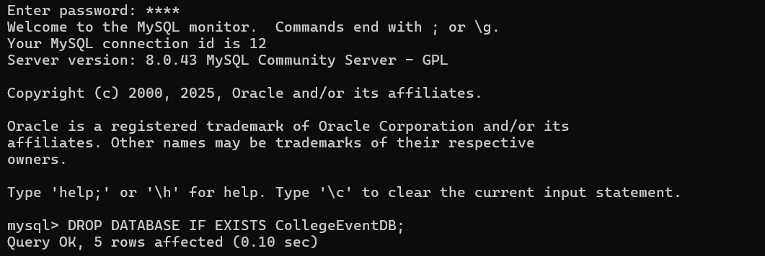
Table creation
DDL command create
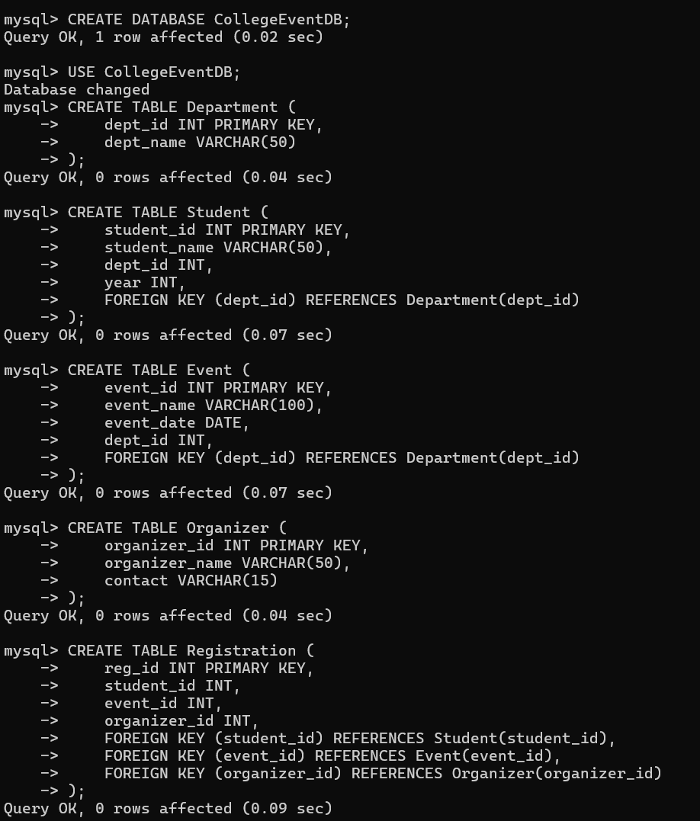
Describe tables
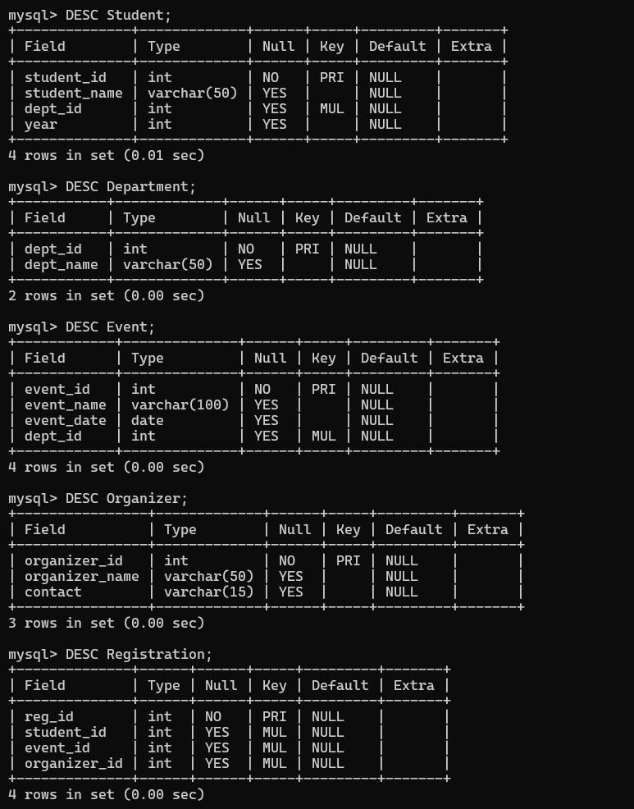

DML Command insert
Insert
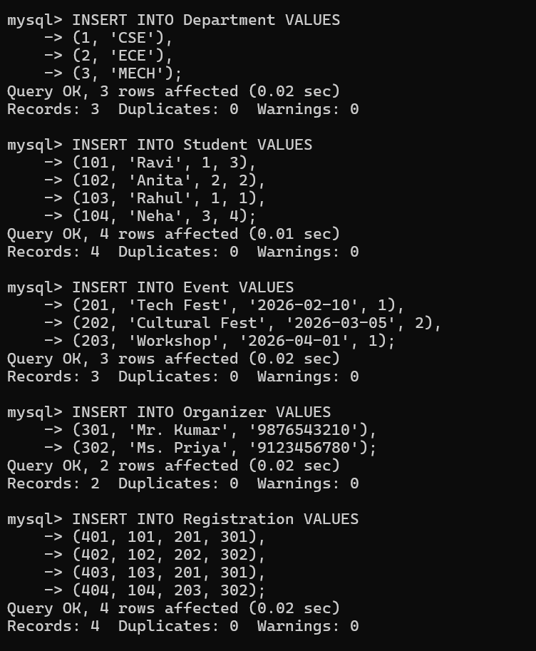

TCL commands
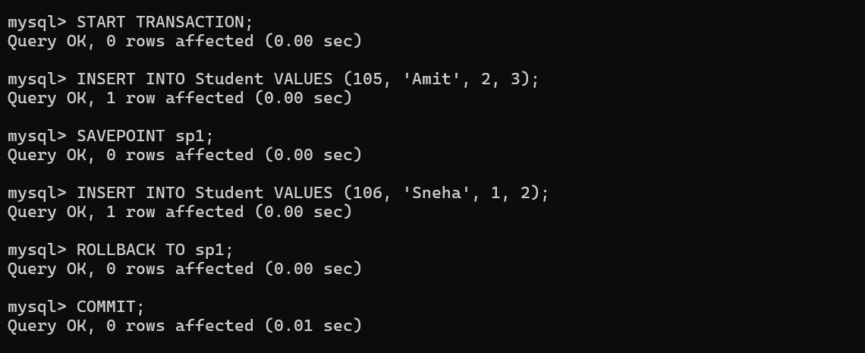

DML commands -update and delete
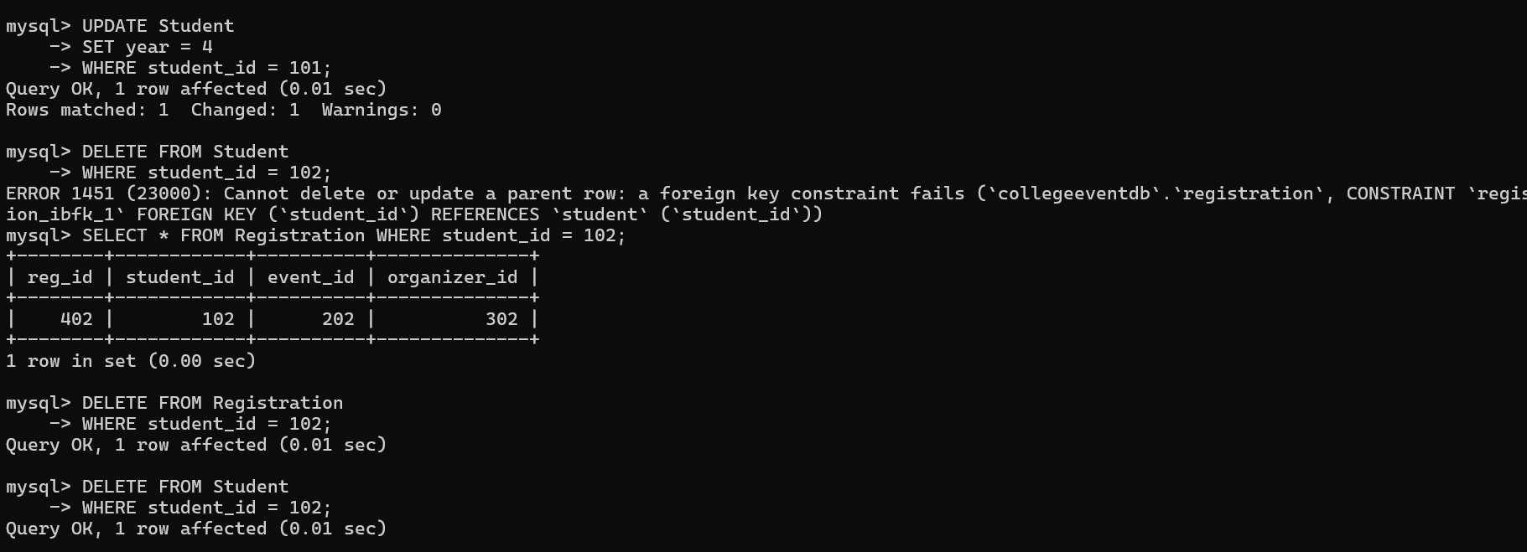

Ddl command -alter


JOINS
Inner join and right join
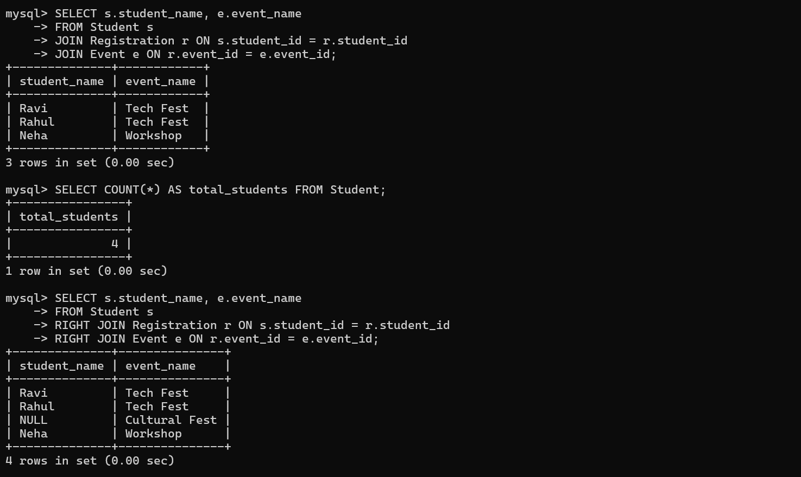

Left join and Full join
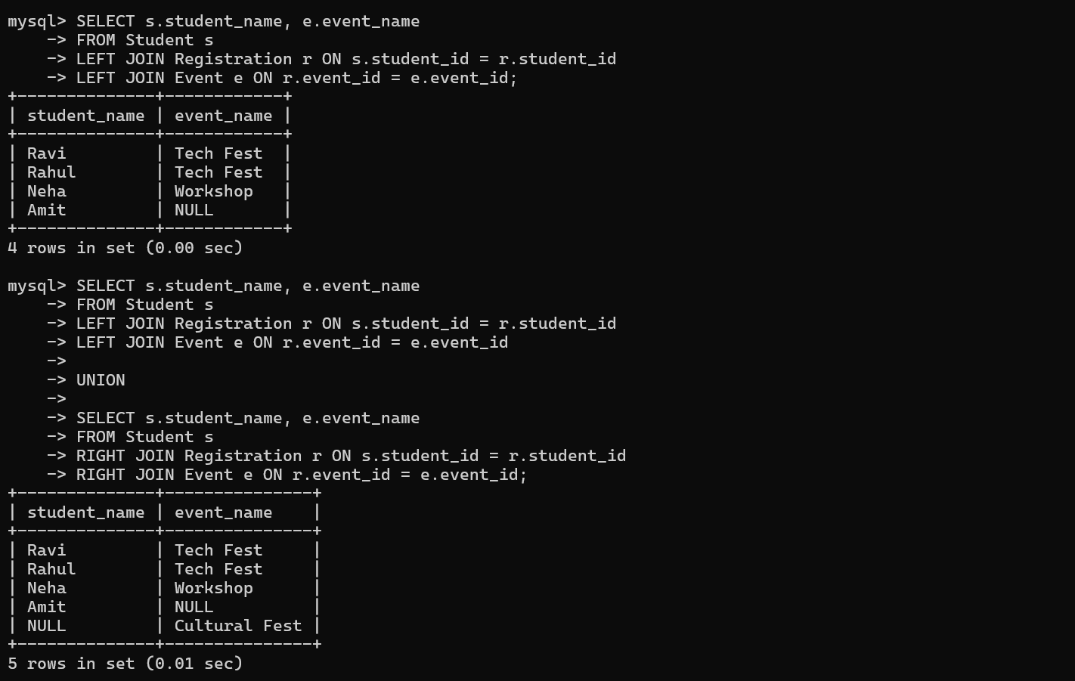
AGGREGATE FUNCTIONS
2 count,sum,avg
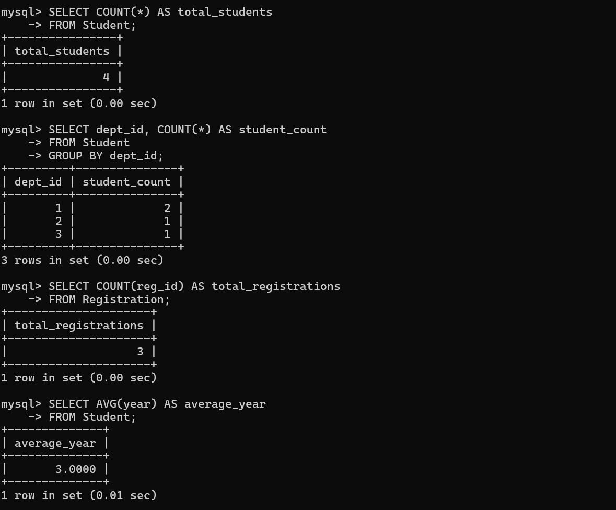
Max ,Min,Multiple aggregations in one query
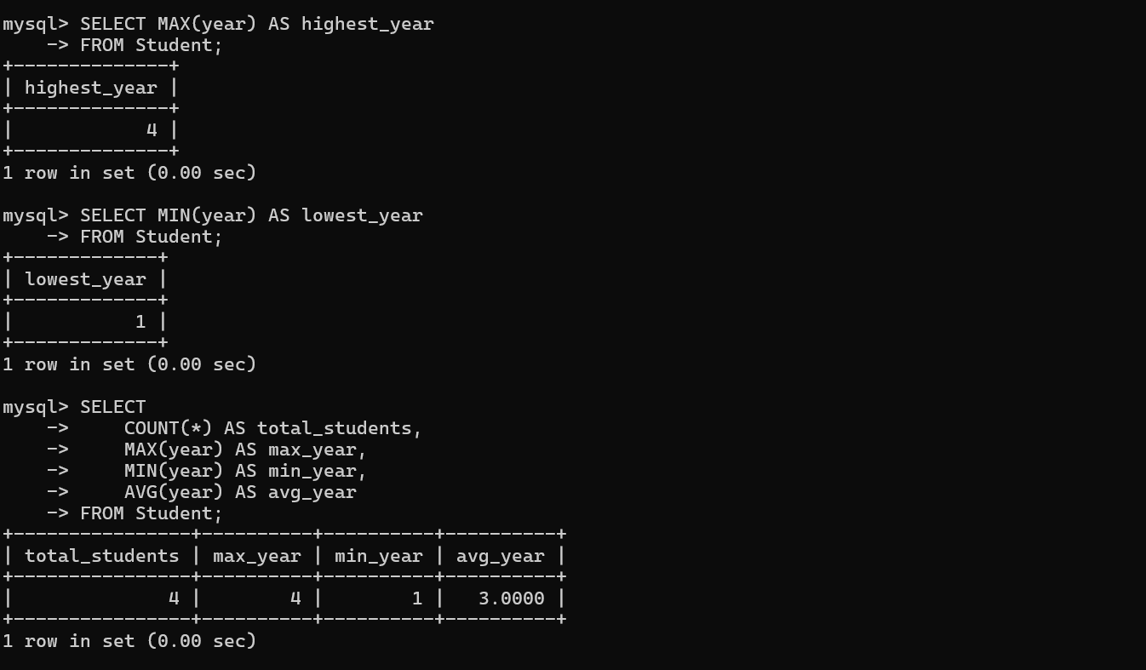
Session 2
Triggers
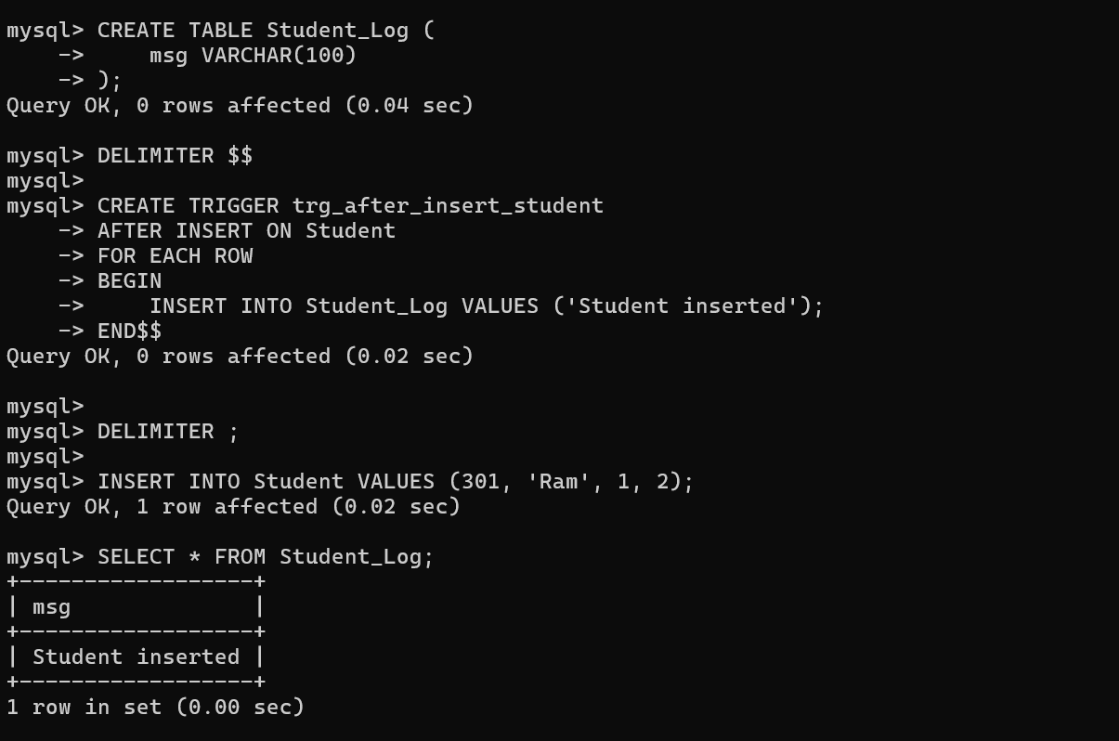

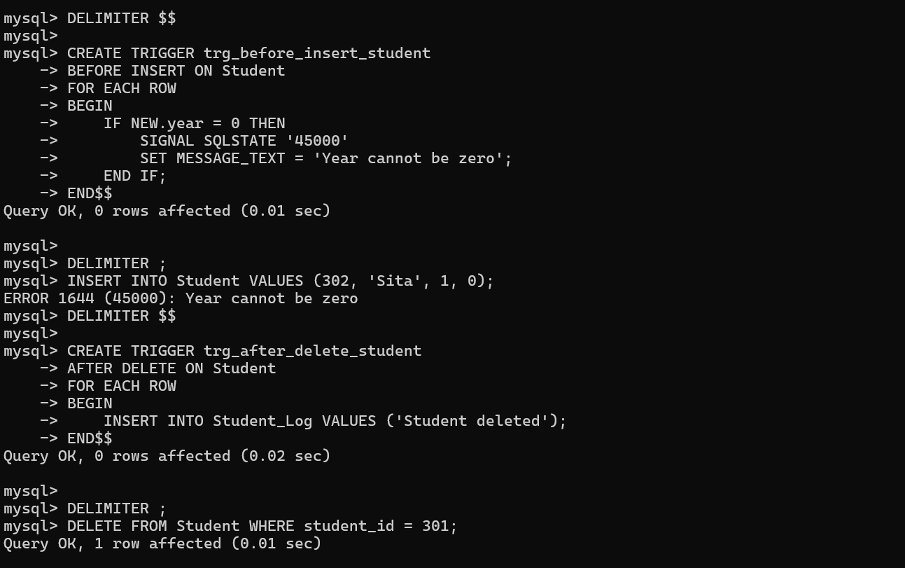

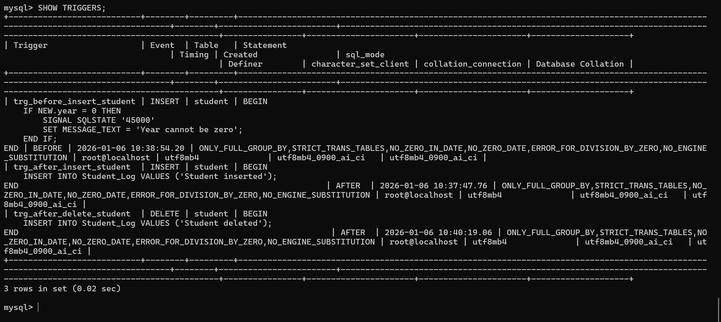

VIEWS
🔹 What is a VIEW?
A VIEW is a virtual table created using a SELECT query.
It does not store data, it stores the query.
✅ Create a VIEW
Example: Student + Department view
CREATE VIEW Student_Department_View AS
SELECT s.student_id, s.student_name, d.dept_name
FROM Student s
JOIN Department d ON s.dept_id = d.dept_id;
✅ Use the VIEW
SELECT * FROM Student_Department_View;
✅ Drop a VIEW
DROP VIEW Student_Department_View;
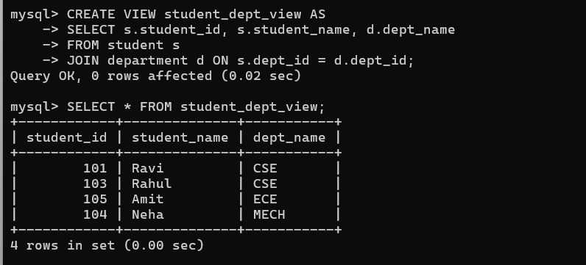
EXCEPTION HANDLING (Error Handling)
🔹 What is Exception Handling?
Handling runtime errors so the program does not crash.
In MySQL, exception handling is used inside:
- Triggers
- Stored Procedures

WHAT IS A STORED PROCEDURE?
Think:
“I want to save some SQL steps and run them with one command”
That saved logic = Stored Procedure
EASIEST procedure possible:
DELIMITER $$
CREATE PROCEDURE show_students()
BEGIN
SELECT * FROM student;
END$$
DELIMITER ;
Run it:
CALL show_students();
📌 Same result as SELECT * FROM student;
But saved with a name.
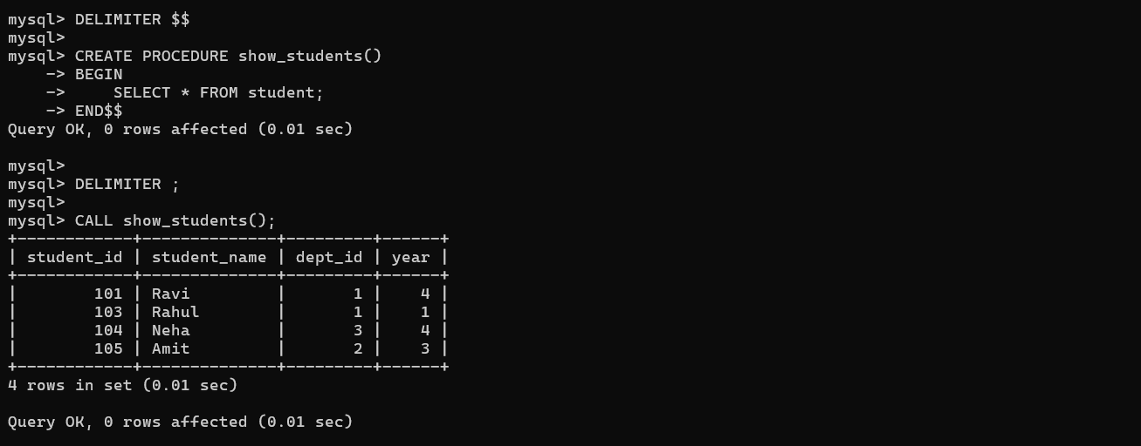

WHAT IS EXCEPTION HANDLING with stored procedure.
Real-life example:
You try something → error happens → instead of crashing, show message.
That is exception handling.
📌 It cannot exist alone
📌 It is written inside procedures or triggers

SIMPLE example (don’t overthink):
DELIMITER $$
CREATE PROCEDURE test_error()
BEGIN
DECLARE CONTINUE HANDLER FOR SQLEXCEPTION
BEGIN
SELECT 'Some error happened' AS message;
END;
INSERT INTO student VALUES (101, 'Test', 1);
END$$
DELIMITER ;
If error happens → message shows
If no error → insert works
You created the procedure.
Now run it 👇
CALL test_error();
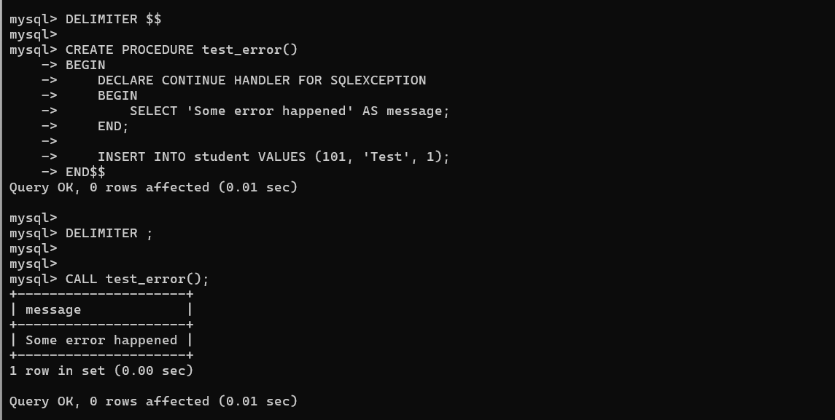

INBUILT FUNCTIONS (Already present in MySQL)
These functions are already available.
You just use them, no need to create.

1️⃣ STRING FUNCTIONS
UPPER()
SELECT UPPER(student_name) FROM student;
LOWER()
SELECT LOWER(student_name) FROM student;
LENGTH()
SELECT student_name, LENGTH(student_name) FROM student;
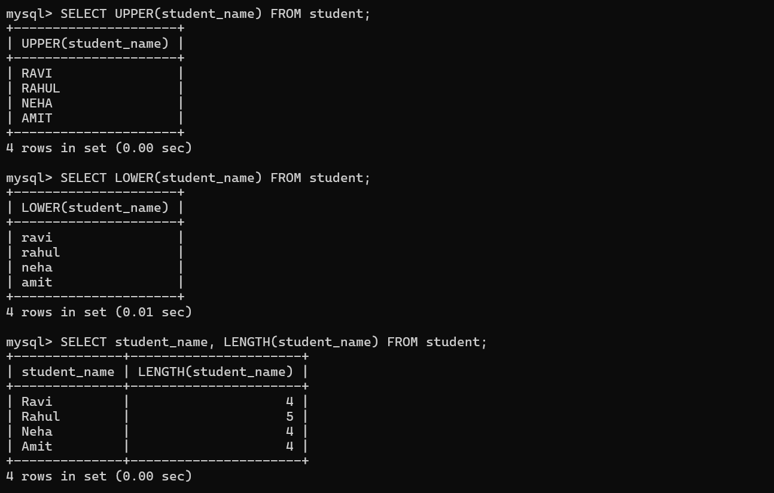
2️⃣ NUMERIC FUNCTIONS
COUNT()
SELECT COUNT(*) FROM student;
MAX()
SELECT MAX(student_id) FROM student;
MIN()
SELECT MIN(student_id) FROM student;

3️⃣ DATE FUNCTIONS
CURRENT_DATE
SELECT CURRENT_DATE;
NOW()
SELECT NOW();

4️⃣ AGGREGATE FUNCTIONS (VERY IMPORTANT)
Total students
SELECT COUNT(*) AS total_students FROM student;
Students per department
SELECT dept_id, COUNT(*)
FROM student
GROUP BY dept_id;
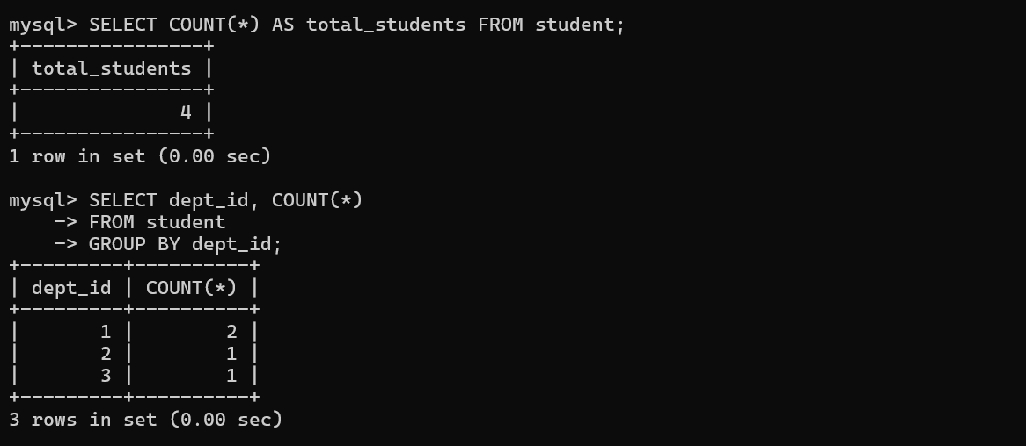

USER-DEFINED FUNCTIONS (You create them)
These return ONE value.
1️⃣ SIMPLE USER-DEFINED FUNCTION
Create function (adds 2 numbers)
DELIMITER $$

CREATE FUNCTION add_two_numbers(a INT, b INT)
RETURNS INT
DETERMINISTIC
BEGIN
RETURN a + b;
END$$
DELIMITER ;
Call function
SELECT add_two_numbers(5, 10);
Output:
15
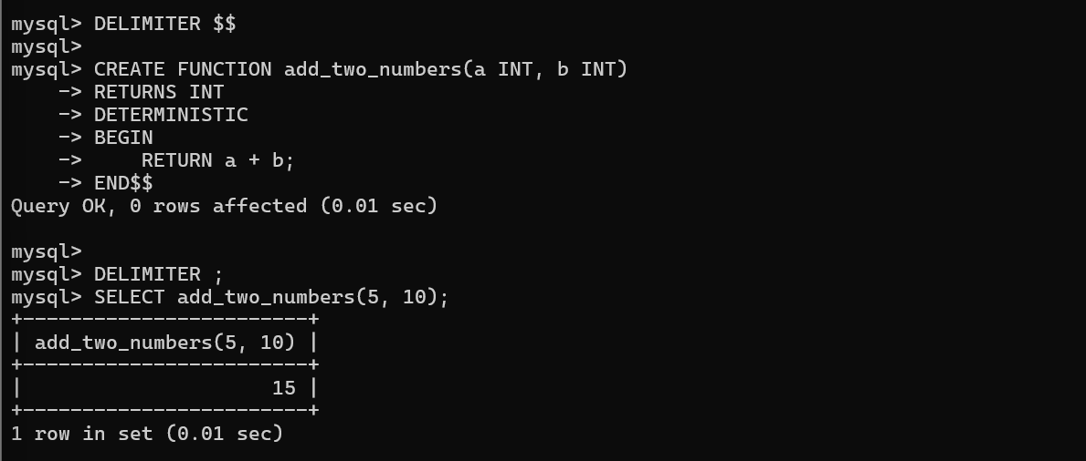
2️⃣ FUNCTION USING TABLE DATA
Function: count students
DELIMITER $$

CREATE FUNCTION total_students()
RETURNS INT
DETERMINISTIC
BEGIN
DECLARE total INT;
SELECT COUNT(*) INTO total FROM student;
RETURN total;
END$$

DELIMITER ;
Call it
SELECT total_students();

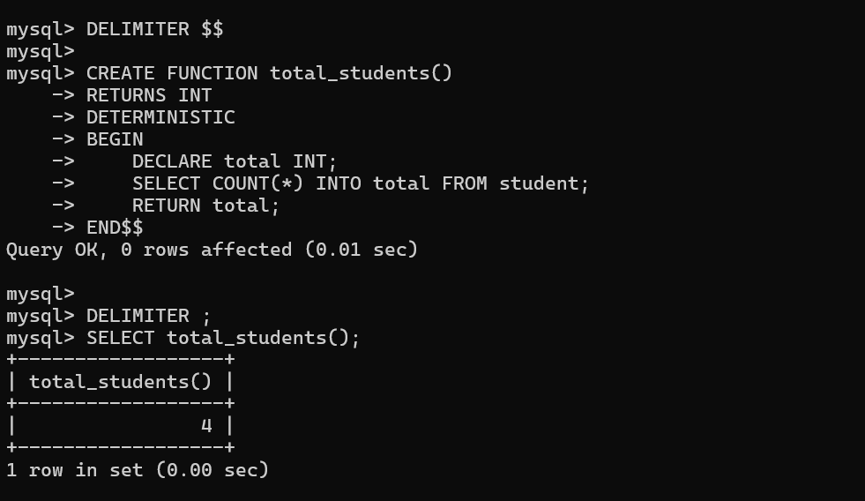

07/01/26
Enter password: ****
Welcome to the MySQL monitor. Commands end with ; or \g.
Your MySQL connection id is 13
Server version: 8.0.43 MySQL Community Server - GPL

Copyright (c) 2000, 2025, Oracle and/or its affiliates.

Oracle is a registered trademark of Oracle Corporation and/or its
affiliates. Other names may be trademarks of their respective
owners.

Type 'help;' or '\h' for help. Type '\c' to clear the current input statement.

mysql> SHOW DATABASES;
+--------------------+
| Database |
+--------------------+
| collegeeventdb |
| information_schema |
| login_demo |
| mysql |
| navspot |
| performance_schema |
| smart_parking |
| sys |
| transport_db |
+--------------------+
9 rows in set (0.01 sec)

mysql> USE collegeeventdb
Database changed
mysql> SHOW TABLES;
+--------------------------+
| Tables_in_collegeeventdb |
+--------------------------+
| department |
| event |
| organizer |
| registration |
| student |
| student_log |
+--------------------------+
6 rows in set (0.02 sec)

mysql> SELECT * FROM student
-> SELECT * FROM student;
ERROR 1064 (42000): You have an error in your SQL syntax; check the manual that corresponds to your MySQL server version for the right syntax to use near 'SELECT * FROM student' at line 2
mysql> SELECT * FROM student;
+------------+--------------+---------+------+
| student_id | student_name | dept_id | year |
+------------+--------------+---------+------+
| 101 | Ravi | 1 | 4 |
| 103 | Rahul | 1 | 1 |
| 104 | Neha | 3 | 4 |
| 105 | Amit | 2 | 3 |
+------------+--------------+---------+------+
4 rows in set (0.00 sec)

mysql> SELECT * FROM event;
+----------+---------------+------------+---------+-------+
| event_id | event_name | event_date | dept_id | venue |
+----------+---------------+------------+---------+-------+
| 201 | Tech Fest | 2026-02-10 | 1 | NULL |
| 202 | Cultural Fest | 2026-03-05 | 2 | NULL |
| 203 | Workshop | 2026-04-01 | 1 | NULL |
+----------+---------------+------------+---------+-------+
3 rows in set (0.00 sec)

mysql> SELECT * FROM registration;
+--------+------------+----------+--------------+
| reg_id | student_id | event_id | organizer_id |
+--------+------------+----------+--------------+
| 401 | 101 | 201 | 301 |
| 403 | 103 | 201 | 301 |
| 404 | 104 | 203 | 302 |
+--------+------------+----------+--------------+
3 rows in set (0.00 sec)

mysql> CREATE VIEW student_dept_view AS
-> SELECT s.student_id, s.student_name, d.dept_name
-> FROM student s
-> JOIN department d ON s.dept_id = d.dept_id;
Query OK, 0 rows affected (0.02 sec)

mysql> SELECT * FROM student_dept_view;
+------------+--------------+-----------+
| student_id | student_name | dept_name |
+------------+--------------+-----------+
| 101 | Ravi | CSE |
| 103 | Rahul | CSE |
| 105 | Amit | ECE |
| 104 | Neha | MECH |
+------------+--------------+-----------+
4 rows in set (0.00 sec)

mysql> SELECT * FROM department;
+---------+-----------+
| dept_id | dept_name |
+---------+-----------+
| 1 | CSE |
| 2 | ECE |
| 3 | MECH |
+---------+-----------+
3 rows in set (0.00 sec)

mysql> DROP VIEW Student_Department_View;
ERROR 1051 (42S02): Unknown table 'collegeeventdb.student_department_view'
mysql> DROP VIEW student_department_view;
ERROR 1051 (42S02): Unknown table 'collegeeventdb.student_department_view'
mysql> SELECT * FROM Student_Department_View;
ERROR 1146 (42S02): Table 'collegeeventdb.student_department_view' doesn't exist
mysql> DROP VIEW student_department_view;
ERROR 1051 (42S02): Unknown table 'collegeeventdb.student_department_view'
mysql> DROP VIEW student_dept_view;
Query OK, 0 rows affected (0.02 sec)

mysql> DELIMITER $$
mysql>
mysql> CREATE PROCEDURE show_students()
-> BEGIN
-> SELECT * FROM student;
-> END$$
Query OK, 0 rows affected (0.01 sec)

mysql>
mysql> DELIMITER ;
mysql>
mysql> CALL show_students();
+------------+--------------+---------+------+
| student_id | student_name | dept_id | year |
+------------+--------------+---------+------+
| 101 | Ravi | 1 | 4 |
| 103 | Rahul | 1 | 1 |
| 104 | Neha | 3 | 4 |
| 105 | Amit | 2 | 3 |
+------------+--------------+---------+------+
4 rows in set (0.01 sec)

Query OK, 0 rows affected (0.01 sec)

mysql> DELIMITER $$
mysql>
mysql> CREATE PROCEDURE test_error()
-> BEGIN
-> DECLARE CONTINUE HANDLER FOR SQLEXCEPTION
-> BEGIN
-> SELECT 'Some error happened' AS message;
-> END;
->
-> INSERT INTO student VALUES (101, 'Test', 1);
-> END$$
Query OK, 0 rows affected (0.01 sec)

mysql>
mysql> DELIMITER ;
mysql>
mysql>
mysql> CALL test_error();
+---------------------+
| message |
+---------------------+
| Some error happened |
+---------------------+
1 row in set (0.00 sec)

Query OK, 0 rows affected (0.01 sec)

mysql> SELECT UPPER(student_name) FROM student;
+---------------------+
| UPPER(student_name) |
+---------------------+
| RAVI |
| RAHUL |
| NEHA |
| AMIT |
+---------------------+
4 rows in set (0.00 sec)

mysql> SELECT LOWER(student_name) FROM student;
+---------------------+
| LOWER(student_name) |
+---------------------+
| ravi |
| rahul |
| neha |
| amit |
+---------------------+
4 rows in set (0.01 sec)

mysql> SELECT student_name, LENGTH(student_name) FROM student;
+--------------+----------------------+
| student_name | LENGTH(student_name) |
+--------------+----------------------+
| Ravi | 4 |
| Rahul | 5 |
| Neha | 4 |
| Amit | 4 |
+--------------+----------------------+
4 rows in set (0.00 sec)

mysql> SELECT COUNT(*) FROM student;
+----------+
| COUNT(*) |
+----------+
| 4 |
+----------+
1 row in set (0.00 sec)

mysql> SELECT MAX(student_id) FROM student;
+-----------------+
| MAX(student_id) |
+-----------------+
| 105 |
+-----------------+
1 row in set (0.00 sec)

mysql> SELECT MIN(student_id) FROM student;
+-----------------+
| MIN(student_id) |
+-----------------+
| 101 |
+-----------------+
1 row in set (0.00 sec)

mysql> SELECT CURRENT_DATE;
+--------------+
| CURRENT_DATE |
+--------------+
| 2026-01-07 |
+--------------+
1 row in set (0.00 sec)

mysql> SELECT NOW();
+---------------------+
| NOW() |
+---------------------+
| 2026-01-07 15:04:43 |
+---------------------+
1 row in set (0.00 sec)

mysql> SELECT COUNT(*) AS total_students FROM student;
+----------------+
| total_students |
+----------------+
| 4 |
+----------------+
1 row in set (0.00 sec)

mysql> SELECT dept_id, COUNT(*)
-> FROM student
-> GROUP BY dept_id;
+---------+----------+
| dept_id | COUNT(*) |
+---------+----------+
| 1 | 2 |
| 2 | 1 |
| 3 | 1 |
+---------+----------+
3 rows in set (0.00 sec)

mysql> DELIMITER $$
mysql>
mysql> CREATE FUNCTION add_two_numbers(a INT, b INT)
-> RETURNS INT
-> DETERMINISTIC
-> BEGIN
-> RETURN a + b;
-> END$$
Query OK, 0 rows affected (0.01 sec)

mysql>
mysql> DELIMITER ;
mysql> SELECT add_two_numbers(5, 10);
+------------------------+
| add_two_numbers(5, 10) |
+------------------------+
| 15 |
+------------------------+
1 row in set (0.01 sec)

mysql> DELIMITER $$
mysql>
mysql> CREATE FUNCTION total_students()
-> RETURNS INT
-> DETERMINISTIC
-> BEGIN
-> DECLARE total INT;
-> SELECT COUNT(*) INTO total FROM student;
-> RETURN total;
-> END$$
Query OK, 0 rows affected (0.01 sec)

mysql>
mysql> DELIMITER ;
mysql> SELECT total_students();
+------------------+
| total_students() |
+------------------+
| 4 |
+------------------+
1 row in set (0.00 sec)

