V. Venkata Susheel Chowdary
192472060

1.Aim:
To read an image using Python and convert the image into grayscale using the OpenCV library.
Pseudocode:
- Start the program.
- Import the OpenCV library.
- Read the input image using the imread() function.
- Check whether the image is loaded successfully.
- Convert the color image into grayscale using the cvtColor() function.
- Display the original image and grayscale image using the imshow() function.
- Wait for a key press and close all windows.
- Stop the program.

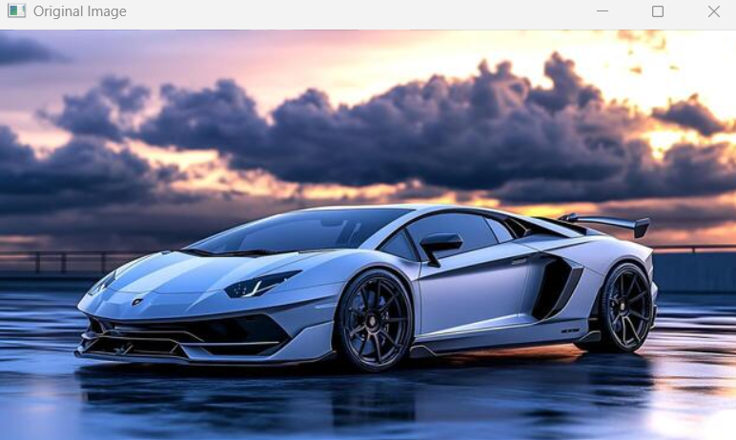

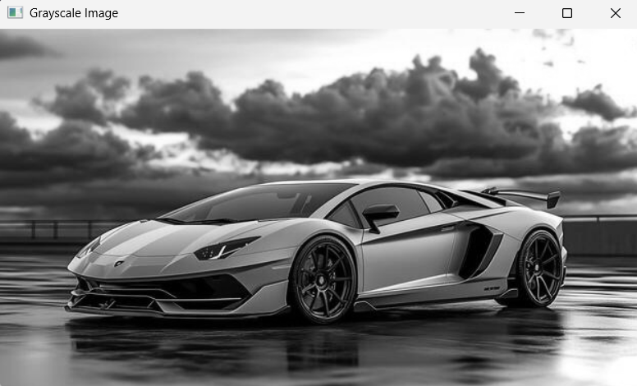
Result:
Thus, the input image was successfully read using Python and converted into a grayscale image using the OpenCV library. The original and grayscale images were displayed successfully.

