V. Venkata Susheel Chowdary
192472060

11.Aim:
To rotate a given image by 180 degrees clockwise using Python and OpenCV.
Pseudocode:
- Start the program.
- Import the OpenCV library.
- Read the input image.
- Apply the rotate() function with the 180-degree rotation option.
- Display the original and rotated images.
- Stop the program.

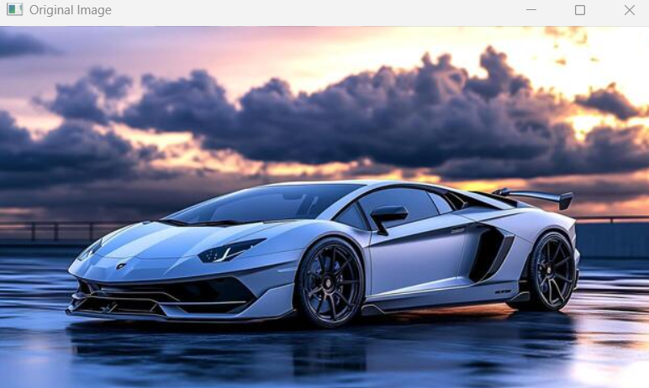

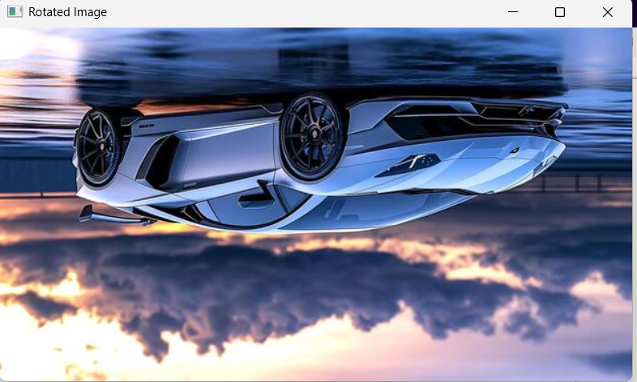

Result: Thus, the input image was successfully rotated by 180 degrees clockwise.

