V. Venkata Susheel Chowdary
192472060

13.Aim:
To perform affine transformation on a given image using Python and OpenCV.
Pseudocode:
- Start the program.
- Import the OpenCV and NumPy libraries.
- Read the input image.
- Select three points from the original image.
- Define three corresponding destination points.
- Calculate the transformation matrix using getAffineTransform().
- Apply warpAffine() to transform the image.
- Display the original and transformed images.
- Stop the program.

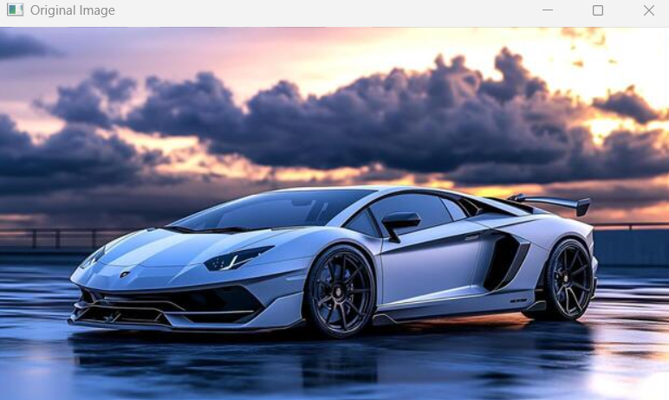

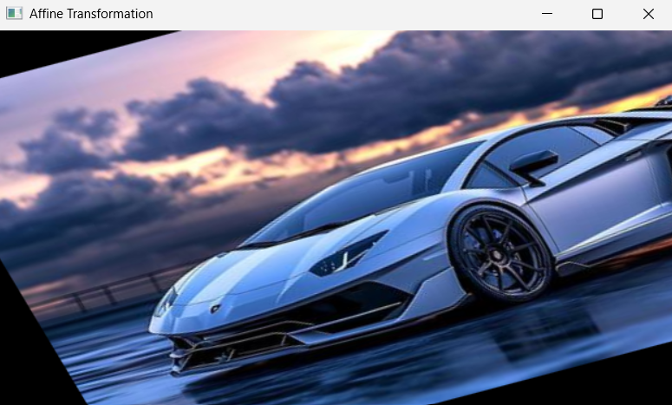

Result: Thus, affine transformation was successfully performed on the input image using OpenCV.

