V. Venkata Susheel Chowdary
192472060

14.Aim:
To perform perspective transformation on a given image using Python and OpenCV.
Pseudocode:
- Start the program.
- Import the OpenCV and NumPy libraries.
- Read the input image.
- Select four points from the original image.
- Define four corresponding destination points.
- Calculate the transformation matrix using getPerspectiveTransform().
- Apply warpPerspective() to transform the image.
- Display the original and transformed images.
- Stop the program.

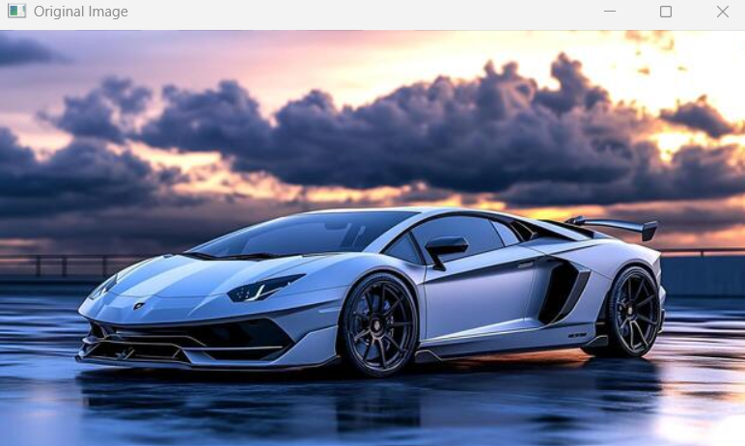

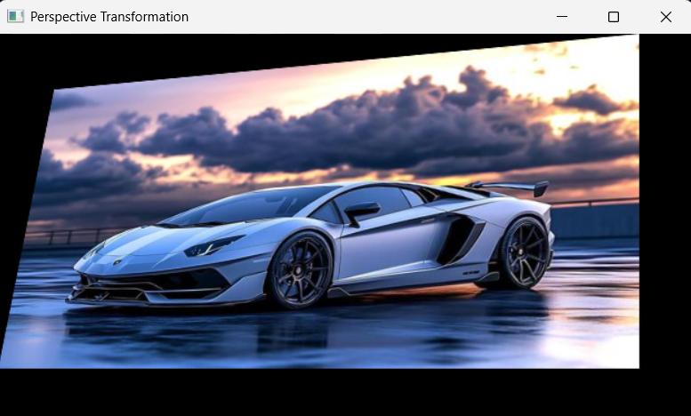

Result: Thus, perspective transformation was successfully performed on the input image using OpenCV.

