V. Venkata Susheel Chowdary
192472060

15.Aim:
To read an image using Python and detect corners in the image using the Harris Corner Detection function in OpenCV.
Pseudocode:
- Start the program.
- Import the OpenCV and NumPy libraries.
- Read the input image.
- Convert the image into grayscale.
- Convert the grayscale image to floating-point format.
- Apply the cornerHarris() function to detect corners.
- Mark the detected corners on the original image.
- Display the image with detected corners.
- Stop the program.

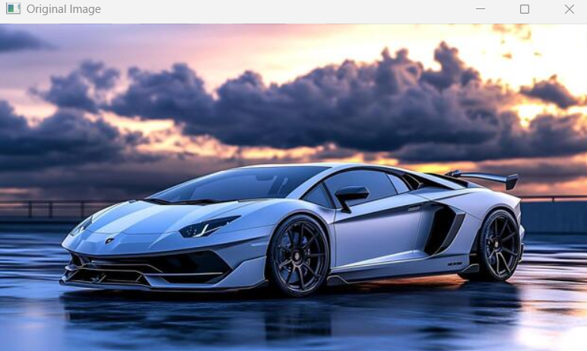

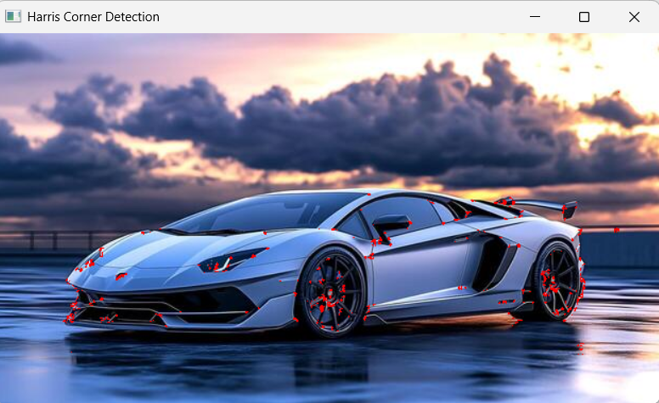

Result: Thus, the corners in the input image were successfully detected using the Harris Corner Detection method.

