V. Venkata Susheel Chowdary
192472060

Aim:
To read an image using Python and apply Gaussian Blur to reduce noise and smooth the image using OpenCV.
Pseudocode:
- Start the program.
- Import the OpenCV library.
- Read the input image.
- Apply Gaussian Blur using the GaussianBlur() function.
- Display the original and blurred images.
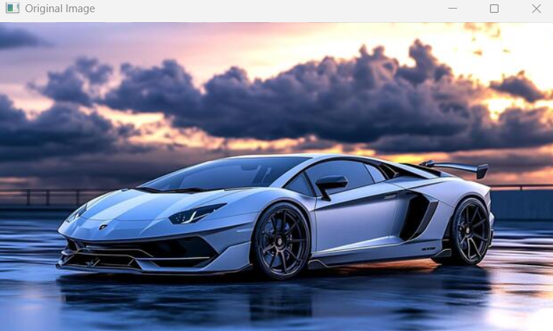
- Stop the program.

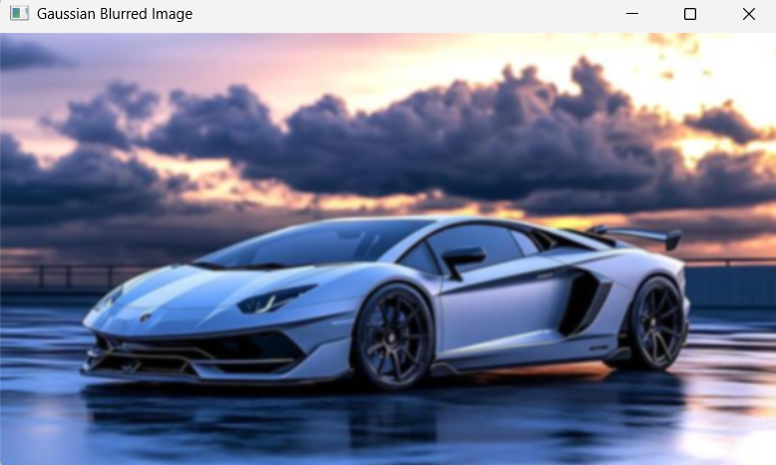

Result:
Thus, the input image was successfully blurred using the Gaussian Blur function in OpenCV.

