V. Venkata Susheel Chowdary
192472060

3. Aim:
To read an image using Python and detect its outlines using the Canny edge detection function in OpenCV.
Pseudocode:
- Start the program.
- Import the OpenCV library.
- Read the input image.
- Convert the image into grayscale.
- Apply the Canny() function to detect edges.
- Display the original and edge-detected images.
- Stop the program.



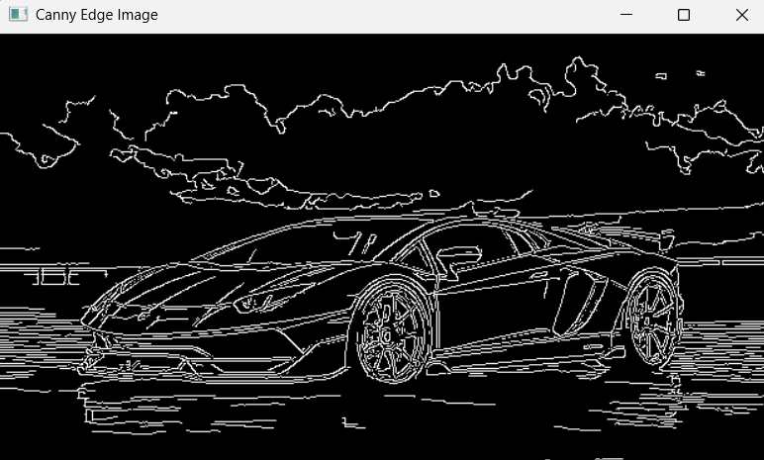

Result:
Thus, the outlines of the input image were successfully detected using the Canny edge detection function.

