V. Venkata Susheel Chowdary
192472060

4.Aim:
To implement histogram equalization on a given image and compare the result with the original image using OpenCV.
Pseudocode:
- Start the program.
- Import the OpenCV library.
- Read the input image.
- Convert the image into grayscale.
- Apply the equalizeHist() function.
- Display the original and equalized images.
- Stop the program.

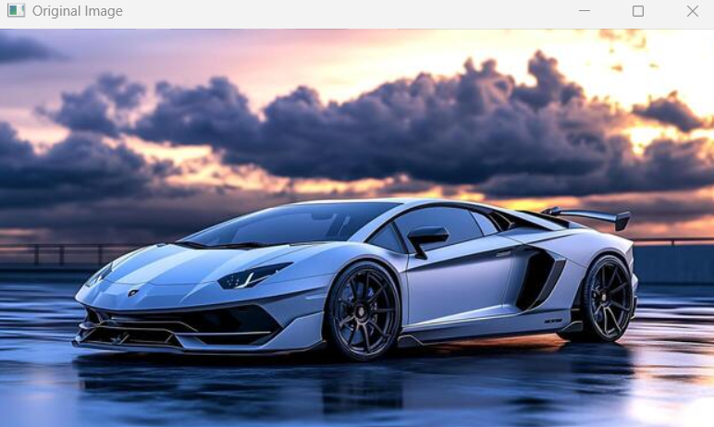

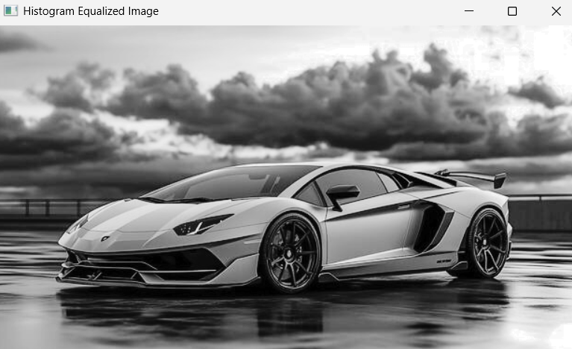

Result: Thus, histogram equalization was successfully performed, improving the contrast of the grayscale image.

