V. Venkata Susheel Chowdary
192472060

5.Aim:
To write a Python function to analyze and display the histogram of an input image based on its color levels using OpenCV.
Pseudocode:
- Start the program.
- Import the OpenCV and Matplotlib libraries.
- Read the input color image.
- Separate the image into blue, green, and red channels.
- Calculate the histogram of each channel using the calcHist() function.
- Plot the histograms for all three color channels.
- Display the histogram.
- Stop the program.
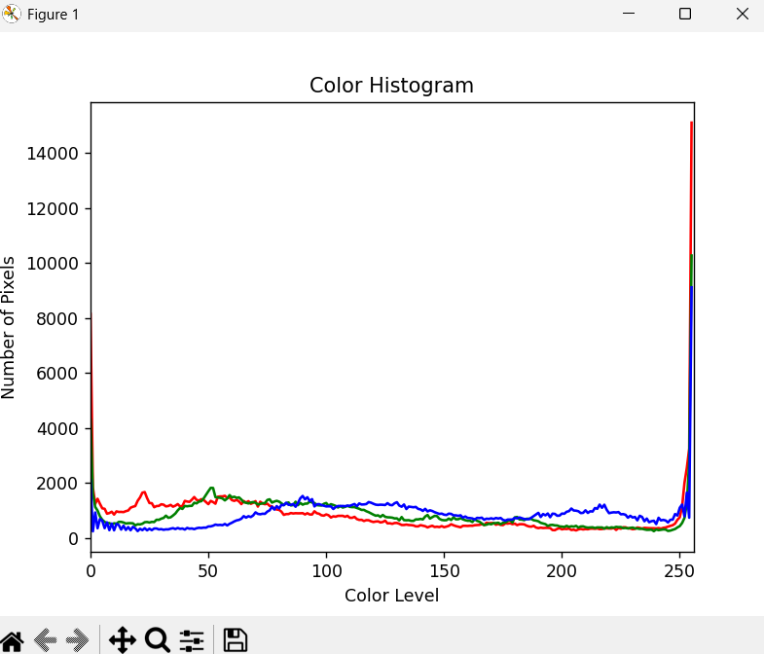

Result:
Thus, the histogram of the input image was successfully calculated and displayed for the blue, green, and red color channels.

