V. Venkata Susheel Chowdary
192472060

7.Aim:
To read and display a captured video using Python and perform slow-motion and fast-motion video processing.
Pseudocode:
- Start the program.
- Import the OpenCV library.
- Open the captured video using VideoCapture().
- Read and display the video frames.
- Add delays between frames to display the video in slow motion.
- Skip frames or reduce delays to display the video in fast motion.
- Release the video and close all windows.
- Stop the program.

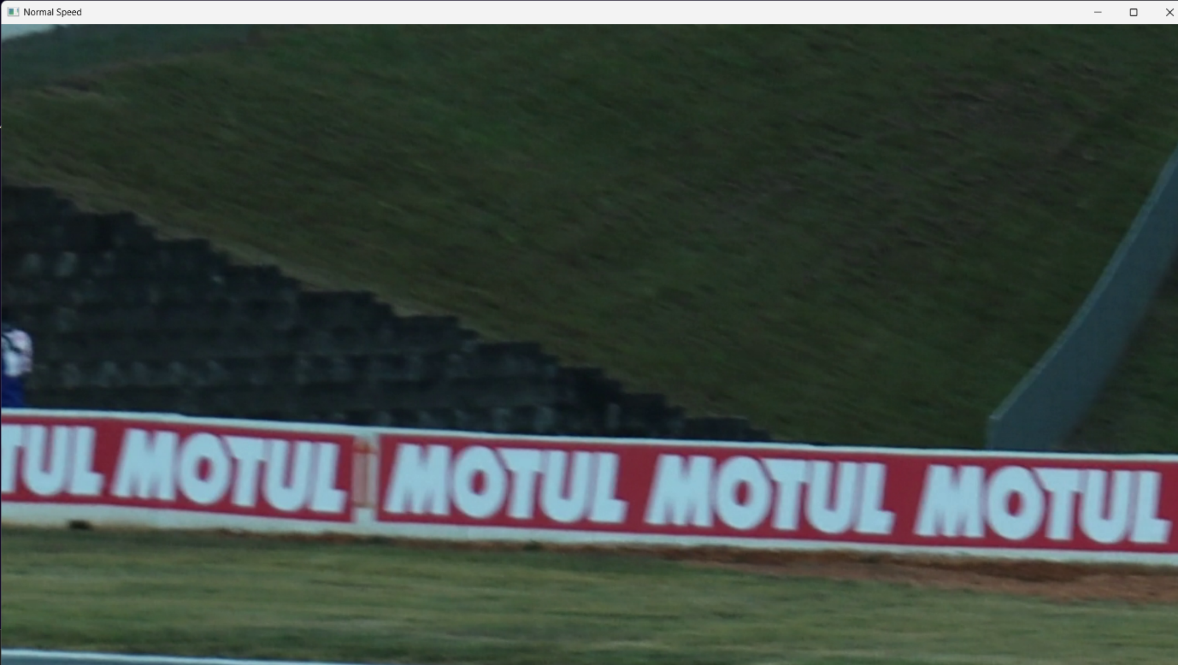

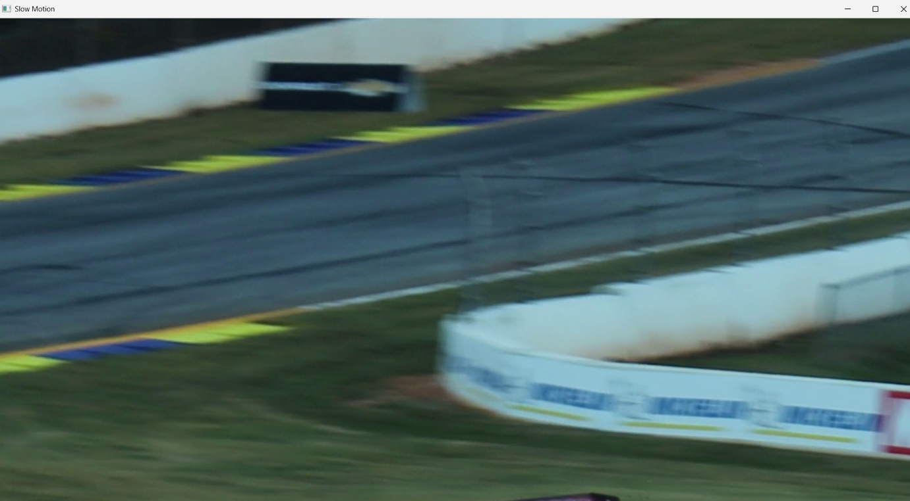

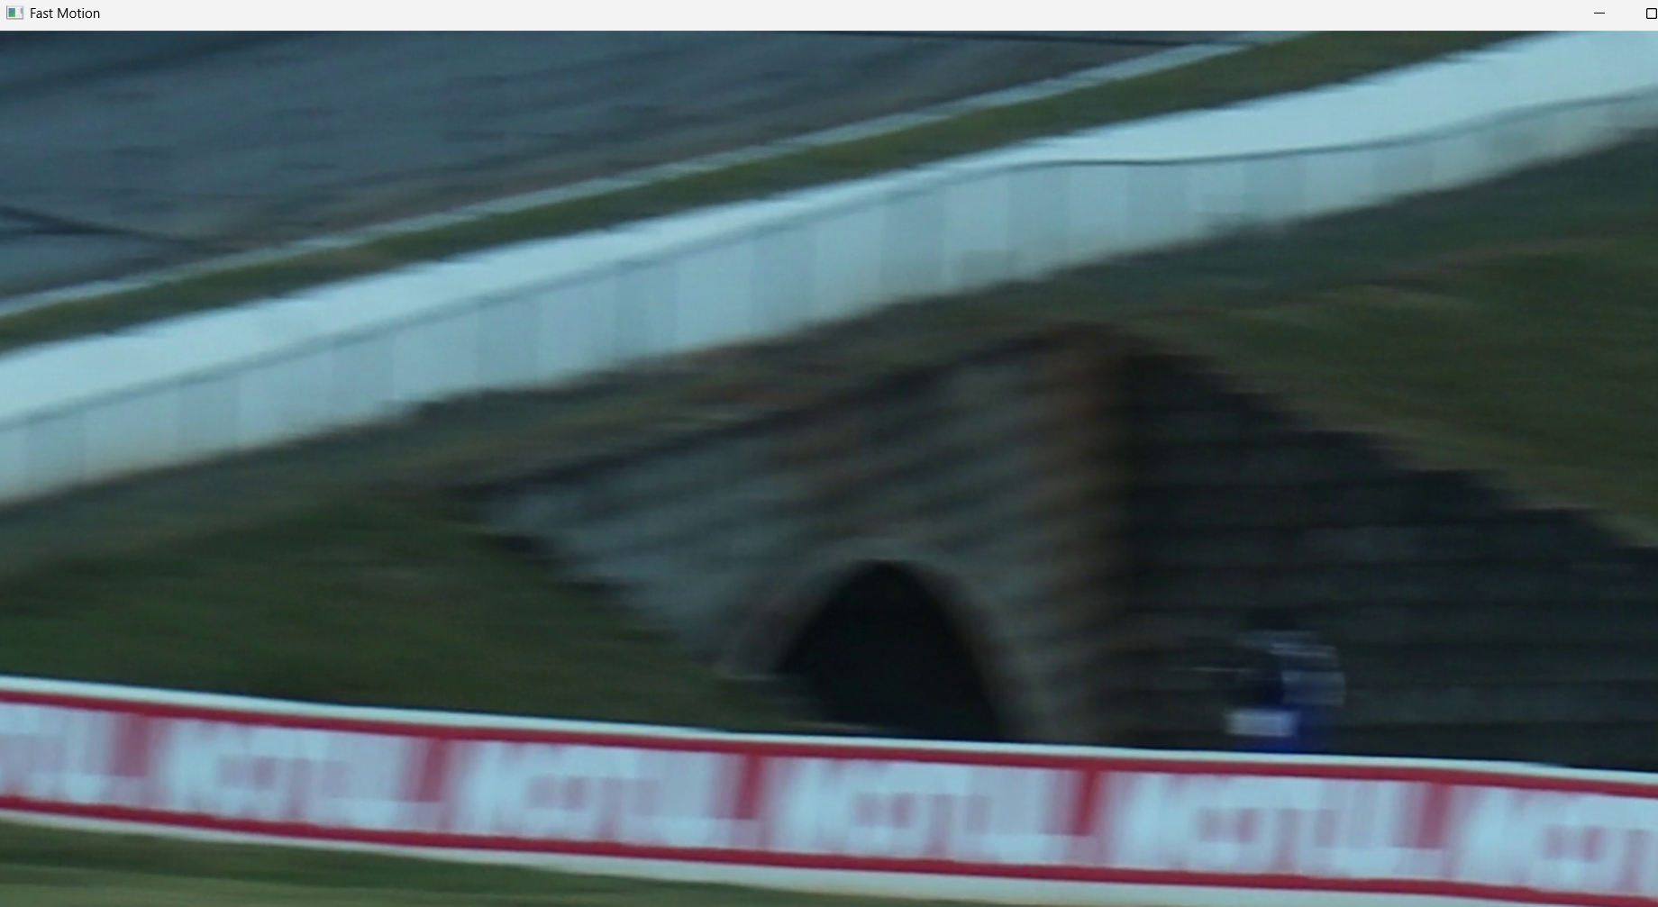

Result:
Thus, the captured video was successfully read and displayed in normal, slow-motion, and fast-motion modes.

