V. Venkata Susheel Chowdary
192472060

8.Aim:
To read an image using Python and perform image dilation using the dilate() function in OpenCV.
Pseudocode:
- Start the program.
- Import the OpenCV library.
- Read the input image.
- Create a structuring element (kernel).
- Apply the dilate() function to the image.
- Display the original and dilated images.
- Stop the program.

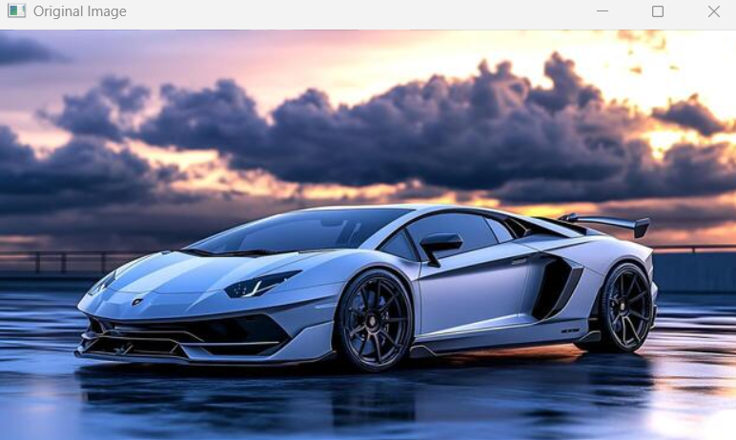

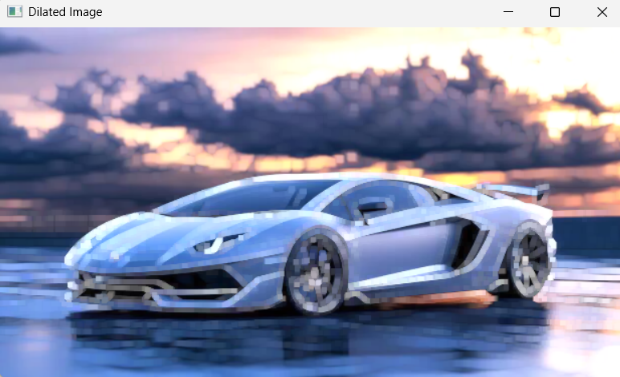

Result:
Thus, image dilation was successfully performed, expanding the foreground regions of the image.

