V. Venkata Susheel Chowdary
192472060

9.Aim:
To implement image scaling techniques in Python to resize an image into larger and smaller sizes using OpenCV.
Pseudocode:
- Start the program.
- Import the OpenCV library.
- Read the input image.
- Resize the image to a larger size using resize().
- Resize the image to a smaller size using resize().
- Display the original, enlarged, and reduced images.
- Stop the program.

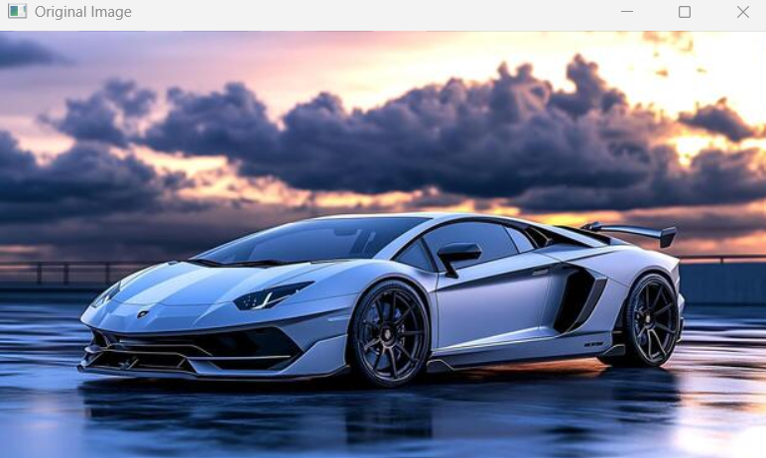

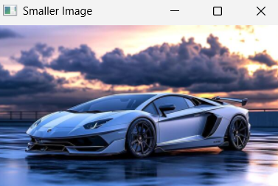

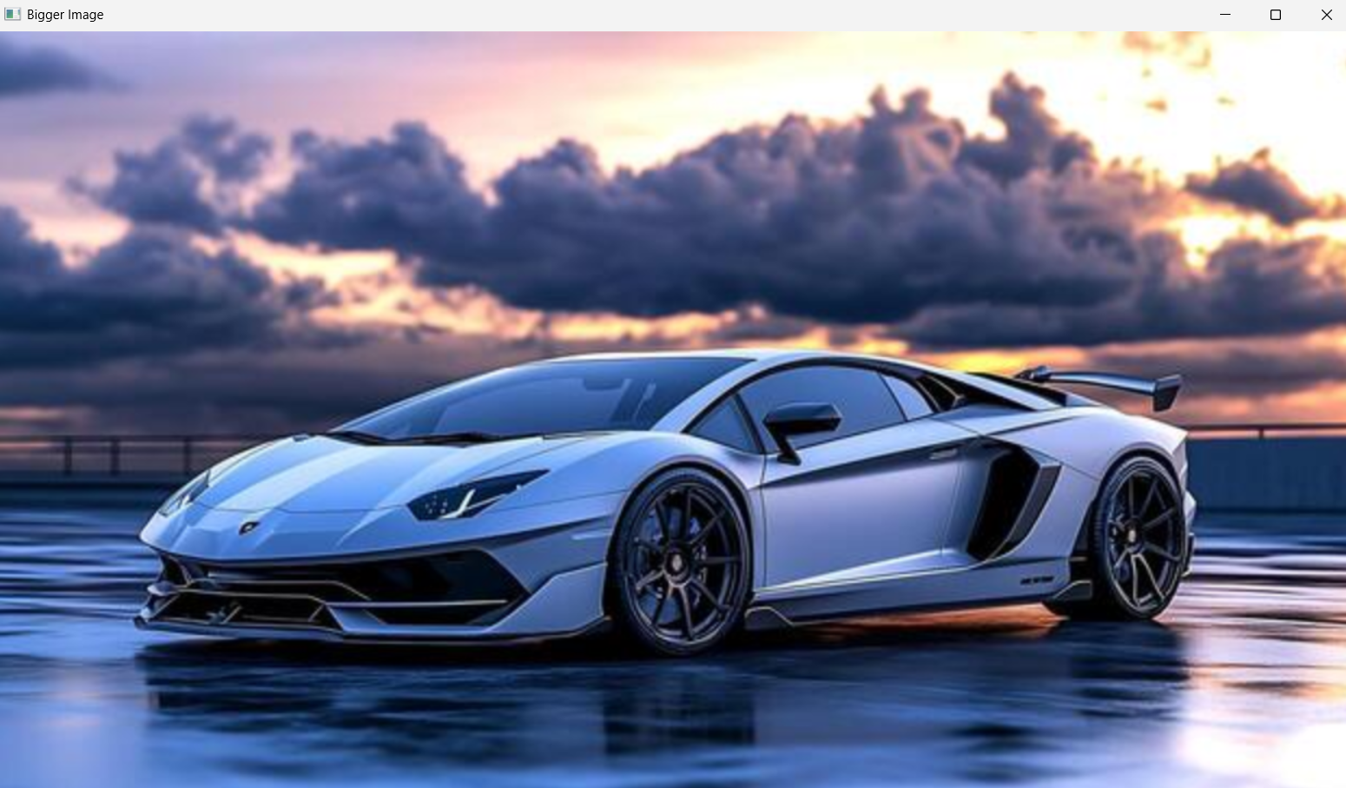

Result: Thus, image scaling was successfully performed to produce both enlarged and reduced versions of the original image.

