CardioPredict: An AI-Based Heart Disease Risk Prediction System Using Machine Learning

AI Project Planning Report

Yuva Intern - Week 1

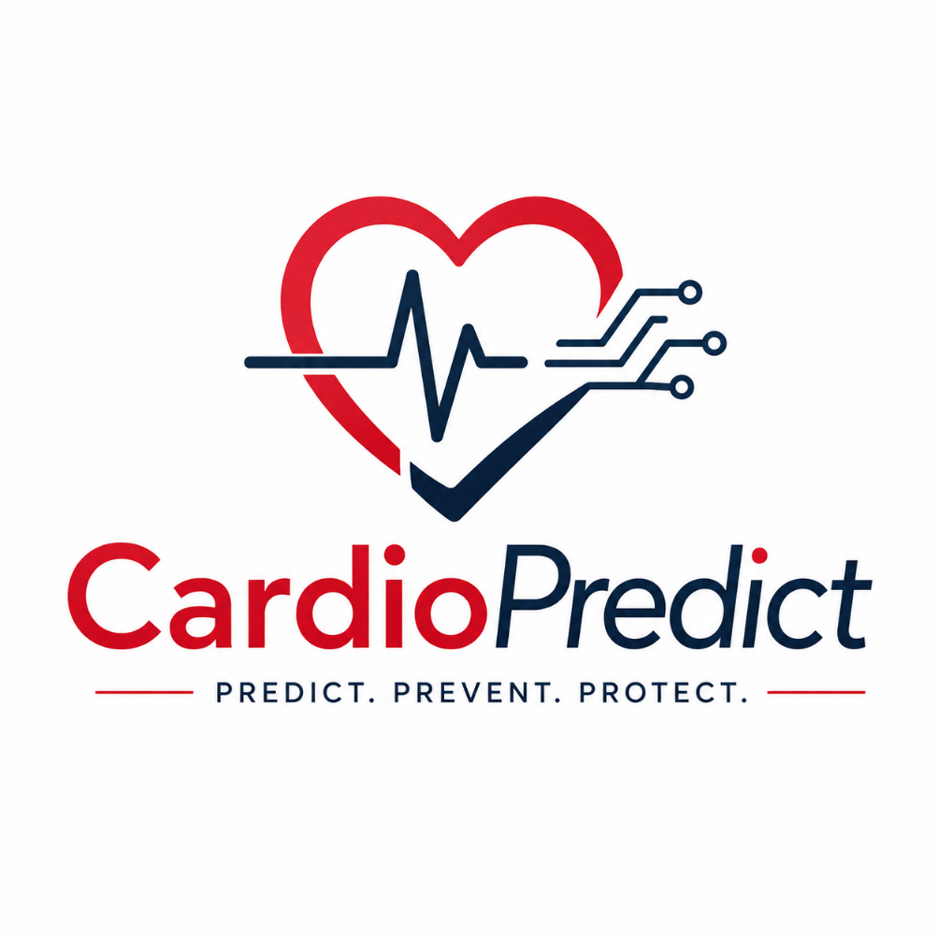

Prepared by:
Venkatachalam K

Abstract

Heart disease is one of the leading causes of death worldwide, making early detection and timely medical intervention extremely important. Healthcare professionals often rely on multiple clinical parameters such as age, blood pressure, cholesterol levels, heart rate, and other medical indicators to assess a patient's risk of developing heart disease. However, manually analyzing these factors for every patient can be time-consuming and may become challenging when dealing with large amounts of healthcare data.
This project proposes CardioPredict, an AI-based predictive analytics system that assists in identifying the likelihood of heart disease using machine learning techniques. The system utilizes a publicly available heart disease dataset to train a classification model capable of recognizing patterns in patient medical records. Based on these learned patterns, the trained model predicts whether a patient is likely to have heart disease.
The project focuses on understanding the complete machine learning workflow, including data collection, preprocessing, feature engineering, model selection, training, evaluation, and prediction. Rather than replacing healthcare professionals, the proposed system is designed to support clinical decision-making by providing an early risk assessment based on patient data.
This report presents the planning methodology, dataset selection, AI model justification, system architecture, workflow, evaluation strategy, expected outcomes, and project timeline for developing the proposed predictive analytics system.

Introduction
Artificial Intelligence has become one of the most influential technologies across various industries, with healthcare being one of its most promising application areas. Machine learning algorithms have the ability to analyze large volumes of medical data and identify complex relationships that may not be immediately visible through manual analysis. These capabilities have enabled researchers and healthcare professionals to develop predictive systems that assist in disease diagnosis, treatment planning, and patient monitoring.
Heart disease continues to be a major global health concern, affecting millions of people each year. Early identification of individuals who are at risk allows doctors to recommend lifestyle changes, conduct further medical examinations, and begin treatment before the condition becomes severe. Since several medical factors contribute to heart disease, predicting risk based on historical patient data has become an important area of research.
The proposed project, CardioPredict, aims to develop a machine learning-based predictive system capable of estimating the likelihood of heart disease using patient clinical information. The system will analyze attributes such as age, blood pressure, cholesterol levels, chest pain type, heart rate, and other medical parameters to generate predictions regarding heart disease risk.
Unlike traditional rule-based systems that depend on manually defined conditions, CardioPredict will learn patterns directly from historical patient data. This allows the system to make predictions based on relationships discovered during model training rather than fixed human-written rules.
The project provides an opportunity to understand how predictive analytics can be applied to healthcare while introducing fundamental machine learning concepts such as supervised learning, data preprocessing, feature engineering, model training, and performance evaluation.
Problem Statement
Heart disease is responsible for a significant number of deaths worldwide and often develops due to a combination of multiple medical and lifestyle factors. Physicians evaluate several clinical parameters before determining whether a patient is at risk. As the amount of healthcare data continues to increase, manually analyzing every patient's medical information becomes increasingly difficult and time-consuming.
Although experienced healthcare professionals can make accurate diagnoses, there is always a need for intelligent systems that can assist in identifying high-risk patients quickly and consistently. Existing healthcare systems primarily store patient information but often provide limited support for predictive analysis based on historical medical data.
The absence of automated prediction systems may delay early detection and increase the burden on healthcare providers. Therefore, there is a need for an intelligent machine learning-based solution capable of analyzing patient medical records and predicting the likelihood of heart disease using previously learned patterns.
The proposed system aims to address this problem by developing an AI-powered predictive analytics model that assists healthcare professionals in identifying patients who may require further medical examination.

Existing System
Traditional healthcare diagnosis primarily depends on clinical examinations, laboratory tests, and the experience of medical professionals. Doctors analyze various health indicators such as blood pressure, cholesterol levels, chest pain symptoms, electrocardiogram results, and heart rate before making a diagnosis. While this approach provides accurate medical assessments, it can become time-consuming when handling a large number of patient records.
Several hospitals and healthcare organizations maintain electronic health records that digitally store patient information. However, these systems mainly function as repositories for medical data and often lack intelligent prediction capabilities. They require healthcare professionals to manually interpret patient information before making clinical decisions.
Although some hospitals utilize decision-support software, many existing systems rely on predefined medical guidelines rather than learning from historical patient data. As a result, opportunities to discover hidden patterns and improve prediction accuracy may be limited.
These limitations highlight the need for machine learning-based predictive systems that can analyze historical healthcare data, recognize complex relationships among medical attributes, and assist doctors by providing early risk predictions.

Proposed System
The proposed system, CardioPredict, is an AI-based predictive analytics platform designed to estimate the likelihood of heart disease using patient clinical information. Instead of relying solely on manually defined medical rules, the system employs supervised machine learning techniques to learn patterns from historical patient data.
The project utilizes the UCI Heart Disease Dataset, which contains various clinical attributes associated with heart disease diagnosis. During training, the machine learning model analyzes relationships between patient characteristics and corresponding diagnosis labels. Once trained, the model can predict whether a new patient is likely to have heart disease based on the information provided.
The system begins by collecting patient information such as age, gender, chest pain type, blood pressure, cholesterol level, fasting blood sugar, maximum heart rate, and additional clinical parameters. These values are preprocessed, cleaned, and converted into a suitable format before being provided to the machine learning model.
After analyzing the input data, the trained model generates a prediction indicating whether the patient is at risk of heart disease. The prediction is intended to support healthcare professionals by providing an additional decision-support tool rather than replacing medical expertise.
The proposed system demonstrates how predictive analytics and machine learning can improve healthcare decision-making through efficient analysis of historical medical data.

Hypothesis
This project is based on the hypothesis that machine learning algorithms trained on historical patient data can accurately predict the likelihood of heart disease by identifying patterns among various clinical attributes.
It is assumed that factors such as age, chest pain type, blood pressure, cholesterol level, maximum heart rate, fasting blood sugar, and electrocardiogram results collectively influence the probability of heart disease. By learning these relationships from the training dataset, the machine learning model should be capable of making reliable predictions for previously unseen patient records.
If appropriate preprocessing techniques and a suitable classification algorithm are applied, the resulting predictive model is expected to achieve satisfactory accuracy while assisting healthcare professionals in early risk assessment.

Project Objectives
The primary objective of the CardioPredict project is to develop a machine learning-based predictive analytics system that can estimate the likelihood of heart disease using patient clinical data. The system aims to assist healthcare professionals by providing an early risk prediction based on historical medical records.
Another objective is to understand the complete workflow involved in building a machine learning application, including data collection, preprocessing, feature engineering, model training, evaluation, and prediction. Through this project, the practical implementation of predictive analytics in healthcare can be explored using publicly available datasets.
The project also aims to compare different machine learning algorithms and identify the model that provides the best prediction accuracy. Based on the performance of each model, the most suitable algorithm will be selected for deployment.
Finally, the project seeks to demonstrate how Artificial Intelligence can support medical decision-making by analyzing patient information quickly and consistently while serving as an assistive tool rather than replacing professional medical expertise.

Dataset Description
The proposed system will utilize the UCI Heart Disease Dataset, one of the most widely used benchmark datasets for machine learning research in healthcare. This dataset contains anonymized patient information collected for the purpose of studying heart disease prediction.
The dataset includes several clinical attributes that are commonly considered during medical diagnosis. These features include age, gender, chest pain type, resting blood pressure, cholesterol level, fasting blood sugar, resting electrocardiogram results, maximum heart rate achieved, exercise-induced angina, ST depression, number of major blood vessels, and thalassemia. The target variable indicates whether the patient has heart disease.
The dataset is publicly available and has been extensively used in academic research, making it a reliable source for developing and evaluating predictive machine learning models. Since the data has already been labeled, it is suitable for supervised learning algorithms that learn relationships between patient characteristics and disease outcomes.
Using a standardized public dataset also ensures that the proposed project follows ethical research practices while allowing the model's performance to be compared with similar studies.
Data Collection Methodology
The data required for this project will be obtained from the publicly available UCI Heart Disease Dataset. Since the dataset has already been collected, anonymized, and organized for research purposes, no direct interaction with patients or hospitals is required. This approach simplifies data collection while ensuring compliance with ethical standards regarding patient privacy.
After downloading the dataset, each attribute will be examined to understand its purpose and relevance to heart disease prediction. The collected data will then be inspected for missing values, duplicate records, inconsistent entries, and data quality issues before preprocessing begins.
The dataset will be divided into three subsets: a training set, a validation set, and a testing set. The training set will be used to teach the machine learning model, the validation set will help in selecting the best-performing algorithm and tuning its parameters, and the testing set will evaluate the final model using previously unseen patient records. This process ensures that the evaluation reflects the model's ability to generalize to new data.

Data Preprocessing
Data preprocessing is one of the most important stages in the machine learning pipeline because the quality of the input data directly affects the model's predictive performance. Before training begins, the dataset must be cleaned and prepared to ensure consistency and reliability.
Initially, the dataset will be inspected for missing values and invalid entries. If missing values are present, appropriate techniques such as imputation or removal will be applied depending on the nature of the data. Duplicate records will also be identified and removed to prevent bias during model training.
Categorical variables, including chest pain type and resting electrocardiogram results, will be converted into numerical representations that can be processed by machine learning algorithms. Continuous numerical features may also be normalized or standardized when necessary to improve training efficiency.
Finally, the cleaned dataset will be divided into input features and the target variable before being split into training and testing datasets. These preprocessing steps help ensure that the machine learning model receives accurate and consistent data during training.

AI Model Selection
Selecting the appropriate machine learning algorithm is an essential step in developing an accurate predictive analytics system. Since heart disease prediction is a binary classification problem, several supervised machine learning algorithms are suitable for this task.
Initially, Logistic Regression will be considered because it is widely used for binary classification problems and provides a simple baseline model. A Decision Tree model will also be evaluated due to its ability to represent decision-making processes in an interpretable manner.
The primary model selected for this project is Random Forest. Random Forest is an ensemble learning algorithm that combines multiple decision trees to improve prediction accuracy while reducing the risk of overfitting. It performs well on structured medical datasets, handles both numerical and categorical features effectively, and is capable of identifying complex relationships among patient attributes.
The model selection process will involve comparing the performance of the candidate algorithms using evaluation metrics such as accuracy, precision, recall, and F1-score. The algorithm that provides the best balance between predictive performance and reliability will be chosen as the final model for the proposed system.

System Architecture
The proposed CardioPredict system follows a structured machine learning architecture that transforms patient clinical information into meaningful predictions regarding heart disease risk.
The process begins with the collection of patient information from the dataset. The collected data is first passed through a preprocessing stage where missing values, duplicate records, and inconsistent data are handled appropriately. The cleaned dataset is then prepared for machine learning through feature engineering techniques such as encoding categorical variables and selecting important clinical features.
The processed data is used to train a Random Forest classification model. During training, the model learns relationships between patient attributes and heart disease outcomes. Once training is completed, the model is evaluated using unseen testing data to measure its predictive performance.
When a new patient's medical details are entered into the system, the trained model analyzes the information and predicts whether the patient is likely to have heart disease. The generated prediction can assist healthcare professionals by providing an additional decision-support tool during diagnosis.

System Architecture Diagram
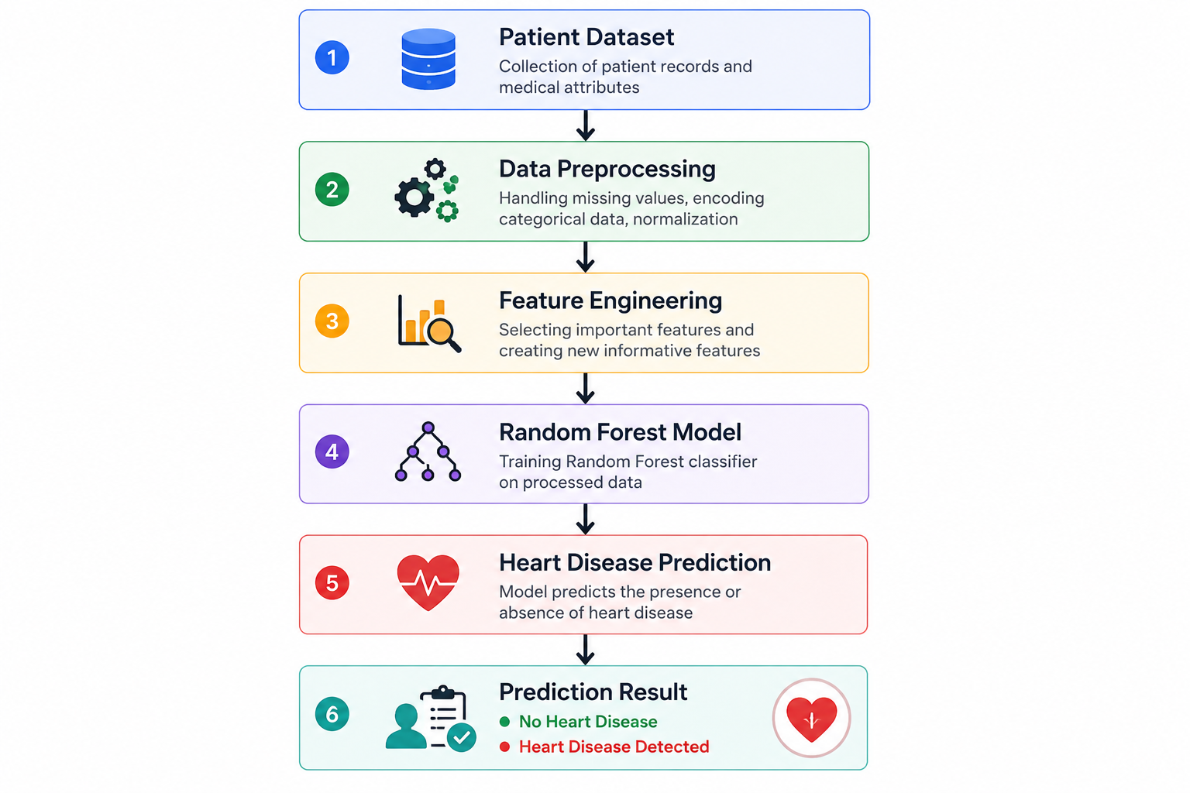
p

Workflow Diagram
The workflow of the proposed system illustrates the sequence of activities involved in developing and using the predictive model.
Initially, the heart disease dataset is collected from a publicly available source. The data is then cleaned and prepared before feature engineering techniques are applied. The processed dataset is divided into training and testing subsets, allowing the machine learning model to learn from historical patient records.
After training, the model is evaluated using multiple performance metrics. Once satisfactory performance is achieved, the trained model can be used to predict heart disease risk for new patient records.
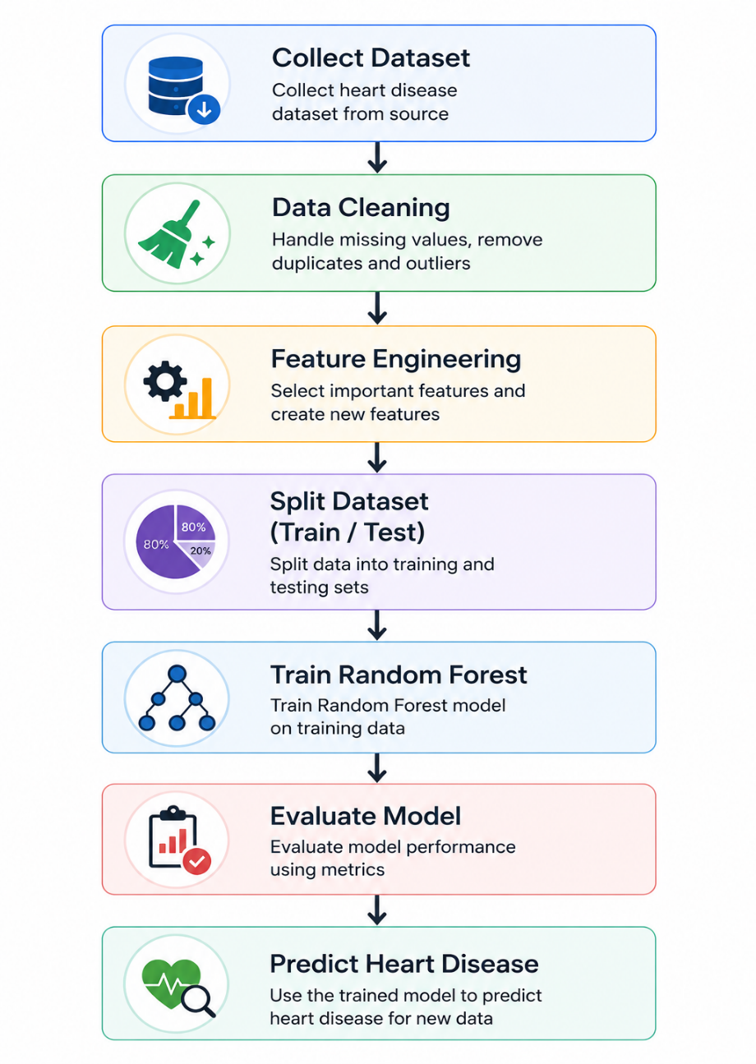

Technology Stack
The proposed project will utilize commonly used machine learning tools and libraries that are suitable for developing predictive analytics applications.

Technology | Purpose
Python | Programming Language
Pandas | Data Handling
NumPy | Numerical Computation
Scikit-learn | Machine Learning Algorithms
Matplotlib | Data Visualization
Jupyter Notebook | Model Development
VS Code | Code Editor

These technologies were selected because they are widely adopted within the machine learning community, provide extensive documentation, and simplify the implementation of predictive analytics projects.

Methodology
The proposed project follows the standard machine learning development lifecycle. Initially, the heart disease dataset will be collected and analyzed to understand the available features and prediction target. Data preprocessing techniques will then be applied to remove inconsistencies, handle missing values, and prepare the dataset for training.
Following preprocessing, relevant clinical features will be selected to improve prediction performance. The processed dataset will then be divided into training and testing subsets. Several machine learning algorithms will be evaluated, and the Random Forest classifier will be selected based on its prediction accuracy and reliability.
The trained model will subsequently be evaluated using standard classification metrics before being used to predict heart disease risk for new patient data. Throughout the project, the emphasis will remain on building an accurate, reliable, and easy-to-understand predictive model.
Model Training
Model training is the stage where the machine learning algorithm learns patterns from historical patient records. The prepared dataset will be divided into training and testing subsets using an appropriate ratio, such as 80% for training and 20% for testing.
During training, the Random Forest algorithm will analyze the relationships between patient features and the corresponding diagnosis labels. By constructing multiple decision trees and combining their predictions, the algorithm develops a robust classification model capable of generalizing to unseen patient data.
After training, the model will be tested using the reserved testing dataset. This evaluation ensures that the model performs effectively on new patient records rather than memorizing the training data.

Evaluation Metrics
The effectiveness of the proposed machine learning model will be measured using several standard evaluation metrics commonly employed in classification problems.
Accuracy measures the overall percentage of correct predictions made by the model.
Precision evaluates how many patients predicted as having heart disease actually have the disease.
Recall measures the model's ability to correctly identify patients who truly have heart disease.
F1-Score combines precision and recall into a single metric, providing a balanced measure of model performance.
A Confusion Matrix will also be generated to visualize the number of correct and incorrect predictions for each class. Together, these metrics provide a comprehensive assessment of the model's predictive capability.

Expected Outcomes
The expected outcome of this project is the successful development of a machine learning model capable of predicting the likelihood of heart disease using patient clinical information. The trained model should demonstrate reliable prediction accuracy when evaluated on unseen patient records.
The project is also expected to provide a practical understanding of the complete machine learning development process, including data collection, preprocessing, feature engineering, model training, evaluation, and prediction.
In addition to developing a predictive model, the project will demonstrate how Artificial Intelligence can support healthcare professionals by providing quick and consistent risk assessments based on historical medical data. Although the system is not intended to replace medical diagnosis, it can serve as a valuable decision-support tool for early disease detection.

Project Timeline (6 Weeks)
Week | Activity
Week 1 | Project Planning, Research, and Documentation
Week 2 | Dataset Collection and Exploratory Data Analysis
Week 3 | Data Cleaning, Preprocessing, and Feature Engineering
Week 4 | Model Development and Training
Week 5 | Model Evaluation and Performance Analysis
Week 6 | Documentation, Final Report Preparation, and Project Submission

Conclusion
The CardioPredict project presents a practical application of Artificial Intelligence and machine learning in the healthcare domain. By utilizing historical patient clinical data, the proposed system aims to predict the likelihood of heart disease and assist healthcare professionals in identifying high-risk patients at an early stage.
The project demonstrates the complete workflow involved in developing a predictive analytics system, from data collection and preprocessing to model training and evaluation. Through the use of the publicly available UCI Heart Disease Dataset and the Random Forest algorithm, the proposed solution provides a simple yet effective approach to heart disease prediction.
This project not only contributes to a better understanding of machine learning techniques but also highlights the potential of predictive analytics in supporting healthcare decision-making. As a learning project, CardioPredict provides valuable hands-on experience in developing AI-based solutions while addressing an important real-world healthcare challenge.

