Approach:



* ISO Image ( Linux or Windows)
* Packer ( Used to create offline template)
* Vault (securely accessing secrets)
* Ansible ( Configuration Management tool – Used to install specific software tools)
* Terraform ( deploying the live infrastructure resources from template, scalable)
* Hosting service( Ex- On-premises, vpshere center or Cloud)

Proposal Solution:

DB Tier

Front Tier

Middle Tier

Packer

Ansible

DB T

Template

MT

Template

FT

Template

Terraform

**On-Premises or Cloud**

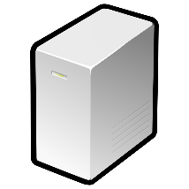  

DB T System text here

MT System text here

FT System text here