**Issues**

CAR MODEL TABLE:

1. Default value in select drop down is not changing to Korean once user changes locale

Actual:

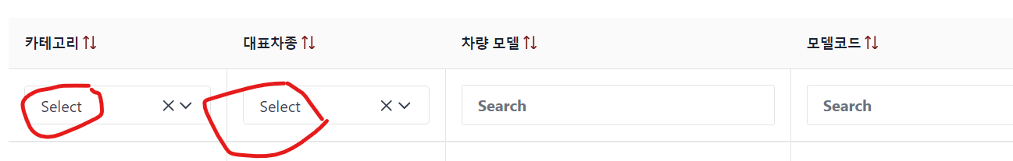

Expected:

Dropdown Default value in Korean  
'-- 선택—

1. Drop down values of class field in add car model not designed as expected

Actual:

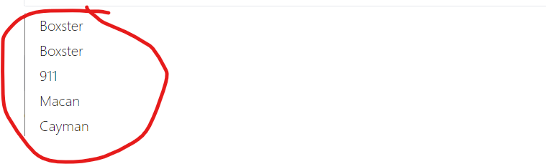

Expected:

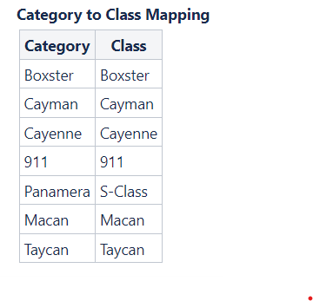

Note: QA not able to create new car model as the sample data covering all the combinations, Back end team needs to remove few records to allow the user to add car from front end.