Encryption of Image Using Triple DES

In today’s world almost all digital services like internet communication, medical and military imaging systems, multimedia system needs a high level security. There is a need for security level in order to safely store and transmit digital images containing critical information. This is because of the faster growth multimedia technology, internet and cell phones. Therefore there is a need for image encryption techniques in order to hide images from such attacks. In this system we use Triple DES (Data Encryption Standard) in order to hide image. Such Encryption technique helps to avoid intrusion attacks.

Working
Triple DES uses total three DES Keys say K₁, K₂ and K₃, each of 56 bits. This does not include parity bits. The encryption algorithm is:
CipherText= E_{K3}(D_{K2}(E_{K1}(plaintext)))
I.e., DES encrypt with K₁, DES decrypt with K₂, then DES encrypt with K₃.
Decryption is the reverse:
Plain Text = D_{K1}(E_{K2}(D_{K3}(CipherText)))
I.e., decrypt with K₃, encrypt with K₂, then decrypt with K₁.

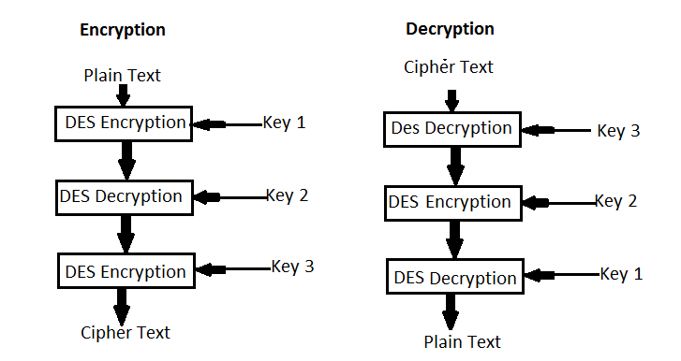

Advantages
- The image can only be viewed by the receiver as the image is encrypted using Triple DES and the key is only known to the sender and receiver.
- Since the image is encrypted using Triple DES, it is more secure than the DES.
- Since the key is entered by the sender and receiver, it makes the encryption and decryption more secure.

Disadvantages
- The file size to be transmitted becomes large since it contains encrypted data.
- Since the file size is huge it can be suspected to contain some critical information.

Conclusion
Since image steganography is done using AES, this system provides security from intrusion attacks and the usage of AES technique allows the encryption and decryption process to be more secure and faster. Thus this system provides security in storage and transmission of digital images.

Reference

- http://ieeexplore.ieee.org/xpl/articleDetails.jsp?arnumber=5071626&queryText=image%20thriple%20des&newsearch=true

- http://ieeexplore.ieee.org/xpl/articleDetails.jsp?arnumber=6187857&queryText=image%20thriple%20des&newsearch=true

