Proof of updates
Engineer / Drafter - My Work. Changes requested in the PDF dated 12-11-2026
Date: 12 Nov 2026 Branch: dev/vishwa Status: changes made locally, not yet committed
How this was checked: the app was run locally (API on :5000, web on :5173, local MongoDB) with a Team Lead and an Engineer/Drafter test login on a project called "Verify Tower A". Every "Before" screenshot is the original code and every "After" screenshot is the updated code, on the same test data. It is test data only; no company or production data was used.

Summary
# | Asked in the PDF | Result | What was done
1 | Keep Engineer/Drafter > My Work > Overview simple and consistent with the reference image (pp. 4-5) | Done | Overview now holds only "Assigned to me" (grouped by stage, due-date pill per row, stage filter top-right) and "Awaiting response". Extra panels removed.
2 | Drawing submission status is not getting reflected in TLs (p. 6) | Done | A drawing the TL has not yet decided on now reads "Submitted" (it was blank). TL and engineer pages refresh every 15 s, so new submissions and TL decisions appear without a reload.
3 | Remove Drawing register under engineer/drafter (p. 7) | Done | Drawing register panel and its "Upload to register" form removed from the engineer Overview.
4 | Remove Revision under engineers (p. 8) | Done | "My revisions" panel (incl. Log revision form), "Revision details" panel and the "Revision status" line on project cards removed.
5 | Only drawing log should be visible for engineer (p. 9) | Done (see open points) | "List of deliverables" hidden; the engineer sees the Deliverables log and the drawing log, which now lists every drawing on their projects with the TL status and remark.
Pages 1-3 of the PDF describe the TL to Engineer workflow (allocation, acknowledgement, daily updates, submission, review, revision, final approval). They request no change on their own, so nothing there was altered; the Acknowledge / Start / Submit actions stay on the Overview.

1. Overview: simple and consistent with the reference (pp. 4-5)
Asked: keep Engineers/Drafters > My Work > Overview simple, user-friendly and in the layout of the reference image.
Done:
- "Assigned to me" is now a list grouped by stage heading (Concept, GFC...), each row showing Project - Deliverable, its status and a "Due ..." pill, with the stage filter at the top right, as in the reference. Acknowledge / Start / Submit are kept under each task.
- "Awaiting response - items with me" uses the same row style (e.g. "Client - 1d"). The log form is unchanged.
- Removed from the Overview: My revisions, Drawing register, Today's work progress, Recent updates and the Leave & Travel card. The reference shows none of these; the same information remains in the Work Progress and My submissions tabs and in the sidebar.
BEFORE: cards, plus extra panels below
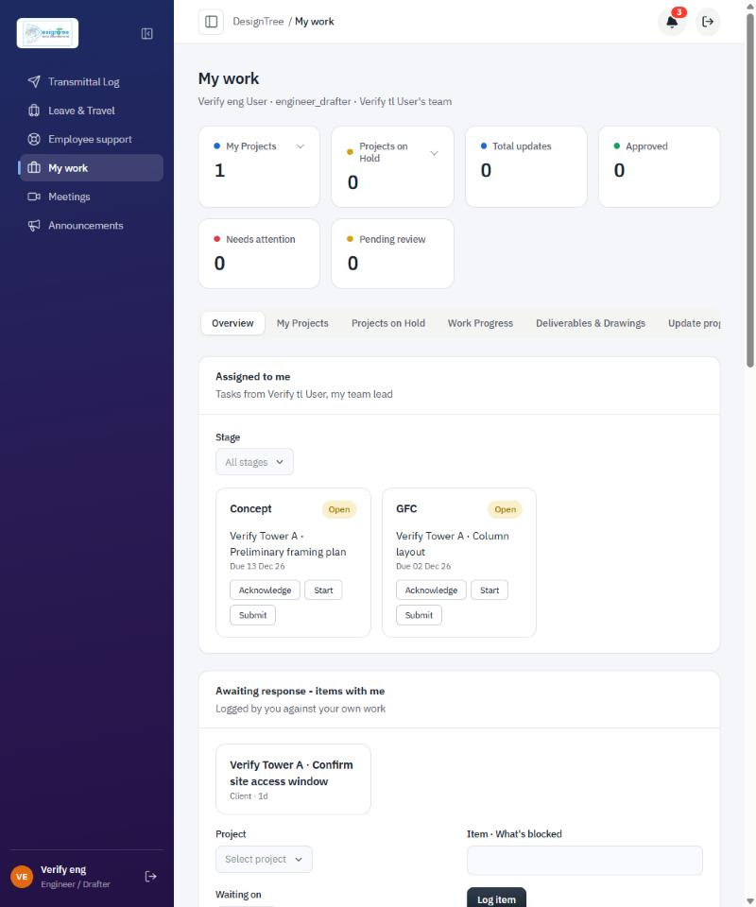
Original Overview: task cards in a grid, followed by more panels.
AFTER: grouped list like the reference
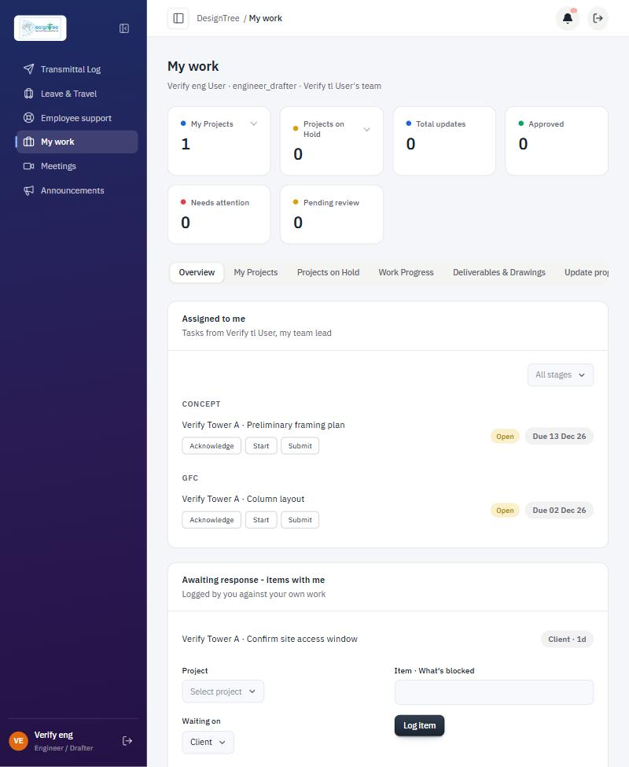
Updated Overview: stage groups, due-date pills, stage filter on the right.
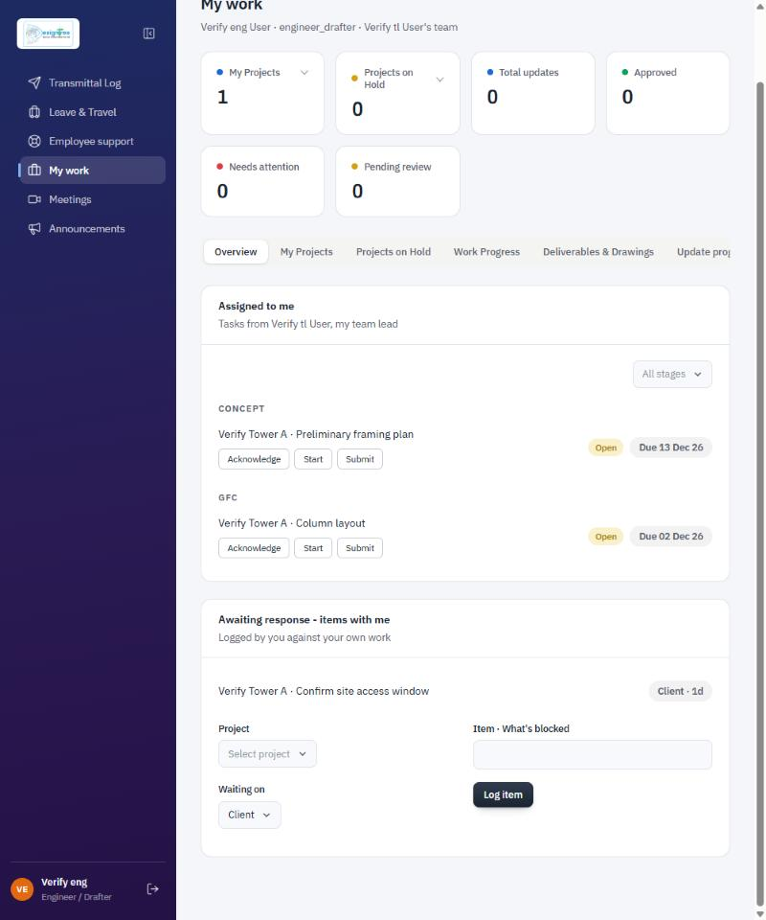
The page now ends after "Awaiting response". Nothing else follows.

2. Drawing submission status not reflected in TLs (p. 6)
Asked: the drawing submission status was not getting reflected in the TL view.
What was wrong: the data reached the TL correctly, but a drawing nobody had decided on yet had no status at all. The TL register showed an empty Status cell and the engineer saw a dash. Neither page refreshed by itself, so a newly submitted drawing or a TL decision only appeared after a manual reload.
Done:
- An undecided drawing now shows "Submitted" on both the TL Drawing register and the engineer drawing log, with the TL "Set status" button next to it.
- After the TL decides, both sides show the decision with its detail, e.g. "Awaiting - Client" with the remark "Sent to client", or "Revise" with "Fix grid".
- Both pages refresh every 15 seconds. In the check, a drawing submitted by the engineer appeared on the open TL page, and a TL decision appeared on the open engineer page, without reloading.
- The status is derived for display only. No database field or API was changed.
BEFORE: TL view, undecided drawings show no status
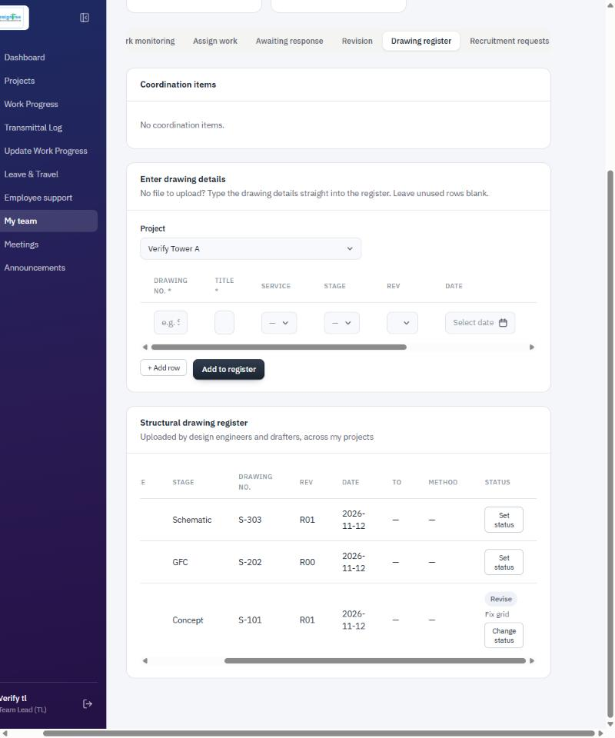
TL > My team > Drawing register (Status column). S-303 and S-202 have only a "Set status" button.
AFTER: TL view, "Submitted" shown
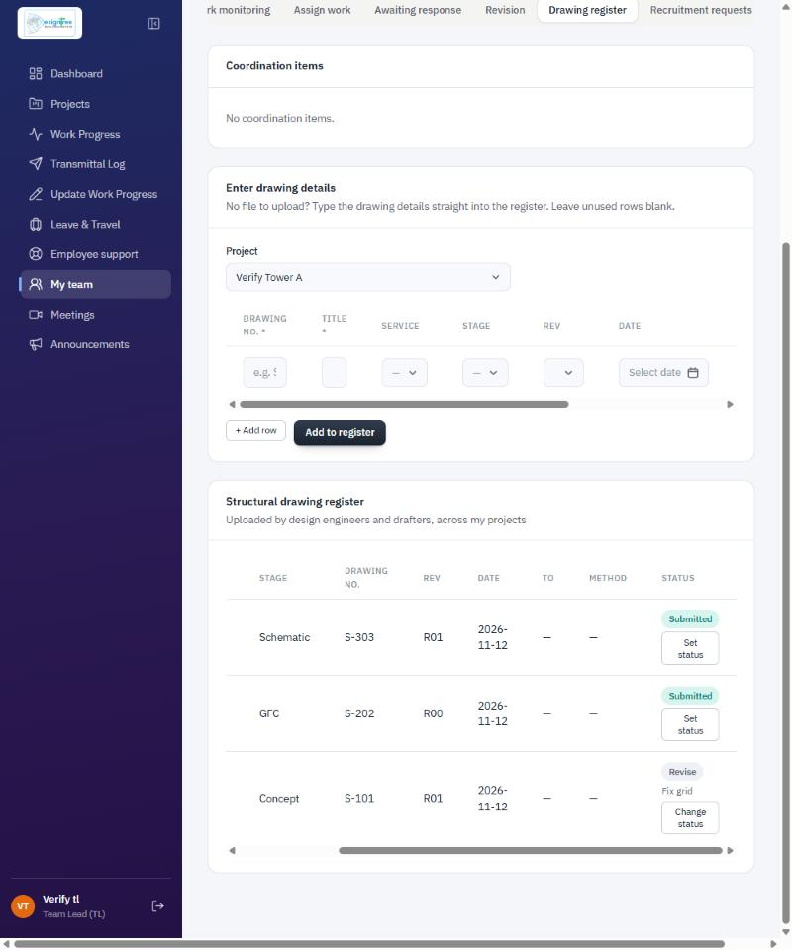
S-303 and S-202 show "Submitted"; S-101 shows the earlier "Revise" decision and remark.

3. Remove Drawing register under engineer/drafter (p. 7)
Asked: remove the Drawing register from the engineer/drafter My Work.
Done: the whole Drawing register panel (the uploaded-drawings table and the Project / Service / Stage / Drawing no. / Revision / Drawing file / "Upload to register" form) is gone from the engineer Overview. See the "After" Overview screenshots in section 1: no Drawing register follows "Awaiting response".
BEFORE: Drawing register with upload form on the engineer Overview
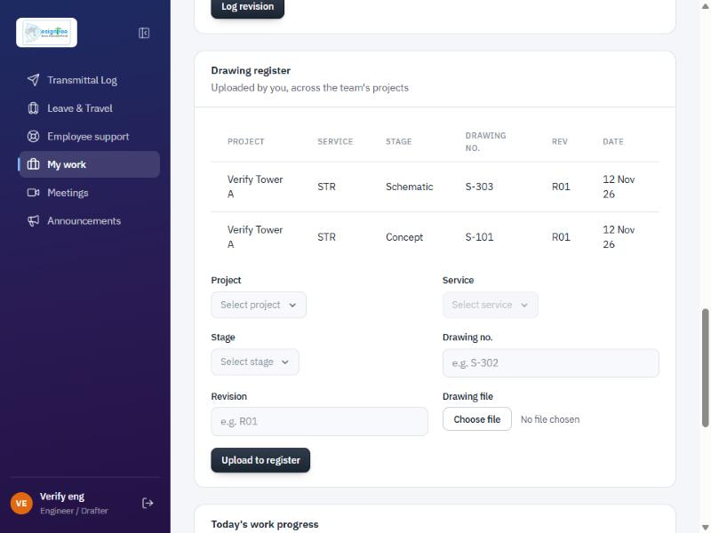
Original Overview, lower part: Drawing register table and upload form.

4. Remove Revision under engineers (p. 8)
Asked: remove Revision from the engineer view.
Done:
- "My revisions" panel removed from the Overview (revision cards, Resubmit button, and the Project / Stage / Item / Details form with "Log revision").
- "Revision details" panel removed from Deliverables & Drawings.
- The "Revision status" line removed from the My Projects cards, so no revision information remains on the engineer My Work page.
BEFORE: My revisions with the Log revision form
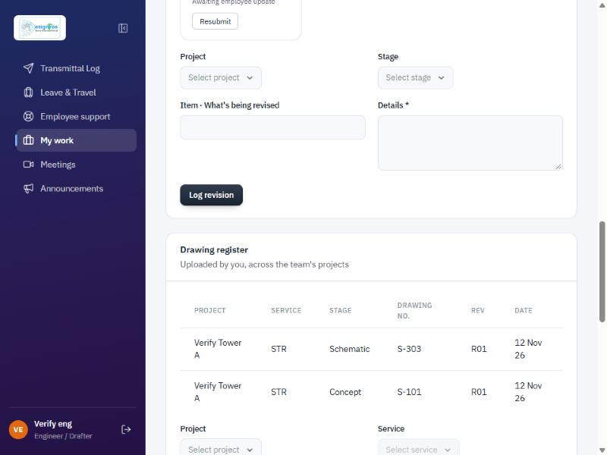
Original Overview: My revisions (with Resubmit) and the Log revision form, directly above the Drawing register.
AFTER
No revision panel appears anywhere on the engineer My Work page. See the Overview and Deliverables & Drawings screenshots in sections 1 and 5.

5. Only drawing log visible for engineer (p. 9)
Asked: only the drawing log should be visible for the engineer.
Done on Deliverables & Drawings:
- "List of deliverables" (the TL-maintained list) is hidden for the engineer; the read-only Deliverables log stays.
- "Revision details" removed (see section 4).
- The drawing log ("Drawing submission status") now lists every drawing on the engineer allotted projects, including ones the TL registered. Before, it only listed drawings the engineer had uploaded themselves. It also shows a Rev column, the TL status and the TL remark.
BEFORE: list of deliverables, drawing status with a blank, revision details
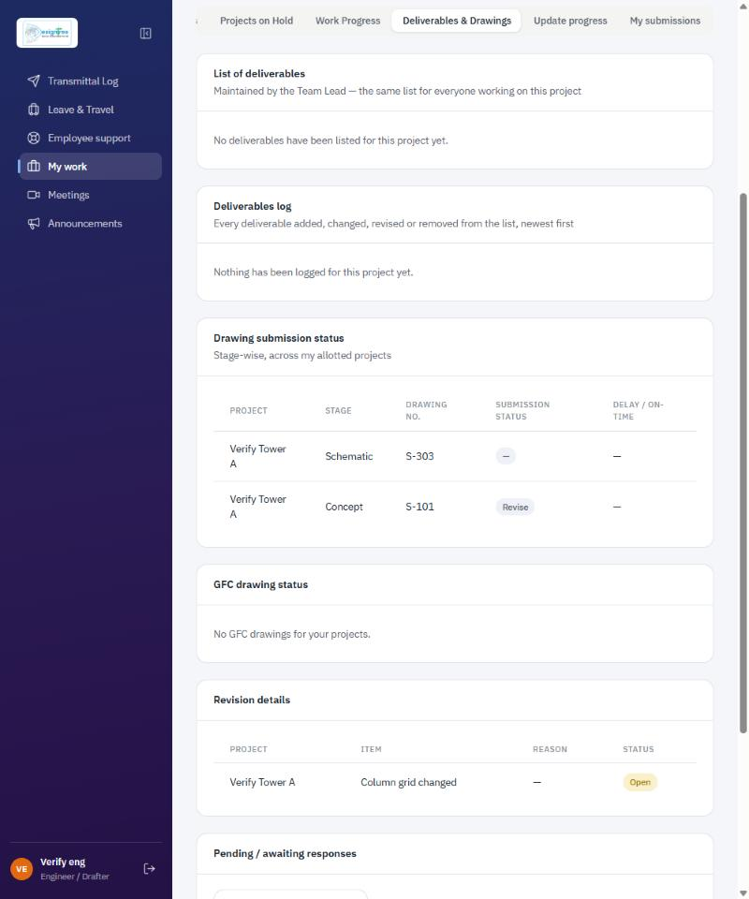
Original tab. S-303 has a blank status; only drawings the engineer uploaded are listed (S-202, registered by the TL, is missing).
AFTER
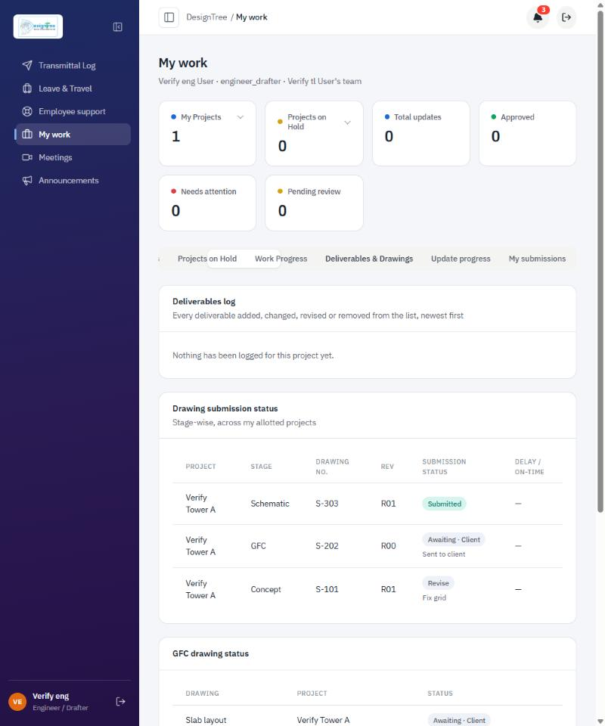
Updated tab: no list of deliverables; all three drawings listed with Submitted / Awaiting - Client / Revise.
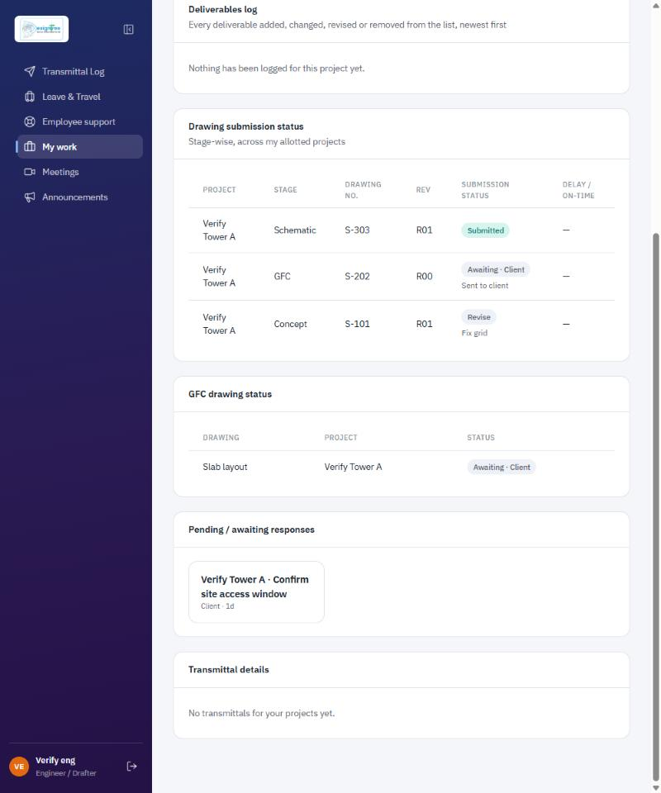
Rest of the tab: no Revision details panel.

Open points to confirm
- What "drawing log" means. I read it as the Deliverables log plus the Drawing submission status table on Deliverables & Drawings. I kept three other panels on that tab (GFC drawing status, Pending / awaiting responses, Transmittal details) because the PDF does not name them. Tell me if they should also be hidden.
- "Not reflected in TLs". I took this as the submitted/pending state and live refresh described in section 2. If the TL needs a different view (for example a count of drawings pending their review), that is a separate change.
- UI only. The engineer drawing upload and revision actions are removed from the screens, but the server still accepts them. Say if you also want them blocked at the API.

Files changed
- web/src/pages/MyWorkPage.jsx: engineer Overview and Deliverables & Drawings
- web/src/pages/MyTeamPage.jsx: TL drawing register status and refresh
- web/src/lib/drawingStatus.js (new): shared "Submitted / Awaiting - Client" label
- web/src/index.css: styles for the grouped task list
Build passes. No new lint findings; the remaining findings were already in the code before these changes.

