DESIGNTREE SERVICE CONSULTANTS
Employee Meetings Module
Functional documentation: Employee Meeting Dashboard features, screens, rules and workflow
Item | Detail
Module | Employee Meeting Dashboard ("My Meetings")
Document type | Functional specification and user guide
Version documented | Version 1.1 (latest), including the display fixes of 7 October 2026
Document date | 7 October 2026
Related module | SPOC Meetings module (documented separately in "SPOC Meetings Module – Functional Documentation")
Prepared for | DesignTree / Arictech project team members, SPOCs, coordinators and the development team

Contents

Right-click the table above and choose Update Field if page numbers are not shown.

1. Introduction

1.1 Purpose of this document
This document describes the Employee Meetings module in full: every screen, field and control, the rules the system applies, and how meetings, responses, MOMs and action items flow between the SPOC and the employee. It is written so that the complete behaviour can be understood without opening the dashboard.

1.2 Objective of the module
The Employee Meeting Dashboard gives every project team member (other than the SPOC) one place to manage and track the project meetings the SPOC has assigned to them. Employees receive meeting details and links, confirm whether they are available, see the meeting log and the MOM after each meeting, and update the action items assigned to them.

1.3 Users
User | Use of the module
Project team members (employees) | Structural, Mechanical, Electrical, Plumbing, Fire and MEP Coordination engineers, designers, modellers and draughtsmen assigned to projects. They are the users of this dashboard.
SPOC / Coordinator / Structural Lead | Not a user of this dashboard for the meetings they organise. They schedule meetings, select participants, record attendance and MOM, and assign action items from the SPOC Meetings module, and they see the employees' responses and updates there.

1.4 Scope
Covered: how meetings reach an employee, the Overview, Meeting invitations, Meeting log and My action items views, the Available / Not Available response with mandatory reasons, the meeting details panel, MOM viewing and download, action-item updates, statuses, reminders, the end-to-end workflow and business rules.
Prototype note. The module has been built as a working interactive prototype with sample projects, people and meetings. It is available as a standalone Employee Meeting Dashboard page and as the Employee portal inside the combined SPOC and Employee dashboard; both behave the same. Data entered is saved only in the browser where it was entered (section 16).

1.5 Version history
Version | Date | Changes
1.0 | 1 Oct 2026 | Employee Meeting Dashboard created: Overview, Meeting invitations with Available / Not Available responses and mandatory reasons, Meeting log with attendance, unavailability and MOM status, MOM viewing and download, My action items with status update and progress notes. Linked to the SPOC module through the Employee portal, and published as a standalone page.
1.1 | 7 Oct 2026 | Display fixes: the Available / Not available buttons are now sized to their labels instead of stretching across the card; the "YOU" tag in the attendance list sits beside the employee's name; action-item status dropdowns are wide enough to show "In Progress" in full.

2. Key terms
Term | Meaning in this module
Invitation | A scheduled meeting for which the SPOC has selected the employee as a participant. It appears in the employee's dashboard automatically.
Organiser (SPOC) | The person who scheduled and owns the meeting: the SPOC, MEP Coordinator or Structural Design Lead, depending on the project's services.
Availability response | The employee's answer to an invitation: Available or Not available. Not available always carries a reason.
Attendance | Whether the employee actually attended, marked by the SPOC after the meeting. It can differ from the availability response.
Meeting log | The list of the employee's meetings that have been held, cancelled or whose date has passed.
MOM | Minutes of Meeting recorded or uploaded by the SPOC: discussion points, decisions, follow-up, next meeting and MOM document.
MOM number | Meeting reference in the format MOM-<project number>-<sequence>, for example MOM-2460-004.
Action item | A task from the MOM assigned to a person with priority and due date.
Scheduled / Ad-hoc | Scheduled meetings are planned in advance and send invitations. Ad-hoc (sudden) meetings are recorded by the SPOC during or after the meeting and do not ask for availability.

2.1 Service codes
Code | Service
S | Structural
M | Mechanical
E | Electrical
P | Plumbing
F | Fire
MC | MEP Coordination

3. How meetings reach the employee
The employee does not create meetings. Every meeting in the dashboard comes from the SPOC Meetings module:
- The SPOC schedules a meeting from the SPOC portal, selecting the project, title, date, start and end time, type, link or location, agenda, services and reference documents.
- While creating the meeting, the SPOC selects the required project team members. The list comes from the project's team, showing name, designation and service.
- When the meeting is saved, it appears automatically in each selected employee's Meeting Dashboard as an invitation dated that day.
- The employee sees all meeting details, including the meeting link shared by the SPOC and any reference documents.
An employee sees only meetings in which they were selected as a team member. Meetings of other projects, or meetings they were not selected for, do not appear.

3.1 Information exchanged with the SPOC module
From SPOC to employee | From employee to SPOC
Meeting details, link and reference documents | Available / Not available response with reason and optional note
Reschedule or cancellation (with reason) | Action-item status changes (Pending, In Progress, Completed)
Attendance marked after the meeting | Progress notes on action items
MOM: discussion, decisions, follow-up, next meeting, document
Action items assigned to the employee with due dates

4. Dashboard layout
Area | Contents
Header | Title "My Meetings" with the employee's name, designation and service, for example "Rohit Kulkarni · Electrical Engineer · Electrical".
Viewing as (demo) | Prototype only: a dropdown to switch between sample employees. In production this is replaced by the employee's login. The list contains all project team members except Project SPOCs. The choice is remembered on that browser.
Information banner | Notes that the data is sample data, with Reset sample data to restore the demonstration records.
Tabs | Overview · Meeting invitations (red badge "N awaiting" when responses are pending) · Meeting log · My action items (red badge "N overdue" when any item is overdue).
Meeting details panel | Opens from the right when any meeting is selected (section 7).
Confirmation messages | Short messages at the bottom of the screen after an action, for example "Response sent to Sneha Gowda."

The panel can be closed with ✕, by clicking outside it, or with Esc. The dashboard works on desktop, tablet and phone screens, in light and dark display themes. The last tab used is remembered.

5. Overview tab
The Overview is the employee's landing page. It summarises today, what needs a response, and what work is open.
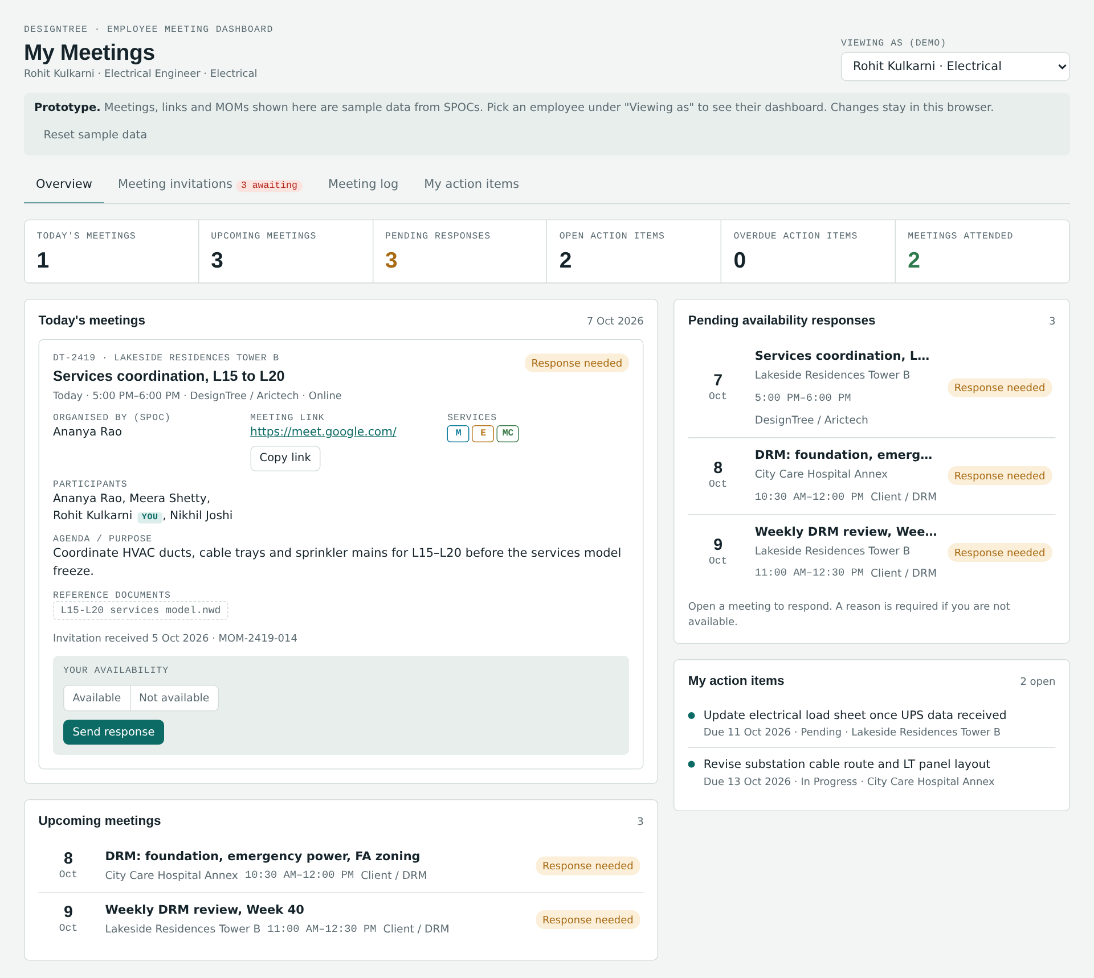
Figure 1. Overview tab

5.1 Summary counts
Count | Definition | Click opens
Today's meetings | The employee's upcoming meetings dated today. | Meeting invitations
Upcoming meetings | Meetings with status Scheduled or Rescheduled and a date of today or later. | Meeting invitations
Pending responses | Upcoming scheduled meetings the employee has not yet responded to. Amber when above zero. | Meeting invitations
Open action items | Action items assigned to the employee that are Pending or In Progress. | My action items
Overdue action items | Open items whose due date has passed. Red when above zero. | My action items
Meetings attended | Meetings in the log where the SPOC marked the employee as Attended. Green. | Meeting log

5.2 Panels
Panel | Contents
Today's meetings | A full invitation card for each meeting today, with the meeting link, details and the availability response form (section 6.2). Shows "No meetings today." if there are none.
Upcoming meetings | Other upcoming meetings (after today) in date order: date, title, project, start–end time, type, and the employee's response status. Selecting a row opens the meeting.
Pending availability responses | Meetings still waiting for the employee's response, with a reminder that a reason is required if not available. Shows "You have responded to every invitation." when clear.
My action items | Up to five open action items, nearest due date first, with due date, overdue days, status and project. Red dot = overdue; amber = due within 3 days. Selecting one opens its meeting.

6. Meeting invitations
This tab lists every upcoming meeting the SPOC has invited the employee to, as full cards. A filter at the top switches between All upcoming, Awaiting my response and Responded.
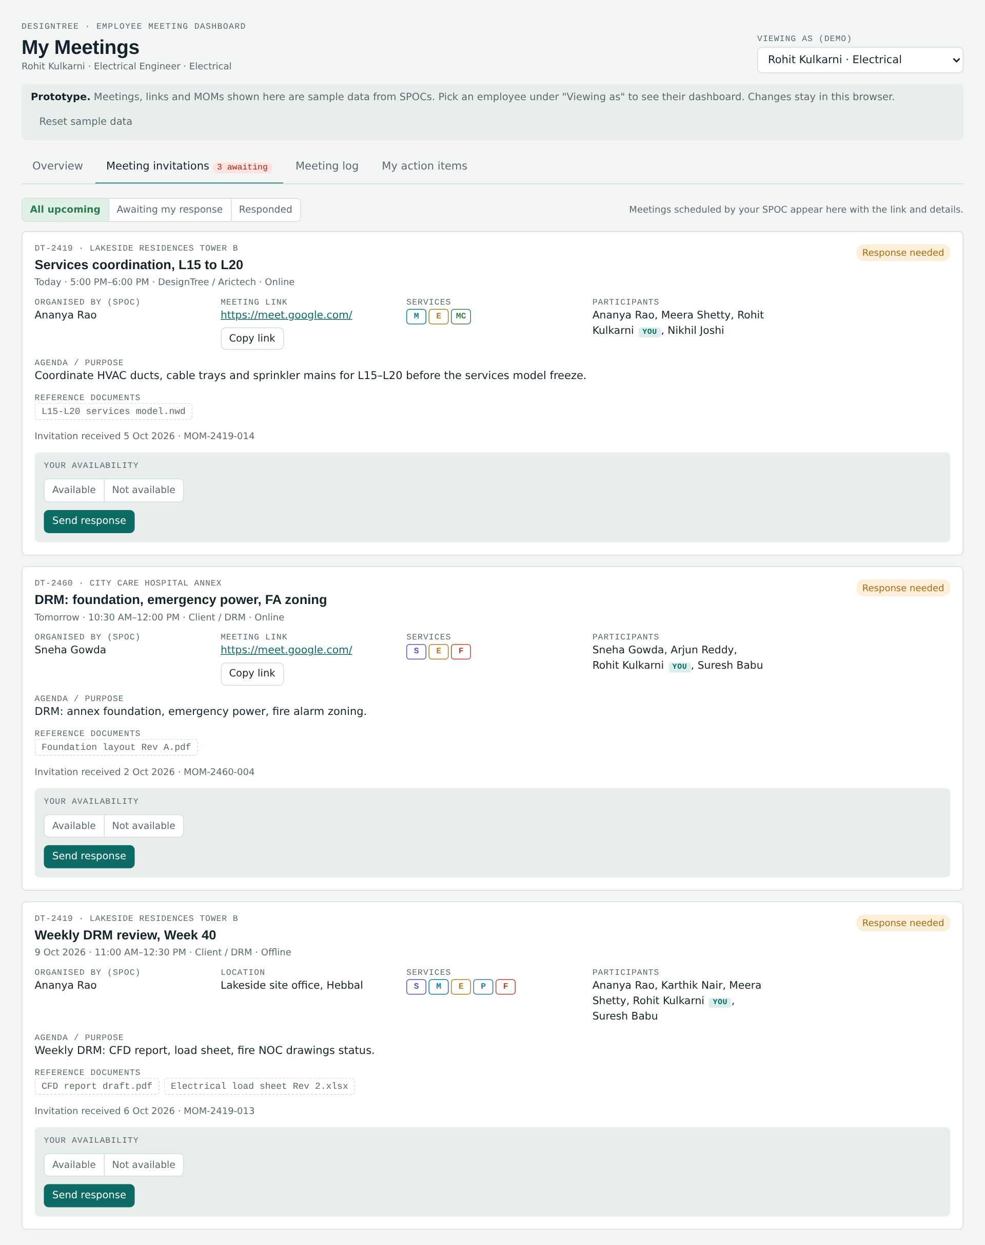
Figure 2. Meeting invitations tab

6.1 Meeting details on each invitation
Detail | Description
Project name | Project code and name, for example "DT-2460 · City Care Hospital Annex".
Meeting title / subject | As entered by the SPOC.
Date | Shown as Today, Tomorrow or the date.
Start time & end time | For example "10:30 AM–12:00 PM".
Meeting type | Client / DRM, DesignTree / Arictech, PMC or Other; plus mode (Online / Offline).
Meeting link | For online meetings, a clickable link that opens in a new tab, with a Copy link button ("Meeting link copied."). For offline meetings, the location.
Meeting agenda / purpose | As entered by the SPOC.
Organised by (SPOC) | The meeting organiser.
Services | Service codes for the services to be discussed.
Participants / team members | All selected team members and additional participants; the employee's own name is tagged "YOU".
Reference documents | Project references or documents shared by the SPOC with the invitation.
Invitation received | Date the SPOC sent the invitation, and the MOM number.
Response status | Top-right label: Response needed (amber), You: available (green) or You: not available (red).

6.2 Responding to an invitation
Each invitation for a scheduled meeting has a Your availability box:
- Choose Available or Not available.
- If Not available is chosen, two fields appear: Reason (required) and a text field. The text field is labelled "Note for SPOC (optional)" for most reasons, and "Specify reason (required)" when the reason is Other – specify.
- Press Send response. The message "Response sent to <organiser>." appears, the status label changes, and the box shows "Sent <date> to <organiser>".
- To change the answer later, edit the choice and press Update response. Responses can be changed until the meeting moves to the meeting log.

Reasons for non-availability
Reason | Extra text
Another scheduled meeting | Optional note
Project work / deadline | Optional note
Leave | Optional note
Client engagement | Optional note
Personal reason | Optional note
Other – specify | Required description

Validation messages
Situation | Message shown
Send pressed with no choice made | Choose Available or Not available.
Not available chosen without a reason | Select a reason for not being available.
Other – specify chosen without a description | Describe the reason.

The response is not sent until the message is resolved.
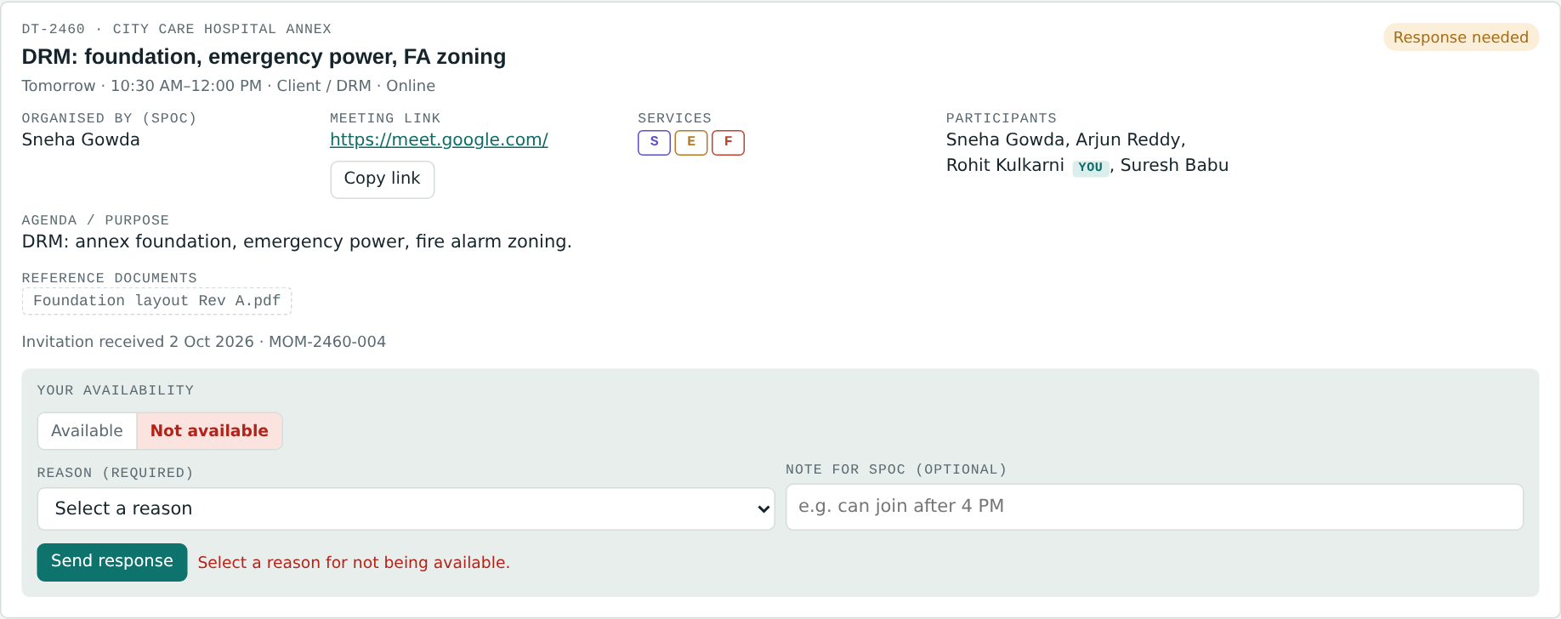
Figure 3. Not available chosen without a reason: the response is blocked
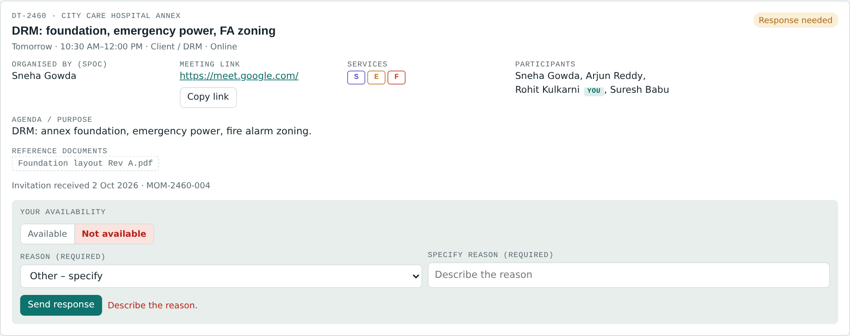
Figure 4. Other – specify requires a written reason
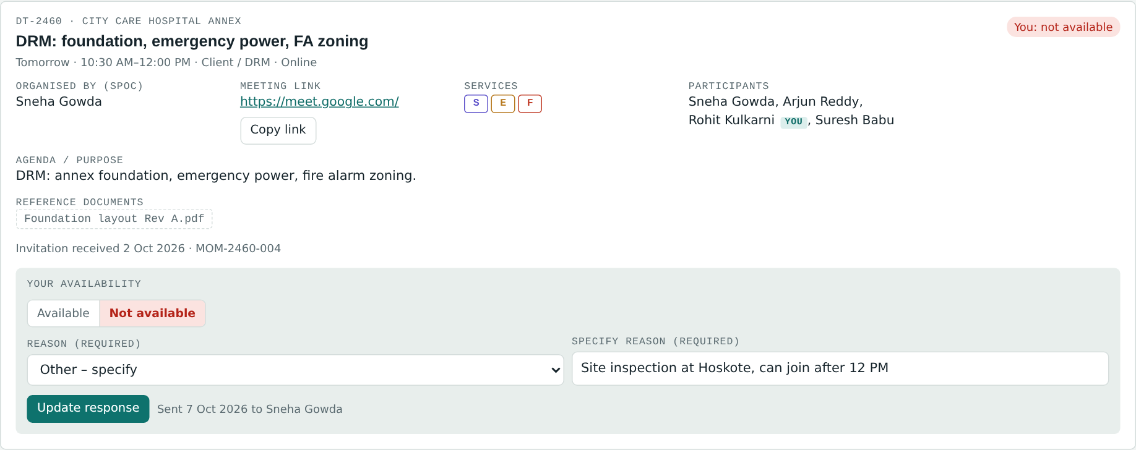
Figure 5. Response sent: status changes to "You: not available" and the send date is shown

6.3 What the SPOC sees
Each response appears immediately in the SPOC module: in the meeting's Availability responses section (name, Available / Not available / Awaiting response, and the reason with any note), in the Responses column of the meeting list, and as alerts for meetings with members not available or responses still awaited.
When no response is asked. Ad-hoc (sudden) meetings are recorded by the SPOC during or after the meeting, so they do not ask for availability and go straight to the meeting log. Cancelled meetings also do not show the response box.

7. Meeting details panel
Selecting a meeting from any list opens the details panel. Its sections depend on the stage of the meeting.
Section | Shown when | Contents
Header | Always | MOM number, project code, meeting title, project, meeting status, the employee's response status, type, date and start–end time.
Your availability | Upcoming scheduled meetings | The same response form as on the invitation card (section 6.2).
Cancellation notice | Cancelled meetings | "Cancelled by SPOC: <reason>".
Meeting details | Always | Project, date, start–end, meeting type and category, meeting link (with Copy link) or location, organiser, services, agenda, participants ("YOU" tag) and reference documents.
Attendance | After the meeting is held | Every invited member with Attended / Not attended / Not marked, the reason for absence where given, and additional participants. The heading shows "N/M attended".
Minutes of meeting | Meetings in the log (not cancelled) | See section 9.
Action items | When the meeting has action items | All action items of the meeting; the employee's own are highlighted and tagged "YOU", with an editable status. Others' items are read-only. The heading shows "N assigned to you".

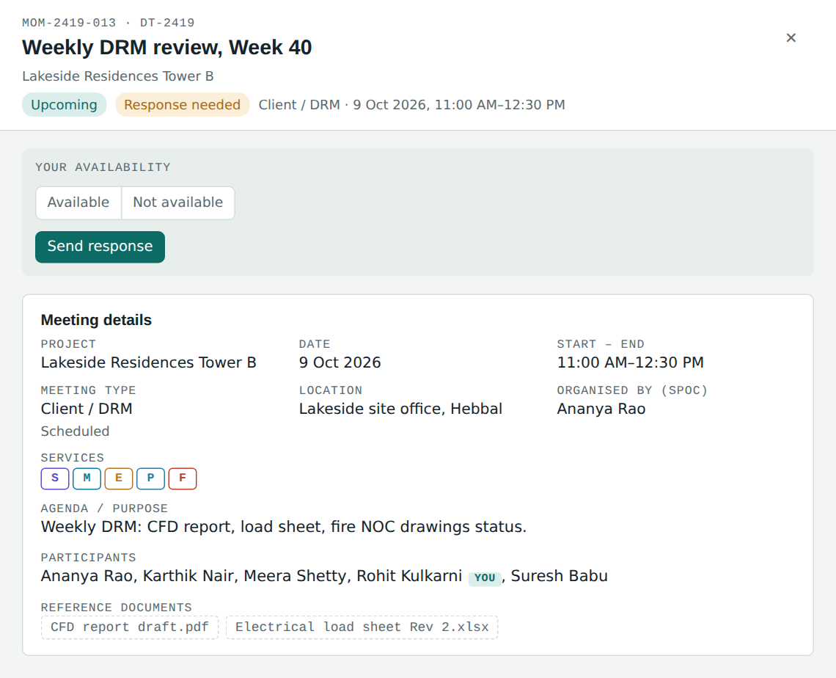
Figure 6. Details panel for an upcoming meeting, with the response form
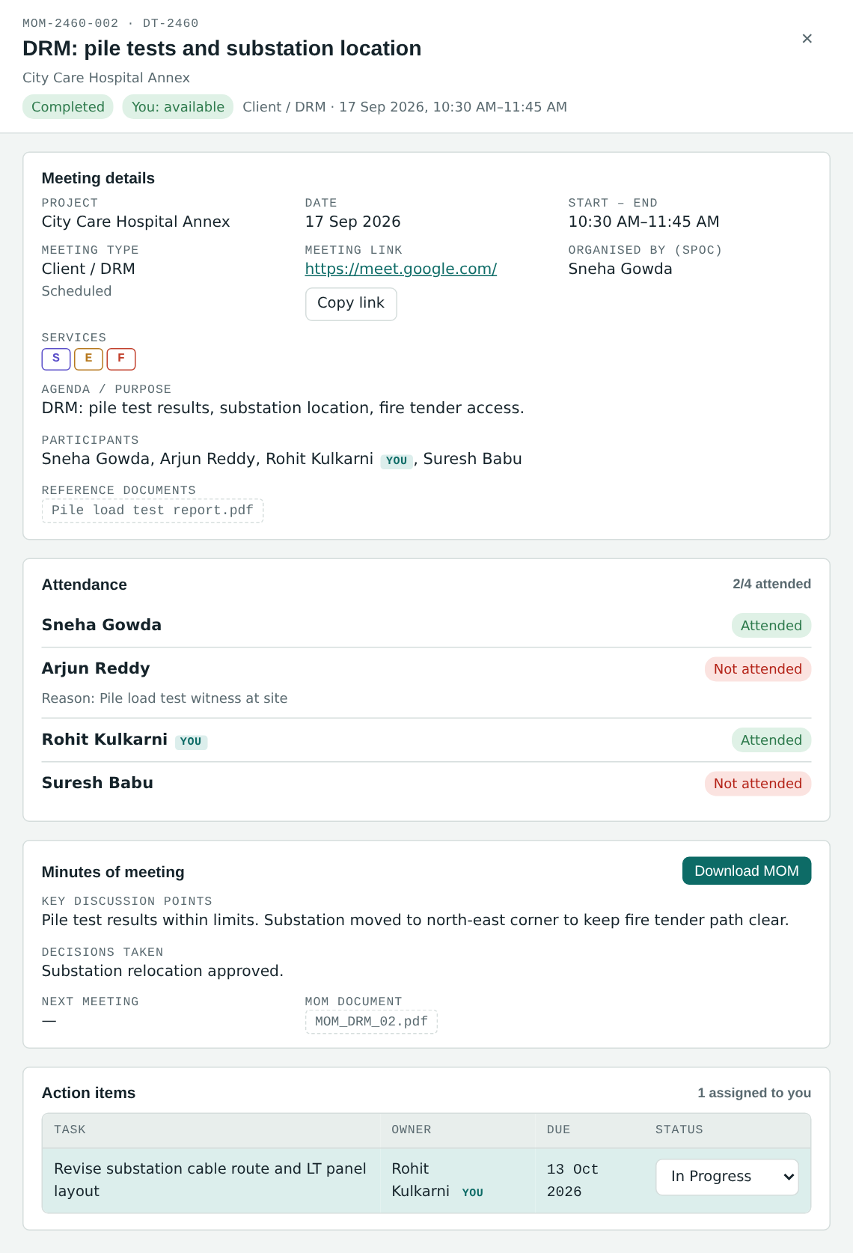
Figure 7. Details panel for a completed meeting: attendance, MOM with download, and the employee's action item

8. Meeting log
After the meeting, it moves automatically from invitations into the Meeting log. A meeting is in the log when the SPOC has marked it held, when it has been cancelled, or when its date has passed. The log is sorted newest first.

8.1 Filters
- Project: all of the employee's projects, or one project.
- MOM: All, MOM available, or MOM pending (meeting held but MOM not yet recorded).

8.2 Columns
Column | Content
Date & time | Meeting date, start–end time.
Project | Project name.
Meeting | Meeting title and type.
Link | Meeting link for online meetings, or "Offline: <location>".
Organiser | SPOC / meeting organiser.
Invited | Number of invited participants (team members plus additional participants).
Attended | Names of participants marked Attended (including additional participants); "Not marked" if attendance is not yet entered; — if not held.
Unavailable & reason | Each employee who was unavailable with the reason. Uses the absence reason from attendance; if none was entered, the reason from their Not available response; "Not given" if neither exists. For meetings not yet marked held, lists Not available responses.
You | The employee's own attendance: Attended, Absent or Not marked.
Status | Meeting status (section 11).
MOM | Available (green), Pending (amber) or —.

Selecting a row opens the meeting details panel with the full attendance, MOM and action items.
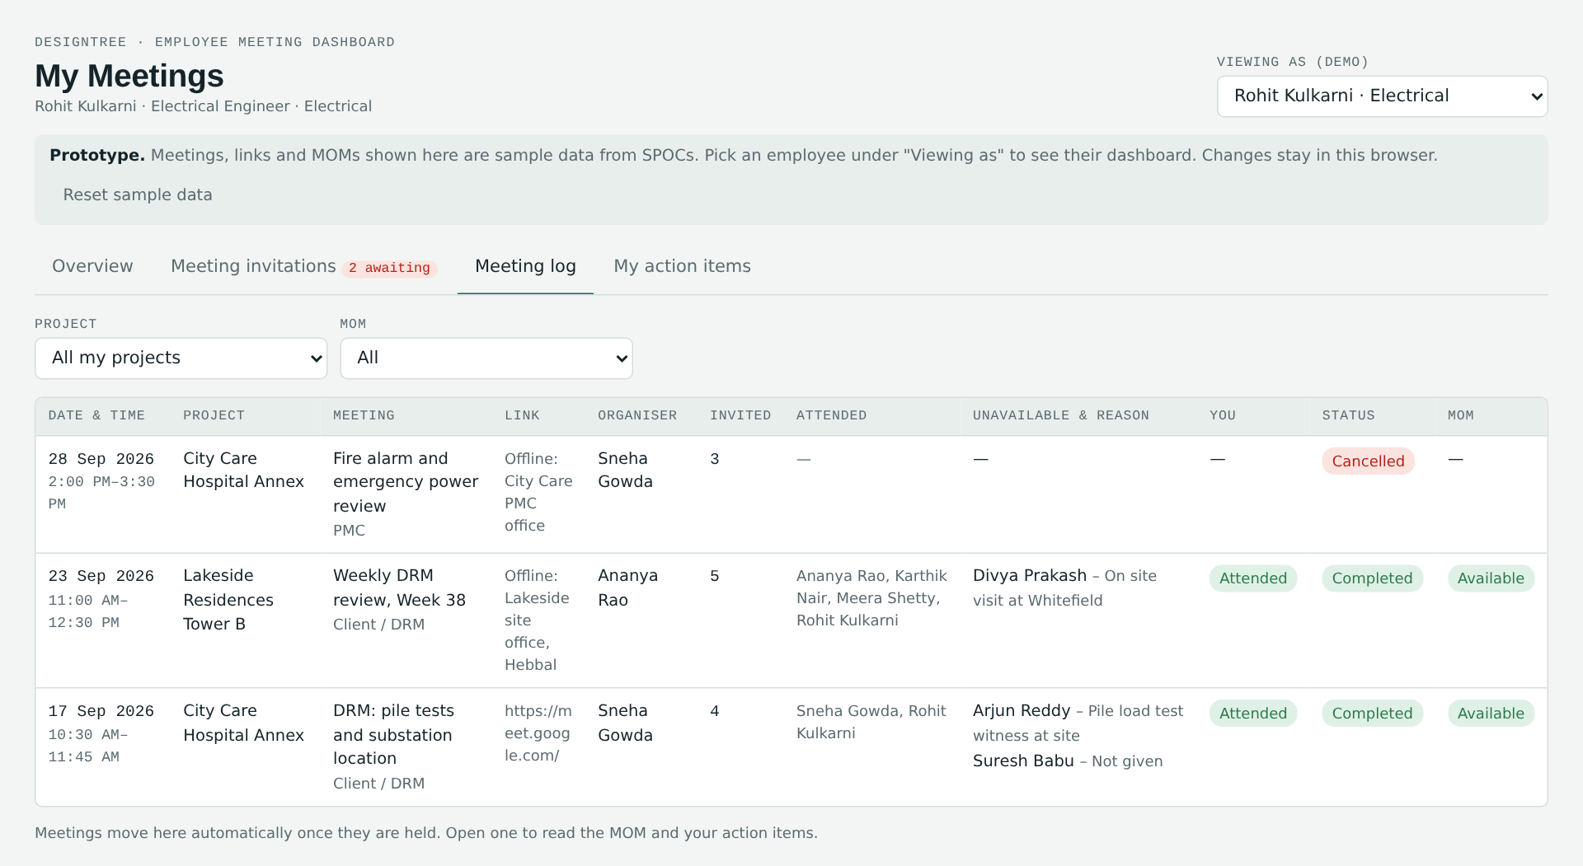
Figure 8. Meeting log

9. MOM integration
The MOM prepared and uploaded by the SPOC is reflected automatically in the meeting log of every employee invited to that meeting. A MOM counts as available once the SPOC has entered key discussion points or uploaded a MOM document.

9.1 Viewing the MOM
Open the meeting from the Meeting log. The Minutes of meeting section shows:
- Key discussion points
- Decisions taken
- Follow-up requirements (when entered)
- Next meeting date
- MOM document: the uploaded file name, or "Entered in system" if the SPOC typed the MOM directly
If the SPOC has not yet recorded the MOM, the section shows "Not yet shared by SPOC" and "The MOM will appear here as soon as <organiser> records it."

9.2 Downloading the MOM
Press Download MOM to save the minutes as a text file named "<MOM number>_MOM.txt". In the hosted version the browser asks the employee to confirm the save. The file contains:
Section of file | Content
Header | MOM number, project code and name, meeting title, date, time, meeting type and category, mode and link / location, organiser, services.
Attendance | Each invited member: Attended / Not attended (with reason) / Not marked; additional participants.
Key discussion points | As recorded.
Decisions taken | As recorded.
Follow-up | As recorded, plus next meeting date.
Action items | Numbered list: task | owner (service) | priority | due date | status.
MOM document | Name of the uploaded MOM document, if any.

A sample downloaded MOM is reproduced in Appendix A.

9.3 Action items in the MOM
The action items listed in the MOM appear in the meeting's Action items section, with the employee's own items highlighted. The employee can see each due date and update the status of their own items there or in My action items.

10. My action items
All action items assigned to the employee in MOMs, across all projects, sorted by due date.

10.1 Filters
- Open (default): Pending and In Progress.
- Overdue: open items past their due date.
- Completed.
- All.

10.2 Columns and updates
Column | Content / action
Action / task | Task description and the SPOC's remarks.
Project | Project name.
From meeting | MOM number button (opens the meeting) and meeting title.
Priority | High (red), Medium (amber), Low (grey).
Due date | Target date. Red with "Nd overdue" when overdue; amber when due within 3 days.
Status | Dropdown: Pending, In Progress, Completed. Changing it shows "Status set to <status>." and is visible to the SPOC immediately.
Completed | Completion date, set automatically to today when the status becomes Completed, and cleared if the item is reopened.
Update note | Free-text progress update for the SPOC. Saved when the employee leaves the field ("Update saved."). The SPOC sees it as "Update from <name>: …" in their Action items tab.

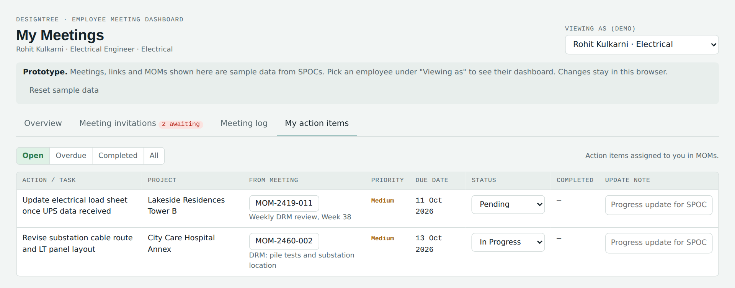
Figure 9. My action items

11. Statuses shown to the employee

11.1 Meeting status
Status | Colour | Meaning
Upcoming | Teal | Scheduled, date today or later.
Rescheduled | Amber | The SPOC moved the meeting to a new date (today or later).
Awaiting update | Grey | The date has passed but the SPOC has not yet marked the meeting held, rescheduled or cancelled it.
Completed · MOM pending | Amber | Held; MOM not yet recorded.
Completed | Green | Held and MOM recorded.
Cancelled | Red | Cancelled by the SPOC (reason shown in the details panel).

11.2 Response status
Label | Meaning
Response needed | The employee has not yet responded to this scheduled meeting.
You: available | The employee responded Available.
You: not available | The employee responded Not available with a reason.

11.3 Attendance status (own)
Label | Meaning
Attended | Marked attended by the SPOC.
Absent / Not attended | Marked not attended by the SPOC, with the reason if entered.
Not marked | The meeting is held but attendance is not yet entered.

12. Reminders and alerts for the employee
Reminder | Where it appears
Today's meetings | Today's meetings count and panel on the Overview, with the join link.
Pending availability responses | "N awaiting" badge on the Meeting invitations tab, the Pending responses count, the Pending availability responses panel and the "Response needed" labels.
Rescheduled or cancelled meetings | Rescheduled status with the new date; cancelled meetings move to the log with the reason.
New MOM available | MOM column shows Available in the Meeting log; Download MOM becomes available.
Assigned action items | Open action items count, My action items panel on the Overview and the My action items tab.
Action items due soon | Amber due date and amber dot (due within 3 days).
Overdue action items | "N overdue" badge on My action items, red count on the Overview, red due date with days overdue.

In the prototype these reminders are shown inside the dashboard. Email or mobile notifications are listed as a production recommendation (section 16).

13. End-to-end workflow
Step | Who | Where | What happens
1. SPOC schedules meeting | SPOC | SPOC portal → Schedule Meeting | Meeting details, link and documents entered.
2. Selects required team members | SPOC | Schedule form | Team members picked from the project team.
3. Meeting appears in selected employees' dashboards | System | Employee: Overview, Meeting invitations | Invitation card with "Response needed"; pending count and badge increase.
4. Employee receives link and details | Employee | Invitation card / details panel | Link (with Copy link), date, time, agenda, organiser, participants, documents.
5. Employee selects Available / Not available | Employee | Your availability box | Response sent to the SPOC; status label updates.
6. If Not available → reason mandatory | Employee | Your availability box | Reason from list; "Other – specify" needs text. Blocked until given.
7. Meeting conducted | SPOC | SPOC portal | SPOC marks the meeting held and marks attendance. Meeting moves to the employee's Meeting log.
8. SPOC prepares / uploads MOM | SPOC | SPOC portal → MOM | Discussion, decisions, follow-up, document.
9. MOM reflected in employees' Meeting log | System | Employee: Meeting log / details panel | MOM shows Available; employee can view and download it.
10. Employee views assigned action items | Employee | My action items / details panel | Own items highlighted with due dates and priority.
11. Employee updates action-item status | Employee | My action items | Pending → In Progress → Completed, plus progress notes. SPOC sees updates immediately.

14. Business rules
# | Rule
E1 | An employee sees only meetings for which the SPOC selected them as a team member.
E2 | Project SPOCs are not listed as employees of this dashboard.
E3 | A scheduled meeting appears as an invitation as soon as the SPOC saves it.
E4 | Availability is asked only for scheduled meetings that are upcoming and not cancelled.
E5 | A Not available response requires a reason from the list; Other – specify also requires a description.
E6 | A response can be changed until the meeting moves to the meeting log; the latest response and its date are kept.
E7 | A meeting moves to the log when it is marked held, cancelled, or its date has passed.
E8 | The MOM is visible once the SPOC has entered discussion points or uploaded a MOM document.
E9 | Employees can change the status only of action items assigned to them.
E10 | Completing an action item sets its completion date automatically; reopening clears it.
E11 | An action item is overdue when its due date has passed and it is not Completed; due soon within 3 days.

15. Sample data in the prototype
The prototype includes four sample projects and these sample employees (selectable under Viewing as):
Employee | Designation | Service
Arjun Reddy | Structural Engineer | Structural
Divya Prakash | Plumbing Designer | Plumbing
Karthik Nair | Sr. Structural Engineer | Structural
Kiran Thomas | Structural Draughtsman | Structural
Lakshmi Iyer | Structural Design Lead | Structural
Meera Shetty | Mechanical Designer | Mechanical
Nikhil Joshi | MEP Coordinator | MEP Coordination
Priya Menon | BIM Modeller | MEP Coordination
Rohit Kulkarni | Electrical Engineer | Electrical
Sanjay Rao | Clash Detection Engineer | MEP Coordination
Suresh Babu | Fire Protection Engineer | Fire
Varun Hegde | MEP Coordinator | MEP Coordination

Projects: DT-2419 Lakeside Residences Tower B (SMEPF), DT-2433 Northgate Tech Park Ph-2 (MEP Coordination only), DT-2451 Greenfield Villas, Hoskote (Structural only), DT-2460 City Care Hospital Annex (Structural, Electrical, Fire). Sample meeting dates are set relative to the day the dashboard is opened, so there is always a mix of today's, upcoming and past meetings.

16. Prototype limitations and production recommendations

16.1 Current limitations
- Data is sample data saved in the browser of the computer where it was entered; it is not shared between users or computers.
- The standalone Employee Meeting Dashboard page has its own data. To see a SPOC's meeting arrive in an employee's dashboard in the prototype, use the combined dashboard and switch from the SPOC portal to the Employee portal.
- Reference and MOM documents are shown by file name; the files themselves are not stored. Download MOM produces a text summary.
- Reminders are shown inside the dashboard only.
- "Viewing as" is a demonstration control in place of a login.

16.2 Recommendations for the production build
- Use employee login so each person sees only their own meetings and action items.
- Read meetings, responses, attendance, MOMs and action items from the same shared database as the SPOC module.
- Store reference documents and MOM files in the document management system and let employees open the original file.
- Send invitations, responses-due reminders, MOM-published notices and action-item due / overdue reminders by email or app notification, with calendar invites carrying the meeting link.
- Notify the SPOC when an employee responds Not available or updates an action item.
- Keep an audit trail of responses and action-item updates.

Appendix A. Sample downloaded MOM
Example of the file produced by Download MOM for meeting MOM-2460-002, as seen by Rohit Kulkarni:
MINUTES OF MEETING

MOM no.: MOM-2460-002
Project: DT-2460 – City Care Hospital Annex
Meeting: DRM: pile tests and substation location
Date: 17 Sep 2026
Time: 10:30 AM–11:45 AM
Meeting type: Client / DRM (Scheduled)
Mode: Online – https://meet.google.com/
Organised by (SPOC): Sneha Gowda
Services: Structural, Electrical, Fire

ATTENDANCE
- Sneha Gowda: Attended
- Arjun Reddy: Not attended (Pile load test witness at site)
- Rohit Kulkarni: Attended
- Suresh Babu: Not attended

KEY DISCUSSION POINTS
Pile test results within limits. Substation moved to north-east corner to keep fire tender path clear.

DECISIONS TAKEN
Substation relocation approved.

FOLLOW-UP
—

ACTION ITEMS
1. Revise substation cable route and LT panel layout | Rohit Kulkarni (Electrical) | Medium | Due 13 Oct 2026 | In Progress

MOM document on file: MOM_DRM_02.pdf

