DESIGNTREE SERVICE CONSULTANTS
SPOC Meetings Module
Functional documentation: features, screens, business rules and workflows
Item | Detail
Module | SPOC Dashboard → Meetings
Document type | Functional specification and user guide
Version documented | Prototype version 3 (latest), including the availability-response and employee-integration changes
Document date | 7 October 2026
Prepared for | DesignTree / Arictech project delivery teams, SPOCs, MEP Coordinators, Structural Design Leads and the development team

Contents

Right-click the table above and choose Update Field if page numbers are not shown.

1. Introduction

1.1 Purpose of this document
This document describes the SPOC Meetings module in full: what each screen shows, what every field and control does, the rules the system applies automatically, and the end-to-end workflows for scheduled and sudden (ad-hoc) meetings. It is written so that a reader can understand the complete behaviour of the module without opening the dashboard.

1.2 Objective of the module
The SPOC Meetings module is a single meeting-management system for all project meetings: Client / DRM, DesignTree / Arictech, PMC, service-specific meetings, scheduled meetings and sudden / ad-hoc meetings. For every meeting it keeps a complete record of participants, availability responses, attendance, minutes of meeting (MOM), decisions, action items, responsibilities, deadlines and follow-ups.

1.3 Users and roles
Role | What they do in the module
SPOC (Single Point of Contact) | Owns meetings on SMEPF projects and on projects with multiple services. Schedules meetings, selects participants, tracks responses, marks attendance, records the MOM, assigns and tracks action items.
MEP Coordinator | Takes the SPOC role on projects where only MEP Coordination services are committed.
Structural Design Lead / Design Team | Takes the SPOC role on projects where only Structural services are committed.
Project team members (employees) | Receive meeting invitations, respond Available / Not Available, view the MOM, and update the status of action items assigned to them. They use the separate Employee Meeting Dashboard (section 17).

1.4 Scope
Covered: meeting categories and types, service-based responsibility, scheduling and ad-hoc entry, team-member selection, invitations and availability responses, attendance, MOM, action items, the consolidated dashboard, alerts, filters, the absence log, project meeting history, and the link to the Employee Meeting Dashboard.
Prototype note. The module has been built as a working interactive prototype using sample projects, team members and meetings. Data entered is saved in the browser of the computer it was entered on. Section 19 lists what is needed to move it into production with shared data.

1.5 Version history
Version | Date | Changes
1 | 1 Oct 2026 | Initial Meetings module: scheduled and sudden meetings, service-based responsibility, team selection from Project Team, attendance, MOM, action items, dashboard summary, filters, project history, alerts.
2 | 1 Oct 2026 | Added the Absence Log tab (absent members with project, service, reason and meeting details; summaries by member and service; copy to Excel) and the Absences Recorded summary count.
3 (current) | 1 Oct 2026 | Added meeting title, end time and reference documents to the meeting form; invitations to selected team members; Availability Responses section with reasons; response alerts; Responses column in the meeting list; employee progress notes on action items; SPOC / Employee portal switch.
3.1 | 7 Oct 2026 | Fix: dashboard bar charts (By meeting type, By service, Absences by service) now display their filled bars.

2. Key concepts and terminology
Term | Meaning in this module
Meeting category | Whether the meeting was planned in advance (Scheduled) or happened without prior scheduling (Sudden / Ad-Hoc).
Meeting type | Who conducted the meeting: Client / DRM, DesignTree / Arictech, PMC, or Other.
DRM | Design Review Meeting, usually weekly or periodic, conducted by the client.
PMC | Project Management Consultant.
MOM | Minutes of Meeting: discussion points, decisions, follow-up requirements, next meeting date, and an optional uploaded document.
MOM number | A reference number generated for every meeting in the format MOM-<project number>-<sequence>, for example MOM-2419-013.
Responsible person | The SPOC, MEP Coordinator or Structural Design Lead who owns the meeting, assigned automatically from the project's committed services.
Availability response | A team member's reply to an invitation: Available or Not Available (with a mandatory reason).
Attendance | Whether each invited team member actually Attended or Did Not Attend, marked by the SPOC after the meeting.
Action item | A task arising from the meeting, assigned to a person with a priority and target date, tracked until completed.
Overdue | An action item whose target date has passed and whose status is not Completed.

2.1 Service codes
Services appear throughout the module as short coloured codes:
Code | Service
S | Structural
M | Mechanical
E | Electrical
P | Plumbing
F | Fire
MC | MEP Coordination
SMEPF | Full Structural + MEP + Fire scope (used for project scope and dashboard counts)

3. Module layout
The module opens on the SPOC Meetings screen. It has the following parts:
Area | Contents
Header | Title "Meetings", the SPOC portal / Employee portal switch, and the two entry buttons: + Add Sudden Meeting and + Schedule Meeting.
Information banner | Notes that the data is sample data, with a Reset sample data button that restores the original demonstration records.
Tabs | Dashboard · All meetings · Action items (shows a red badge with the number of overdue items) · Absence log · Project history.
Meeting details panel | Opens from the right whenever a meeting is selected anywhere in the module. Holds every detail and action for that one meeting (section 8).
Schedule / Add Sudden Meeting form | Opens as a pop-up form over the page (sections 5 and 6).
Confirmation messages | A short message appears at the bottom of the screen after each save, for example "Meeting scheduled. Invitations sent to 5 team members."

The panel or form can be closed with the ✕ button, by clicking outside it, or with the Esc key. The layout adapts to phone and tablet screens, and supports both light and dark display themes.
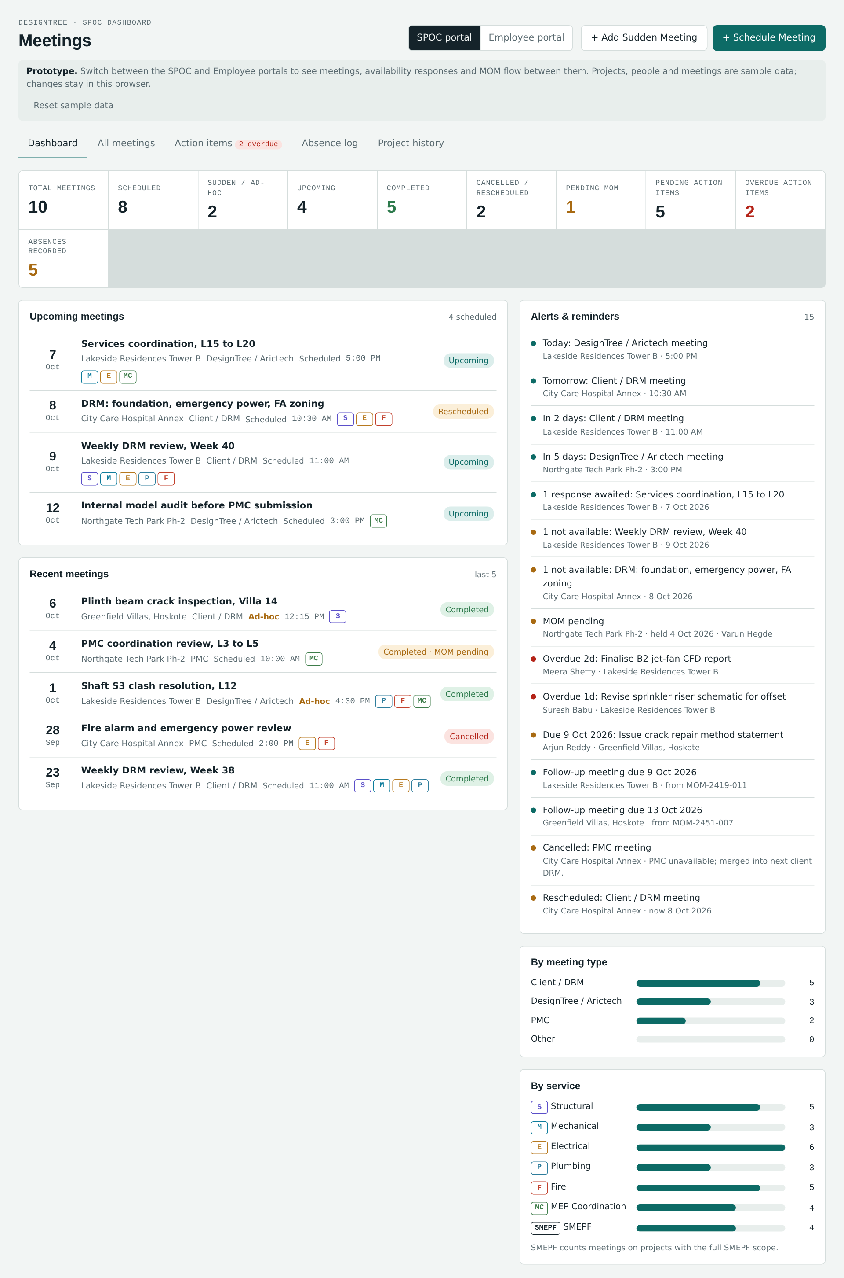
Figure 1. SPOC Meetings: Dashboard tab with summary counts, upcoming and recent meetings, alerts and breakdowns

4. Meeting categories, types and responsibility

4.1 Meeting categories
Category | Description | How it is created
Scheduled | Meeting planned and entered in advance. | + Schedule Meeting. Starts with status Scheduled; selected team members receive an invitation and respond.
Sudden / Ad-Hoc | Meeting that happens without prior scheduling and is recorded during or after the meeting. | + Add Sudden Meeting. Saved directly as held so attendance and MOM can be entered immediately. No invitation responses are collected.

4.2 Meeting types
Meeting type | Conducted by | "Meeting conducted by" options offered
Client / DRM | Client, weekly or periodic | Client, DRM
DesignTree / Arictech | DesignTree / Arictech team | DesignTree, Arictech, or any member of the project team
PMC | Project Management Consultant | PMC
Other | Any other project-related meeting | Other, or any member of the project team

4.3 Service-based responsibility
The responsible person for a meeting is not typed in. The system identifies it from the services committed for the selected project and the project team, and shows it in the form as soon as the project is selected:
Project's committed services | Responsible person (assigned automatically)
SMEPF services | Project SPOC coordinates and tracks the meeting.
MEP Coordination services only | MEP Coordinator.
Structural services only | Structural Design Lead / Design Team.
Multiple services (not full SMEPF) | Project SPOC, together with the assigned service-team members who are selected as participants.

The responsible person is shown on the form with the reason, for example "Responsible: Ananya Rao · SPOC (SMEPF services)", and is stored on the meeting. It is also used by the SPOC / Coordinator filter.

5. Scheduling a meeting
Select + Schedule Meeting in the header. The Schedule meeting form opens.
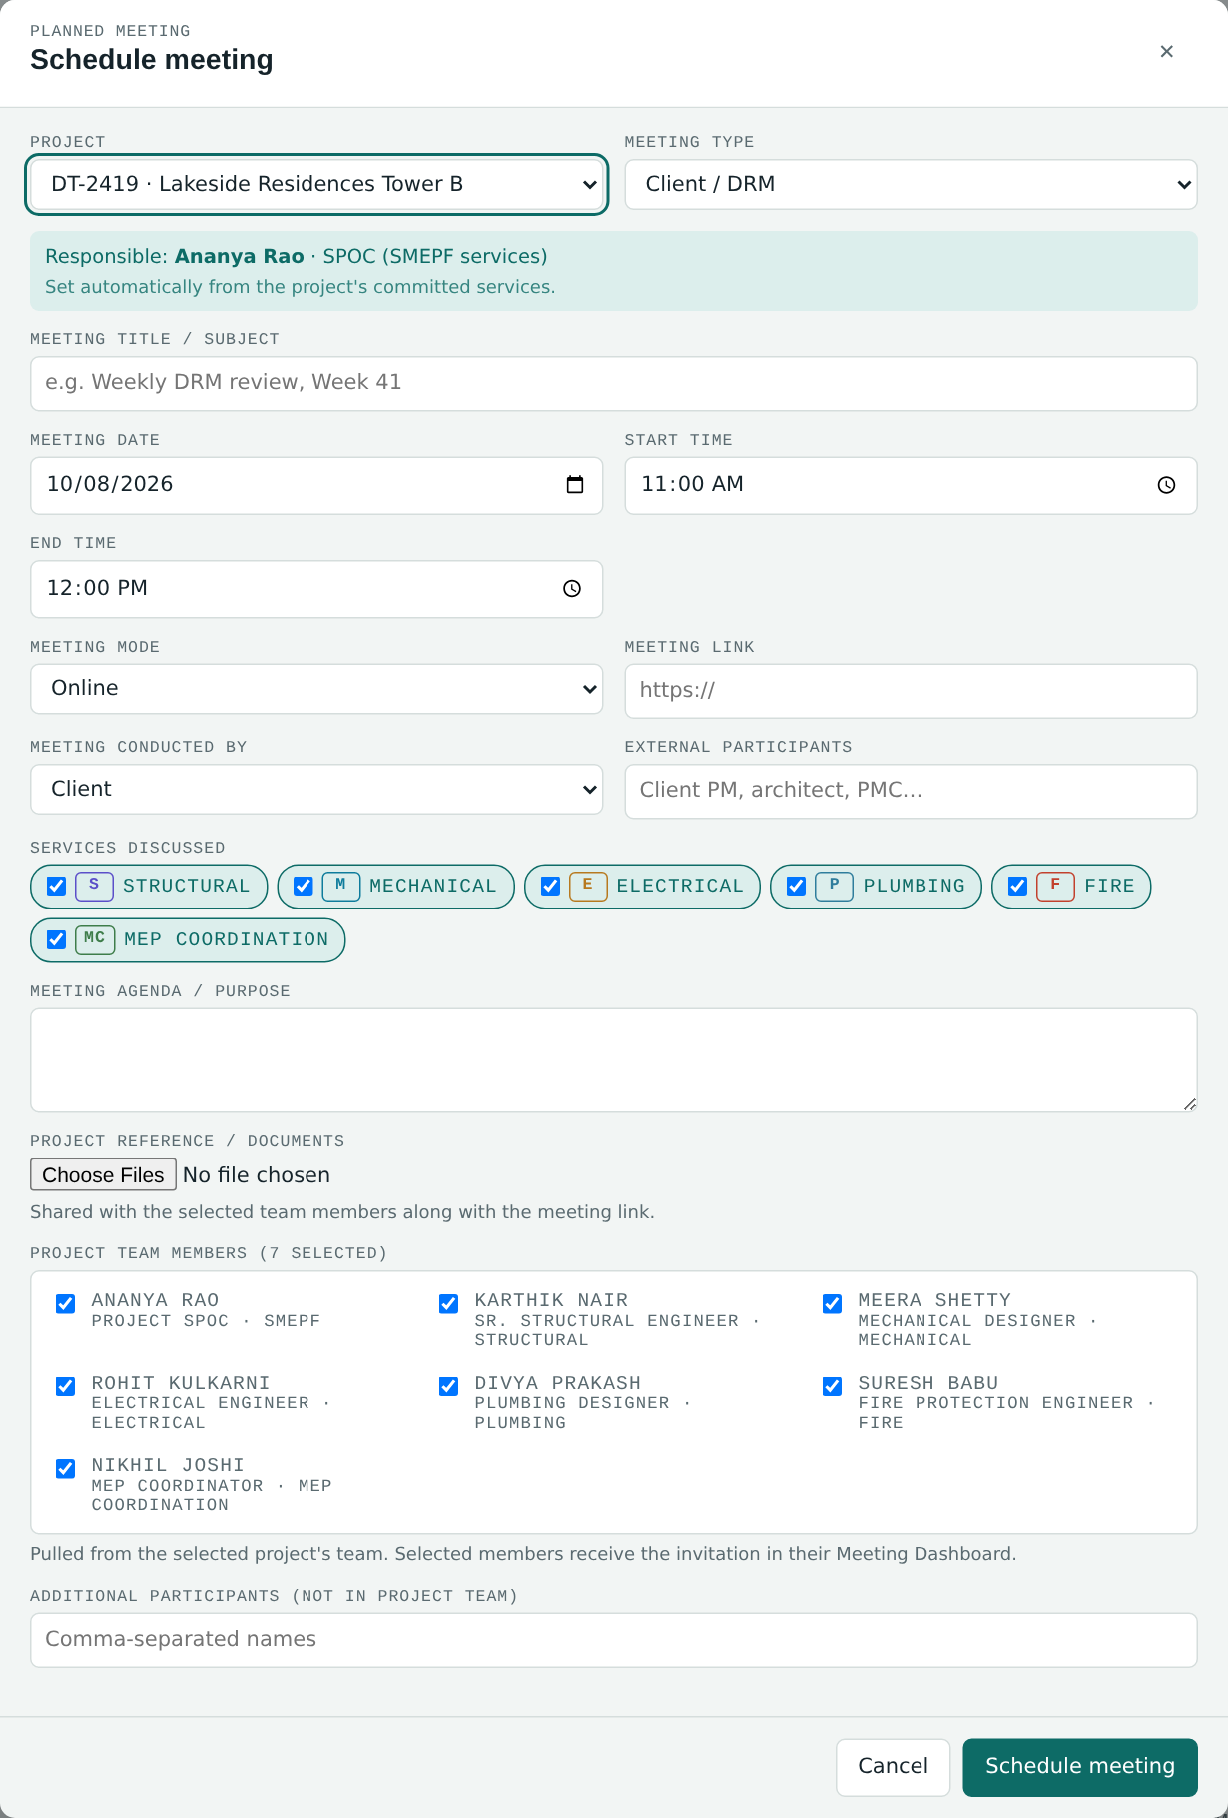
Figure 2. Schedule meeting form

5.1 Form fields
Field | Input type | Required | Behaviour
Project | Dropdown | Yes | Lists projects as <code> · <name>. Changing it reloads the responsible person, default services, "conducted by" options and team members.
Meeting type | Dropdown | Yes | Client / DRM, DesignTree / Arictech, PMC, Other. Changes the "Meeting conducted by" options.
Responsible SPOC / Coordinator | Auto-populated (read-only) | — | Set from the project's committed services (section 4.3).
Meeting title / subject | Text | Yes | Short subject shown on invitations, lists and the log, e.g. "Weekly DRM review, Week 41".
Meeting date | Date | Yes | Defaults to tomorrow.
Start time | Time | Yes | Defaults to 11:00.
End time | Time | Optional | Defaults to 12:00. If entered, it must be later than the start time.
Meeting mode | Dropdown | Yes | Online or Offline. Switches the next field label between Meeting link and Meeting location.
Meeting link / location | Text / URL | Recommended | For online meetings, the link is shared with participants and shown as a clickable link with a Copy link option.
Meeting conducted by | Dropdown | Yes | Options depend on the meeting type (section 4.2).
External participants | Text | Optional | Client PM, architect, PMC representatives etc.
Services discussed | Multi-select chips | At least one | Pre-selected with the project's committed services; can be changed.
Meeting agenda / purpose | Text area | Optional | Shown to participants and in history.
Project reference / documents | File upload (multiple) | Optional | Drawings, reports or other references shared with the selected team members along with the meeting link.
Project team members | Multi-select checklist | At least one | Fetched from the selected project's team (section 7). All members are ticked by default. A live count shows how many are selected.
Additional participants | Text (comma-separated) | Optional | People who are not part of the project team.

5.2 Validation
When Schedule meeting is pressed, the form checks that it has a meeting title, a meeting date, an end time later than the start time (if an end time is given), at least one service and at least one team member. Anything missing is listed in one message, for example "Add a meeting title, at least one service to continue." The meeting is not saved until the message is resolved.

5.3 What happens on save
- The meeting is created with status Scheduled and a new MOM number.
- The responsible person and the organiser (SPOC) are stored on the meeting.
- An invitation is sent to every selected team member, dated today. The confirmation reads "Meeting scheduled. Invitations sent to N team members."
- The meeting appears in each selected employee's Meeting Dashboard with all its details, the link and the reference documents, ready for an Available / Not Available response (section 9).
- The meeting appears in Upcoming meetings, All meetings, Project history and, if within 7 days, Alerts & reminders.

6. Adding a sudden / ad-hoc meeting
Select + Add Sudden Meeting. The form is the same as the Schedule meeting form (section 5.1) with these differences:
Difference | Detail
Reason for the sudden meeting | Text area, mandatory. Records what triggered the meeting (for example, a site clash or client complaint).
Recording option | Two choices: "Meeting is over: record attendance and MOM now" and "Meeting in progress: add details as it runs". Either way the meeting is entered directly without prior scheduling and details can be added during or after the meeting.
Default date and time | Date defaults to today; start time to the current hour; end time one hour later.
Status on save | Saved directly as held (Completed), so the Attendance, MOM and Action items sections are open straight away.
After saving | The meeting details panel opens automatically. The confirmation reads "Sudden meeting saved. Mark attendance and record the MOM."
Invitations | No availability responses are collected for ad-hoc meetings. In the meeting list, the Responses column shows "Ad-hoc".

Validation is the same as for scheduled meetings, plus the reason for the sudden meeting.
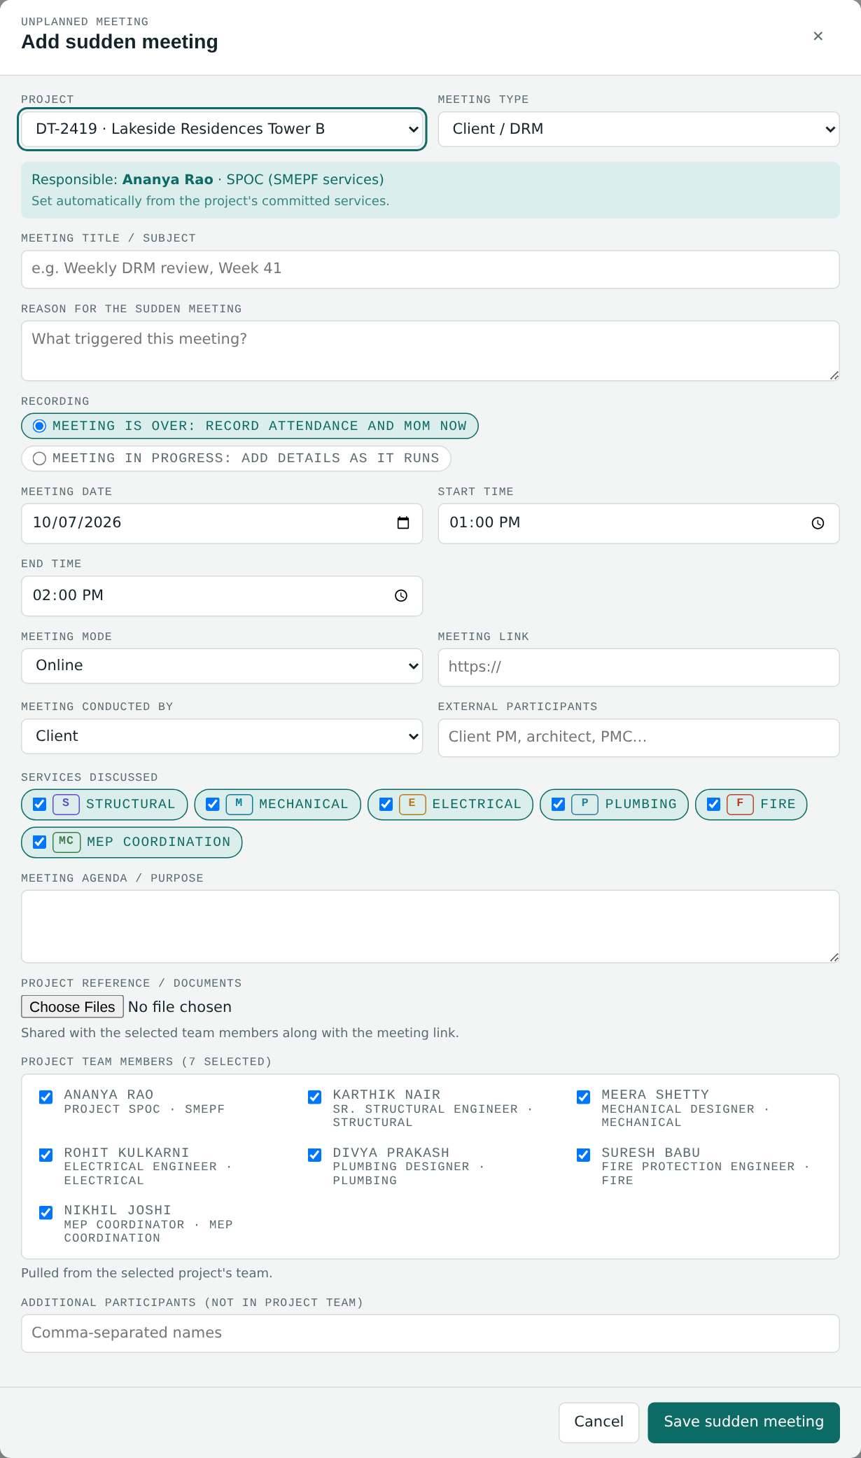
Figure 3. Add sudden meeting form with the mandatory reason and recording option
Same history. Scheduled and sudden meetings are stored together and appear side by side in every list, the dashboard counts, the absence log and the project meeting history. Sudden meetings are labelled "Ad-hoc" in amber.

7. Project team member selection
The Project team members list is linked directly to the Project Team of the selected project. No separate employee database is kept for meetings.
- The list loads automatically when a project is selected and reloads if the project changes.
- Each entry shows Name, Designation and Department / Service, for example "Meera Shetty · Mechanical Designer · Mechanical".
- Members from Structural, Mechanical, Electrical, Plumbing, Fire, MEP Coordination and SMEPF are listed according to their project assignment.
- Multiple members can be selected; all are selected by default and can be unticked.
- People outside the project team are added through Additional participants (when scheduling) or Add participant who attended (after the meeting).
The selected members become: the invitation list (section 9), the attendance list (section 10), and the list of people action items can be assigned to (section 12).

8. Meeting details panel
Selecting a meeting anywhere in the module (dashboard rows, alerts, table rows, the From meeting button on an action item) opens the meeting details panel. It contains every piece of information and every action for that meeting, in this order.
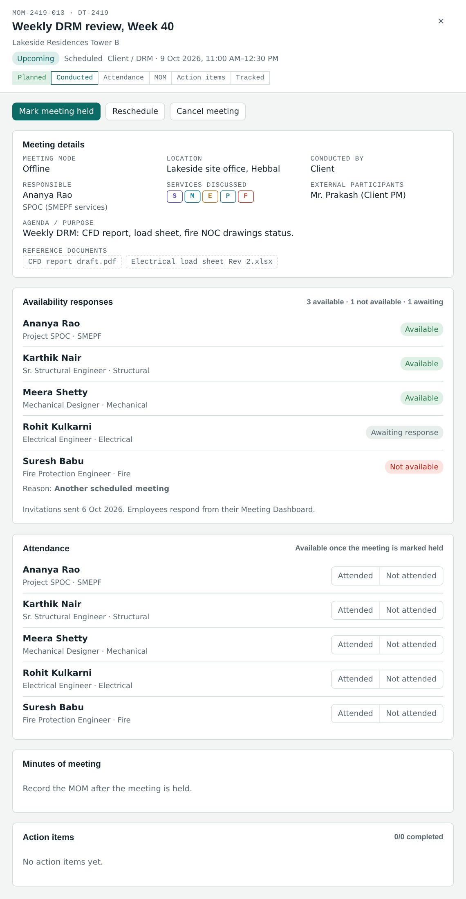
Figure 4. Details panel for an upcoming scheduled meeting: controls, details and availability responses

8.1 Header
- MOM number and project code, meeting title, project name.
- Current status (section 13), category, meeting type, date and start–end time.
- Workflow progress tracker with six steps. Completed steps are shaded green; the next step to do is outlined.
Step | Shown as complete when
Planned | Always (the meeting exists).
Conducted | The meeting has been marked held (status Completed).
Attendance | Every selected team member has been marked Attended or Not attended.
MOM | The MOM has been recorded: discussion points entered or a MOM document uploaded.
Action items | At least one action item has been added.
Tracked | All action items are Completed.

8.2 Meeting controls
Control | Available when | Effect
Mark meeting held | Meeting not yet held and not cancelled | Sets status to Completed and opens Attendance, MOM and Add action item. Confirmation: "Marked as held. Now mark attendance and record the MOM."
Reschedule | Meeting not yet held and not cancelled | Shows an inline box with New date (defaults to one week after the meeting date, or after today if that date has passed) and Time. Confirm reschedule moves the meeting, records the original date (shown as "Moved from <date>") and sets status Rescheduled. Keep date closes the box.
Cancel meeting | Meeting not yet held and not cancelled | Shows an inline box asking for the reason for cancelling. Confirming sets status Cancelled and shows "Cancelled: <reason>" on the panel. Keep meeting closes the box.

8.3 Sections of the panel
Section | Contents
Meeting details | Mode, link or location (links open in a new tab), conducted by, responsible person with role, services discussed, external participants, reason for sudden meeting (ad-hoc only), agenda / purpose, reference documents.
Availability responses | Scheduled meetings only. Each invited member with Available, Not available (with reason) or Awaiting response. Section 9.
Attendance | Section 10.
Minutes of meeting | Section 11.
Action items | Section 12.

9. Invitations and availability responses
When a scheduled meeting is saved, each selected team member receives an invitation in their Employee Meeting Dashboard with the project name, meeting title, date, start and end time, meeting type, meeting link, agenda, organiser (SPOC), participants and reference documents.

9.1 Employee response
Each employee responds Available or Not available. If Not available is chosen, a reason is mandatory and must be one of:
- Another scheduled meeting
- Project work / deadline
- Leave
- Client engagement
- Personal reason
- Other – specify (a written explanation is then also mandatory)
When not available, the employee may also add a short note for the SPOC (for example "can join after 4 PM"). The response can be changed until the meeting takes place; the latest response is kept with its date.

9.2 What the SPOC sees
Where | What is shown
Meeting details panel → Availability responses | Every invited member with name, designation and service, and a status: Available (green), Not available (red) with the reason, or Awaiting response (grey). A heading summary such as "3 available · 1 not available · 1 awaiting" and the date invitations were sent.
All meetings → Responses column | The same summary for each scheduled meeting; "Ad-hoc" for sudden meetings.
Dashboard → Alerts & reminders | "N not available: <meeting title>" for any upcoming scheduled meeting with a Not available response; "N responses awaited: <meeting title>" when responses are outstanding and the meeting is within 2 days.

Response vs attendance. The availability response is the employee's advance answer. Attendance is what actually happened and is marked separately by the SPOC after the meeting. The Absence log is based on attendance.

10. Attendance tracking
The Attendance section becomes active once the meeting is marked held (sudden meetings are held from the start). Before that, it shows "Available once the meeting is marked held" and the buttons are disabled.
- All selected team members appear automatically, with name, designation and service.
- For each member, choose Attended or Not attended.
- Choosing Not attended opens a Reason for absence field directly under the member; the cursor moves to it. The reason is saved as it is typed.
- Add participant who attended: enter a name and organisation and press Add to record anyone else who attended. They are listed under Additional participants.
The heading shows a summary such as "4/5 attended". Attendance status per meeting is one of: All attended, Some absent (at least one member not marked as attended), or Not marked.
Not-attended entries feed the Absence log (section 16). A Not attended entry left without a reason is shown there as Not given in red so the SPOC can follow up.
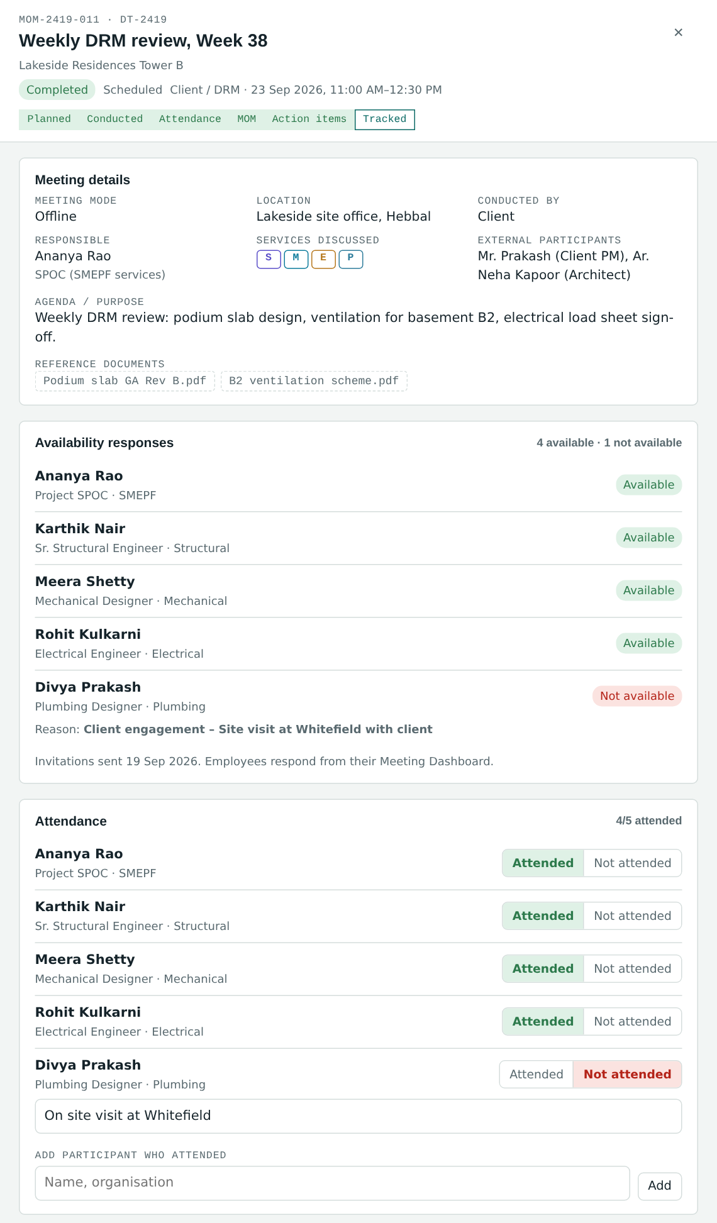
Figure 5. Completed meeting: details, availability responses and attendance with a reason for absence

11. Minutes of meeting (MOM)
After the meeting, the responsible person records the MOM in the Minutes of meeting section. The section is available once the meeting is held.
Field | Purpose
Key discussion points | Text area for what was discussed.
Decisions taken | Text area for decisions agreed in the meeting.
Follow-up requirements | Text area for follow-ups (for example, inputs awaited from the client).
Next / follow-up meeting | Date. Triggers a follow-up reminder in Alerts when within 7 days.
Upload MOM document | Accepts PDF, Word and Excel files. The attached file name is shown under the field.

Press Save MOM to store it. The MOM counts as recorded when key discussion points are entered or a MOM document is uploaded. Until then a completed meeting shows the status "Completed · MOM pending", counts in the Pending MOM total, and raises a "MOM pending" alert.
Once recorded, the MOM automatically appears in the Meeting Log of every invited employee, who can view the discussion points and decisions and download the MOM (section 17).
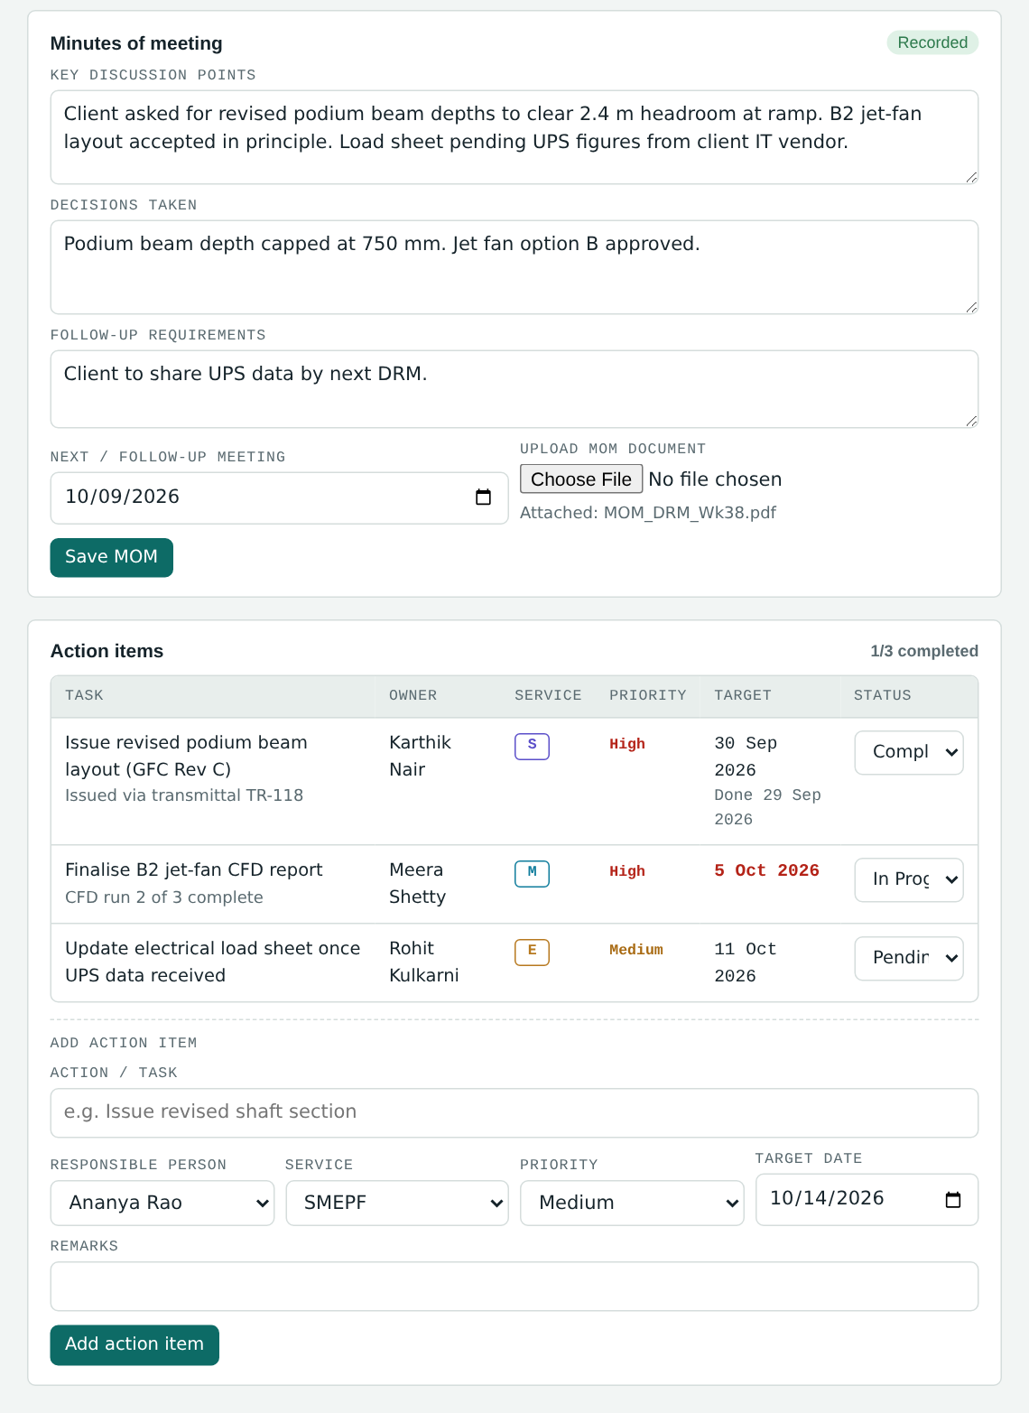
Figure 6. MOM entry and action items for a completed meeting

12. Action items

12.1 Adding an action item
In the meeting details panel (after the meeting is held), fill in Add action item and press Add action item:
Field | Input | Rules
Action / task | Text | Required. Message "Enter the task first." if empty.
Responsible person | Dropdown | Project team members plus any additional participants of the meeting.
Department / Service | Dropdown | Filled automatically from the selected person's service; can be changed.
Priority | Dropdown | High, Medium (default), Low.
Target date | Date | Defaults to one week from today.
Remarks | Text | Optional.

A new action item starts with status Pending. The confirmation reads "Action item assigned to <name>." The item immediately appears in the SPOC Action items tab and in the assignee's My action items list.

12.2 Action item record
Attribute | Description
Action / task | What has to be done.
Responsible person | Assignee.
Department / Service | Shown as a service code.
Priority | High (red), Medium (amber), Low (grey).
Target date | Shown in red with "Nd overdue" when overdue, amber when due within 3 days.
Status | Pending / In Progress / Completed, editable from the meeting panel, the SPOC Action items tab, or by the assignee.
Remarks | SPOC remarks, plus the assignee's latest progress note shown as "Update from <name>: …".
Completion date | Set automatically to today when status changes to Completed; cleared if the status is moved back.

12.3 Automatic overdue tracking
- Overdue: target date earlier than today and status not Completed. Counted in Overdue action items, shown on the Action items tab badge, flagged in red, and raised as an alert "Overdue Nd: <task>".
- Due soon: target date today or within the next 3 days and not Completed. Shown in amber and raised as an alert "Due <date>: <task>".

13. Meeting status lifecycle
Each meeting stores one of four statuses: Scheduled, Completed, Rescheduled, Cancelled. The screens display a more specific label derived from the status, date and MOM:
Displayed status | Colour | Condition
Upcoming | Teal | Status Scheduled and the meeting date is today or later.
Rescheduled | Amber | Status Rescheduled and the new date is today or later.
Awaiting update | Grey | Status Scheduled or Rescheduled but the date has passed and the meeting has not been marked held. The SPOC should mark it held, reschedule or cancel it.
Completed · MOM pending | Amber | Meeting held but the MOM has not been recorded.
Completed | Green | Meeting held and MOM recorded.
Cancelled | Red | Meeting cancelled (with reason).

Typical flow: Scheduled (Upcoming) → optionally Rescheduled → Completed · MOM pending → Completed. A meeting can be cancelled at any point before it is held.

14. Dashboard tab

14.1 Meeting summary counts
A row of counts across all projects. Each count can be clicked to open the relevant filtered list.
Count | Definition | Click opens
Total meetings | All meetings, both categories. | All meetings, no filter
Scheduled | Meetings of category Scheduled. | All meetings filtered to Scheduled
Sudden / ad-hoc | Meetings of category Sudden / Ad-Hoc. | All meetings filtered to Sudden
Upcoming | Scheduled or Rescheduled with date today or later. | All meetings filtered to Upcoming
Completed | Meetings marked held. Shown in green. | All meetings filtered to Completed
Cancelled / rescheduled | Status Cancelled or Rescheduled. | All meetings filtered to Cancelled or rescheduled
Pending MOM | Held meetings without a recorded MOM. Amber when above zero. | All meetings filtered to Completed · MOM pending
Pending action items | Action items not Completed. | Action items tab
Overdue action items | Open action items past target date. Red when above zero. | Action items tab
Absences recorded | Members marked Not attended across all meetings. Amber if any has no reason. | Absence log tab

14.2 Panels
Panel | Contents
Upcoming meetings | All upcoming meetings in date and time order: date, title, project, type, category, start time, service codes, status.
Recent meetings | The five most recent meetings that are no longer upcoming, newest first.
Alerts & reminders | All current alerts with a coloured dot (teal information, amber attention, red overdue). Selecting an alert opens the meeting. Section 15.
By meeting type | Bar chart of meetings per type: Client / DRM, DesignTree / Arictech, PMC, Other. Clicking a bar filters All meetings by that type.
By service | Bar chart of meetings per service: Structural, Mechanical, Electrical, Plumbing, Fire, MEP Coordination (a meeting counts under every service it discussed) and SMEPF (meetings on projects with full SMEPF scope). Clicking a bar filters All meetings by that service.

15. Notifications, alerts and reminders
Alerts are calculated automatically every time the screen is refreshed. They appear in the Alerts & reminders panel on the Dashboard.
Alert | Raised when | Level
Today / Tomorrow / In N days: <type> meeting | An upcoming meeting is within the next 7 days. | Information
N not available: <title> | An upcoming scheduled meeting has one or more Not available responses. | Attention
N responses awaited: <title> | Responses are still awaited and the meeting is within 2 days. | Information
MOM pending | A meeting has been held but no MOM is recorded. Shows the responsible person. | Attention
Overdue Nd: <task> | An action item is past its target date and not Completed. Shows the owner and project. | Overdue (red)
Due <date>: <task> | An action item is due within 3 days. | Attention
Follow-up meeting due <date> | A MOM's next / follow-up meeting date falls in the next 7 days. | Information
Cancelled / Rescheduled: <type> meeting | A meeting dated within 14 days either side of today was cancelled (shows reason) or rescheduled (shows new date). | Attention

Employees see their own reminders in the Employee Meeting Dashboard: today's meetings, pending responses, assigned action items and due or overdue items.

16. Lists and logs

16.1 All meetings tab
A table of all meetings, newest first, with the filters described below. The count above the table shows "N of M meetings", and Clear filters appears when any filter is set. Clicking a row opens the meeting.
Column | Content
Date | Date and start time.
MOM no. | Meeting reference.
Meeting / project | Meeting title and project name.
Category | Scheduled or Ad-hoc.
Type | Meeting type.
Services | Service codes discussed.
Responsible | SPOC / coordinator.
Responses | Availability summary (scheduled) or "Ad-hoc".
Attendance | "N/M attended", Not marked, or —.
Actions | Number of open action items and number overdue.
Status | Displayed status (section 13).

Filters
Filter | Options
Project | All, or one project.
Category | Scheduled, Sudden / Ad-Hoc.
Meeting type | Client / DRM, DesignTree / Arictech, PMC, Other.
Service | Structural, Mechanical, Electrical, Plumbing, Fire, MEP Coordination, SMEPF (project scope).
SPOC / coordinator | Each responsible person.
From / To | Meeting date range.
Meeting status | Upcoming, Scheduled, Completed, Completed · MOM pending, Rescheduled, Cancelled, Cancelled or rescheduled.
Attendance | All attended, Some absent, Not marked.
Action items | Has pending, Has overdue, All completed, No action items.

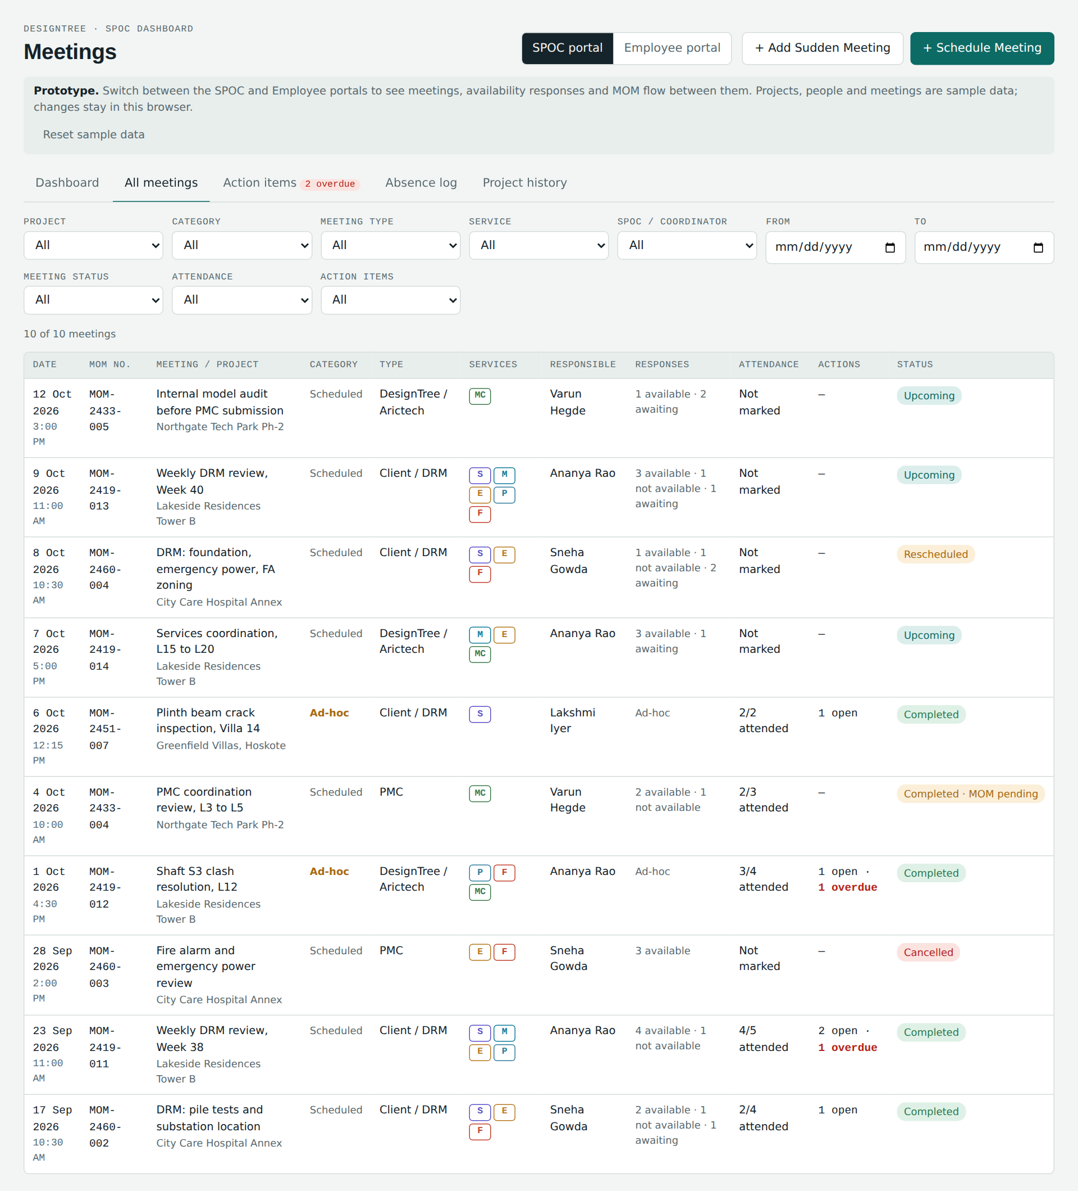
Figure 7. All meetings tab with filters and the Responses column

16.2 Action items tab
All action items from all meetings in one table, sorted by target date. Filters: Status (All, Open = Pending + In Progress, Overdue, Pending, In Progress, Completed) and Project. Columns: Action / task, Responsible, Service, Priority, Target (with overdue days), Status (editable dropdown), Completed date, Remarks (with the assignee's latest update), and From meeting (button that opens the source meeting). Changing a status here shows "Status set to <status>."
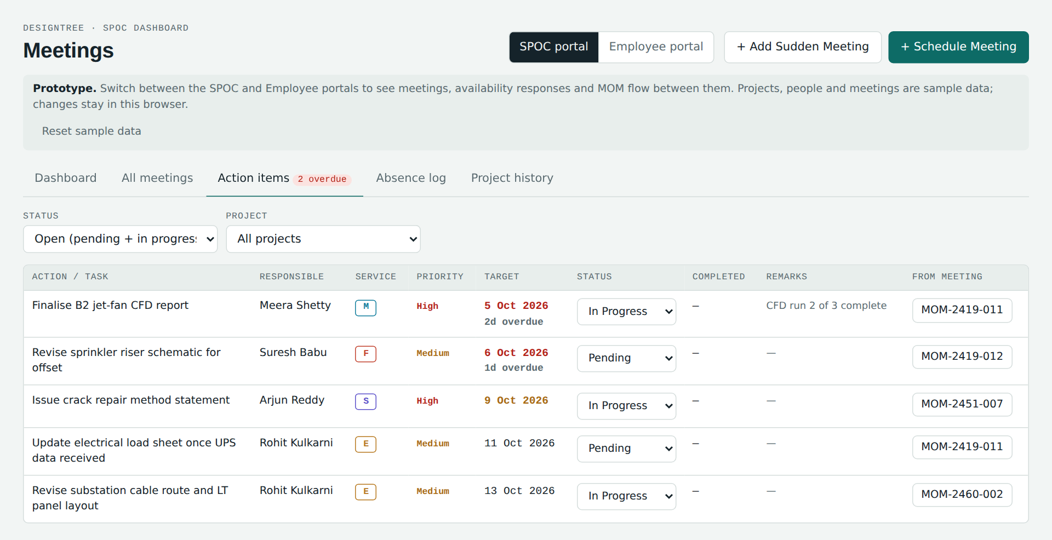
Figure 8. Action items tab across all meetings

16.3 Absence log tab
A log of every team member marked Not attended, with project, service, reason and the full meeting details. It is built automatically from the attendance marked on held meetings.

Filters
Project, Service (of the absent member), Team member, Meeting type, and From / To date range.

Summaries
- Absences by team member: name, service, number of absences (highlighted when more than one) and the projects concerned. Clicking a member filters the log to that person.
- By service: bar chart of absences per service. Clicking a bar filters the log to that service.

Log columns
Column | Content
Date | Meeting date and time.
MOM no. | Meeting reference.
Project | Project name and code.
Absent member | Name and designation.
Service | Member's service.
Reason for absence | As entered in attendance; "Not given" in red if blank.
Meeting | Meeting type, category and services discussed.
Mode / location | Online with link, or Offline with location.
Responsible | Responsible person and who conducted the meeting.
Agenda | Meeting agenda / purpose.

Copy log for Excel
Copies the currently filtered log to the clipboard as a table that pastes directly into Excel with 17 columns: Date, Time, MOM no., Project, Project code, Meeting category, Meeting type, Mode, Location / link, Conducted by, Responsible, Services discussed, Agenda, Absent member, Designation, Service, Reason for absence. If the browser blocks copying, the text is shown selected so it can be copied with Ctrl+C.
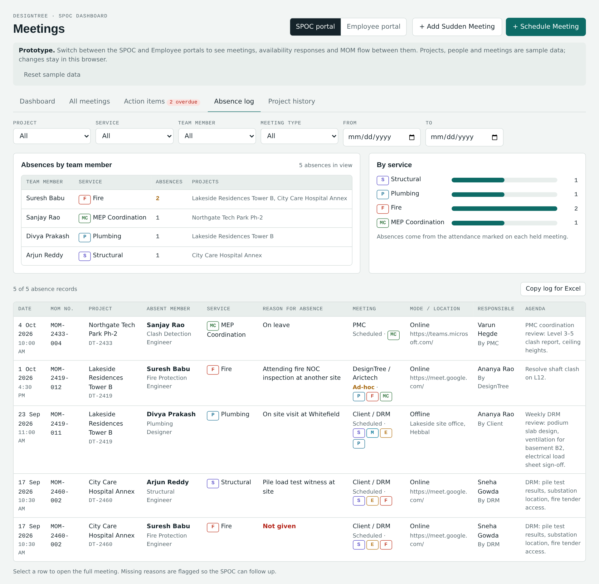
Figure 9. Absence log with summaries by member and service

16.4 Project history tab
Select a project to see its complete meeting history in chronological order. Above the table: client name, project scope (service codes) and the responsible person with role. Scheduled and sudden meetings appear together.
Column | Content
Date | Meeting date.
Category | Scheduled / Ad-hoc.
Type | Meeting type.
Service | Services discussed.
Participants | Selected team members, plus additional participants.
Attendance | Attendance summary.
Key discussions | First part of the MOM discussion points, or the agenda if no MOM yet.
MOM | Recorded, Pending, or —.
Action items | "N/M done".
Status | Displayed status.

Clicking a row opens the complete meeting details.
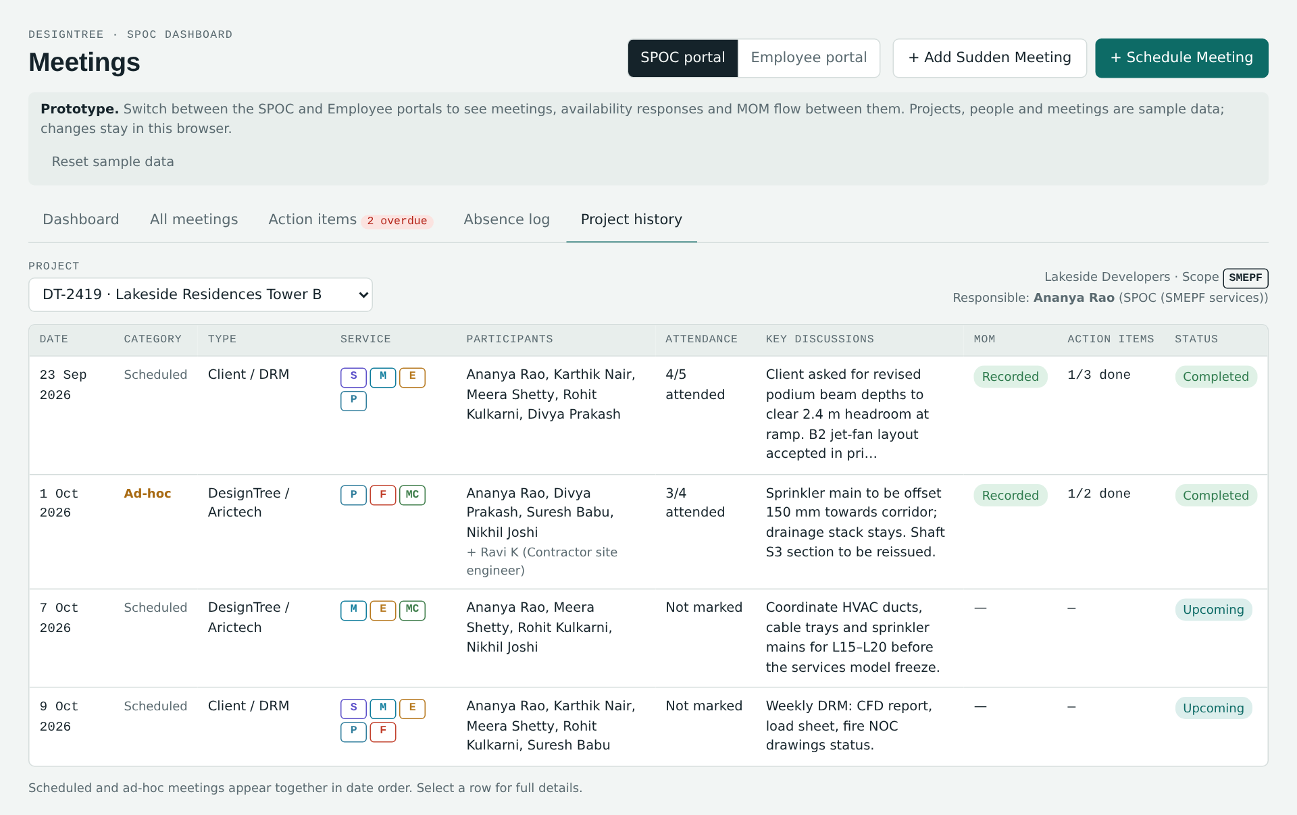
Figure 10. Project meeting history

17. Link with the Employee Meeting Dashboard
The SPOC module works together with a separate Employee Meeting Dashboard used by project team members (excluding the SPOC). In the prototype the two can be viewed in one page using the SPOC portal / Employee portal switch; a standalone employee page is also available. Both read the same meetings.
SPOC action | Result for the employee | Result back to the SPOC
Schedules a meeting and selects team members | Invitation appears in the employee's Meeting invitations and Overview, with project, title, date, start–end time, type, link (with Copy link), agenda, organiser, participants and documents. | Responses section shows "Awaiting response" for each member.
— | Employee responds Available / Not available; reason mandatory if not available. | Response and reason appear in the Availability responses section, Responses column and alerts.
Marks meeting held and marks attendance | Meeting moves automatically into the employee's Meeting log with attendance, unavailable members and reasons. | Absence log updates.
Records or uploads the MOM | MOM appears in the employee's Meeting log: discussion points, decisions, follow-up, next meeting, and a Download MOM option. | —
Assigns action items | Item appears in the employee's My action items with due date and priority, and is highlighted in the meeting. | —
— | Employee updates action-item status and adds a progress note. | Status and "Update from <name>" appear in the SPOC Action items tab and the meeting panel.

17.1 Employee dashboard views (summary)
- Overview: counts for today's meetings, upcoming meetings, pending responses, open and overdue action items, and meetings attended; today's meetings with links; pending responses; open action items.
- Meeting invitations: meetings received from the SPOC, filterable by all / awaiting my response / responded, each with the Available / Not available response form.
- Meeting log: completed and past meetings with date and time, link, organiser, invited count, who attended, who was unavailable and why, own attendance, meeting status and MOM status. Filters by project and MOM availability.
- My action items: actions arising from MOMs, with project, source meeting, priority, due date, status update and a progress note for the SPOC.

18. End-to-end workflows

18.1 Scheduled meeting
Step | Who | Where | Action and system response
1. Schedule Meeting | SPOC | Header button | Opens the Schedule meeting form.
2. Select Project | SPOC | Form | Responsible person, default services and the project team load automatically.
3. Select Meeting Type | SPOC | Form | "Conducted by" options update.
4. Select Service | SPOC | Form | Adjust the pre-selected services discussed.
5. Select Participants | SPOC | Form | Tick team members; add external and additional participants; attach reference documents; save.
6. Invitations sent | System | Employee dashboards | Selected members receive the meeting details and link.
7. Respond | Employees | Employee dashboard | Available / Not available with mandatory reason. SPOC sees responses and alerts.
8. Conduct Meeting | SPOC | Details panel | Mark meeting held (or Reschedule / Cancel beforehand).
9. Mark Attendance | SPOC | Attendance section | Attended / Not attended with reason; add extra attendees.
10. Enter MOM | SPOC | MOM section | Discussion, decisions, follow-up, next meeting date, upload document. Save MOM. MOM is reflected in employees' Meeting log.
11. Add Action Items | SPOC | Action items section | Task, person, service, priority, target date, remarks.
12. Assign Responsibility | System | Employee dashboards | Item appears in the assignee's My action items.
13. Track Completion | Employee and SPOC | Action items tabs | Status updates and progress notes; overdue tracked automatically until Completed.

18.2 Sudden / ad-hoc meeting
Step | Who | Action and system response
1. Add Sudden Meeting | SPOC | Opens the Add sudden meeting form.
2. Select Project | SPOC | Responsible person and team load automatically.
3. Enter Meeting Details | SPOC | Title, type, date and time, mode and location, services, agenda, and the mandatory reason for the sudden meeting; choose whether it is over or in progress.
4. Select Participants | SPOC | Tick the team members present; add others. Save. The details panel opens.
5. Mark Attendance | SPOC | Attended / Not attended with reasons.
6. Enter MOM | SPOC | Record or upload the MOM, during or after the meeting.
7. Add Action Items | SPOC | Create tasks with owner, priority and target date.
8. Assign Responsibility | System | Items appear in the assignees' dashboards.
9. Track Completion | Employee and SPOC | Status updates until Completed; overdue tracked automatically.

19. Business rules summary and production notes

19.1 Business rules
# | Rule
R1 | The responsible person is assigned from the project's committed services (SMEPF → SPOC; MEP Coordination only → MEP Coordinator; Structural only → Structural Design Lead; multiple → SPOC with service leads).
R2 | Team members are selected only from the selected project's team; others are added as additional participants.
R3 | A meeting needs a title, date, at least one service and at least one team member; end time must be after start time.
R4 | A sudden meeting needs a reason and is saved as held.
R5 | Invitations go to selected members of scheduled meetings only.
R6 | A Not available response requires a reason from the list; "Other – specify" also requires text.
R7 | Attendance, MOM and action items can be entered only after the meeting is held.
R8 | A MOM is recorded when discussion points are entered or a document is uploaded.
R9 | An action item is overdue when its target date has passed and it is not Completed; due soon within 3 days.
R10 | Completion date is set automatically when an action item is marked Completed and cleared if reopened.
R11 | Reschedule and cancel are allowed only before a meeting is held; rescheduling keeps the original date.
R12 | Scheduled and sudden meetings share one history per project.

19.2 Current prototype limitations
- Projects, team members and meetings are sample data held in the page.
- Data is saved in the browser on the computer where it was entered; it is not shared between users or computers. Reset sample data restores the demonstration data.
- Uploaded MOM and reference documents are recorded by file name only; the files themselves are not stored.
- Notifications appear inside the dashboards; no email or mobile notifications are sent.
- The SPOC / Employee portal switch and the "Viewing as" selector are for demonstration and would be replaced by user login.

19.3 Recommendations for the production build
- Connect projects, committed services and Project Team to the live project master so team lists and responsibility load from real assignments.
- Store meetings, responses, attendance, MOMs and action items in a shared database so SPOCs and employees see the same records.
- Add user login with role-based access (SPOC / Coordinator / Lead vs employee).
- Store uploaded MOM and reference documents in the document management system and link them to the meeting.
- Send invitations, reminders, MOM-published and overdue alerts by email and/or in-app notification, optionally with calendar invites.
- Keep an audit trail of changes to meetings, attendance and action-item statuses.

