**Topics: Descriptive Statistics and Probability**

1. Look at the data given below. Plot the data, find the outliers and find out $μ, σ, σ^{2}$

|  |  |
| --- | --- |
| **Name of company** | **Measure X** |
| Allied Signal | 24.23% |
| Bankers Trust | 25.53% |
| General Mills | 25.41% |
| ITT Industries | 24.14% |
| J.P.Morgan & Co. | 29.62% |
| Lehman Brothers | 28.25% |
| Marriott | 25.81% |
| MCI | 24.39% |
| Merrill Lynch | 40.26% |
| Microsoft | 32.95% |
| Morgan Stanley | 91.36% |
| Sun Microsystems | 25.99% |
| Travelers | 39.42% |
| US Airways | 26.71% |
| Warner-Lambert | 35.00% |

**Ans:**

|  |  |
| --- | --- |
| Mean (µ) | 0.3327 |
| Variance ($σ^{2}$) | 0.0287 |
| Standard Deviation ($σ$) | 0.1694 |

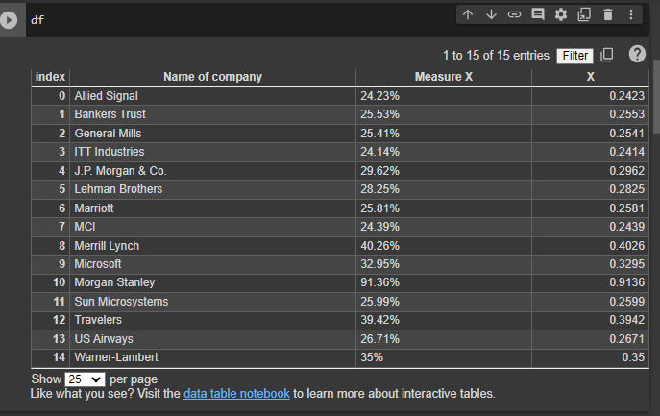



Answer the following three questions based on the box-plot above.

1. What is inter-quartile range of this dataset? (please approximate the numbers) In one line, explain what this value implies.

**ANS:** IQR is the range that liaise between the upper quartile (Q3) and lower quartile (Q1)

Here IQR= Q3-Q1= 12-5 = 7

Because of this 50% of the data lies between IQR

1. What can we say about the skewness of this dataset?

**Ans:** This data is positively skewed

1. If it was found that the data point with the value 25 is actually 2.5, how would the new box-plot be affected?

**Ans:** If value 25 is 2.5 then there is no outlier is present.



Answer the following three questions based on the histogram above.

1. Where would the mode of this dataset lie?

**Ans:** Most of the data lies between 6-8.

1. Comment on the skewness of the dataset.

**Ans:** Data is positively right side skewed.

1. Suppose that the above histogram and the box-plot in question 2 are plotted for the same dataset. Explain how these graphs complement each other in providing information about any dataset.

**Ans:** Both have outlier a (25) also both are positively right skewed

1. AT&T was running commercials in 1990 aimed at luring back customers who had switched to one of the other long-distance phone service providers. One such commercial shows a businessman trying to reach Phoenix and mistakenly getting Fiji, where a half-naked native on a beach responds incomprehensibly in Polynesian. When asked about this advertisement, AT&T admitted that the portrayed incident did not actually take place but added that this was an enactment of something that “could happen.” Suppose that one in 200 long-distance telephone calls is misdirected. What is the probability that at least one in five attempted telephone calls reaches the wrong number? (Assume independence of attempts.)

**Ans:** The probability of the event E is

P(E)= 1/200

Probability of having at least one successful call will be

1-P(X)= 1-1/200= 199/200= 0.967

As every event is independent of other event the probability will be

1- (0.967) ^5

0.02475 = 2% chance.

1. Returns on a certain business venture, to the nearest $1,000, are known to follow the following probability distribution

|  |  |
| --- | --- |
| x | P(x) |
| -2,000 | 0.1 |
| -1,000 | 0.1 |
| 0 | 0.2 |
| 1000 | 0.2 |
| 2000 | 0.3 |
| 3000 | 0.1 |

1. What is the most likely monetary outcome of the business venture?

**Ans:** 2000$ have most change of occurrence.

1. Is the venture likely to be successful? Explain

**Ans:** Yes, it is, because 60% chance to give results and 20% change of failure. And 20% chance to no loss and no profit

1. What is the long-term average earning of business ventures of this kind? Explain

**Ans:**

(-2000*0.1) +(-1000*0.1) +(0*0.2) +(1000*0.2) +(2000*0.3) +(3000*0.1) =800

1. What is the good measure of the risk involved in a venture of this kind? Compute this measure
2. **Ans:** We can calculate the risk by using the variance and standard deviation.
3. Variance = 3500000
4. Standard deviation = 1870.83
5. This venture at high risk because the standard deviation is $1870 with the average return of $800