
Ex.No: 5 | Implementation of matrix-chain multiplication algorithm with experiments on analysis and efficiency | Name : Venkatesan M
Date : 05.09.2024 |  | Reg.No : 22BAI1259

Aim
Given the dimension of a sequence of matrices in an array arr[], where the dimension of the ith matrix is (arr[i-1] * arr[i]).
the task is to find the most efficient way to multiply these matrices together such that the total number of element multiplications is minimum.
When two matrices of size m*n and n*p when multiplied, they generate a matrix of size m*p and the number of multiplications performed are m*n*p.
Algorithm
Matrix-Chain Multiplication (Dynamic Programming Approach)
- Initialization:
Let the chain of matrices be A1,A2,…,An
Define a table m where m[i][j] represents the minimum number of scalar multiplications needed to multiply matrices Ai​ to Aj
Let s be the table to store the index k at which the optimal split occurs.
- Compute Cost:
For each chain length l from 2 to n:
For each starting index i from 1 to n−l+1:
Set the ending index j=i+l−1.
Initialize m[i][j] to infinity.
For each possible split point k from gi to j−1:
Compute the cost of multiplying matrices Ai​ to Ak and Ak+1 to Aj, plus the cost of multiplying the two resulting matrices.
Update m[i][j] if a lower cost is found.
Store the split point in s[i][j].
- Parenthesization:
Use the table s to determine the optimal parenthesization of the matrices.
- Output:
The minimum number of scalar multiplications is stored in m[1][n].
The optimal parenthesization is obtained using the s table.
Example
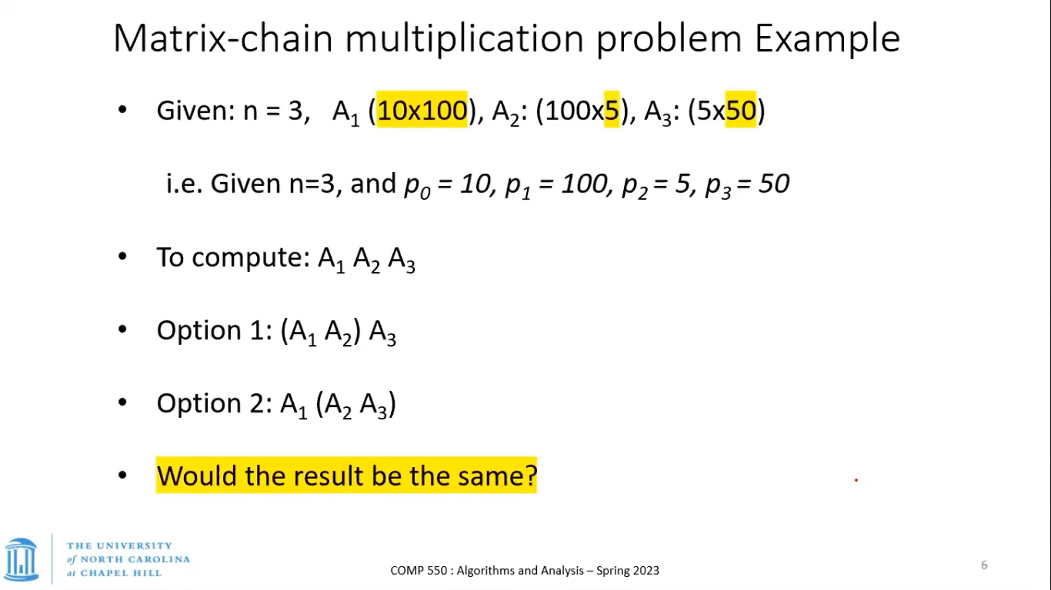

i = 0, j = 0, k = l
while i < n1 and j < n2
if L[i] <= R[j]
arr[k] = L[i]
i++
else

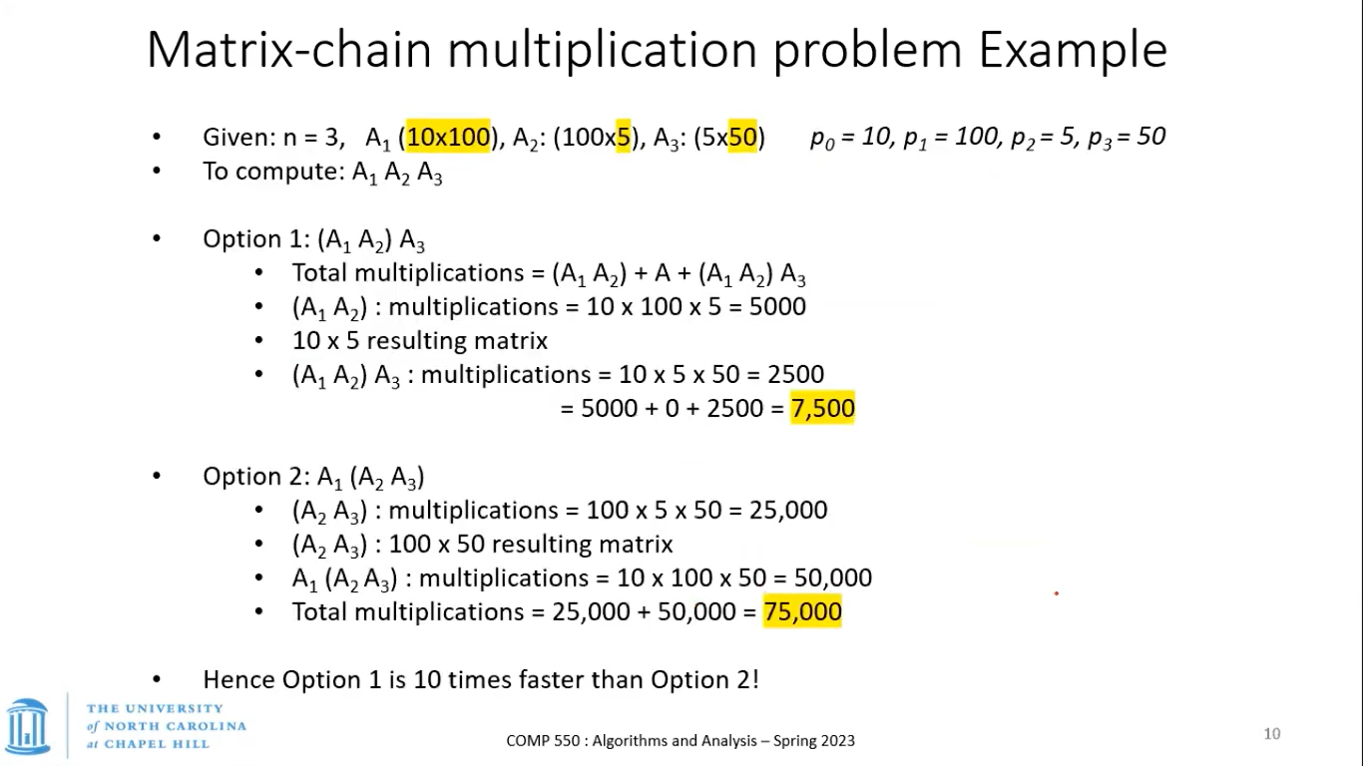
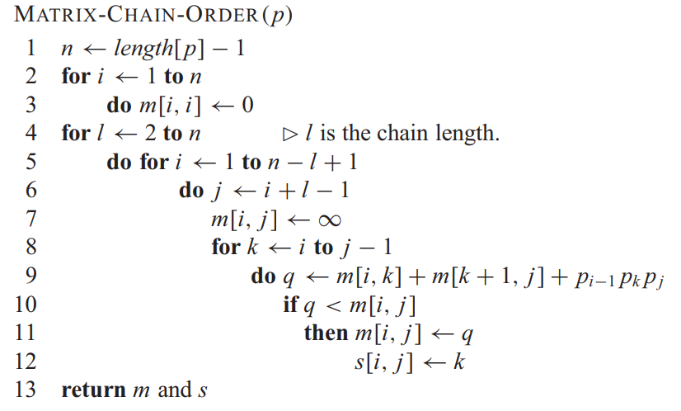
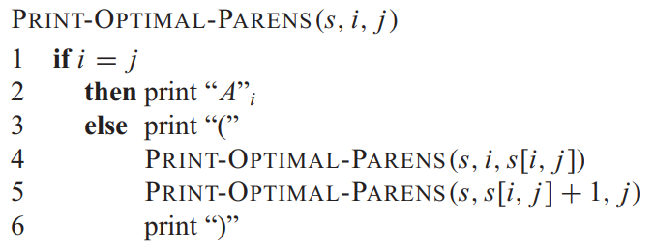
C++ Implementation
#include <iostream>
#include <limits.h>
#include <vector>
#include <chrono>

using namespace std;

// Function to print optimal parenthesization
void printOptimalParens(vector<vector<int>>& s, int i, int j) {
if (i == j)
cout << "A" << i;
else {
cout << "(";
printOptimalParens(s, i, s[i][j]);
printOptimalParens(s, s[i][j] + 1, j);
cout << ")";
}
}

// Matrix Chain Multiplication using Dynamic Programming
int matrixChainOrder(vector<int>& p, int n) {
vector<vector<int>> m(n, vector<int>(n, 0));
vector<vector<int>> s(n, vector<int>(n, 0));

for (int l = 2; l < n; l++) { // l is the chain length
for (int i = 1; i < n - l + 1; i++) {
int j = i + l - 1;
m[i][j] = INT_MAX;
for (int k = i; k < j; k++) {
int q = m[i][k] + m[k + 1][j] + p[i - 1] * p[k] * p[j];
if (q < m[i][j]) {
m[i][j] = q;
s[i][j] = k;
}
}
}
}

cout << "Optimal Parenthesization: ";
printOptimalParens(s, 1, n - 1);
cout << "\nMinimum number of multiplications is " << m[1][n - 1] << endl;

return m[1][n - 1];
}

int main() {
vector<int> p = {40, 20, 30, 10, 30};
int n = p.size();

auto start = chrono::high_resolution_clock::now();

int minMultiplications = matrixChainOrder(p, n);

auto end = chrono::high_resolution_clock::now();

auto duration = chrono::duration_cast<chrono::microseconds>(end - start);
cout << "Time taken by function: " << duration.count() << " microseconds" << endl;
return 0;
}
Input
Array P = {40, 20, 30, 10, 30};
Size N = 5

Output
Optimal Parenthesization: ((A1(A2A3))A4)
Minimum number of multiplications is 26000
Time taken by function: 65 microseconds
Random Sampling
vector<int> sizes = {1,5, 10,50, 100,500, 1000, 2000}; // Different sizes of input
vector<long long> times;
for (int n : sizes) {
// Generate random matrix dimensions
vector<int> p(n + 1);
for (int i = 0; i <= n; ++i) {
p[i] = rand() % 100 + 1; // Random dimensions between 1 and 100
}

auto start = chrono::high_resolution_clock::now();
int minMultiplications = matrixChainOrder(p, n + 1); // n+1 as p has n+1 elements
auto end = chrono::high_resolution_clock::now();

auto duration = chrono::duration_cast<chrono::microseconds>(end - start);
times.push_back(duration.count());

cout << "Input size: " << n << " -> Time: " << duration.count() << " microseconds" << endl;
}

Time Complexity Analysis
Input | Time (Microseconds)
1 | 6
5 | 3
10 | 8
50 | 445
100 | 3291
500 | 363912
1000 | 2870975
2000 | 22679698

Graph between varying size of inputs and time
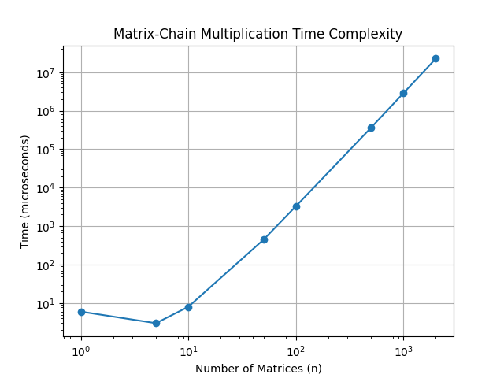
Complexity Analysis:
- Time Complexity: The time complexity of the matrix-chain multiplication algorithm is , which explains the exponential increase in execution time as observed in the plot.
- Space Complexity: The space complexity is , reflecting the storage required for the dynamic programming tables used in the computation.

