
Ex.No: 5 | Implementation of Longest Common Subsequence Algorithm with experiments on analysis and efficiency. You have to print the length of the longest sequence and sequence of the string also | Name : Venkatesan M
Date : 15.09.2024 |  | Reg.No : 22BAI1259

Aim
To implement the Longest Common Subsequence (LCS) algorithm using dynamic programming, analyze its efficiency by measuring execution time for varying input sizes, and visualize the time complexity through a plot.
Algorithm
- Given two sequences X and Y of lengths m and n, we compute the length of the LCS using dynamic programming.
- We initialize a 2D table dp where dp[i][j] holds the length of the LCS of the sequences X[0..i-1] and Y[0..j-1].
- We fill the table using the recurrence relation:
- If X[i-1] == Y[j-1], then dp[i][j] = dp[i-1][j-1] + 1.
- Else, dp[i][j] = max(dp[i-1][j], dp[i][j-1]).
- The length of the LCS is found at dp[m][n].
- To retrieve the LCS, we trace back through the table from dp[m][n] to construct the sequence.
Pseudocode
LCS(X, Y, m, n):
Create a 2D table dp of size (m+1) x (n+1)
for i from 0 to m:
for j from 0 to n:
if i == 0 or j == 0:
dp[i][j] = 0
else if X[i-1] == Y[j-1]:
dp[i][j] = dp[i-1][j-1] + 1
else:
dp[i][j] = max(dp[i-1][j], dp[i][j-1])

# Length of LCS is dp[m][n]

# To retrieve the LCS:
Initialize an empty string LCS_seq
Set i = m, j = n
while i > 0 and j > 0:
if X[i-1] == Y[j-1]:
Add X[i-1] to LCS_seq
i = i - 1, j = j - 1
else if dp[i-1][j] > dp[i][j-1]:
i = i - 1
else:
j = j - 1

return dp[m][n], reverse(LCS_seq)

C++ Implementation
#include <iostream>
#include <vector>
#include <string>
#include <chrono> // Include for timing
#include <cstdlib> // For random character generation

using namespace std;

// Function to find LCS
pair<int, string> LCS(string X, string Y) {
int m = X.size();
int n = Y.size();
vector<vector<int>> dp(m + 1, vector<int>(n + 1, 0));

// Fill dp table
for (int i = 1; i <= m; i++) {
for (int j = 1; j <= n; j++) {
if (X[i - 1] == Y[j - 1])
dp[i][j] = dp[i - 1][j - 1] + 1;
else
dp[i][j] = max(dp[i - 1][j], dp[i][j - 1]);
}
}

// Backtrack to find the LCS
string lcs = "";
int i = m, j = n;
while (i > 0 && j > 0) {
if (X[i - 1] == Y[j - 1]) {
lcs = X[i - 1] + lcs;
i--, j--;
} else if (dp[i - 1][j] > dp[i][j - 1]) {
i--;
} else {
j--;
}
}

return {dp[m][n], lcs};
}

int main() {
vector<int> sizes = {1, 10, 100, 1000, 10000}; // Varying input sizes
vector<long long> times;

for (int n : sizes) {
string X, Y;

// Generate random strings of length n
for (int i = 0; i < n; ++i) {
X += 'A' + rand() % 26; // Random uppercase letters
Y += 'A' + rand() % 26;
}

auto start = chrono::high_resolution_clock::now();
pair<int, string> result = LCS(X, Y);
auto end = chrono::high_resolution_clock::now();

auto duration = chrono::duration_cast<chrono::microseconds>(end - start);
times.push_back(duration.count());

cout << "Input size: " << n << " -> Time: " << duration.count() << " microseconds" << endl;
}

// Output the times to a file for plotting
freopen("lcs_times.txt", "w", stdout);
for (size_t i = 0; i < sizes.size(); ++i) {
cout << sizes[i] << " " << times[i] << endl;
}
fclose(stdout);

return 0;
}

Explanation
- LCS Function: Computes the length of the longest common subsequence and reconstructs the sequence using the dynamic programming table.
- Timing: For each random string pair (with varying lengths), the execution time is measured using chrono::high_resolution_clock.

Random Sampling
- Input sizes: {1, 10, 100, 1000, 10000}.
- Strings X and Y are generated randomly for each input size.

Plotting Time Complexity
Once the times are recorded in the file lcs_times.txt

import matplotlib.pyplot as plt

# Read data from the file
sizes = []
times = []

with open('lcs_times.txt', 'r') as file:
for line in file:
size, time = map(int, line.split())
sizes.append(size)
times.append(time)

# Plotting the results
plt.plot(sizes, times, marker='o')
plt.xscale('log') # Use logarithmic scale for the x-axis
plt.yscale('log') # Use logarithmic scale for the y-axis
plt.title('Longest Common Subsequence Time Complexity')
plt.xlabel('Input Size (n)')
plt.ylabel('Time (microseconds)')
plt.grid(True)
plt.savefig('lcs_time_complexity.png')
plt.show()

Time Complexity Analysis
Input size | Time (microseconds)
1 | 6
10 | 7
100 | 228
1000 | 23283
10000 | 2284478
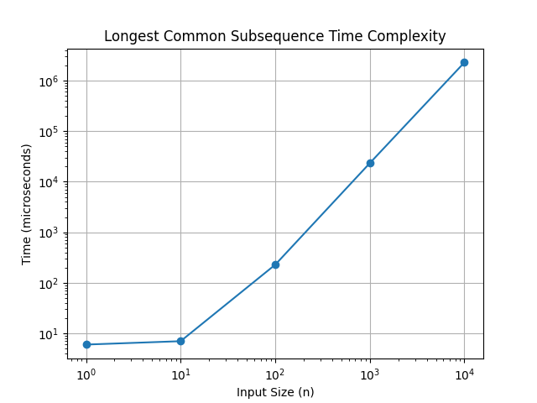
Graph between varying size of inputs and time

Complexity Analysis:

- Time Complexity: The time complexity of the LCS algorithm is , where m and n are the lengths of the two strings.
- Space Complexity: The space complexity is also , due to the 2D DP table used to store intermediate LCS lengths.

