
Ex.No: 2 | Implementation Insertion Sort with experiments on the analysis and the efficiency | Name : Venkatesan M
Date : 25.07.2024 |  | Reg.No : 22BAI1259

Aim
To implement the Insertion Sort algorithm and analyze its time complexity by executing the algorithm for different input sizes and plotting the running time T(n) versus input size n.
Algorithm
Read the number of elements, N.
- Read the data of each element and store them in an array.
- Start from the second element (index 1) to the last element (index N−1).
- For each element:
  - Take the current element as the key.
  - Compare the key with the elements before it (from right to left).
  - Shift each element one position to the right until you find the correct position for the key.
  - Insert the key into its correct position.
- Repeat step 4 for all elements.
- Print the sorted array.
- Measure and print the time taken to execute the sorting process.
Source Code
#include <iostream>
using namespace std;

void InsertionSort(int arr[], int n) {
for (int i = 1; i < n; ++i) {
int key = arr[i];
int j = i - 1;
while (j >= 0 && arr[j] > key) {
arr[j + 1] = arr[j];
j = j - 1;
}
arr[j + 1] = key;
}
}

int main() {
int n;
cout << "Enter the number of elements: ";
cin >> n;

int arr[n];
cout << "Enter the elements: ";
for (int i = 0; i < n; ++i) {
cin >> arr[i];
}

InsertionSort(arr, n);

cout << "Sorted array: ";
for (int i = 0; i < n; ++i) {
cout << arr[i] << " ";
}
cout << endl;

return 0;
}

Sample Input and Output
Sample Input:
Enter the number of elements: 5
Enter the elements: 12 11 13 5 6

Sample Output:
Sorted array: 5 6 11 12 13
Graph Between inputs and time
#include <iostream>
#include <ctime>
#include <cstdlib>
using namespace std;

void InsertionSort(int arr[], int n) {
for (int i = 1; i < n; ++i) {
int key = arr[i];
int j = i - 1;
while (j >= 0 && arr[j] > key) {
arr[j + 1] = arr[j];
j = j - 1;
}
arr[j + 1] = key;
}
}

void measureExecutionTime(int n) {
int arr[n];
for (int i = 0; i < n; ++i) {
arr[i] = rand() % 100;
}

clock_t start = clock();
InsertionSort(arr, n);
clock_t end = clock();

double duration = double(end - start) / CLOCKS_PER_SEC;
cout << "Input size: " << n << ", Time taken: " << duration << " seconds" << endl;
}

int main() {
srand(time(0));
int sizes[] = {10, 100, 1000, 10000, 100000};
for (int size : sizes) {
measureExecutionTime(size);
}
return 0;
}

Timing Output

Input size: 10, Time taken: 1e-06 seconds
Input size: 100, Time taken: 7e-06 seconds
Input size: 1000, Time taken: 0.00054 seconds
Input size: 10000, Time taken: 0.048506 seconds
Input size: 100000, Time taken: 4.54818 seconds
Plotting

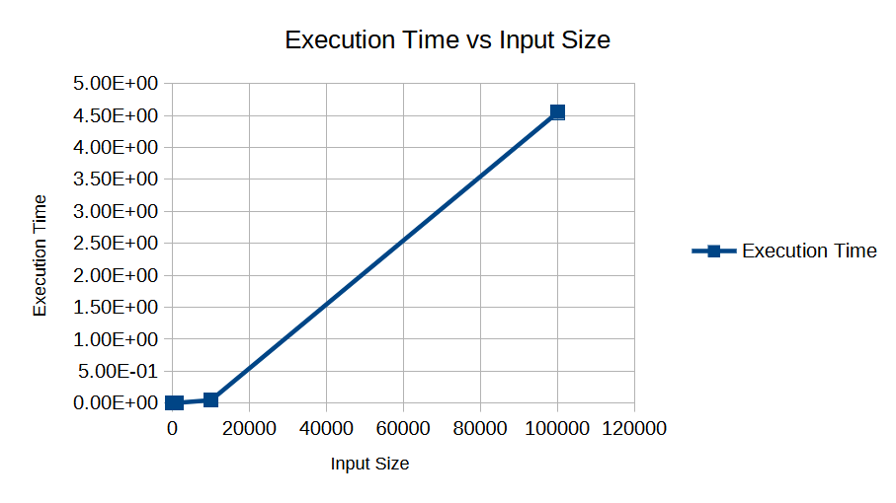
T(n) of Insertion Sort
The running time of the insertion sort algorithm T(n) is given by:
where n is the size of the input, ci are the constants representing the time taken for the respective operations, and tj, is the number of times the while loop is executed for a given input.
Complexity Analysis
Best Case
- In the best-case, the array is already sorted. The time complexity is O(n) because the inner while loop is never executed.

Average Case
- In the average-case, the elements are in random order. The time complexity is O(n^2).

Worst Case
- In the worst-case, the array is sorted in reverse order. The time complexity is O(n^2) because the inner while loop is executed the maximum number of times.
Result
The execution time graph clearly shows that the time complexity of the insertion sort algorithm increases significantly as the input size increases. This confirms the quadratic nature of the insertion sort algorithm's time complexity.

