
Ex.No: 7 | Implementation of Huffman Encoding for the given problem statement. | Name : Venkatesan M
Date : 03.10.2024 |  | Reg.No : 22BAI1259

Aim
To implement Huffman Encoding on the given alphabet Σ={a,g,h,i,l,m,o,r,t} with corresponding frequencies to compute an optimal prefix-free code and represent the result as a binary tree. The expected encoding length (average number of bits per element) will also be calculated.

Algorithm
The Huffman's problem is solved using Greedy Algorithm.
Input: A set of characters and their corresponding frequencies.
Create a Priority Queue (min-heap): Each character is treated as a leaf node with its frequency being the weight.
Build the Huffman Tree:
Extract two nodes with the lowest frequencies.
Create a new internal node with these two nodes as children and the sum of their frequencies as the new node's frequency.
Insert this new node back into the heap.
Repeat until only one node remains (the root of the tree).
Assign binary codes: Traverse the tree from the root. Assign a '0' for left traversal and '1' for right traversal.
Output the codes for each character and the expected encoding length.
Pseudocode
function HuffmanEncoding(frequencies):
priorityQueue = initializePriorityQueue(frequencies)
while size of priorityQueue > 1:
leftNode = priorityQueue.extractMin()
rightNode = priorityQueue.extractMin()

mergedNode = createNode(leftNode, rightNode)
priorityQueue.insert(mergedNode)

root = priorityQueue.extractMin()
return buildHuffmanTree(root)

function buildHuffmanTree(root):
assignBinaryCode(root, "")
return binaryCodes

function assignBinaryCode(node, currentCode):
if node is leaf:
storeBinaryCode(node.character, currentCode)
else:
assignBinaryCode(node.left, currentCode + "0")
assignBinaryCode(node.right, currentCode + "1")

function expectedEncodingLength(frequencies, codes):
length = 0
for each character:
length += frequencies[character] * lengthOf(codes[character])
return length
C++ Implementation

#include <iostream>
#include <queue>
#include <unordered_map>
#include <vector>

using namespace std;

// Node structure for Huffman Tree
struct Node {
char ch;
float freq;
Node *left, *right;

Node(char ch, float freq) : ch(ch), freq(freq), left(nullptr), right(nullptr) {}
};

// Custom comparator for priority queue
struct Compare {
bool operator()(Node* l, Node* r) {
return l->freq > r->freq;
}
};

// Recursively build and assign codes
void assignCodes(Node* root, string code, unordered_map<char, string>& huffmanCode) {
if (!root) return;
if (!root->left && !root->right) huffmanCode[root->ch] = code;

assignCodes(root->left, code + "0", huffmanCode);
assignCodes(root->right, code + "1", huffmanCode);
}

// Huffman encoding algorithm
void huffmanEncoding(vector<char>& letters, vector<float>& frequencies) {
priority_queue<Node*, vector<Node*>, Compare> pq;

for (int i = 0; i < letters.size(); i++) {
pq.push(new Node(letters[i], frequencies[i]));
}

while (pq.size() != 1) {
Node* left = pq.top(); pq.pop();
Node* right = pq.top(); pq.pop();

float sum = left->freq + right->freq;
Node* newNode = new Node('\0', sum);
newNode->left = left;
newNode->right = right;

pq.push(newNode);
}

Node* root = pq.top();
unordered_map<char, string> huffmanCode;
assignCodes(root, "", huffmanCode);

cout << "Huffman Codes:\n";
for (auto pair : huffmanCode) {
cout << pair.first << ": " << pair.second << "\n";
}

// Calculate expected encoding length
float expectedLength = 0;
for (int i = 0; i < letters.size(); i++) {
expectedLength += frequencies[i] * huffmanCode[letters[i]].length();
}

cout << "Expected Encoding Length: " << expectedLength << "\n";
}

int main() {
vector<char> letters = {'a', 'g', 'h', 'i', 'l', 'm', 'o', 'r', 't'};
vector<float> frequencies = {0.14, 0.06, 0.10, 0.17, 0.07, 0.11, 0.10, 0.08, 0.17};

huffmanEncoding(letters, frequencies);
return 0;
}

Explanation
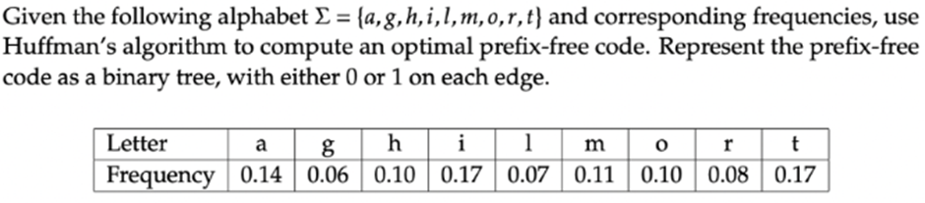

Huffman Codes:

i: 110

a: 101

l: 1001

t: 111

g: 1000

m: 011

o: 010

h: 001

r: 000

Expected Encoding Length: 3.13
Random Sampling
#include <iostream>
#include <queue>
#include <unordered_map>
#include <vector>
#include <chrono>
#include <fstream>
#include <cstdlib> // for rand() and srand()
#include <ctime> // for time()

using namespace std;

// Node structure for Huffman Tree
struct Node {
char ch;
float freq;
Node *left, *right;

Node(char ch, float freq) : ch(ch), freq(freq), left(nullptr), right(nullptr) {}
};

// Custom comparator for priority queue
struct Compare {
bool operator()(Node* l, Node* r) {
return l->freq > r->freq;
}
};

// Recursively build and assign codes
void assignCodes(Node* root, string code, unordered_map<char, string>& huffmanCode) {
if (!root) return;
if (!root->left && !root->right) huffmanCode[root->ch] = code;

assignCodes(root->left, code + "0", huffmanCode);
assignCodes(root->right, code + "1", huffmanCode);
}

// Huffman encoding algorithm
void huffmanEncoding(vector<char>& letters, vector<float>& frequencies) {
priority_queue<Node*, vector<Node*>, Compare> pq;

for (int i = 0; i < letters.size(); i++) {
pq.push(new Node(letters[i], frequencies[i]));
}

while (pq.size() != 1) {
Node* left = pq.top(); pq.pop();
Node* right = pq.top(); pq.pop();

float sum = left->freq + right->freq;
Node* newNode = new Node('\0', sum);
newNode->left = left;
newNode->right = right;

pq.push(newNode);
}

Node* root = pq.top();
unordered_map<char, string> huffmanCode;
assignCodes(root, "", huffmanCode);
}

// Function to generate random letters and frequencies
void generateRandomInput(int size, vector<char>& letters, vector<float>& frequencies) {
srand(time(0)); // Seed for randomness
for (int i = 0; i < size; i++) {
char letter = 'a' + (rand() % 26); // Random letter from a-z
float frequency = static_cast <float> (rand()) / static_cast <float> (RAND_MAX); // Random frequency
letters.push_back(letter);
frequencies.push_back(frequency);
}
}

int main() {
ofstream out("huffman_times.txt", ios::app);

for (int size = 5; size <= 100; size += 5) { // Varying input sizes from 5 to 100
vector<char> letters;
vector<float> frequencies;

// Generate random input
generateRandomInput(size, letters, frequencies);

auto start = chrono::high_resolution_clock::now();

// Run Huffman encoding
huffmanEncoding(letters, frequencies);

auto end = chrono::high_resolution_clock::now();
chrono::duration<double> elapsed = end - start;

out << size << " " << elapsed.count() << "\n"; // Save input size and time taken
cout << "Input size: " << size << ", Time taken: " << elapsed.count() << " seconds\n";
}

out.close();
return 0;
}

Time Complexity Analysis
Input size | Time (microseconds)
10 | 1.235e-05
100 | 0.00011403
1000 | 0.00126255
10000 | 0.0162262
100000 | 0.251076
Graph between varying size of inputs and time
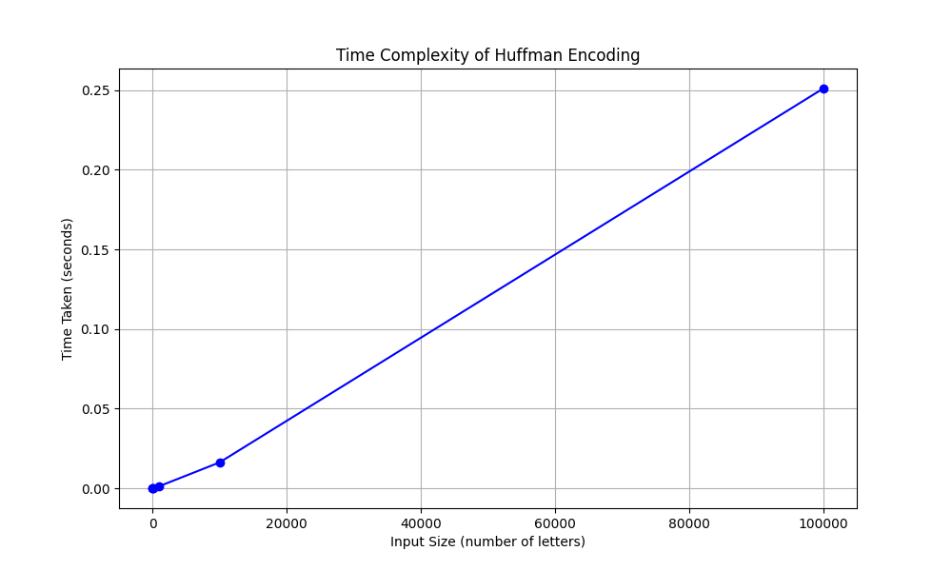
Complexity Analysis:
Building the Huffman Tree: Constructing the tree requires operations, where n is the number of characters (because inserting into the priority queue takes time, and we do this n−1 times).
Assigning Codes: Traversing the tree to assign binary codes takes .
Total Time Complexity: The total time complexity of Huffman Encoding is .

