
Ex.No: 9 | Implementation of Rabin-Karp algorithm. | Name : Venkatesan M
Date : 24.10.2024 | Implementation of Rabin-Karp algorithm. | Reg.No : 22BAI1259

Aim
The goal is to implement the Rabin-Karp algorithm for string matching in C++. We will use the Rabin-Karp algorithm to find the occurrences of a pattern P in a given text T using a rolling hash technique. The algorithm works modulo a prime number q. Additionally, we will analyze the number of spurious hits encountered and measure the time taken to execute the algorithm on different input sizes.
Working modulo q = 11, how many spurious hits does the Rabin-Karp matcher encounter in the text T= 3141592653589793 when looking for the pattern P=26?
Algorithm
Hash Calculation: The algorithm computes the hash value for the pattern and the initial segment of the text. It uses a rolling hash function to efficiently update the hash values for subsequent segments of the text.
Pattern Matching: If the hash values of the current segment of the text and the pattern are equal, it performs a direct comparison to check if the actual strings match (this step helps identify spurious hits).
Spurious Hits Counting: If the hash values match but the strings do not, it counts it as a spurious hit.
Sliding the Window: The algorithm slides the pattern over the text one character at a time, updating the hash value using a rolling hash function.
Pseudocode
1. Input: Pattern P, Text T, Prime number q, Length of P (m), Length of T (n)
2. Compute hash(P) and hash(T) for the first m characters
3. Set spurious_hits = 0
4. for i = 0 to n - m
a. If hash(P) == hash(T) then
i. If P == T[i:i+m], then print "Pattern found at index i"
ii. Else, increment spurious_hits
b. Update hash(T) for the next window
5. Output the number of spurious_hits
C++ Implementation

#include <iostream>
#include <string>
#include <cmath>
#include <chrono>
#include <fstream>

using namespace std;

// Rabin-Karp Algorithm
int rabinKarpMatcher(const string &T, const string &P, int q) {
int n = T.length();
int m = P.length();
int d = 10; // The number of characters in the input alphabet (0-9 for digits)
int h = 1; // The value of d^(m-1)
int pHash = 0; // Hash value for pattern
int tHash = 0; // Hash value for text
int spuriousHits = 0;

// Precompute h = d^(m-1) % q
for (int i = 0; i < m - 1; i++) {
h = (h * d) % q;
}

// Compute initial hash values for pattern and text
for (int i = 0; i < m; i++) {
pHash = (d * pHash + P[i]) % q;
tHash = (d * tHash + T[i]) % q;
}

// Slide the pattern over text one by one
for (int i = 0; i <= n - m; i++) {
// Check if the hash values are the same
if (pHash == tHash) {
// Verify the actual characters match
if (T.substr(i, m) == P) {
cout << "Pattern found at index " << i << endl;
} else {
// Count spurious hits if hash matches but pattern does not
spuriousHits++;
}
}

// Calculate hash value for the next window of text
if (i < n - m) {
tHash = (d * (tHash - T[i] * h) + T[i + m]) % q;
if (tHash < 0) {
tHash = (tHash + q);
}
}
}

return spuriousHits;
}

int main() {
string T = "3141592653589793";
string P = "26";
int q = 11; // Prime number for modulo

// Measure time
auto start = chrono::high_resolution_clock::now();
int spuriousHits = rabinKarpMatcher(T, P, q);
auto end = chrono::high_resolution_clock::now();
chrono::duration<double> elapsed = end - start;

// Output the number of spurious hits and time taken
cout << "Number of spurious hits: " << spuriousHits << endl;
cout << "Time taken: " << elapsed.count() << " seconds" << endl;

// Save results to file for graph plotting
ofstream out("rabin_karp_times.txt", ios::app);
out << T.length() << " " << elapsed.count() << "\n";
out.close();

return 0;
}

Explanation

Pattern found at index 6

Number of spurious hits: 3

Time taken: 5.3031e-05 seconds
Random Sampling
#include <iostream>
#include <string>
#include <chrono>
#include <fstream>
#include <cstdlib>
#include <ctime>

using namespace std;

// Rabin-Karp Algorithm
int rabinKarpMatcher(const string &T, const string &P, int q) {
int n = T.length();
int m = P.length();
int d = 10; // The number of characters in the input alphabet (0-9 for digits)
int h = 1; // The value of d^(m-1)
int pHash = 0; // Hash value for pattern
int tHash = 0; // Hash value for text
int spuriousHits = 0;

// Precompute h = d^(m-1) % q
for (int i = 0; i < m - 1; i++) {
h = (h * d) % q;
}

// Compute initial hash values for pattern and text
for (int i = 0; i < m; i++) {
pHash = (d * pHash + P[i]) % q;
tHash = (d * tHash + T[i]) % q;
}

// Slide the pattern over text one by one
for (int i = 0; i <= n - m; i++) {
// Check if the hash values are the same
if (pHash == tHash) {
// Verify the actual characters match
if (T.substr(i, m) == P) {
// Pattern found
} else {
// Count spurious hits if hash matches but pattern does not
spuriousHits++;
}
}

// Calculate hash value for the next window of text
if (i < n - m) {
tHash = (d * (tHash - T[i] * h) + T[i + m]) % q;
if (tHash < 0) {
tHash = (tHash + q);
}
}
}

return spuriousHits;
}

// Function to generate random text of given length
string generateRandomText(int length) {
string text;
for (int i = 0; i < length; i++) {
text += '0' + rand() % 10; // Random digit between 0 and 9
}
return text;
}

int main() {
srand(time(0));
ofstream out("rabin_karp_times.txt");

// Pattern to search for
string P = "26";
int q = 11; // Prime number for modulo

// Varying input sizes
for (int length = 1000; length <= 10000; length += 1000) {
// Generate random text
string T = generateRandomText(length);

// Measure time
auto start = chrono::high_resolution_clock::now();
int spuriousHits = rabinKarpMatcher(T, P, q);
auto end = chrono::high_resolution_clock::now();
chrono::duration<double> elapsed = end - start;

// Output the number of spurious hits and time taken
cout << "Text length: " << length << ", Time taken: " << elapsed.count() << " seconds, Spurious hits: " << spuriousHits << endl;

// Save results to file for graph plotting
out << length << " " << elapsed.count() << "\n";
}

out.close();
return 0;
}
Plotting
import matplotlib.pyplot as plt

# Read data from file
input_sizes = []
times = []

with open("rabin_karp_times.txt", "r") as file:
for line in file:
size, time = line.split()
input_sizes.append(int(size))
times.append(float(time))

# Plotting
plt.figure(figsize=(10, 6))
plt.plot(input_sizes, times, marker='o', linestyle='-', color='b')
plt.title('Time Complexity of Rabin-Karp Algorithm')
plt.xlabel('Input Size (length of text)')
plt.ylabel('Time Taken (seconds)')
plt.grid(True)

# Save the plot as a PNG file
plt.savefig("rabin_karp_time_complexity.png")

# Show the plot
plt.show()
Time Complexity Analysis
Input size | Time (microseconds)
1000 | 1.561e-05
2000 | 2.758e-05
3000 | 4.099e-05
4000 | 5.177e-05
5000 | 6.813e-05
Graph between varying size of inputs and time
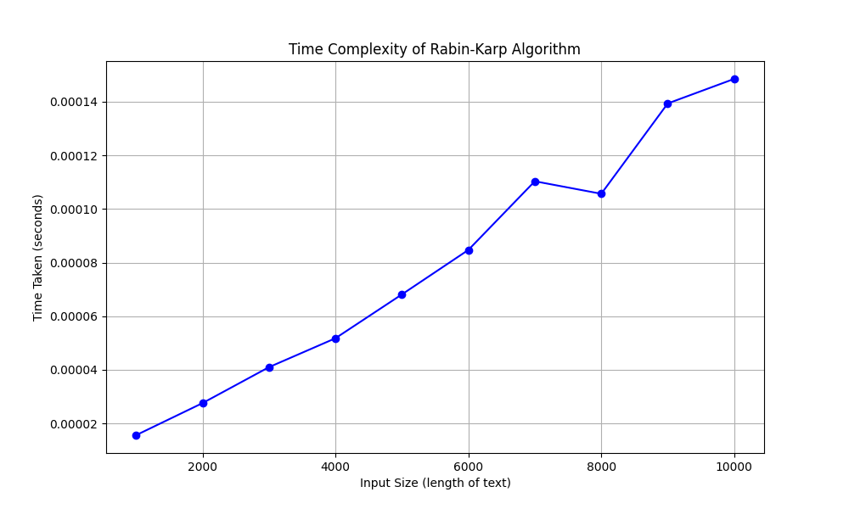
Complexity Analysis:
Preprocessing: Calculating the initial hash values takes O(m), where m is the length of the pattern.
- Pattern Matching: The matching loop executes n−m+1 times, where n is the length of the text. In each iteration, updating the hash value takes O(1), making the overall complexity O(n).
- Verification: In the worst case, all hash matches might require O(m) character comparisons.
Thus, the average case time complexity is O(n+m), while the worst case, considering spurious hits, could be O(nm).

