HandRehab-AI: Monitoring Hand Recovery Using Patient Diaries and Computer Vision

A PROJECT REPORT

Submitted by

NAME OF THE CANDIDATE(S)

in partial fulfillment for the award of the degree
of

BACHELOR OF TECHNOLOGY

in
COMPUTER SCIENCE AND ENGINEERING
(Artificial Intelligence and Data Analytics)

SRI RAMACHANDRA FACULTY OF ENGINEERING AND TECHNOLOGY

OCTOBER 2026

SRI RAMACHANDRA FACULTY OF ENGINEERING AND TECHNOLOGY
CHENNAI – 600116

BONAFIDE CERTIFICATE

Certified that this project report "HandRehab-AI: Monitoring Hand Recovery Using Patient Diaries and Computer Vision" is the bonafide work of the candidate(s) who carried out the project work under my supervision in ADA23DLU04 – Natural Language Processing Laboratory.

SIGNATURE
DR. SUJA GOLDEN SHINY S,
ASSISTANT PROFESSOR,
DEPARTMENT OF COMPUTER SCIENCE AND ENGINEERING (AIDA),
SRI RAMACHANDRA FACULTY OF ENGINEERING AND TECHNOLOGY,
SRI RAMACHANDRA INSTITUTE OF HIGHER EDUCATION AND RESEARCH,
PORUR, CHENNAI - 600 116.

EVALUATION DATE:

INTERNAL EXAMINER EXTERNAL EXAMINER

ACKNOWLEDGEMENT
We express our sincere gratitude to our respected Dean, Vice-Dean, and Head of the Department of Computer Science and Engineering (Artificial Intelligence and Data Analytics) at Sri Ramachandra Faculty of Engineering and Technology for providing the research infrastructure and academic environment to pursue this work.
We extend our heartfelt gratitude to our project supervisor and course faculty, Dr. Suja Golden Shiny S., Assistant Professor, Department of Computer Science and Engineering (AIDA), for her invaluable guidance, constant encouragement, constructive suggestions, and continuous support throughout the development and evaluation of this project in the Natural Language Processing Laboratory.
We also thank the faculty members, technical staff, and our peers for their helpful feedback and assistance.

TABLE OF CONTENTS
CHAPTER NO. | TITLE |  |  | PAGE NO.
 | ABSTRACT |  |  | v
 | LIST OF TABLE |  |  | vi
 | LIST OF FIGURES |  |  | vii
 | LIST OF SYMBOLS |  |  | viii
1. | INTRODUCTION |  |  | 1
 | 1.1 | Project overview |  | 2
 | 1.2 | Problem Statement |  | 4
 | 1.3 | Objectives |  | 4
 | 1.4 | Scope of Work (or) Social Contribution |  | 5
2. | LITERATURE REVIEW |  |  | 6
 | 2.1 | Background |  | 6
 |  | 2.1.1 | Review of related works | 7
 | 2.2 | Research Gaps |  | 8
3. | PROPOSED METHODOLOGY |  |  | 9
 | 3.1 | Architecture in Nutshell |  | 9
 |  | 3.1.1 | Dataset Description and Exploratory Analysis | 12
 |  | 3.1.2 | Negation-Preserving Preprocessing Pipeline | 16
 | 3.2 | Hardware Specifications |  | 18
 | 3.3 | Software Specifications |  | 20
4. | PERFORMANCE EVALUATION |  |  | 21
 | 4.1 | Evaluation Metrics |  | 22
 | 4.2 | Results and Analysis |  | 23
5. | CONCLUSION AND FUTURE WORK |  |  | 24
 | 5.1 | Summary of the contributions |  | 24
 | 5.2 | Future work |  | 25

ABSTRACT

Hand rehabilitation after surgery or injury requires regular monitoring of symptoms, movement, and recovery progress. However, manually tracking patient diary entries and identifying changes in recovery can be time-consuming. This project presents HandRehab AI, an artificial intelligence-based hand rehabilitation recovery monitoring system that combines Natural Language Processing (NLP), deep learning, and browser-based hand movement tracking to support recovery monitoring. The main engineering challenge addressed is extracting meaningful information from patient-written diary entries and analysing recovery trends over time. The NLP component uses text preprocessing and GloVe and FastText word embeddings to represent textual information. Recurrent Neural Network (RNN), Long Short-Term Memory (LSTM), Gated Recurrent Unit (GRU), and Bidirectional Long Short-Term Memory (BiLSTM) models are compared for diary text classification. The BiLSTM classifier incorporates an attention mechanism to identify relevant contextual information and classify symptom severity related to pain, stiffness, mobility, and grip. Token-level occlusion attribution is also used to help interpret the influence of words on model predictions. The system includes LSTM- and GRU-based models for recovery trend forecasting using simulated recovery data to examine patterns such as recovery plateaus and possible relapse. MediaPipe Tasks Vision enables browser-based hand landmark tracking to estimate range of motion and count repetitions. The application is developed using Python, PyTorch, Flask, SQLite, HTML, CSS, and JavaScript, with a dashboard for recording and visualising rehabilitation progress. The integrated system brings diary analysis, recovery trend estimation, and movement monitoring into a single platform. It can help organise rehabilitation information and present recovery summaries for patients and physiotherapists to review.

CHAPTER 1

INTRODUCTION

1.1. Project Overview
Advancements in Artificial Intelligence (AI) are opening up new possibilities for improving how healthcare information is analysed and monitored. One area that can benefit from these developments is post-surgical rehabilitation, particularly hand rehabilitation, where recovery involves gradual improvements in finger movement, flexibility, and functional ability. Procedures such as flexor tendon repair often require patients to follow prescribed exercise programmes and maintain records of their symptoms over several weeks. Monitoring these changes consistently is important for understanding how recovery progresses over time.
A major challenge in rehabilitation monitoring is that patient feedback is often recorded as unstructured diary entries rather than measurable data. Descriptions of pain, stiffness, mobility difficulties, and grip limitations may contain useful information, but manually interpreting and comparing these entries over several weeks can be time-consuming. Natural Language Processing (NLP) provides a way to analyse such text and convert it into structured information. When combined with deep learning, it can help identify symptom severity from the context of a patient's written description.
HandRehab AI applies these technologies to develop an integrated hand rehabilitation monitoring prototype. It analyses daily diary entries and predicts severity scores for pain, stiffness, mobility limitation, and grip limitation on a scale from 0 to 3. Several machine learning and neural network models are evaluated to compare their classification performance, while a BiLSTM model with an attention mechanism is used to capture contextual information in diary text. Token-level occlusion attribution provides additional insight into how individual words influence predictions.
The project extends beyond text analysis by incorporating browser-based hand tracking through MediaPipe Tasks Vision. Hand landmarks are used to estimate range of motion (ROM) and count exercise repetitions. These measurements can be viewed alongside diary-based symptom scores through a dashboard developed using Flask, SQLite, HTML, CSS, JavaScript, and Chart.js. Recurrent models also analyse simulated recovery sequences to forecast next-day values and identify patterns associated with possible recovery plateaus or relapses.

The importance of this approach lies in bringing written symptom records, movement measurements, and recovery trends together within a single platform. Rather than requiring users to review separate records manually, HandRehab AI presents rehabilitation-related information in a structured and visual format that patients and physiotherapists can review. The current implementation is a research prototype: its diary and trend experiments use synthetic data and have not been clinically validated. Therefore, its predictions are intended for monitoring and research purposes, not for diagnosis or as a replacement for professional physiotherapy assessment.

1.2 Problem Statement
Monitoring recovery after hand surgery requires tracking several factors, including pain, stiffness, finger mobility, grip function, and range of motion (ROM). However, the information needed to understand recovery is often recorded in different forms, such as daily patient diaries and movement measurements. Reviewing these records manually can be time-consuming, making it difficult to compare daily changes, identify patterns, and maintain a consistent overview of rehabilitation progress.
One of the main challenges is that rehabilitation diary entries are written in natural language and vary between patients. Individuals may describe the same symptom using different words or mention multiple symptoms within a single sentence. For example, an entry may indicate that pain has decreased while finger stiffness continues. Extracting these details and converting them into consistent severity scores requires an approach that can interpret textual context rather than rely only on individual keywords.
Another challenge is the lack of integration between diary-based symptom analysis and movement monitoring. Symptom descriptions and hand movement measurements are often considered separately, making it difficult to view them together over time. In addition, identifying changes such as a recovery plateau or a possible relapse requires systematic analysis of previous records and trends.
The primary target users of HandRehab AI are patients undergoing hand rehabilitation after surgery or injury and physiotherapists who monitor their recovery progress. Patients can use the system to record daily symptoms, track hand movement, and review changes in their rehabilitation records. Physiotherapists can use the organised symptom scores, movement measurements, and recovery trend visualisations to review patient-reported progress. The system may also be useful to researchers and developers exploring the application of Natural Language Processing and deep learning in rehabilitation monitoring.
HandRehab AI aims to address these challenges by developing an integrated system that automatically analyses rehabilitation diary entries, predicts severity scores for pain, stiffness, mobility limitation, and grip limitation, and combines this information with hand movement measurements. It also incorporates recovery trend forecasting and visual dashboards to present daily records and changes over time in an organised format. By bringing these functions together, the project seeks to reduce the effort involved in reviewing rehabilitation information and make recovery patterns easier to monitor.

1.3 Objectives
The primary objective of HandRehab AI is to develop an integrated hand rehabilitation monitoring system that combines Natural Language Processing, deep learning, recovery trend forecasting, and browser-based hand movement tracking. The specific objectives are:
- To design and develop an NLP-based diary classification system that predicts four symptom severity scores: pain, stiffness, mobility limitation, and grip limitation, using a scale ranging from 0 to 3.
- To implement and compare multiple classification models, including TF-IDF with Logistic Regression, Simple RNN, LSTM, GRU, BiLSTM, and BiLSTM with attention, to evaluate their performance on rehabilitation diary entries.
- To incorporate GloVe word embeddings and text preprocessing techniques to convert written diary entries into numerical representations suitable for machine learning and deep learning models.
- To implement token-level occlusion attribution to identify words that influence symptom severity predictions and improve the interpretability of the classification results.
- To develop a recovery trend forecasting module using recurrent neural networks to estimate next-day recovery measurements and identify patterns associated with recovery plateaus and possible relapses.
- To integrate MediaPipe Tasks Vision for browser-based hand landmark detection, range-of-motion (ROM) estimation, and exercise repetition counting.
- To develop a Flask-based web application with SQLite database integration for managing rehabilitation records and presenting symptom scores, movement measurements, and recovery trends.
- To evaluate the implemented models using appropriate classification and forecasting metrics, including accuracy, macro-F1 score, mean absolute error (MAE), and root mean squared error (RMSE), to compare their performance across the available evaluation datasets.
- To provide an interactive dashboard with visual summaries of rehabilitation records, enabling patients and physiotherapists to review symptom changes, movement measurements, and estimated recovery trends in one place.

1.4 Scope of Work
The scope of HandRehab AI covers the development of an integrated software system for monitoring hand rehabilitation through diary analysis, movement tracking, and recovery trend estimation. The project focuses on combining Natural Language Processing (NLP), machine learning, deep learning, and browser-based computer vision within a single web application.
The diary analysis component includes the generation and validation of a synthetic rehabilitation diary dataset with token-level BIO annotations, text preprocessing, and GloVe word embeddings. Six classification approaches are evaluated for predicting four symptom severity categories: pain, stiffness, mobility limitation, and grip limitation. The severity of each category is represented on a scale from 0 to 3. Token-level occlusion attribution is incorporated to examine the influence of individual words on classification predictions.
The project also covers recovery trend analysis using recurrent neural network models. This component uses simulated rehabilitation sequences to forecast next-day measurements and classify recovery patterns, including normal progress, plateau, and possible relapse. Model performance is assessed using classification metrics and forecasting error measures. The system further incorporates MediaPipe Tasks Vision for browser-based hand landmark tracking, range-of-motion (ROM) estimation, and exercise repetition counting.

The application is developed using Python, PyTorch, Flask, SQLite, HTML, CSS, and JavaScript. Chart.js is used to visualise rehabilitation measurements and recovery trends through a dashboard. The system supports the recording and organisation of daily rehabilitation information, presentation of model predictions, and review of symptom and movement changes over time.
The current phase is limited to an English-language, locally running prototype. The diary classification and recovery trend experiments use synthetic data, while a separate held-out hand-written diary set is used to examine classification performance on manually written entries. The project does not include the collection of real patient data, clinical validation, diagnosis, treatment recommendations, voice-based input, support for languages other than English, a multi-user clinician portal, or deployment on a public server. The system is intended to organise rehabilitation information and support progress review rather than replace professional assessment by a physiotherapist.

CHAPTER 2
LITERATURE REVIEW
2.1 Background
Hand rehabilitation monitoring is an important application area where Artificial Intelligence (AI) can help organise patient-reported symptoms and movement-related information. During rehabilitation after hand surgery or injury, patients may record daily experiences involving pain, stiffness, mobility, and grip difficulties. These diary entries are written in natural language, making it challenging to convert them into consistent severity measurements and analyse changes over time. Natural Language Processing (NLP) and deep learning provide techniques for extracting structured information from such text.
Word embeddings such as Global Vectors for Word Representation (GloVe) convert words into numerical vectors that can be processed by machine learning models. Recurrent neural networks (RNNs), Long Short-Term Memory (LSTM), Gated Recurrent Unit (GRU), and Bidirectional LSTM (BiLSTM) architectures learn sequential and contextual patterns in text. Attention mechanisms further allow models to assign different weights to contextual representations during classification. These techniques are relevant to HandRehab AI because the meaning of a symptom description can depend on surrounding words, negation, and severity expressions.
Explainable AI techniques can help investigate the words that influence a model's predictions. In addition, computer vision frameworks such as MediaPipe can detect hand landmarks from camera images, supporting movement-related measurements. Recurrent forecasting models can analyse sequences of symptom and movement values to estimate future trends. HandRehab AI brings these approaches together to develop a software prototype for diary-based symptom severity classification, recovery trend analysis, and browser-based hand movement monitoring.

2.1.1 Review of related works
1. Pennington, Socher, and Manning (2014) – GloVe: Global Vectors for Word Representation
According to Pennington et al. (2014), GloVe learns word representations from global word–word co-occurrence statistics, producing vectors that capture useful semantic and syntactic relationships. This work provides the foundation for the word embedding component of HandRehab AI. The project uses pretrained 100-dimensional GloVe embeddings to represent diary words numerically before classification. However, general-purpose embeddings do not independently identify symptom severity or interpret negation; these distinctions must be handled by the text processing and classification pipeline.

2. Hochreiter and Schmidhuber (1997) – Long Short-Term Memory
Hochreiter and Schmidhuber (1997) introduced the LSTM architecture to address the difficulty of learning long-range dependencies in conventional recurrent neural networks. LSTM uses gated memory cells to control the retention and updating of information across a sequence. This capability is relevant to rehabilitation diary classification, where the interpretation of a symptom may depend on words appearing elsewhere in the sentence. HandRehab AI includes LSTM among its evaluated text classification models and uses recurrent modelling in its recovery trend component.

3. Cho et al. (2014) – Learning Phrase Representations Using RNN Encoder–Decoder for Statistical Machine Translation
Cho et al. (2014) proposed an RNN encoder–decoder framework and introduced a gated recurrent unit formulation for sequence modelling. GRU uses update and reset gates to control information flow without the separate cell state employed by LSTM. This architecture provides a relevant alternative for learning sequential patterns from rehabilitation diary entries and recovery measurements. HandRehab AI evaluates GRU alongside other neural models to compare classification and forecasting performance on its available datasets.

4. Schuster and Paliwal (1997) – Bidirectional Recurrent Neural Networks
Schuster and Paliwal (1997) described bidirectional recurrent neural networks that process a sequence in both forward and backward directions. This enables each position to be represented using information from both preceding and following context. The approach is relevant to diary analysis because surrounding words can change the meaning of symptom descriptions, particularly when patients express negation or contrast between symptoms. HandRehab AI applies this principle through a BiLSTM classifier for predicting pain, stiffness, mobility limitation, and grip limitation severity.

5. Bahdanau, Cho, and Bengio (2015) – Neural Machine Translation by Jointly Learning to Align and Translate
Bahdanau et al. (2015) introduced an attention mechanism that allows a neural network to assign different importance to input positions when generating an output. Rather than depending entirely on one fixed-length representation, the model can use information from different parts of the input sequence. This concept is relevant to HandRehab AI because a diary entry may contain several symptom descriptions, with some words contributing more information to classification than others. The project incorporates attention into its BiLSTM classifier to learn weighted contextual representations.

6. Yang et al. (2016) – Hierarchical Attention Networks for Document Classification
Yang et al. (2016) proposed hierarchical attention networks that apply attention at the word and sentence levels for document classification. Their research demonstrated how attention can help construct text representations and identify informative parts of a document. This work provides relevant background for the attention mechanism used in HandRehab AI. However, the project processes short rehabilitation diary entries using a BiLSTM-based attention classifier rather than the hierarchical document architecture proposed in the original study.

7. Kim (2014) – Convolutional Neural Networks for Sentence Classification
Kim (2014) investigated convolutional neural networks combined with pretrained word vectors for sentence classification and demonstrated their effectiveness on several text classification benchmarks. Although HandRehab AI does not use a convolutional text classifier in its reported comparison, this study demonstrates how pretrained embeddings can be combined with neural architectures to classify text. It also provides a useful reference for considering alternative architectures in future development.

8. Jain and Wallace (2019) – Attention Is Not Explanation
Jain and Wallace (2019) investigated whether attention weights provide faithful explanations of neural NLP predictions. Their findings showed that attention distributions do not always correspond reliably to other measures of feature importance. This research is relevant to HandRehab AI because its BiLSTM classifier incorporates attention, but attention weights alone are not treated as definitive explanations. The project also uses token-level occlusion attribution to investigate how removing individual words changes predicted symptom severity.

9. Wiegreffe and Pinter (2019) – Attention Is Not Not Explanation
Wiegreffe and Pinter (2019) revisited the debate about attention-based explanations and argued that the explanatory value of attention depends on how explanations are defined and evaluated. Their work provides a balanced perspective on using attention to interpret neural models. In HandRehab AI, attention contributes to the contextual representation used for classification, while token-level occlusion provides a complementary method for examining the influence of individual words on predictions.

10. Vakunov et al. (2020) – MediaPipe Hands: On-Device Real-Time Hand Tracking
Vakunov et al. (2020) presented MediaPipe Hands, a real-time hand-tracking pipeline that estimates hand landmarks from a single camera input. The system combines palm detection and hand landmark prediction to support efficient hand tracking. This research is directly relevant to the movement-monitoring component of HandRehab AI. The project uses MediaPipe Tasks Vision in the browser to detect hand landmarks, estimate range of motion (ROM), and count exercise repetitions. These movement measurements complement the symptom information obtained from diary entries.

Together, these studies provide the methodological foundation for HandRehab AI's main components: word embeddings, recurrent text classification, attention mechanisms, input-based explanations, and camera-based hand tracking. Although the reviewed studies do not collectively present the same rehabilitation monitoring system, their methods support the development of its individual modules.

2.2 Research Gaps
The reviewed studies establish useful methods for text representation, sequence learning, model interpretability, and hand tracking. However, several gaps remain when these techniques are applied to the specific task of hand rehabilitation monitoring.

1. Limited task-specific symptom classification
Most foundational NLP studies focus on general text classification, translation, or document analysis rather than hand rehabilitation diaries. Their findings cannot automatically establish how well models classify pain, stiffness, mobility limitation, and grip limitation. HandRehab AI addresses this gap by evaluating multiple classification models on a four-category symptom severity task, with each category scored from 0 to 3.

2. Difference between synthetic and hand-written diary entries
Models trained on synthetic or template-generated text may not perform equally well on independently written entries. Differences in vocabulary, sentence structure, and symptom descriptions can affect classification results. HandRehab AI evaluates models on both a synthetic test split and a separate held-out hand-written diary set. For example, BiLSTM achieves an overall macro-F1 score of 0.933 on the synthetic test split and 0.546 on the held-out hand-written set. This difference highlights the importance of evaluating models under distinct text conditions.

3. Prevention of data leakage
Repeated diary entries or similar templates appearing in both training and testing data can produce overly optimistic evaluation results. Dataset preparation should therefore account for duplicate text and template overlap. In HandRehab AI, 62 exact duplicates are removed from the 2,500 raw entries, and the reported dataset split has zero train–test template overlap. This provides a more controlled evaluation of model behaviour on distinct examples.

4. Contextual interpretation and prediction explanations
Symptom descriptions may contain negation, severity modifiers, or contrasting information. Models must therefore interpret the surrounding context rather than depend only on symptom keywords. In addition, attention weights do not always provide sufficient evidence about why a prediction was made. HandRehab AI combines contextual modelling through BiLSTM with attention and token-level occlusion attribution to investigate the influence of individual words on predicted severity scores.

5. Separation of symptom analysis and movement monitoring
Diary classification captures patient-reported symptoms, while camera-based hand tracking provides movement-related measurements. When these functions are implemented separately, users may need to review different sources to understand changes in rehabilitation progress. HandRehab AI integrates diary-based symptom severity scores with browser-based ROM estimation and exercise repetition counting, allowing both types of information to be presented through one dashboard.

6. Limited integration of longitudinal recovery forecasting
Classifying individual diary entries does not, by itself, show how symptoms and movement measurements change over several days. Recovery monitoring also requires methods for analysing sequential measurements and estimating future values. HandRehab AI incorporates recurrent trend models to forecast next-day measurements and classify patterns associated with normal progress, plateaus, and possible relapses. The models are compared with simple forecasting baselines to examine their performance on simulated recovery data.

7. Need for a unified monitoring platform
Research on individual NLP or computer vision methods does not necessarily address the practical integration of diary analysis, movement measurements, recovery forecasts, and record management. HandRehab AI combines these functions within a locally running web application using Flask, SQLite, JavaScript, and Chart.js. This integration provides a common interface for viewing symptom predictions, movement measurements, and recovery trends.

In summary, the key research gaps addressed by HandRehab AI involve task-specific symptom classification, evaluation on hand-written diary entries, leakage-aware dataset preparation, interpretable predictions, movement monitoring, and longitudinal trend analysis. The project combines established techniques to investigate these challenges within a unified rehabilitation monitoring prototype.

References
[1] J. Pennington, R. Socher, and C. D. Manning, “GloVe: Global Vectors for Word Representation,” in Proceedings of the 2014 Conference on Empirical Methods in Natural Language Processing (EMNLP), 2014, pp. 1532–1543.

[2] S. Hochreiter and J. Schmidhuber, “Long Short-Term Memory,” Neural Computation, vol. 9, no. 8, pp. 1735–1780, 1997.

[3] K. Cho et al., “Learning Phrase Representations Using RNN Encoder–Decoder for Statistical Machine Translation,” in Proceedings of the 2014 Conference on Empirical Methods in Natural Language Processing (EMNLP), 2014, pp. 1724–1734.

[4] M. Schuster and K. K. Paliwal, “Bidirectional Recurrent Neural Networks,” IEEE Transactions on Signal Processing, vol. 45, no. 11, pp. 2673–2681, 1997.

[5] D. Bahdanau, K. Cho, and Y. Bengio, “Neural Machine Translation by Jointly Learning to Align and Translate,” in Proceedings of the International Conference on Learning Representations (ICLR), 2015.

[6] Z. Yang et al., “Hierarchical Attention Networks for Document Classification,” in Proceedings of the 2016 Conference of the North American Chapter of the Association for Computational Linguistics: Human Language Technologies, 2016, pp. 1480–1489.

[7] Y. Kim, “Convolutional Neural Networks for Sentence Classification,” in Proceedings of the 2014 Conference on Empirical Methods in Natural Language Processing (EMNLP), 2014, pp. 1746–1751.

[8] S. Jain and B. C. Wallace, “Attention Is Not Explanation,” in Proceedings of the 2019 Conference of the North American Chapter of the Association for Computational Linguistics: Human Language Technologies, 2019, pp. 3543–3556.

[9] S. Wiegreffe and Y. Pinter, “Attention Is Not Not Explanation,” in Proceedings of the 2019 Conference on Empirical Methods in Natural Language Processing and the 9th International Joint Conference on Natural Language Processing (EMNLP-IJCNLP), 2019, pp. 11–20.

[10] A. Vakunov et al., “MediaPipe Hands: On-Device Real-Time Hand Tracking,” 2020.

CHAPTER 3
PROPOSED METHODOLOGY
3.1 Architecture in Nutshell
HandRehab AI follows a modular architecture that integrates diary-based symptom classification, recovery trend forecasting, browser-based hand movement tracking, and progress visualisation. The system consists of four main components: the data and preprocessing component, the Natural Language Processing (NLP) component, the recovery monitoring component, and the web application component.
The data component contains the synthetic rehabilitation diary corpus, pretrained GloVe word vectors, and simulated recovery trajectories used for model development and evaluation. The NLP component processes a diary entry and converts it into a sequence of word representations. A recurrent neural network encoder extracts contextual information and passes the resulting representation to four classification heads that estimate severity scores for pain, stiffness, mobility limitation, and grip limitation. Each symptom receives a score from 0 to 3.
The recovery monitoring component analyses recorded symptom scores and range-of-motion (ROM) measurements over a sequence of 14 days. A recurrent trend model predicts the following day's measurements and classifies the recovery pattern as normal recovery, plateau, or possible relapse. The vision component uses MediaPipe Tasks Vision in the browser to detect hand landmarks, estimate finger movement, and count exercise repetitions.
The application component connects these functions through a Flask backend, an SQLite database, and a browser-based interface developed using HTML, CSS, and JavaScript. The dashboard presents symptom predictions, influential words, movement measurements, historical records, and recovery trends. This architecture brings the main functions of rehabilitation monitoring into one software application.
During a typical session, the user enters a rehabilitation diary entry and receives four predicted symptom severity scores. The user can then perform finger flexion and extension exercises in front of a webcam. The vision module estimates movement and counts repetitions, while the application records the session. When sufficient daily history is available, the trend module uses the latest 14-day window to generate a next-day forecast and recovery-status prediction.

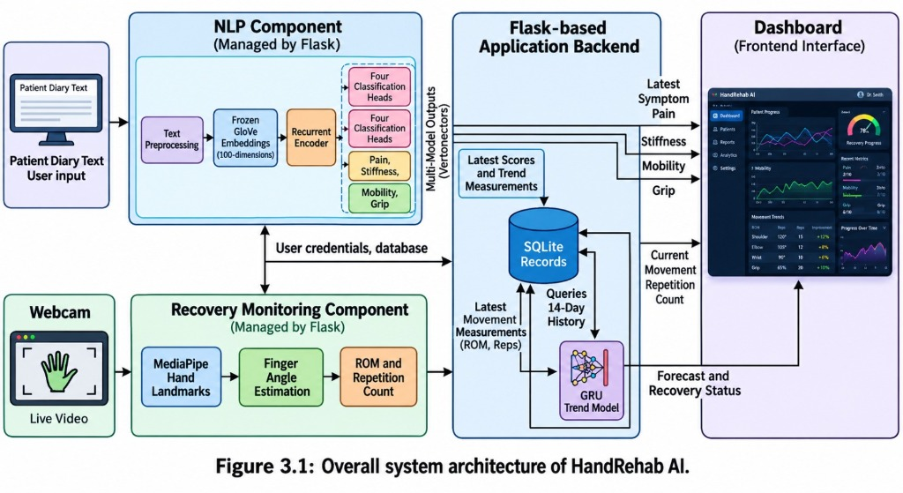
Figure 3.1: Overall system architecture of HandRehab AI.

The architecture diagram should show the diary-processing pathway as:
Patient Diary Text → Text Preprocessing → Frozen GloVe Embedding (100 dimensions) → Recurrent Encoder → Four Classification Heads (Pain, Stiffness, Mobility, Grip) → Dashboard.
The second pathway should show:
Webcam → MediaPipe Hand Landmarks → Finger Angle Estimation → ROM and Repetition Count → SQLite Records → 14-Day History → GRU Trend Model → Forecast and Recovery Status → Dashboard
Both pathways should connect to the Flask-based application.

3.1.1 Dataset Description
HandRehab AI uses a programmatically generated synthetic diary corpus for developing and evaluating the symptom classification models. The corpus contains 2,500 generated entries describing different combinations of pain, stiffness, mobility limitation, and grip limitation. Each symptom is assigned an ordinal severity label ranging from 0 to 3, where 0 represents the absence of the symptom and higher values represent increasing severity.
The diary generator uses a phrase bank containing descriptions associated with the four symptoms and their severity levels. The phrases include expressions of no symptoms, mild discomfort, moderate difficulty, and severe functional limitation. Examples include “no pain noticed”, “a bit tight”, “moderate soreness”, and “cannot make a fist at all”. These phrases are combined into diary-style sentences using connectors such as “but”, “although”, and “on the other hand”. Some entries also include time-related expressions and informal spellings to introduce variation into the generated text.

The generator was configured with a fixed random seed of 42 to support reproducibility. It creates entries that mention different numbers of symptoms, ranging from a single symptom to all four symptoms. Entries representing full recovery are also included. When a symptom is not mentioned, its assigned severity is 0. The corpus therefore supports multi-output classification, in which one diary entry produces four separate severity predictions.
The generated dataset initially contained 2,500 entries. After exact duplicate texts were removed, 2,438 unique entries remained. The entries were grouped according to their template signatures, derived from the sequence of non-outside BIO tags associated with each entry. The grouped data were divided into training, validation, and testing sets containing 1,784, 341, and 313 entries, respectively. Group-based splitting was used to prevent entries with the same template signature from appearing in different partitions. The dataset preparation process also checked for exact text overlap and template overlap between the partitions.
A separate set of 62 hand-written diary entries was prepared to evaluate performance on text that differs from the generated phrase templates. These entries contain more varied expressions, including negation, contrasting symptoms, and descriptive language. For example, a diary entry may report an absence of pain while describing stiffness that continues to restrict finger movement. Each entry has four severity labels and is kept separate from model training and model selection.
The corpus was examined to ensure that all four severity classes were represented for each symptom. Class 0 accounts for approximately 45% to 49% of the labels, while classes 1, 2, and 3 each account for approximately 17% to 19%, depending on the symptom. This distribution allows the models to learn from all four severity levels, although the relatively high proportion of class 0 reflects the dataset-generation rule that unmentioned symptoms receive a score of 0.
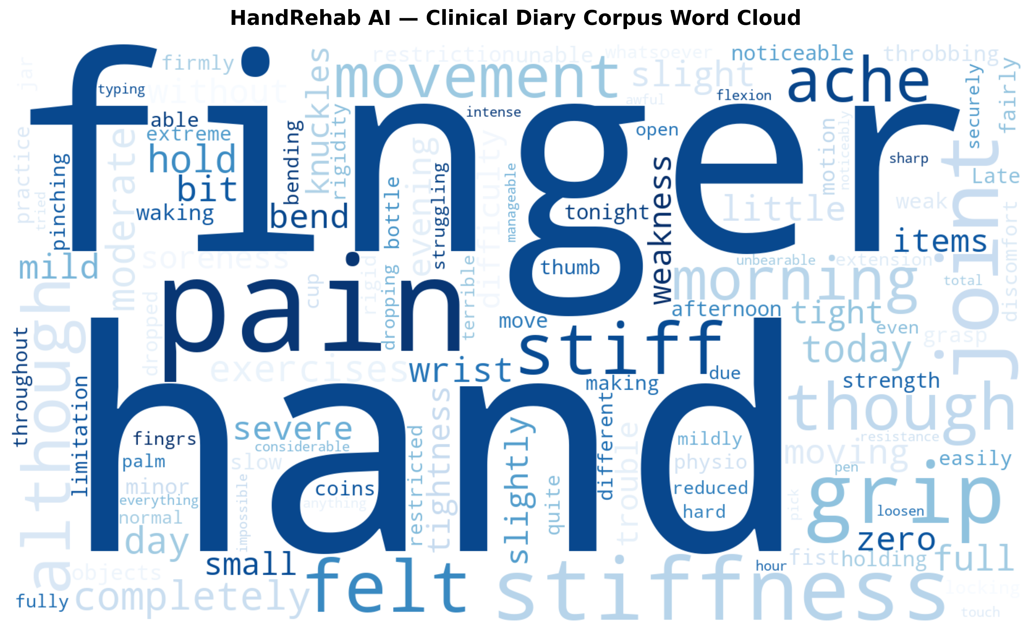
Figure 3.1b: Word Cloud of the HandRehab AI Clinical Diary Corpus displaying the most prominent symptom descriptors and recovery terms.
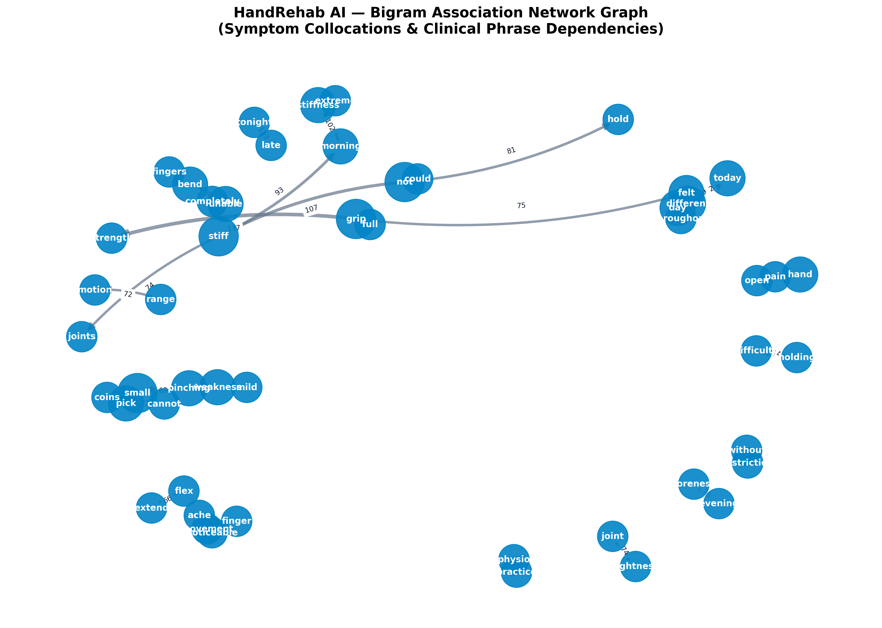
Figure 3.1c: Bigram Association Network Graph showing common symptom collocations and clinical dependency pairs across the HandRehab AI corpus.
The dataset is intended for developing and comparing symptom classification methods. The separate hand-written evaluation set provides an additional check of how the models perform on more varied wording than the generated entries.

3.1.2. Preprocessing
Text preprocessing converts the original diary entry into a consistent sequence of tokens suitable for embedding and recurrent neural network processing. The same preprocessing function is used during model development, evaluation, and live application inference to maintain consistency between training and deployment.

The first step expands contractions and selected informal spellings using regular expressions. For example, “can't” is converted to “cannot”, “don't” to “do not”, “w/o” to “without”, “2day” to “today”, and “fingrs” to “fingers”. This step reduces unnecessary vocabulary variation and helps the classifier recognise common expressions
The text is then converted to lowercase so that words with different capitalisation are treated consistently. Tokenisation separates the text into individual alphanumeric word tokens. Stop-word removal is subsequently applied to reduce the number of words that contribute little to the classification task. However, negation words and selected modifiers are protected because they can change the meaning or severity of a symptom description. Examples include “no”, “not”, “never”, “without”, “zero”, “bit”, “slightly”, “very”, and “but”.
After stop-word removal, WordNet lemmatisation converts eligible words to their base forms. The lemmatiser processes words as nouns and then as verbs, while protected words are excluded from this transformation. This helps standardise word forms without unintentionally changing the meaning of important negation or intensity expressions.
For example, the sentence “Mild ache after typing, wrist is a bit tight but moving fine” is converted into the token sequence “mild ache type wrist bit tight but move fine”. In this example, less informative words are removed and selected words are converted to their base forms. The words “bit” and “but” are retained because they contribute to the meaning of the diary entry
If preprocessing produces an empty sequence, a placeholder token is inserted to ensure that the model always receives at least one token. The resulting sequence is converted into vocabulary indices and then padded or truncated to a maximum length of 40 tokens. The actual sequence length is retained so that recurrent encoders can ignore padding during processing.
The vocabulary contains 398 entries, including padding and unknown tokens, and 396 content words. The content-word vocabulary was checked against the available GloVe vectors, and all 396 words had corresponding pretrained embeddings. This produced complete GloVe coverage for the vocabulary used in the project.

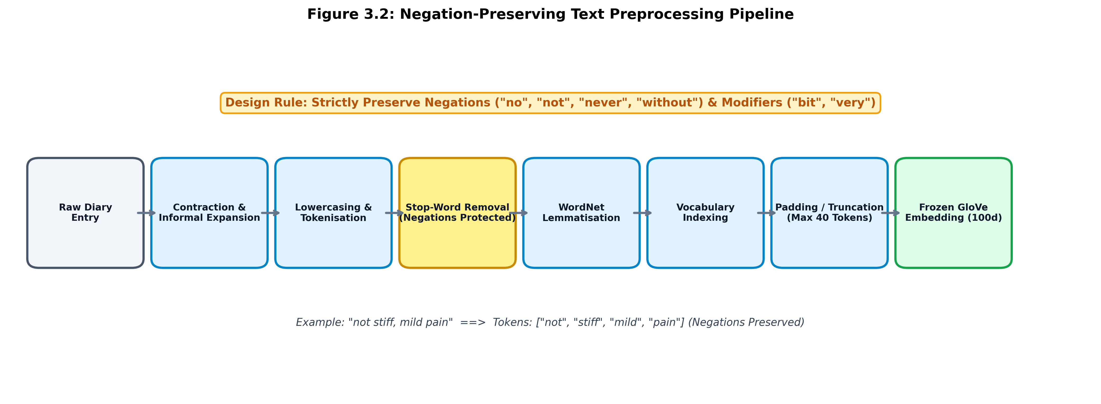
Figure 3.2: Negation-preserving text preprocessing pipeline.

The flowchart should show:
Raw Diary Entry → Contraction and Informal-Spelling Expansion → Lowercasing → Tokenisation → Stop-Word Removal with Negation and Modifier Protection → WordNet Lemmatisation → Vocabulary Indexing → Padding or Truncation to 40 Tokens → GloVe Embedding.

3.1.3. Embedding Layer
The embedding layer converts each vocabulary index into a numerical vector that represents the corresponding word. HandRehab AI uses pretrained GloVe vectors from the glove.6B.100d collection. Each word is represented by a 100-dimensional vector, allowing the recurrent encoder to process semantic information rather than raw text.
An embedding matrix is constructed with one row for each vocabulary entry. The padding token at index 0 is represented by a zero vector, while index 1 is reserved for the unknown token. The embedding matrix is initialised using the available pretrained vectors. The unknown-token vector is initialised using a normal distribution based on the mean and standard deviation of the loaded GloVe vectors, with seed 42.
The embedding layer is frozen during training. Consequently, the pretrained word vectors remain unchanged while the recurrent encoder and classification heads learn from the labelled diary corpus. Freezing the embedding layer reduces the number of trainable parameters and helps preserve the pretrained representations of words such as “stiff”, “weak”, and “pain”.
A dropout rate of 0.3 is applied to the embedded sequence to reduce over-reliance on individual features during training. The resulting sequence of 100-dimensional vectors is passed to the selected recurrent encoder.

3.1.4 Encoder Layer
The encoder layer learns contextual representations from the preprocessed diary sequence. Instead of treating each word independently, recurrent networks process tokens in sequence and maintain hidden states that incorporate information from preceding words. This is useful for symptom descriptions in which negation, modifiers, or contrasting statements affect the meaning of a phrase.
Five recurrent encoder configurations were implemented and compared: Simple RNN, LSTM, GRU, BiLSTM, and BiLSTM with attention. Each recurrent encoder uses a single layer with 128 hidden units. Variable-length sequences are packed during recurrent processing so that padding does not influence the learned hidden states.

Simple Recurrent Neural Network (RNN)
The Simple RNN updates its hidden state using the current token representation and the previous hidden state. Its computation can be expressed as:

h_{t} = tanh(W x_{t} + U h_{t-1} + b)

The Simple RNN provides a basic recurrent baseline. However, it may have difficulty retaining information across longer sequences because of vanishing gradients.

Long Short-Term Memory (LSTM)
The LSTM introduces a cell state and gating mechanisms that regulate information retention and updates. Its forget, input, and output gates control which information is retained, added, and exposed through the hidden state. The main operations are represented as:

c̃_{t} = tanh(W_{c} x_{t} + U_{c} h_{t-1} + b_{c})
c_{t} = f_{t} ⊙ c_{t-1} + i_{t} ⊙ c̃_{t}, h_{t} = o_{t} ⊙ tanh(c_{t})
f_{t} = σ(W_{f} x_{t} + U_{f} h_{t-1} + b_{f}), i_{t} = σ(W_{i} x_{t} + U_{i} h_{t-1} + b_{i}), o_{t} = σ(W_{o} x_{t} + U_{o} h_{t-1} + b_{o})

The gating mechanism allows the LSTM to retain useful contextual information over a sequence.

Gated Recurrent Unit (GRU)
The GRU uses update and reset gates to regulate information flow. Unlike the LSTM, it does not maintain a separate cell state. Its simpler structure can reduce computational requirements while still modelling dependencies across tokens. The main operations are:

z_{t} = σ(W_{z} x_{t} + U_{z} h_{t-1} + b_{z}), r_{t} = σ(W_{r} x_{t} + U_{r} h_{t-1} + b_{r})
h̃_{t} = tanh(W_{h} x_{t} + U_{h} (r_{t} ⊙ h_{t-1}) + b_{h}), h_{t} = (1 − z_{t}) ⊙ h_{t-1} + z_{t} ⊙ h̃_{t}

The GRU configuration is used by the live diary-classification backend. Its output representation is passed to the four symptom classification heads.

Bidirectional LSTM (BiLSTM)
The BiLSTM processes the input sequence in both forward and backward directions. The two hidden-state sequences are combined to create a representation containing contextual information from both sides of each token. With 128 hidden units in each direction, the concatenated representation has 256 dimensions. Bidirectional processing can help interpret expressions where words appearing later in a sentence change the meaning of earlier words.

BiLSTM with Attention
The attention-based configuration assigns a learned weight to each valid hidden state and uses these weights to create a context vector. The attention score for token \(t\) is calculated as:

e_{t} = v^{T} tanh(W_{a} h_{t} + b_{a})
α_{t} = exp(e_{t}) / Σ_{j} exp(e_{j}), c = Σ_{t} α_{t} h_{t}

Padding positions are masked so that they do not receive attention probability. This model allows the contribution of different token positions to be examined during offline model analysis.
For the other encoder configurations, the sentence representation is obtained using the configured pooling strategy. The LSTM and GRU use their final hidden-state representation, while the Simple RNN and BiLSTM use the mean of the valid hidden states. Dropout with a rate of 0.3 is applied to the resulting representation before classification.

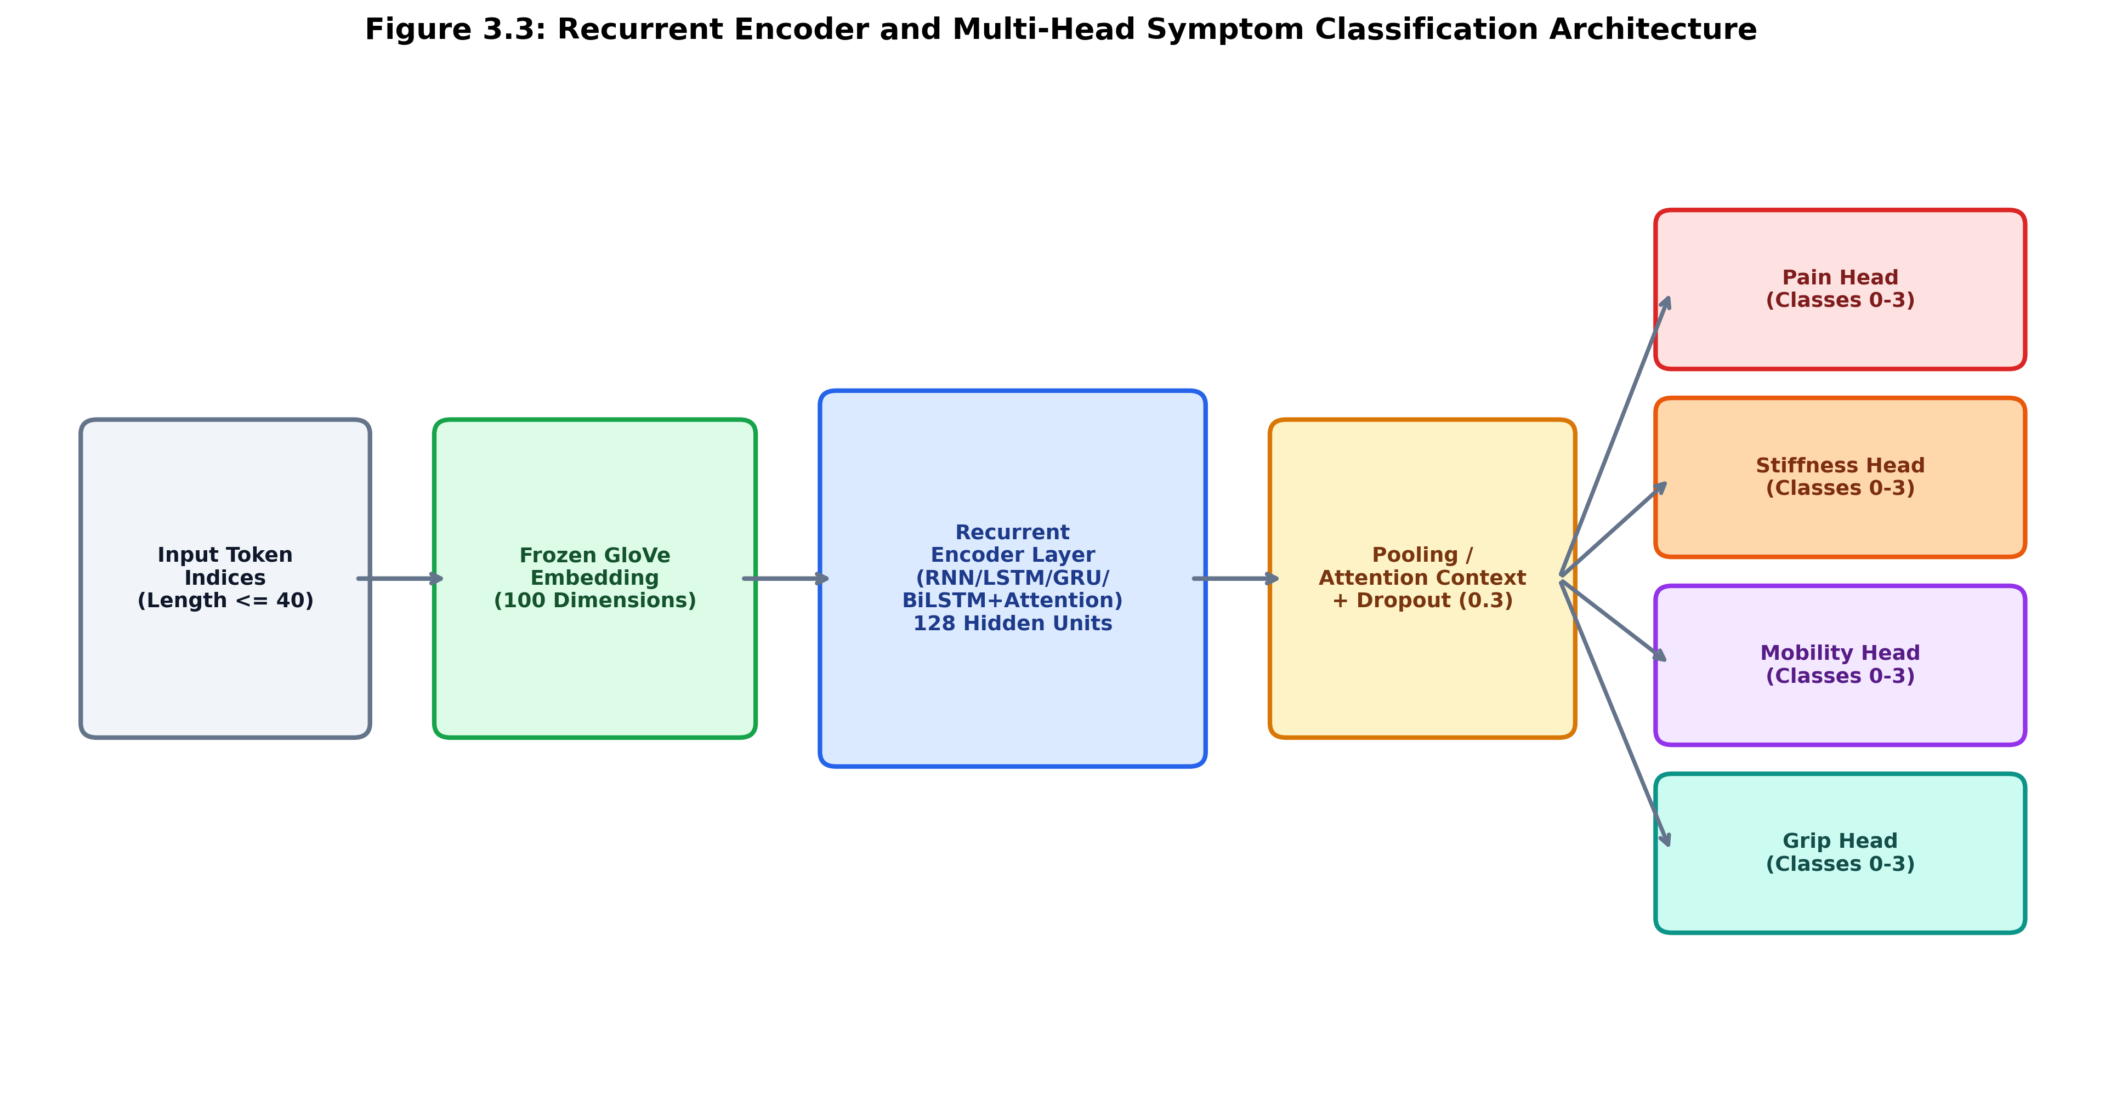
Figure 3.3: Recurrent encoder and multi-head symptom classification architecture.

The diagram should show: Token Indices → Frozen GloVe Embedding (100 dimensions) → Selected Recurrent Encoder → Pooling or Attention → Dropout (0.3) → Four Parallel Classification Heads. Label each head Pain, Stiffness, Mobility, and Grip, with four output classes (0–3) per head.

3.1.5 Multi-Head Classification and Loss Function
The encoder representation is passed to four independent linear classification heads. Each head corresponds to one symptom: pain, stiffness, mobility limitation, or grip limitation. Every head produces four output logits representing severity classes 0, 1, 2, and 3. A softmax operation converts the logits into class probabilities, and the class with the highest probability is selected as the predicted severity.
The shared encoder learns features from the diary text, while the independent output heads learn the decision boundaries for each symptom. This structure allows a single diary entry to produce four predictions without requiring four separate recurrent encoders.
Training uses the sum of the four cross-entropy losses:

L_{total} = CE_{pain} + CE_{stiffness} + CE_{mobility} + CE_{grip}

Each head contributes equally to the total loss. The model parameters are updated during training to reduce the difference between the predicted classes and the reference labels.
A classical TF-IDF and Logistic Regression baseline is also evaluated. This baseline uses unigram and bigram features, a maximum of 1,000 text features, sublinear term frequency, and a regularisation parameter of \(C=1.0\). Four separate Logistic Regression classifiers predict the four symptom scores. Comparing this baseline with the recurrent models helps evaluate the value of sequential contextual representations for diary classification.

3.1.6 Explainability Using Token Occlusion
HandRehab AI includes token-level occlusion attribution to indicate which words influence the symptom predictions. Since the deployed GRU does not include an attention layer, the application uses an occlusion-based method rather than relying on attention weights.
First, the model predicts the four severity distributions from the complete preprocessed diary entry. The system then removes one token at a time and runs the model again. The change in output probabilities is measured for each of the four classification heads. The importance score for token \(i\) is calculated as:
I_{i} = Σ_{k} Σ_{c} | p_{k,c}(x) − p_{k,c}(x without token i) |
The scores are normalised to obtain a relative contribution for each token:
w_{i} = I_{i} / Σ_{j} I_{j}

Tokens with a normalised score at least 1.2 times the uniform contribution \(1/n\) are marked as influential. The dashboard highlights these words so that users can see which parts of the entry most affected the predictions.
The BiLSTM with attention is also evaluated as a separate model, allowing its learned attention weights to be inspected during model comparison. In the deployed system, token occlusion provides the word-influence display for the GRU-based classifier.

3.1.7 Recovery Trend Module
The recovery trend module analyses recorded symptom and movement measurements over time. Its input consists of a 14-day sequence, with each day represented by five values: pain, stiffness, mobility limitation, grip limitation, and range of motion. The values are standardised using the mean and standard deviation calculated from the training recovery curves. These scaling values are saved and reused by the application during inference.
Three recurrent architectures are compared for trend forecasting: Simple RNN, LSTM, and GRU. Each architecture uses 64 hidden units. The final hidden state of the recurrent encoder is passed to two output branches. The forecast branch uses a two-layer network with 32 hidden units to predict the five measurements for the following day. The status branch uses a corresponding network to classify the recovery pattern into normal recovery, plateau, or possible relapse.

The two tasks are trained jointly using a combination of mean squared error for numerical forecasting and cross-entropy for recovery-status classification:

L = λ_{f} · MSE(forecast) + λ_{c} · CE(status)

The trained GRU is used by the application for trend inference.The learned models are compared with three baseline approaches. The persistence baseline assumes that the next day's values will be the same as the current day's values. The seven-day moving-average baseline predicts values using the average of the preceding seven days. The rule-based detector evaluates recent changes in symptom scores and ROM to identify patterns associated with recovery, plateau, or relapse. Its thresholds are selected using validation data.
The trend module is developed and evaluated using simulated recovery trajectories. At application level, the forecast values are constrained to the configured valid ranges: symptom scores from 0 to 3 and ROM from 0 to 100. The predicted recovery status is presented on the dashboard so that the user can review the estimated trend alongside recorded measurements.

3.1.8 Web Application and Hand Movement Tracking
The web application integrates diary classification, movement tracking, database operations, and recovery visualisation. Flask provides the backend services and loads the required model checkpoints and vocabulary when the application starts. SQLite stores user information and rehabilitation records in a local database.
The database contains user and rehabilitation-record tables. User credentials are stored as salted password hashes. Rehabilitation records include the date, diary text, four symptom severity scores, ROM measurement, and repetition count. When an existing daily session is updated, repetition counts are accumulated and the best ROM measurement for that day is retained.
The frontend is implemented using HTML, CSS, and JavaScript. It presents the main workflow in three stages: diary analysis, camera-based exercise tracking, and recovery reporting. The diary page displays the predicted symptom severity scores and highlights influential words. The exercise page presents hand tracking information, movement measurements, and the repetition counter. The report page displays historical records, trend charts, the next-day forecast, and the predicted recovery status using Chart.js.
The vision component uses MediaPipe Tasks Vision to detect 21 hand landmarks from webcam frames in the browser. The coordinates of selected finger landmarks are used to estimate the angle at the proximal interphalangeal (PIP) joint. For three points \(a\), \(b\), and \(c\), where \(b\) is the joint being measured, the angle is calculated as:
θ = arccos( (a − b)·(c − b) / (‖a − b‖ ‖c − b‖) )
The implementation estimates angles for the selected index and middle fingers and averages the results. The ROM score is derived from the mean PIP angle:
ROM = min(100, max(0, 180° − θ̄_{PIP}))
This produces a bounded movement score for use in the application. It is a project-specific estimate derived from browser-based landmark tracking rather than a clinical goniometric measurement.
Exercise repetitions are counted using a state-based approach. An angle at or below 85° is treated as a full curl, while an angle at or above 140° is treated as an open-hand position. A repetition is counted when the detected movement progresses from a full curl back to the open position. The application also provides a simulated demonstration mode for showing the interface without using a webcam.

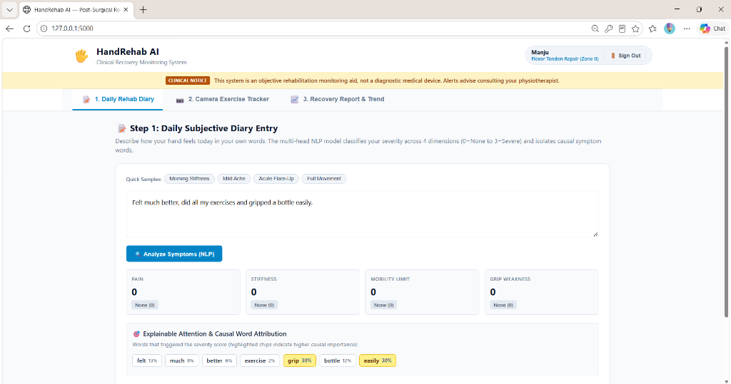
Figure 3.4: Diary analysis interface showing symptom severity predictions and influential words.

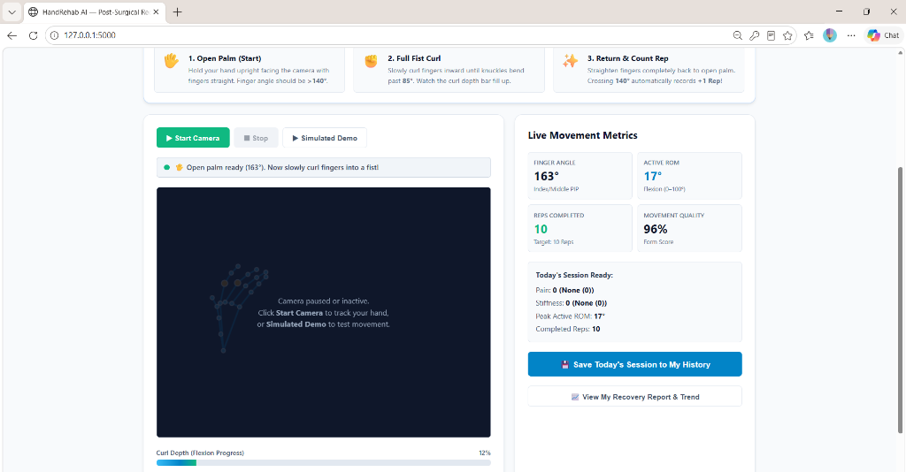
Figure 3.5: Browser-based hand exercise tracking using MediaPipe landmarks.

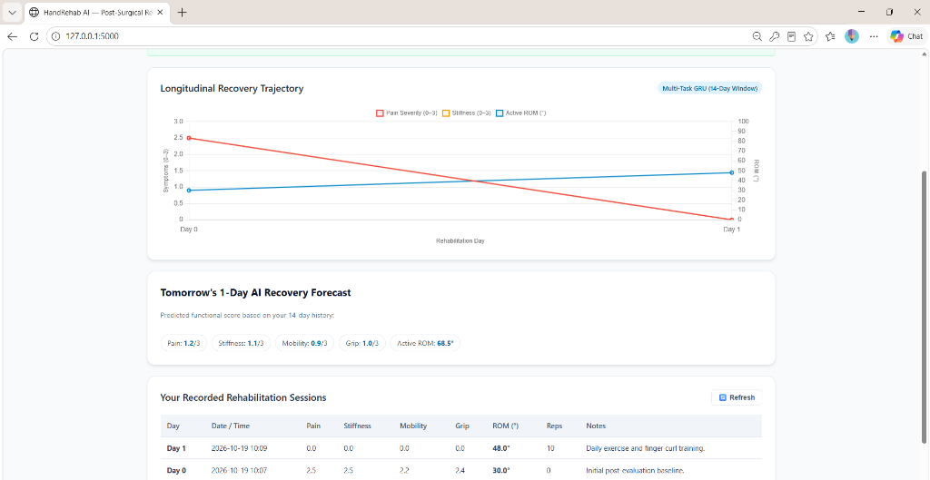
Figure 3.6: Recovery dashboard displaying historical measurements and predicted recovery trends.

3.2 Hardware Specifications
HandRehab AI is a software-based application and does not require dedicated rehabilitation hardware, microcontrollers, wearable sensors, or external measurement devices. The hardware requirements are as follows:
- Computer/Laptop: A standard personal computer or laptop for application development, model training, and execution.
- Processor: A compatible CPU capable of running Python, PyTorch, and the Flask application.
- RAM: Sufficient memory to execute the machine learning models, process the dataset, and run the web application.
- Storage: Disk space for the source code, synthetic datasets, pretrained GloVe vectors, model checkpoints, and SQLite database.
- Webcam: A built-in or USB webcam for browser-based hand landmark detection and exercise tracking.
- Graphics Processor (GPU): Optional. A compatible GPU may be used for supported PyTorch computations; CPU execution is also possible.
The exact processor, RAM capacity, storage capacity, graphics processor, and webcam model should be recorded from the computer used to develop and demonstrate the project.

3.3 Software Specifications
The software components used in HandRehab AI are listed below:
- Python: Used for dataset generation, text preprocessing, model development, training, evaluation, and backend implementation.
- PyTorch: Used to implement and train the RNN, LSTM, GRU, BiLSTM, and BiLSTM with attention models.
- scikit-learn: Used for TF-IDF feature extraction, Logistic Regression, dataset splitting, and model evaluation.
- NLTK: Used for English stop-word processing and text lemmatisation.
- WordNet: Used by the lemmatisation process to convert eligible words into their base forms.
- NumPy: Used for numerical operations and calculations.
- pandas: Used for dataset handling and organisation.
- GloVe (glove.6B.100d): Used to provide pretrained 100-dimensional word embeddings for the diary classification models.
- Flask: Used to develop the backend and provide application API endpoints.
- Werkzeug: Used for password hashing and supporting Flask-related web functionality.
- SQLite: Used to store user accounts and rehabilitation session records locally.
- MediaPipe Tasks Vision: Used for browser-based hand landmark detection and movement tracking.
- Chart.js: Used to display recovery history, symptom measurements, and forecast charts.
- HTML: Used to structure the web application interface.
- CSS: Used to style the dashboard and its components.
- JavaScript: Used for frontend interactions, webcam processing, exercise tracking, and displaying results.
- Web Browser: Used to access the local web application and run the browser-based hand tracking interface.
- Integrated Development Environment (IDE): The environment used to write and test the project code, such as Visual Studio Code or Jupyter Notebook, depending on the actual setup
The application is designed to run locally through a web browser. The exact versions of Python, PyTorch, scikit-learn, NLTK, Flask, MediaPipe, and other installed packages should be verified from the development environment before the final report is submitted.
CHAPTER 4
PERFORMANCE EVALUATION
4.1. Experimental Setup
All six diary models were trained and evaluated under one protocol. The same train, validation and test splits and the same frozen GloVe matrix were used for every model, and each neural model was trained with three random seeds (42, 43 and 44). Training used the Adam optimiser with a learning rate of 0.001 and weight decay of 1e-5 on trainable parameters only, mini-batches of 32, gradient-norm clipping at 5.0, and at most 15 epochs. After every epoch the model was scored on the validation set by mean macro F1 over the four heads, the best checkpoint was kept, and training stopped early if validation macro F1 did not improve for four consecutive epochs. The best model across all runs was chosen by validation score only, never by test score. Each trained model was then evaluated on the synthetic test split and on the held-out set of 62 entries. Results are reported as mean ± standard deviation over the seeds. The TF-IDF baseline is deterministic given the data and shows zero variance across seeds.
Table 4.1: Hyperparameters and training configuration
Parameter | Value
Embedding | GloVe 100d, frozen
Maximum sequence length | 40 tokens
Hidden units | 128 (diary), 64 (trend)
Encoder layers | 1
Dropout | 0.3 (diary), 0.2 (trend)
Optimiser | Adam, lr 0.001, weight decay 1e-5
Batch size | 32
Gradient clipping | Max norm 5.0
Maximum epochs / early-stopping patience | 15 / 4 (monitored on validation macro F1)
Random seeds | 42, 43, 44
Pooling | Last state: LSTM, GRU; mean: RNN, BiLSTM; attention context: BiLSTM+Attention
TF-IDF + LogReg | n-grams (1,2), 1,000 features, sublinear tf, C = 1.0, max 1,000 iterations

4.1 Evaluation Metrics
Classification quality is measured per symptom with accuracy and macro-averaged precision, recall and F1. Accuracy is the share of entries whose predicted class equals the true class (Equation 4.1). Because class 0 forms nearly half of the data, accuracy alone can look high for a model that favours class 0, so macro F1 is reported as the main metric. Macro F1 computes the F1 score of each class c from precision P_{c} and recall R_{c} (Equation 4.2) and averages the four classes with equal weight (Equation 4.3), so a poor result on a rare or hard class lowers the score. The overall score of a model is the mean of its four per-symptom macro F1 values.
Accuracy = (number of correct predictions) / (total predictions) (4.1)
F1_{c} = 2 P_{c} R_{c} / (P_{c} + R_{c}) (4.2)
Macro F1 = (1/4) Σ_{c=0}³ F1_{c} (4.3)
Uncertainty on the small held-out set is estimated by 1,000 bootstrap resamples of the 62 entries, from which a 95% confidence interval for overall macro F1 is taken. The trend module is evaluated with mean absolute error (MAE) and root mean squared error (RMSE) for the forecast, which are the average and the root-mean-square of the gap between predicted and actual next-day values, and with macro precision, recall and F1 for the three-class status.

4.2 Results and Analysis

4.2.1 Diary Severity Classification

Table 4.2 gives the overall results on the synthetic test split and on the held-out set, and Table 4.3 gives the per-symptom macro F1 on the held-out set. Figure 4.1 compares the overall macro F1 of every model on the two test sets, and Figure 4.2 shows the per-symptom results on the held-out set.
Table 4.2: Overall accuracy and macro F1 (mean ± standard deviation over seeds 42, 43, 44)
Model | Test set | Overall accuracy | Overall macro F1 | Pain acc. | Grip acc.
TF-IDF + LogReg | Synthetic | 0.985 ± 0.000 | 0.985 ± 0.000 | 0.984 | 0.987
 | Held-out | 0.726 ± 0.000 | 0.556 ± 0.000 | 0.839 | 0.645
Simple RNN | Synthetic | 0.714 ± 0.002 | 0.685 ± 0.003 | 0.775 | 0.721
 | Held-out | 0.586 ± 0.018 | 0.455 ± 0.007 | 0.817 | 0.527
LSTM | Synthetic | 0.901 ± 0.009 | 0.891 ± 0.013 | 0.956 | 0.927
 | Held-out | 0.667 ± 0.007 | 0.518 ± 0.018 | 0.903 | 0.548
GRU | Synthetic | 0.927 ± 0.008 | 0.919 ± 0.009 | 0.986 | 0.933
 | Held-out | 0.695 ± 0.008 | 0.545 ± 0.013 | 0.925 | 0.613
BiLSTM | Synthetic | 0.939 ± 0.008 | 0.933 ± 0.009 | 0.977 | 0.937
 | Held-out | 0.696 ± 0.007 | 0.546 ± 0.018 | 0.925 | 0.618
BiLSTM + Attention | Synthetic | 0.930 ± 0.008 | 0.924 ± 0.009 | 0.988 | 0.929
 | Held-out | 0.679 ± 0.019 | 0.534 ± 0.010 | 0.860 | 0.602

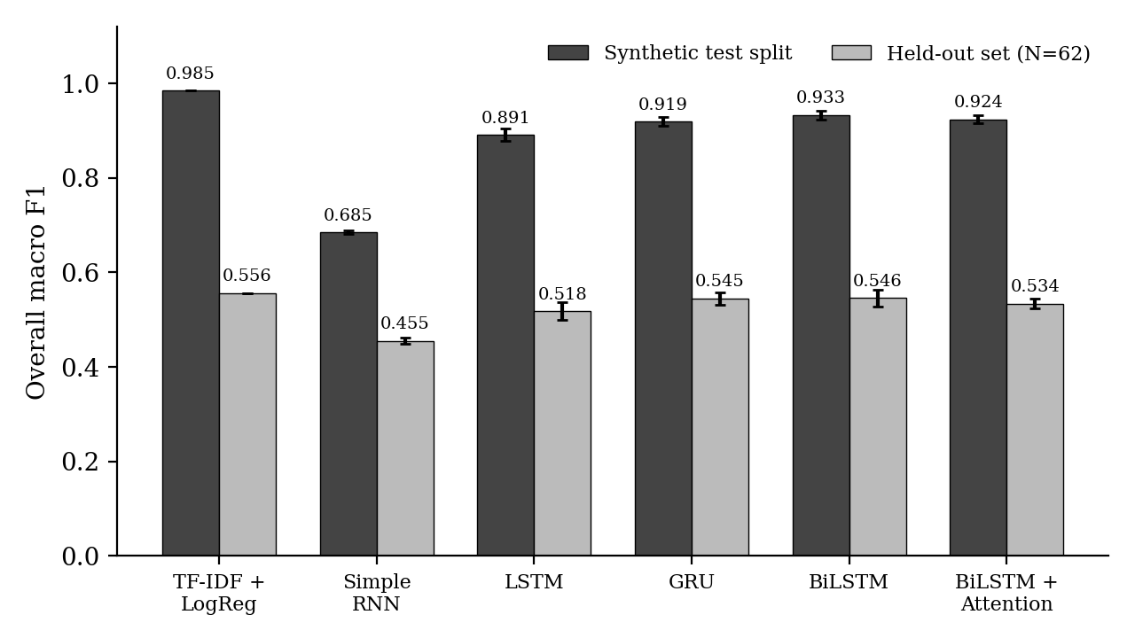
Figure 4.1: Overall macro F1 of each model on the synthetic test split and on the held-out set (error bars show standard deviation over three seeds)
Table 4.3: Per-symptom macro F1 on the held-out set (mean ± standard deviation)
Model | Pain | Stiffness | Mobility | Grip
TF-IDF + LogReg | 0.773 ± 0.000 | 0.633 ± 0.000 | 0.420 ± 0.000 | 0.399 ± 0.000
Simple RNN | 0.768 ± 0.025 | 0.398 ± 0.010 | 0.223 ± 0.014 | 0.430 ± 0.017
LSTM | 0.846 ± 0.040 | 0.477 ± 0.018 | 0.290 ± 0.061 | 0.458 ± 0.049
GRU | 0.897 ± 0.003 | 0.424 ± 0.051 | 0.340 ± 0.017 | 0.518 ± 0.025
BiLSTM | 0.870 ± 0.023 | 0.496 ± 0.040 | 0.319 ± 0.015 | 0.498 ± 0.019
BiLSTM + Attention | 0.802 ± 0.005 | 0.483 ± 0.037 | 0.350 ± 0.032 | 0.502 ± 0.028

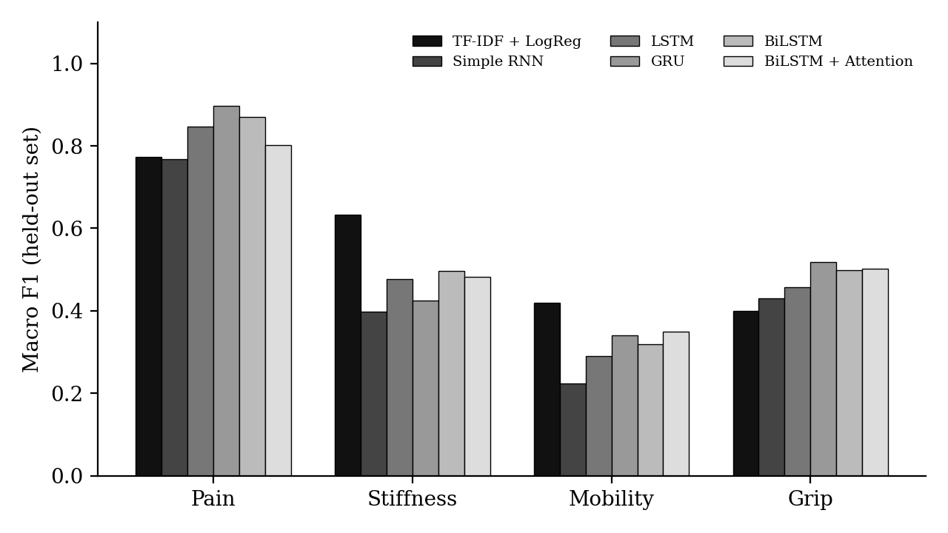
Figure 4.2: Per-symptom macro F1 of each model on the held-out set
Three findings stand out. First, among the neural encoders on the synthetic test split, gating and bidirectionality clearly help. The Simple RNN reaches an overall macro F1 of 0.685, the LSTM 0.891, the GRU 0.919, the BiLSTM 0.933 and the BiLSTM with attention 0.924. This ordering matches the literature, in which gated units outperform plain recurrent units. The TF-IDF and Logistic Regression baseline scores 0.985 on the same split, higher than every neural model. This is expected, because the synthetic text is built from a fixed phrase bank, so a bag of words and bigrams can almost memorise it.
Second, every model loses a great deal on the held-out set. Overall macro F1 falls from 0.985 to 0.556 for TF-IDF plus Logistic Regression, from 0.933 to 0.546 for the BiLSTM and from 0.919 to 0.545 for the GRU. This is the central result of the project: scores obtained on template-generated text greatly overstate performance on freely written text, even with a template-level split. The drop is largest for the TF-IDF model overall. A likely reason, especially for mobility and grip, is that the free-text entries describe function with words the phrase bank never used, such as “dropped a mug”, “button my work shirt” or “turn the key”.
Third, on the held-out set the neural models do not beat the classical baseline overall. The 95% bootstrap confidence intervals for overall macro F1 are wide and overlap heavily, for example [0.467, 0.616] for TF-IDF, [0.463, 0.607] for the GRU and [0.459, 0.615] for the BiLSTM, so with only 62 entries the differences between these three models are not statistically conclusive. The Simple RNN is the weakest at 0.455 with an interval of [0.382, 0.512]. Pain is the easiest symptom for the neural models (F1 up to 0.897 for the GRU), because pain words and their negations are frequent and direct. Mobility is the hardest for all models (F1 between 0.223 and 0.420), since it is often described indirectly through actions. The GRU gives the best grip score (0.518), followed by the attention model (0.502) and the BiLSTM (0.498), while TF-IDF is best on stiffness (0.633). The BiLSTM with attention has no clear advantage in accuracy, so its value lies in the attention weights it provides.
Several limits of these results should be stated. The held-out set is small, so its estimates are noisy. All labels come from synthetic or purpose-written text and not from patients or clinicians. Models were trained only on template text, which explains the transfer gap. The GRU was deployed in the dashboard because it is accurate, light and was the checkpoint loaded by the backend, but Table 4.2 shows it is not statistically better than the alternatives on the held-out set.

4.2.2 Recovery Trend Module

The trend model was compared with the persistence, seven-day moving-average and rule-based baselines on simulated recovery curves. Table 4.4 reports the next-day forecast error and Table 4.5 the plateau and relapse detection quality.
Table 4.4: Next-day forecast error on the simulated test curves
Method | MAE | RMSE
Tomorrow = Today | 0.284 | 0.708
7-Day Moving Average | 0.673 | 1.634
GRU multi-task model | 0.475 ± 0.027 | 1.167 ± 0.064

Table 4.5: Recovery status classification (normal / plateau / relapse)
Method | Macro precision | Macro recall | Macro F1
Majority class (normal) | 0.248 | 0.333 | 0.285
Rule-based detector | 0.509 | 0.578 | 0.509
GRU multi-task model | 0.642 ± 0.007 | 0.593 ± 0.011 | 0.611 ± 0.009

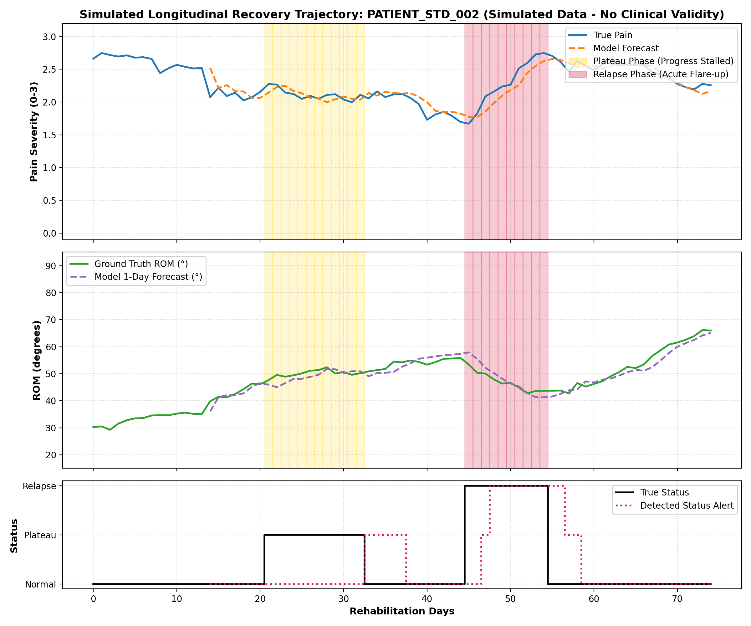
Figure 4.3: Simulated 14-day longitudinal recovery trajectory showing next-day continuous feature forecasts and recovery-status classification (Normal Progression vs. Plateau vs. Relapse).
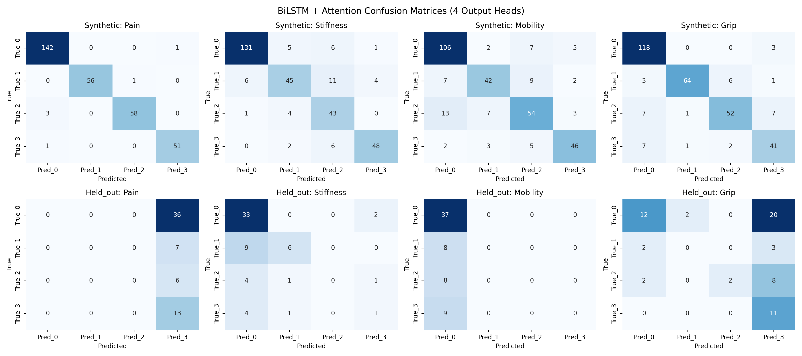
Figure 4.4: Multi-Head Confusion Matrices for BiLSTM + Attention across Pain, Stiffness, Mobility, and Grip severity classes on the held-out evaluation set.
CHAPTER 5
CONCLUSION AND FUTURE WORK

5.1 Summary of the contributions
The project successfully developed HandRehab AI, an AI-based hand rehabilitation monitoring system that integrates rehabilitation diary classification, hand movement tracking, recovery trend forecasting, and an interactive dashboard within a single software application. The primary objective was to provide a unified platform for recording rehabilitation progress, identifying symptom severity, visualising movement measurements, and monitoring potential changes in recovery patterns.
The natural language processing component classifies diary entries into four symptom categories: pain, stiffness, mobility limitation, and grip limitation. Each category is assigned an ordinal severity level from 0 to 3. The preprocessing pipeline preserves negations and applies text normalisation before converting words into numerical representations using frozen 100-dimensional GloVe embeddings. Six classification approaches were evaluated: TF-IDF with Logistic Regression, Simple RNN, LSTM, GRU, BiLSTM, and BiLSTM with Attention. The use of template-level data splitting and a separate hand-written test set helped assess the models under different text conditions.
On the synthetic test split, BiLSTM achieved the highest macro-F1 score among the recurrent neural network models at *0.933, followed by GRU at **0.919. However, TF-IDF with Logistic Regression achieved the highest macro-F1 score of **0.985, demonstrating that a classical machine learning approach can perform strongly on structured synthetic text. On the separate hand-written test set containing 62 entries, the TF-IDF baseline achieved a macro-F1 score of **0.556* and an accuracy of *0.726. Among the recurrent models, BiLSTM achieved a macro-F1 score of **0.546, while GRU achieved **0.545* with an accuracy of *0.695*. The decrease in performance across the two test settings highlights the difficulty of generalising from synthetic diary templates to more varied, naturally written descriptions.
The project also incorporated token-level occlusion attribution to indicate which words influence the classifier's predictions. This provides a means of inspecting model behaviour, although the highlighted words should be interpreted as model-input influences rather than definitive clinical explanations.

The movement-monitoring component uses browser-based hand tracking to estimate range of motion and count exercise repetitions from webcam input. The recovery forecasting component analyses simulated 14-day recovery sequences to predict next-day values and classify recovery status as normal, plateau, or relapse. In the standard simulated test evaluation, the GRU trend model achieved a status-classification accuracy of *0.758* and a macro-F1 score of *0.611* among the learned recurrent models. The persistence baseline achieved lower numerical forecasting errors, with an overall MAE of *0.284* and RMSE of *0.708*, indicating that the learned model did not outperform every baseline across all evaluation objectives.
Overall, HandRehab AI achieved its main engineering objective by bringing diary-based symptom assessment, interpretable predictions, webcam-based movement monitoring, and recovery trend visualisation together in one application. The experimental results also identified important limitations, particularly the generalisation of diary classification to free-form text and the reliance on simulated data for trend forecasting. The developed system therefore provides a functional research prototype and a foundation for further validation, rather than evidence of established clinical effectiveness.

5.2 Future work
Several improvements can be considered to increase the accuracy, reliability, usability, and scalability of HandRehab AI.

1. Collection of Real Rehabilitation Data
Future work should include the collection of consented rehabilitation diary entries from patients. Physiotherapists or other qualified professionals should label the entries according to the four symptom categories and their severity levels. This would allow the classifier to be trained and evaluated using language that more closely reflects real rehabilitation experiences.

2. Expansion of the Evaluation Dataset
The hand-written evaluation set currently contains 62 entries. A substantially larger and more diverse dataset should be developed to improve the reliability of performance estimates. Entries should cover different writing styles, symptom descriptions, severity levels, and ways of expressing functional difficulties. Multiple annotators could label a subset of the data, with inter-annotator agreement reported to assess label consistency.

3. Evaluation of Contextual Language Models
Future experiments could compare the existing GloVe-based recurrent models with pretrained contextual language models, such as BERT-based architectures. Contextual representations may help the system distinguish between phrases that use similar words but communicate different symptom severity or meaning. Any improvement should be verified on an independent, hand-written dataset rather than only on synthetic text.

4. Improved Severity Classification
Since the symptom labels range from 0 to 3, future models could incorporate ordinal-aware loss functions. These methods account for the ordered nature of severity levels and may distinguish between small severity errors and larger disagreements. Per-class precision, recall, F1-score, and confusion matrices should also be reported to identify categories that require further improvement.

5. More Reliable Recovery Trend Forecasting
The current forecasting experiments use simulated recovery trajectories. Future work should evaluate the trend model using real longitudinal rehabilitation records collected over multiple days or weeks. Clinician-informed definitions of normal progress, plateau, and relapse should be established before evaluating these categories. The GRU model should continue to be compared against simple baselines, including persistence and moving-average methods, to confirm whether the added model complexity provides meaningful benefits.

6. Extended Hand Movement Analysis
The current movement-monitoring component could be expanded to track additional fingers, thumb movement, and a wider range of prescribed rehabilitation exercises. Further development could investigate movement smoothness, consistency, exercise completion, and form-quality indicators. These measurements would require validation against appropriate reference measurements before being used for formal rehabilitation assessment.

7. Improved Explainability and User Feedback
The existing token-level occlusion method could be supplemented with additional explanation techniques and systematic evaluation. Future versions could present clearer descriptions of predicted symptom levels, uncertainty, and changes from previous diary entries. User testing with patients and rehabilitation professionals would help determine whether the explanations are understandable and useful.

8. Secure Data Management and Privacy
For use beyond a local prototype, the application should include robust authentication, role-based access control, secure communication, protected storage, backup and recovery procedures, and appropriate data-retention controls. The handling of personal rehabilitation records should follow applicable privacy requirements and informed-consent procedures. Security testing would be necessary before deployment in a clinical or commercial environment.

9. Clinician Dashboard and Integration
A dedicated clinician portal could allow authorised professionals to review patient-reported symptoms, movement measurements, historical trends, and flagged changes. Future versions could support report generation, appointment-based progress reviews, and integration with existing rehabilitation workflows. Any automated alert should remain a decision-support feature and should be evaluated with clinical professionals.

10. Accessibility and Multilingual Support
The system could be extended to support additional languages, speech-based diary entry, adjustable text sizes, and more accessible dashboard layouts. Multilingual models would need to be evaluated using representative data for each supported language to ensure that symptom descriptions are interpreted consistently.

11. Deployment and Performance Optimisation
The current local application could be adapted for secure server-based deployment after validation and security testing. Further work could examine response time, memory usage, concurrent users, database performance, and browser compatibility. Automated testing, logging, monitoring, and version-controlled model updates would help improve maintainability and reliability as usage increases.
In conclusion, HandRehab AI demonstrates the feasibility of integrating text-based symptom classification, webcam-based hand movement monitoring, and recovery trend analysis within a unified rehabilitation application. Future development should prioritise real-world data collection, independent validation, improved generalisation, secure deployment, and evaluation with rehabilitation professionals before considering wider clinical or commercial use.

REFERENCES

1. J. Pennington, R. Socher, and C. D. Manning, “GloVe: Global vectors for word representation,” in Proceedings of the 2014 Conference on Empirical Methods in Natural Language Processing (EMNLP), Doha, Qatar, 2014, pp. 1532–1543.
2. S. Hochreiter and J. Schmidhuber, “Long short-term memory,” Neural Computation, vol. 9, no. 8, pp. 1735–1780, Nov. 1997.
3. K. Cho et al., “Learning phrase representations using RNN encoder–decoder for statistical machine translation,” in Proceedings of the 2014 Conference on Empirical Methods in Natural Language Processing (EMNLP), Doha, Qatar, 2014, pp. 1724–1734.
4. J. Chung, C. Gulcehre, K. Cho, and Y. Bengio, “Empirical evaluation of gated recurrent neural networks on sequence modeling,” arXiv preprint arXiv:1412.3555, 2014.
5. M. Schuster and K. K. Paliwal, “Bidirectional recurrent neural networks,” IEEE Transactions on Signal Processing, vol. 45, no. 11, pp. 2673–2681, Nov. 1997.
6. D. Bahdanau, K. Cho, and Y. Bengio, “Neural machine translation by jointly learning to align and translate,” in Proceedings of the International Conference on Learning Representations (ICLR), 2015.
7. Z. Yang et al., “Hierarchical attention networks for document classification,” in Proceedings of the 2016 Conference of the North American Chapter of the Association for Computational Linguistics: Human Language Technologies, San Diego, CA, USA, 2016, pp. 1480–1489.
8. Y. Kim, “Convolutional neural networks for sentence classification,” in Proceedings of the 2014 Conference on Empirical Methods in Natural Language Processing (EMNLP), Doha, Qatar, 2014, pp. 1746–1751.
9. S. Jain and B. C. Wallace, “Attention is not explanation,” in Proceedings of the 2019 Conference of the North American Chapter of the Association for Computational Linguistics: Human Language Technologies, Minneapolis, MN, USA, 2019, pp. 3543–3556.
10. S. Wiegreffe and Y. Pinter, “Attention is not not explanation,” in Proceedings of the 2019 Conference on Empirical Methods in Natural Language Processing and the 9th International Joint Conference on Natural Language Processing, Hong Kong, China, 2019, pp. 11–20.
11. J. Li, W. Monroe, and D. Jurafsky, “Understanding neural networks through representation erasure,” arXiv preprint arXiv:1612.08220, 2016.

12. F. Zhang et al., “MediaPipe Hands: On-device real-time hand tracking,” arXiv preprint arXiv:2006.10214, 2020.
13. J. Devlin, M.-W. Chang, K. Lee, and K. Toutanova, “BERT: Pre-training of deep bidirectional transformers for language understanding,” in Proceedings of the 2019 Conference of the North American Chapter of the Association for Computational Linguistics: Human Language Technologies, Minneapolis, MN, USA, 2019, pp. 4171–4186.

