https://docs.docker.com/compose/
https://medium.com/it-dead-inside/making-sense-of-docker-compose-overrides-efb757460d64
https://docs.docker.com/compose/extends/
https://kompose.io/

Compose is a tool for defining and running multi-container Docker applications.
With Compose, you use a YAML file to configure your application’s services. Then, with a single command, you create and start all the services.

Say your application contains more than one container(Example: Frontend application(UI),
Backend application(Server side), Database) running in separate containers building, running
And connecting the containers from separate DockerFile is difficult and time consuming.

DockerFile Vs DockerCompose File:
docker-compose.yml files are used for defining and running multi-container Docker applications,
Docker Compose is a tool for defining and running multi-container Docker applications. With Compose, you use a YAML file to configure your application’s services. Then, with a single command, you create and start all the services from your configuration
whereas Dockerfile that contain the docker instruction commands to assemble an image that will be used to deploy containers.
Of course, you could also define everything within the docker-compose.yml file, but making use of both Dockerfile and docker-compose.yml makes for a much more flexible and efficient system.

Docker compose is used for running multiple containers as a single service.
Containers run in isolation but can interact with each other.
Docker compose file is YAML file.
To check the version of docker compose.
docker-compose –v
To check the yaml file validation use the below command.
docker-compose config

In Docker compose you can start and stop all the services(containers) using a single command.
1. docker –compose up
2. docker-compose down

Benefits Of Docker compose:
1. single host deployment.
2. Easy configuration.

The following only builds the images, does not start the containers:

docker-compose build
The following builds the images if the images do not exist and starts the containers:

docker-compose up
Builds, (re)creates, starts, and attaches to containers for a service.

docker-compose up --build
The following skips the image build process:

docker-compose up --no-build
Don't build an image, even if it's missing.

docker-compose start

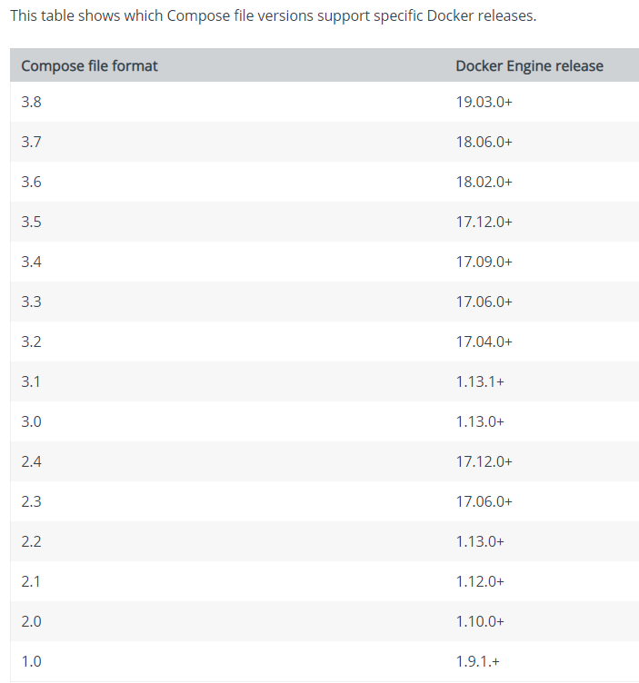

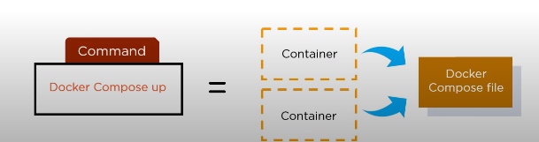

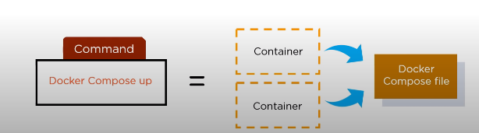
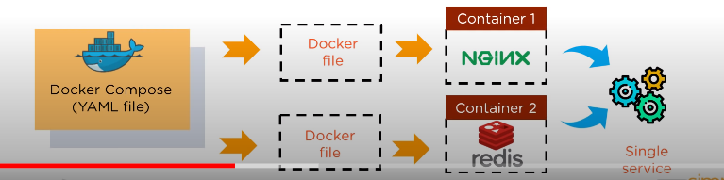

Using Compose is basically a three-step process:
Define your app’s environment with a Dockerfile so it can be reproduced anywhere.

Define the services that make up your app in docker-compose.yml so they can be run together in an isolated environment.

Run docker-compose up and Compose starts and runs your entire app.

Docker Compose overrides:
Docker Compose offers you the ability to not only compose a collection of Docker services via a yaml configuration doc, but to override this configuration based on the environment to which it is being deployed.
Each docker-compose.yml file can (and should) have a corresponding docker-compose.override.yml. The docker-compose.override.yml file is a default for ‘development’ overrides, and will be run by default along with your docker-compose.yml, unless you specify otherwise

How do Docker Compose overrides work?
When docker compose is handed two or more compose files (written in yaml to define the services which comprise your application), it merges them together, bringing all the resources and configuration together into a single merged definition of what you’re after.

By default, Compose reads two files, a docker-compose.yml and an optional docker-compose.override.yml file. By convention, the docker-compose.yml contains your base configuration. The override file, as its name implies, can contain configuration overrides for existing services or entirely new services.
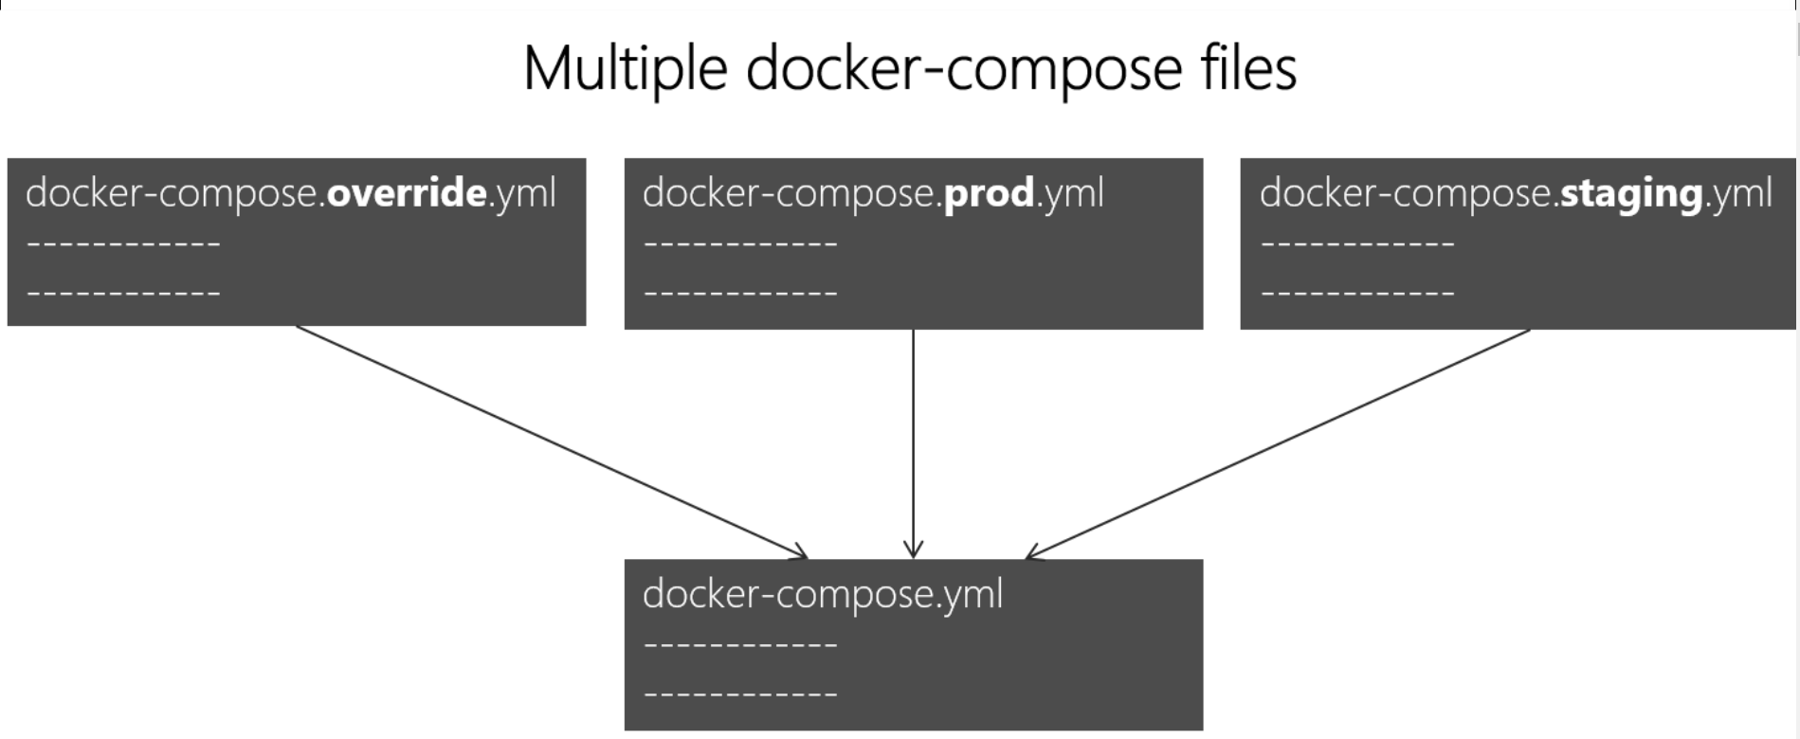
To deploy with this production Compose file you can run
docker-compose -f docker-compose.yml -f docker-compose.prod.yml up -d
This deploys all three services using the configuration in docker-compose.yml and docker-compose.prod.yml (but not the dev configuration in docker-compose.override.yml).

Environment variables in Compose

You can pass multiple environment variables from an external file through to a service’s containers w

What’s Kompose?
Kompose is a conversion tool for Docker Compose to container orchestrators such as Kubernetes (or OpenShift).

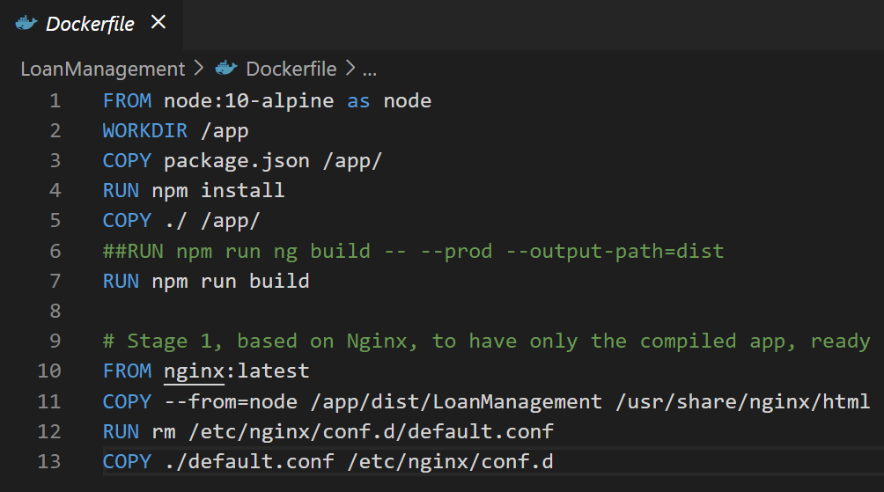

FROM node:10-alpine as node
WORKDIR /app
COPY package.json /app/
RUN npm install
COPY ./ /app/
##RUN npm run ng build -- --prod --output-path=dist
RUN npm run build

# Stage 1, based on Nginx, to have only the compiled app, ready for production with Nginx
FROM nginx:latest
COPY --from=node /app/dist/LoanManagement /usr/share/nginx/html
RUN rm /etc/nginx/conf.d/default.conf
COPY ./default.conf /etc/nginx/conf.d

server {
listen 80;
server_name 192.168.99.100;
location / {
root /usr/share/nginx/html;
index index.html index.htm;
try_files $uri $uri/ /index.html =404;
}
}

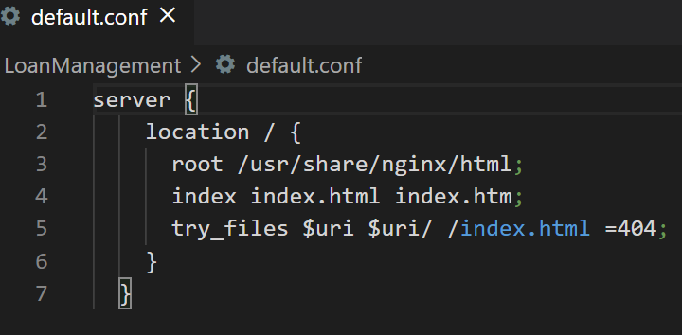
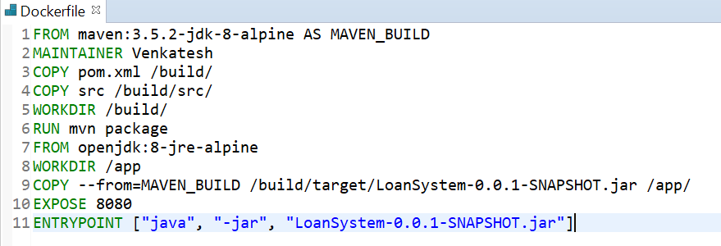

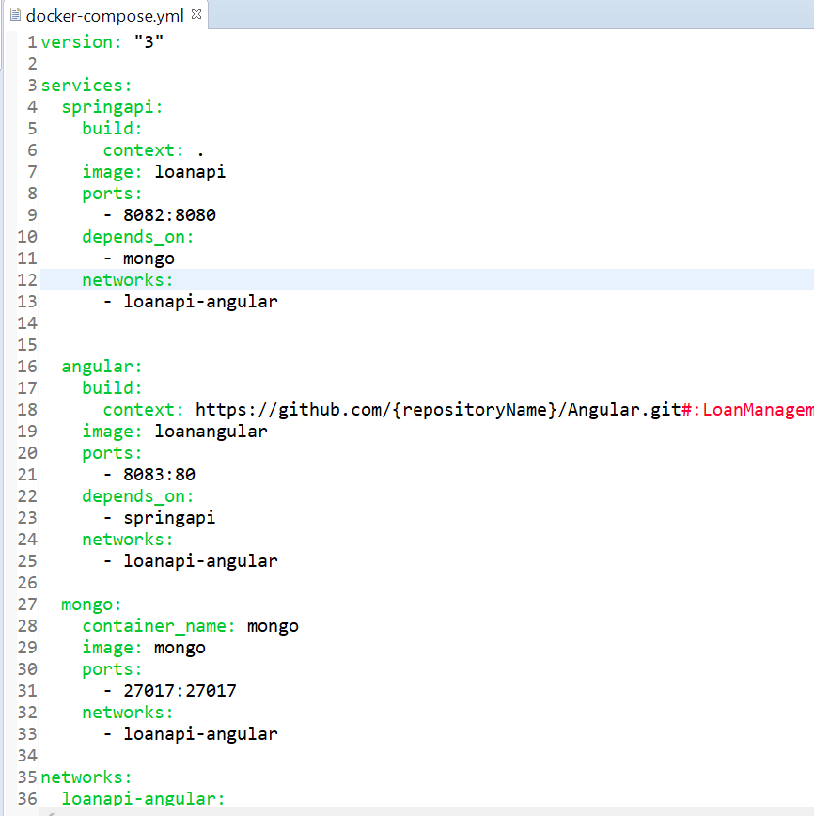

version: "3"

services:
springapi:
build:
context: .
image: loanapi
ports:
- 8082:8080
depends_on:
- mongo
networks:
- loanapi-angular

angular:
build:
context: https://github.com/venkatesh-buddy/Angular.git#:LoanManagement/
image: loanangular
ports:
- 8083:80
depends_on:
- springapi
networks:
- loanapi-angular

mongo:
container_name: mongo
image: mongo
ports:
- 27017:27017
networks:
- loanapi-angular

mongo-init:
build: ./mongo-init
networks:
- loanapi-angular

mongo-client:
image: mongoclient/mongoclient
ports:
- 3030:3000
environment:
- MONGOCLIENT_DEFAULT_CONNECTION_URL=mongodb://mongo:27017
networks:
- loanapi-angular

networks:
loanapi-angular:

FROM maven:3.5.2-jdk-8-alpine AS MAVEN_BUILD
MAINTAINER Venkatesh
COPY pom.xml /build/
COPY src /build/src/
WORKDIR /build/
RUN mvn package
FROM openjdk:8-jre-alpine
WORKDIR /app
COPY --from=MAVEN_BUILD /build/target/LoanSystem-0.0.1-SNAPSHOT.jar /app/
EXPOSE 8080
ENTRYPOINT ["java", "-jar", "LoanSystem-0.0.1-SNAPSHOT.jar"]

