SpringBoot-Kafka-Prometheus-Grafana

Overview:
In this example will take a look of step-by -step guide for integrating Kafka using spring boot to send and receive messages. Then will integrate with Prometheus (Time series database) and Grafana to visualize the monitoring system.

Kafka:
Apache Kafka is an open source project used to publish and subscribe the messages based on the fault-tolerant messaging system.
Prometheus:
Prometheus is a time-series database that stores our metric data by pulling it (using a built-in data scraper) periodically over HTTP.
Grafana:
Grafana offers a rich UI where you can build up custom graphs quickly and create a dashboard out of many graphs in no time.Grafana can pull data from various data sources like Prometheus, Elasticsearch, InfluxDB, etc. It also allows you to set rule-based alerts, which then can notify using email and other tools.

Zookeeper:
Zookeeper keeps track of status of the Kafka cluster nodes and it also keeps track of Kafka topics, partitions etc. Zookeeper it self is allowing multiple clients to perform simultaneous reads and writes and acts as a shared configuration service within the system

Project Structure:
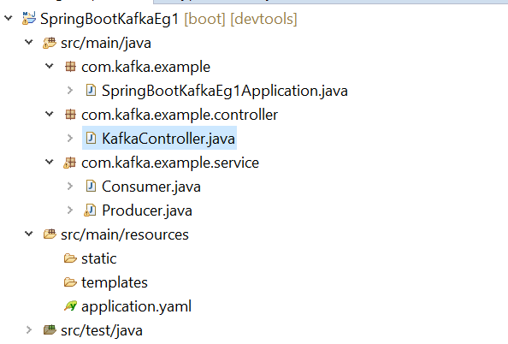
Pom.xml
<?xml version="1.0" encoding="UTF-8"?>
<project xmlns="http://maven.apache.org/POM/4.0.0" xmlns:xsi="http://www.w3.org/2001/XMLSchema-instance"
xsi:schemaLocation="http://maven.apache.org/POM/4.0.0 https://maven.apache.org/xsd/maven-4.0.0.xsd">
<modelVersion>4.0.0</modelVersion>
<parent>
<groupId>org.springframework.boot</groupId>
<artifactId>spring-boot-starter-parent</artifactId>
<version>2.3.4.RELEASE</version>
<relativePath/> <!-- lookup parent from repository -->
</parent>
<groupId>com..kafka.example</groupId>
<artifactId>SpringBootKafkaEg1</artifactId>
<version>0.0.1-SNAPSHOT</version>
<name>SpringBootKafkaEg1</name>
<description>SpringBootKafkaEg1</description>

<properties>
<java.version>1.8</java.version>
</properties>

<dependencies>
<dependency>
<groupId>org.springframework.boot</groupId>
<artifactId>spring-boot-starter-actuator</artifactId>
</dependency>
<dependency>
<groupId>org.springframework.boot</groupId>
<artifactId>spring-boot-starter-web</artifactId>
</dependency>
<dependency>
<groupId>org.springframework.kafka</groupId>
<artifactId>spring-kafka</artifactId>
</dependency>

<dependency>
<groupId>org.springframework.boot</groupId>
<artifactId>spring-boot-devtools</artifactId>
<scope>runtime</scope>
<optional>true</optional>
</dependency>
<dependency>
<groupId>org.springframework.boot</groupId>
<artifactId>spring-boot-starter-test</artifactId>
<scope>test</scope>
<exclusions>
<exclusion>
<groupId>org.junit.vintage</groupId>
<artifactId>junit-vintage-engine</artifactId>
</exclusion>
</exclusions>
</dependency>
<dependency>
<groupId>org.springframework.kafka</groupId>
<artifactId>spring-kafka-test</artifactId>
<scope>test</scope>
</dependency>
<dependency>
<groupId>io.micrometer</groupId>
<artifactId>micrometer-registry-prometheus</artifactId>
</dependency>
</dependencies>

<build>
<plugins>
<plugin>
<groupId>org.springframework.boot</groupId>
<artifactId>spring-boot-maven-plugin</artifactId>
</plugin>
</plugins>
</build>

</project>

application.yaml
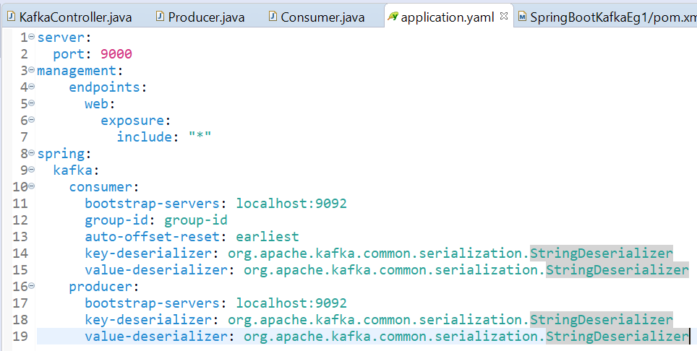

Controller:
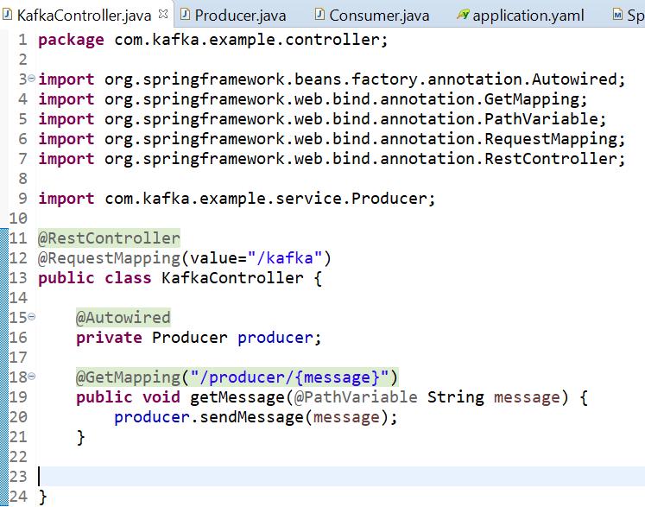

Producer:
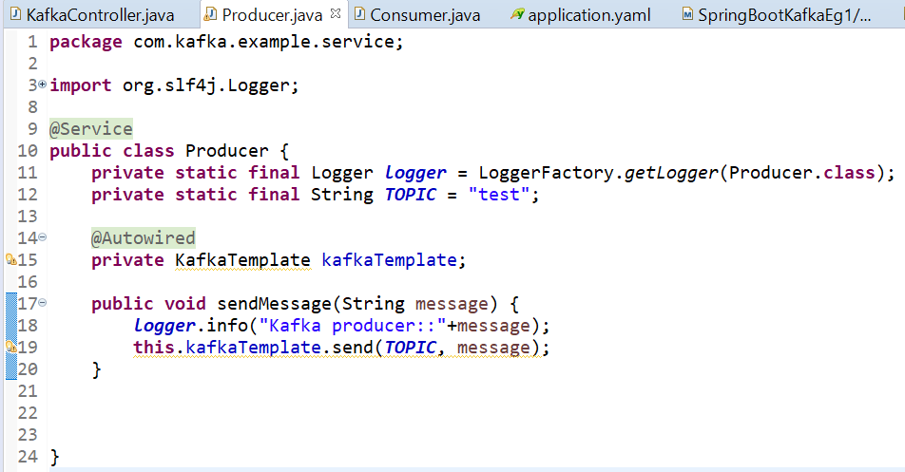

Consumer:
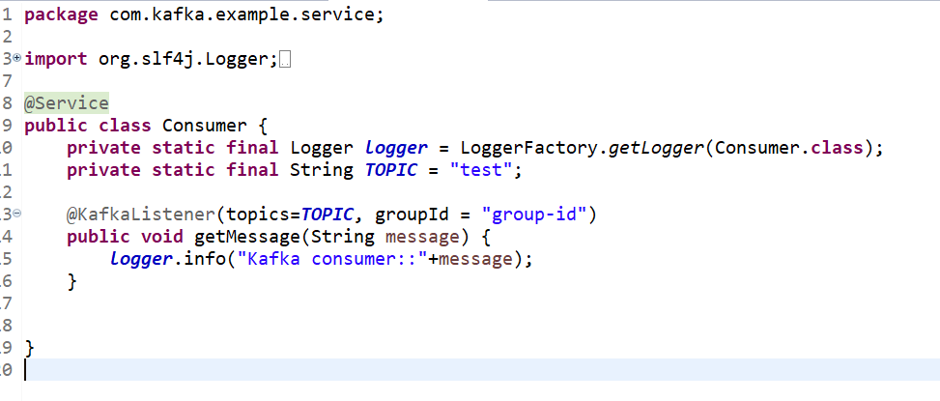

Steps to start other services
1. Zookeeper
2. Apache kafka
3. Prometheus
4. Grafana

Zookeeper:
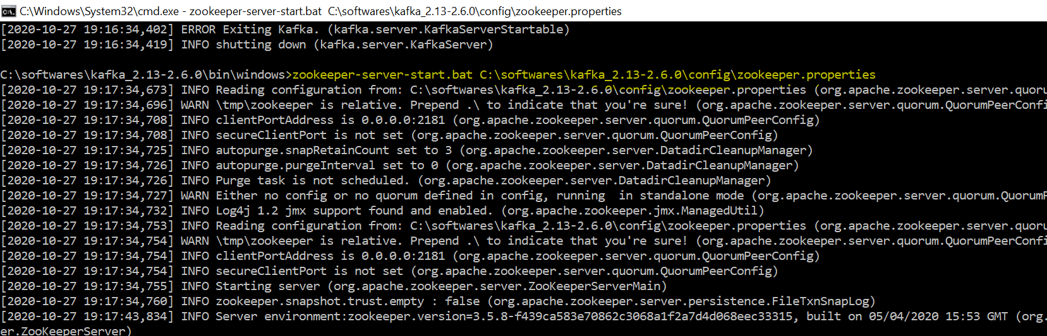

Prometheus:
To configure the application you can add the configuration in Prometheus.yaml or create separate file. I have created spring-kafka.yaml file.
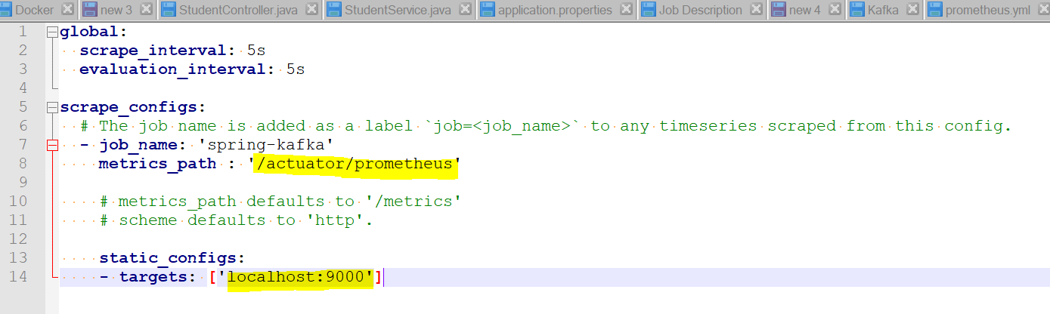
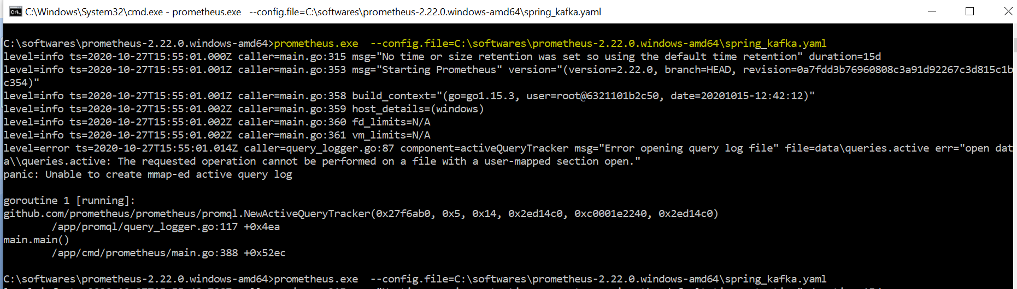
Prometheus: http://localhost:9090/
Grafana:
From services start the grafana. http://localhost:3000/
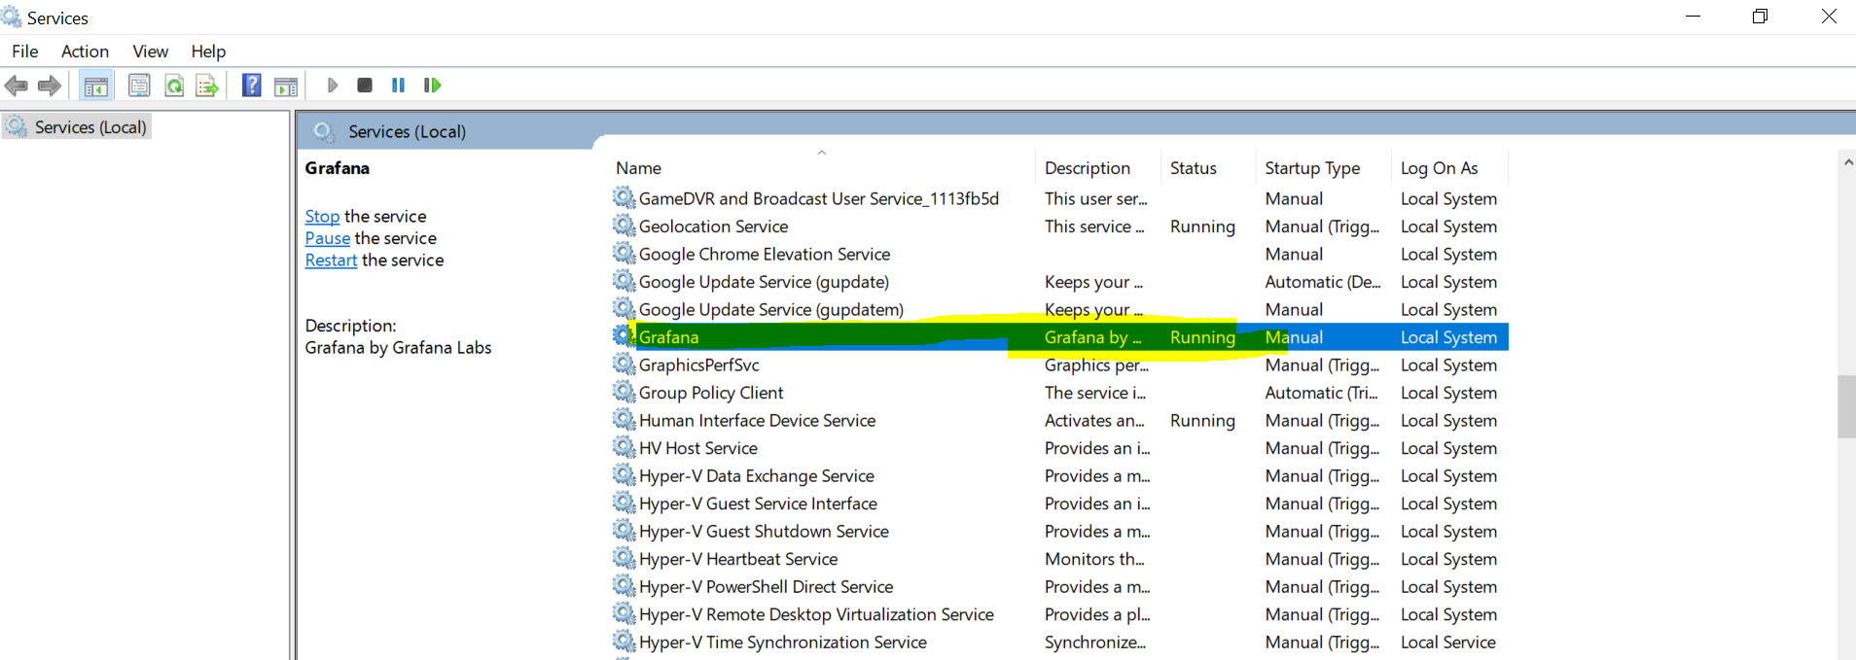
Start the spring boot application:
http://localhost:9000/kafka/producer/Venkatesh%20Azhagiri

For testing I have sent multiple message which you see in the kafka-console.

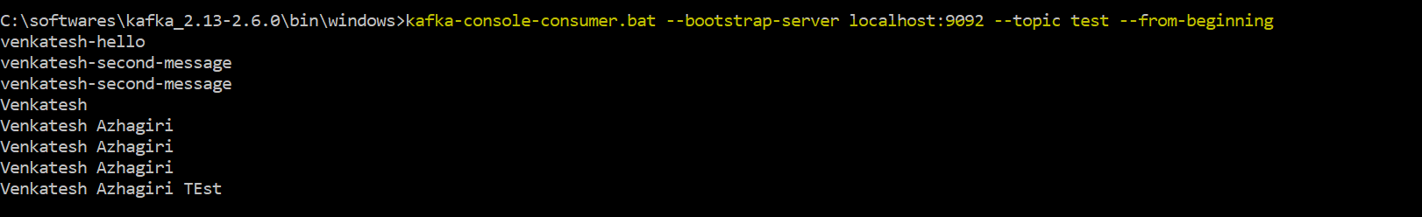

Prometheus:

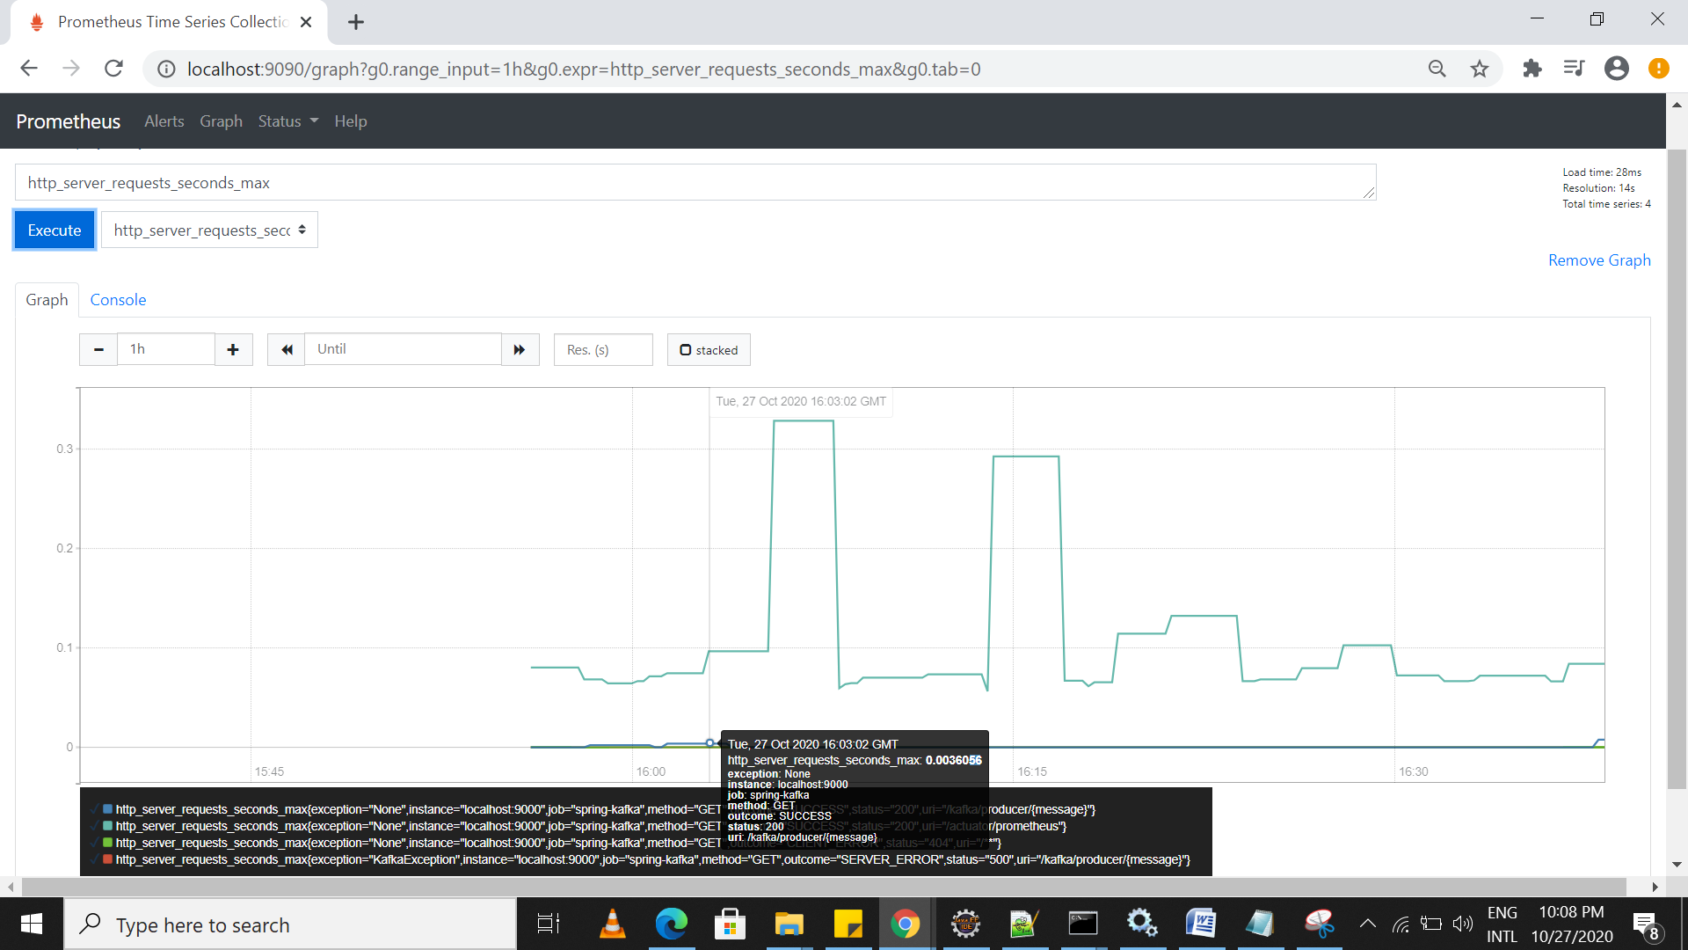

Grafana:
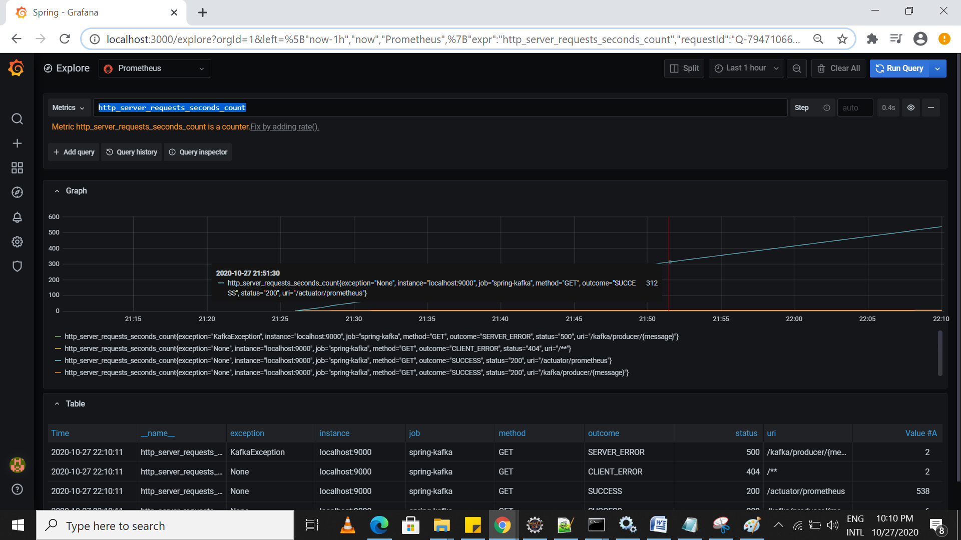

Apache kafka:
