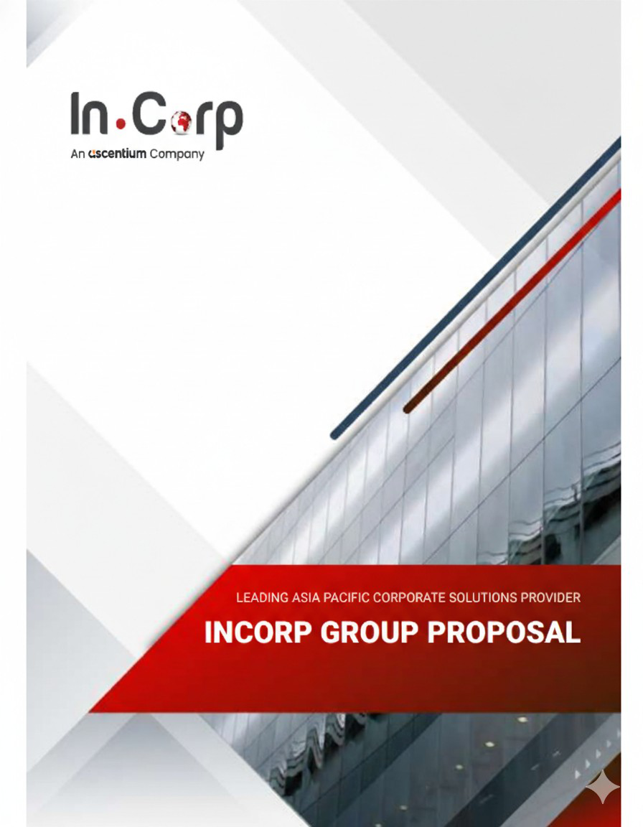
j3k


12. 02. 2026
asxa
jd
j3k
dsf
Dear asxa,
RE: FEE PROPOSAL
We are pleased to be presenting our proposal to you.
Our team of experienced professionals work very closely with clients on various corporate, accounting, compliance and governance matter and identify the unique requirements of individual organizations. As a strong believer of long-term partnerships, we are committed to providing tailored solutions that not only meet our clients' objectives, but also giving them a peace of mind to focus on their core businesses.
The following pages outline our services tailor made to you and we trust that our proposal meets your expectations. We are excited to work with you and look forward to a long and mutually beneficial working relationship with you and the company.
,
Yours Sincerely and on behalf of In.Corp,
CA Bansi Shah
Lead – International clients group
InCorp Advisory Services Pvt Ltd
www.incorp.asia Page 5 of 19
© In.Corp Global Pte Ltd. All Right Reserved.
This document is being furnished to you on a confidential basis and solely for your information.


SCOPE OF SERVICES
FEES
This section outlines the estimated fees for InCorp's services of your company. Our fee structure includes initial setup fees, as well as ongoing charges that may be billed monthly, quarterly, or annually. Additionally, fees may be incurred based on the time spent on specific tasks or on a per-instance basis. For any additional services not encompassed by this proposal that may incur, additional charges, we will receive your approval before any work commences. Please note that all fees mentioned are in US Dollars, exclusive of the prevailing Goods and Services Tax (GST) / Value Added Tax (VAT).
A. One time Handover Service
Since the company has been in existence since 35vfe, we shall need to undertake a handover of the current financial, secretarial, payroll and other records of the company from current service provider.
Services | Frequency | Fee (In USD)
Basic due diligence from perspective of*–• Company's Act, 2013  • Income Tax Act, 1961  • Goods and Service Tax Act, 2017  • Foreign Exchange Management Act, 1999 | One-time | 0
*Any fees for rectification (or) completion of pending past compliances shall attract additional fees and we shall seek your approval prior to commencement of that work.
Note:
• All fees quoted above exclude 18% GST
• Professional fees exclude any fees towards regularisation of past non compliances.• Advance of 100% of the above selected option.
* Any other services not specifically quoted above and not specifically agreed separately shall be chargeable as under:
For Partner: USD 300 per Hour
For Associates: USD 200 per Hour
B. Incorporation / Secretarial Service and Mandatory Registrations post Incorporation
Services | One-time Fee

www.incorp.asia Page 6 of 19
© In.Corp Global Pte Ltd. All Right Reserved.
This document is being furnished to you on a confidential basis and solely for your information.


FCGPR Filing with Reserve Bank of India  Filing of Forms and declaration with RBI as required under FEMA | 0
Note:
• All fees quoted above exclude 18% GST.
• Professional fees exclude all out-of-pocket expenses like filing fees, courier expenses, apostilling & notary cost to any authorities/departments, statutory fees payable to Registrar of companies (ROC) towards incorporation etc. other than those mentioned above.
• Advance of 100% of the above selected option.
• On finalization of shareholding structure, we shall be able to guide on compliances needed for issuance of share certificates and shall share a separate fee quote for the same.
* Any other services not specifically quoted above and not specifically agreed separately shall be chargeable as under
For Partner: USD 300 per Hour
For Associates: USD 200 per Hour
Optional registrations required post incorporation (One-time)
Services | Fees (In USD)
Filing of requisite forms with Registrar of Companies (ROC) with respect to beneficial and nominee shareholding (via Form MGT 4, MGT 5, MGT 6) | 0
*For every new director's professional tax no., there shall be additional cost of $100 per director *Digital signature certificate (DSC) token can be obtained at a cost of USD 200 per applicant.
Note:
• All fees quoted above exclude 18% GST.
• Professional fees exclude all out-of-pocket expenses like filing fees, courier expenses, apostilling & notary cost to any authorities/departments, statutory fees payable to Registrar of companies (ROC) towards incorporation etc. other than those mentioned above.
• Advance of 100% of the above selected option.
*Any other services not specifically quoted above and not specifically agreed separately shall be chargeable as under
For Partner: USD 300 per Hour
For Associates: USD 200 per Hour
Nominee Director and Registered Office Address Service
Services | Monthly Fee(in USD)

www.incorp.asia Page 7 of 19
© In.Corp Global Pte Ltd. All Right Reserved.
This document is being furnished to you on a confidential basis and solely for your information.


Nominee Director Service  A refundable Security deposit per nominee @USD 5000 applies*. Refundable upon cessation of Nominee Director Service  Director's fee for attending a physical or recorded or live board meeting @USD300 per director per board meeting  Every nominee director needs to be protected under a director's indemnity policy. Premium of indemnity bond to be charged on actual basis. InCorp shall enter into a separate nominee directors' agreement at the time of engagement.  To ensure the removal of a nominee director from registrations ***with various authorities where required, InCorp must be notified at least three months in advance. Additionally, professional fees for this service will continue to be charged until the removal is reflected by all relevant authorities as well as Bank & new director is appointed in his place. | 0
*Failure to engage InCorp's services for regular compliances of the company post the setup such as tax, secretarial, FEMA etc. shall result in forfeiture of the security deposit received against nominee director and registered office services.
**Any fees for rectification (or) completion of pending past compliances shall attract additional fees and we shall seek your approval prior to commencement of that work.
*** The Nominee Director shall not sign any return, forms or documents relating to any statutory filing nor will be appointed as the authorized signatory to any of the bank accounts of the entity or under GST, Income Tax any other government portal. The Company may consider appointing one of its key managerial personnel as the authorised signatory across all government portals
Note:
• All fees quoted above exclude 18% GST.
• The Nominee Director will not be involved in day-to-day affairs / management of the Company. He/She shall not sign any return, forms or documents relating to any statutory filing.
• The service of Registered office & Nominee director is offered on discretionary basis only for temporary basis of 6 months. Such services are provided only in case of successful completion of Internal Customer Due diligence at InCorp and formal engagement of Incorp for all the compliances (tax, secretarial, FEMA etc.) post incorporation of the company for the regular maintenance of the company.
•Failure to engage InCorp's services for regular compliances of the company post the setup such as tax, secretarial, FEMA etc. shall result in forfeiture of the security deposit received against registered office and nominee director services.
•Professional fees exclude all out-of-pocket expenses like filing fees, courier expenses, apostilling & notary cost to any authorities/departments, statutory fees payable to Registrar of companies (ROC) towards incorporation etc. other than those mentioned above.
• Advance of 100% of the above selected option.
* Any other services not specifically quoted above shall be chargeable as under:
For Partner: USD 300 per Hour
For Associates: USD 200 per Hour
C. Accounting / Tax / Payroll / Annual Compliance Services
www.incorp.asia Page 8 of 19
© In.Corp Global Pte Ltd. All Right Reserved.
This document is being furnished to you on a confidential basis and solely for your information.


The below quotation is our base fees for first year of business with limited volume of transactions and may change depending upon volume of work and nature of transactions:
Services | Frequency | Notes | Fees (in USD)
Direct tax  compliances | Quarterly | 1) Advance tax Compliances • Quarterly  calculations and payment | 0
Indirect tax  compliances | Monthly and Annual | 1) GST Compliances:  • Calculations and payment of GST• Filing of monthly GST Returns  (The above excludes Annual returns of GST and revision of GST returns) | 0
Foreign Exchange laws | Annual | Annual Filings with Reserve bank of India | 0
Total costs (excluding one time costs) |  |  | 0 per annum
One-time costs |  |  | 0 one time
*The above quotation fee is for approx.20 transactions per month
InCorp's empanelled audit partners can offer the services of statutory audit (applicable to all), tax audit (applicable on if Turnover exceeds Rs. 100 Mn) and GST audit services (If Turnover exceeds Rs. 50 Mn) and transfer pricing reporting & audit (applicable for companies having intercompany transactions). The quotes for the same can be provided separately.
^Audit partner firms (Jayesh Sanghrajka &Associates;, Manish Modi &Associates;) shall be able to assist on that front. The estimated statutory fee quote for the first FY shall be between USD 2500 TO USD 3500.The auditor shall be able to provide the final fee quote closer to year end March 2025 depending on the nature and complexity of transactions.
Note:
• All fees quoted above exclude 18% GST.
• Professional fees exclude all out-of-pocket expenses like filing fees, courier expenses, government/statutory fees etc.
• Advance of 100% of the above selected option
* Any other services not specifically quoted above shall be chargeable as under:
For Partner: USD 300 per Hour
For Associates: USD 200 per Hour
D. Transfer Pricing compliances
Services | Frequency | Notes | Fee (In USD)

www.incorp.asia Page 9 of 19
© In.Corp Global Pte Ltd. All Right Reserved.
This document is being furnished to you on a confidential basis and solely for your information.


Inter-company agreement | One-time | Drafting and finalizing of Inter-company service  agreement covering detailed description of  service to be provided, components to be included while calculating cost of services, Invoicing period, Receivable cycle, withholding, ownership rights, effective date of agreement, indemnity etc.  in compliance with the Transfer Pricing  regulations defined under Income tax laws and other applicable Indian laws | 0
Total one-time costs |  |  | 0
*Please note that the above benchmarking report will not be transfer pricing documentation as required to be maintained under transfer pricing regulations. InCorp's empanelled audit partners can assist with the transfer pricing reporting & audit (applicable for companies having intercompany transactions). The quotes for the same can be provided separately
Note:
• All fees quoted above exclude 18% GST.
• Professional fees exclude all out-of-pocket expenses.
• Advance of 100% of the above selected option. • * Any other services not specifically quoted above shall be chargeable as under:
For Partner: USD 300 per Hour
For Associates: USD 200 per Hour
^ InCorp's empanelled audit partners can assist with the transfer pricing reporting & audit (applicable for companies having intercompany transactions). The quotes for the same can be provided separately.
www.incorp.asia Page 10 of 19
© In.Corp Global Pte Ltd. All Right Reserved.
This document is being furnished to you on a confidential basis and solely for your information.

