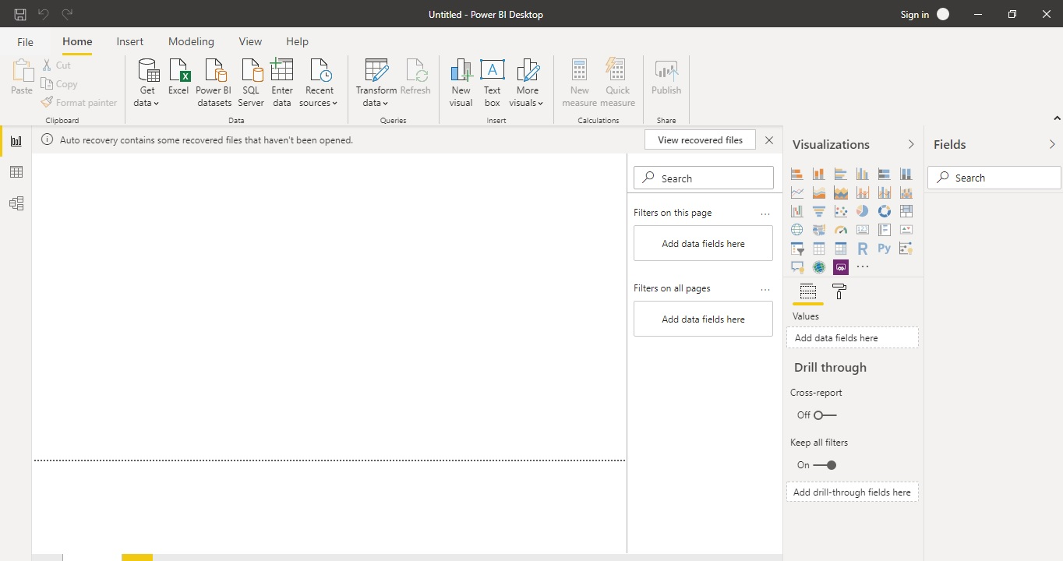

Report View :

A Power BI report is used for viewing into a dataset, with visuals that represent different findings and insights from that dataset. A report can have a sing le visual or pages full of visuals.

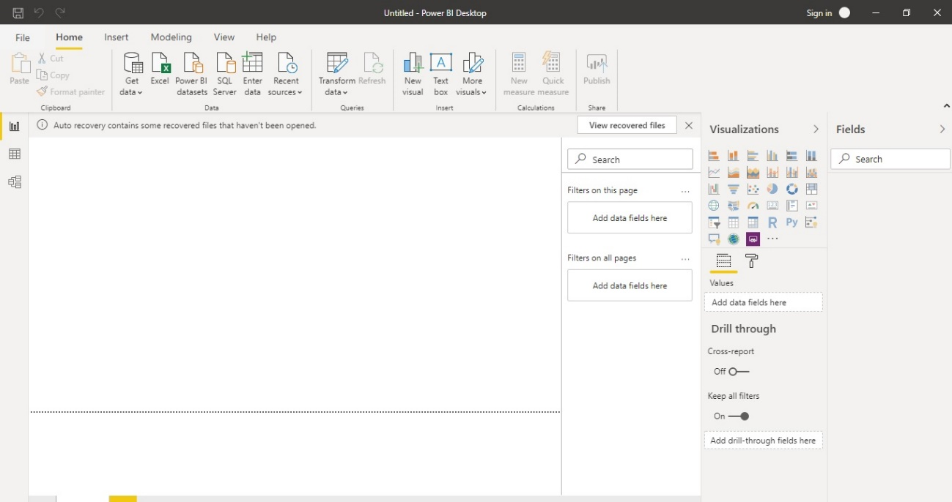

Data View :

Data view is used for inspecting, exploring, and understand data in Power BI Desktop model. With Data view, we can look at your data after it has been loaded into the model.

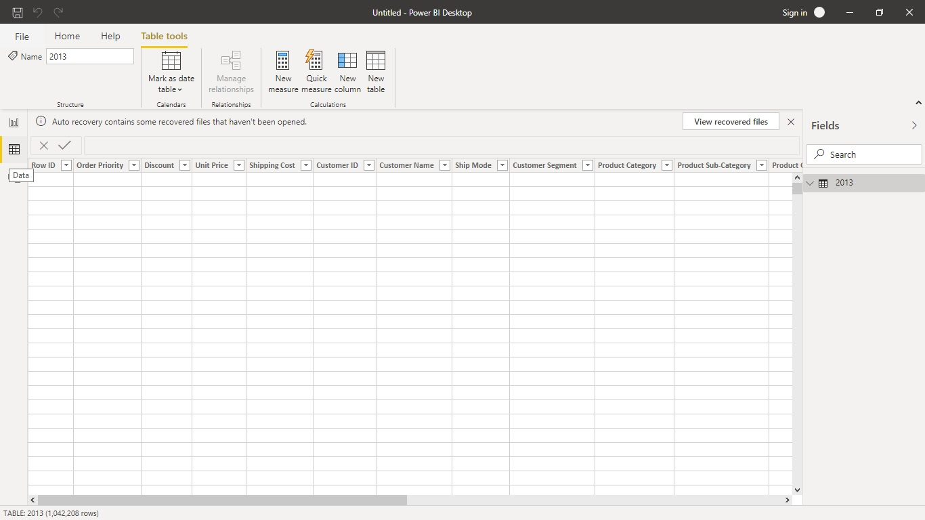

Model View

Model view shows all of the tables, columns, and relationships in your model. This view can be especially helpful when your model has complex relationships between many tables.

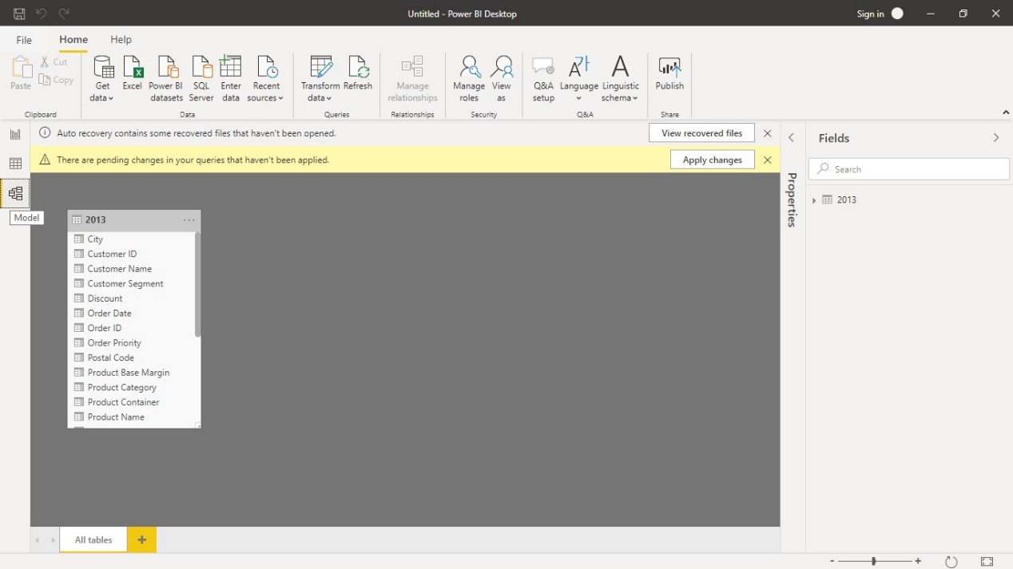

Power Query Editor

Query Editor in Power BI is used to transform or edit data files before they are actually loaded into the Power BI. By using this we can transform our data according to our needs.

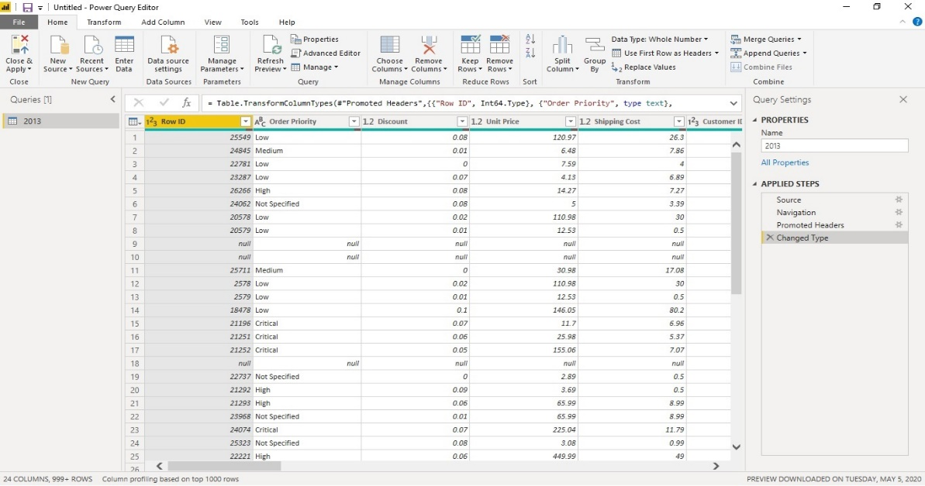

Advance Editor

Advance editors are helpful for seeing the code which are created by the power query editor.

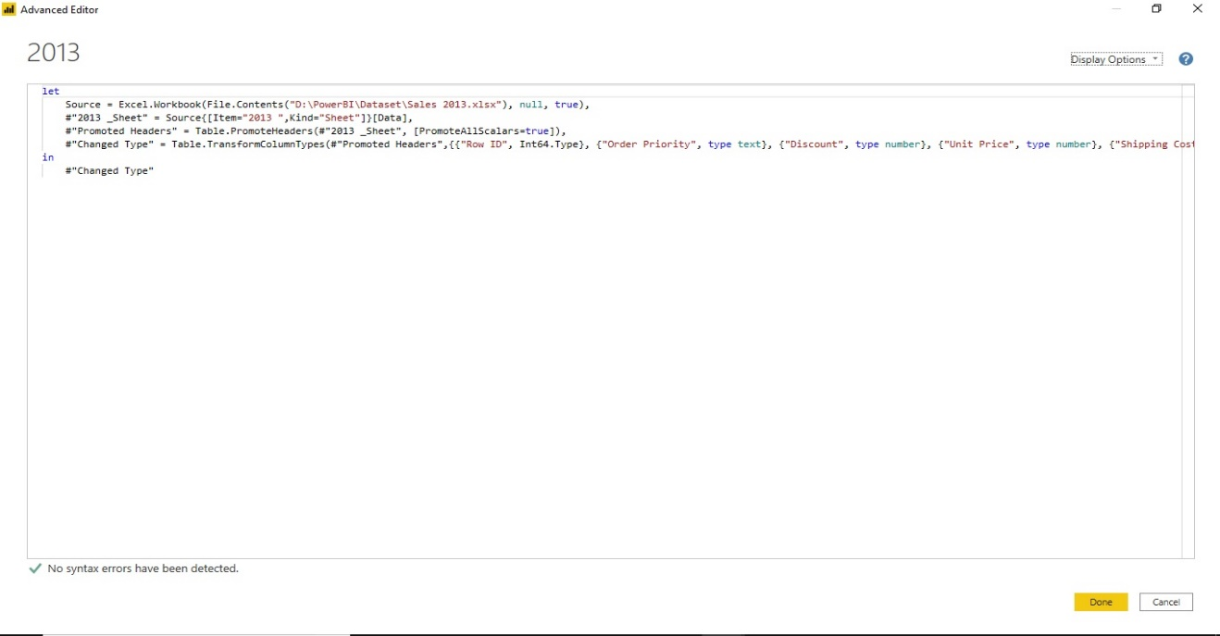

Power BI Desktop

Power BI Desktop is a free software which are implemented in our local computer which are used to connect ,transform ,and visualize of the data.

Cost: Free

Power BI Pro

It is a licensed software which are very helpful for creating and sharing your data, reports, and dashboards with other users.

Cost: $9.99/user/month (755.26 Indian Rupee)

Power BI Premium

Power BI Premium used to get dedicated and enhanced resources for organization, so that users in organization can use the Power BI service with better performance and responsiveness. For example, with a Power BI Premium subscription, users get access to:

* Greater scale and performance
* Flexibility to license by capacity
* Unify self-service and enterprise BI
* Extend on-premises BI with Power BI Report Server
* Support for data residency by region (Multi-Geo)
* Share data with anyone without purchasing a per-user license

Cost:$4,995(Rs. 377,62)