A Technical Seminar Report On

## REVOLUTIONIZING COMMUNICATION WITH

## QUANTUM COMPUTING

Submitted in partial fulfillment of the Requirements for the award of the degree

### BACHELOR OF TECHNOLOGY IN

**ELECTRONICS AND COMMUNICATION ENGINEERING**

Submitted By

**NALLA VENKATESH**

Under the guidance of

**T. SR.CH.MURTHY**

Assistant Professor



**Department of ELECTRONICS AND COMMUNICATION ENGINEERING**

## ANURAG UNIVERSITY

**(Approved by AICTE and NBA Accredited)**

**Venkatapur (V), Ghatkesar (M), Medchal district, Hyderabad, Telangana,500088**

## ANURAG UNIVERSITY

**(Approved by AICTE and NBA Accredited)**

**Venkatapur (V), Ghatkesar (M), Medchal district, Hyderabad, Telangana,500088**

**Department of ELECTRONICS AND COMMUNICATION ENGINEERING**

# CERTIFICATE

This is to certify that the technical seminar report entitled “**REVOLUTIONIZING COMMUNICATION WITH QUANTUM COMPUTING”** is a Bonafide work done and submitted by **NALLA VENKATESH** in partial fulfillment of the requirements for the award of the degree of B. Tech in **Electronics & Communication Engineering** from **Anurag University**, Hyderabad during the academic year 2024-2025.

**Internal Guide HOD**

**Mr.CH.Murthy Dr. Mangala Gowri**

**Assistant Professor Professor**

Department of ECE Department of ECE

**External Examiner**

# DECLARATION

This is to Certify that the technical seminar report work entitled “**REVOLUTIONIZING COMMUNICATION WITH QUANTUM COMPUTING”** submitted to Anurag Group of Institutions in partial fulfillment of the requirement for the award of the Degree of Bachelor of Technology (B-Tech), is an original work by **Nalla Venkatesh (21EG104B37)** under the guidance of **Ms. CH. Murthy, Assistant Professor,** in the Department of ELECTRONICS AND COMMUNICATION ENGINEERING. This matter embodied in this technical seminar report is a genuine work, done by the students and has not been submitted whether the university or to any other university/Institute for the fulfillment of the requirement of any course of study.

**Nalla Venkatesh**

**21EG104B37**

# ACKNOWLEDGEMENT

This technical seminar is a acknowledgement to the inspiration, drive, and

technical assistance contributed by many individuals. It would not have been possible

without the help and guidance we have received. I would like to express our gratitude

to all the people behind the scenes who helped us transform an idea into a successful

presentation.

It is my privilege and pleasure to express our profound sense of gratitude to

**Mr.CH. Murthy** Assistant Professor, Department of ECE, for his guidance

throughout this seminar.

I extend my sincere gratitude to **Dr. N. MANGALA GOURI**, Head of the Department

of Electronics and Communication Engineering, for her valuable suggestions and

continuous support, which greatly contributed to the success of this seminar. She has

been a great source of inspiration to our work.

I would like to express my deep sense of gratitude to **Dr. V. VINAY KUMAR, Dean**

**of Engineering, Anurag University** for his tremendous support, encouragement, and

inspiration.

I extend sincere gratitude to **Dr. Balaji Utla Registrar, Dr Archana Mantri Vice-**

**Chancellor,** Anurag University for their encouragement and motivation towards the

successful completion of this work.

Lastly, I thank almighty, our parents, friends for their constant encouragement without

which this seminar would not be possible. I would like to thank all the other staff

members, both teaching and non- teaching, which have extended their timely help and

eased my work.

**Nalla Venkatesh**

**21EG104B37**

# 

# ABSTRACT

Quantum computing is set to revolutionize communication by introducing ultra-secure methods like quantum cryptography, leveraging quantum key distribution (QKD) to create unbreakable encryption. Its ability to process information at incredible speeds enables advancements in data security, efficiency, and reliability, laying the foundation for a quantum internet.

Additionally, innovations like quantum teleportation promise instantaneous transmission of information, pushing the boundaries of global connectivity. These breakthroughs hold the potential to transform fields like artificial intelligence, data sharing, and collaboration, shaping a future of seamless and advanced communication networks.

**TABLE OF CONTENTS**

|  |  |
| --- | --- |
| **CONTENT** | **PAGE NO** |
| DECLARATION | I |
| ACKNOWLEDGEMENT | II |
| ABSTRACT | III |
| TABLE OF CONTENTS | IV |
| LIST OF FIGURES | V |
| CHAPTER 1: INTRODUCTION | 1 |
| CHAPTER 2: EVOLUTION | 3 |
| CHAPTER 3: QUANTUM COMMUNICATION | 5 |
| CHAPTER 4: WORKING PRINCIPLE | 6 |
| CHAPTER 5: CHALLENGES AND SOLUTIONS | 7 |
| CHAPTER 6: FUTURE IMPLICATIONS | 8 |
| CHAPTER 7: CASE STUDY | 9 |
| CHAPTER 8: CONCLUSION | 11 |
| CHAPTER 9: REFERENCE | 12 |

**LIST OF FIGURES**

|  |  |  |
| --- | --- | --- |
| **FIGURE** | **TITLE** | **PAGE NO** |
| 1 | Structure of Quantum Computer | **1** |
| 2 | Evolution of Quantum Computing | **3** |
| 3 | Working of Quantum Communication | **6** |

**1.INTRODUCTION**

The birth of quantum mechanics dates to December 14, 1900, when Max Planck presented his groundbreaking work on the spectral distribution of blackbody radiation to the German Physical Society. His findings introduced a formula that matched experimental data, paving the way for a deeper understanding of the microscopic world. By the 1920s, quantum mechanics had evolved into a well-established theory. However, the subsequent decades saw a shift in focus towards quantum field theory, culminating in the 1970s with the development of the standard model, signifying its maturity. Towards the close of the 20th century, the fusion of quantum mechanics with information science gave rise to the interdisciplinary field of quantum information, introducing revolutionary areas like quantum communication and quantum computing. This advancement reignited interest in quantum mechanics.

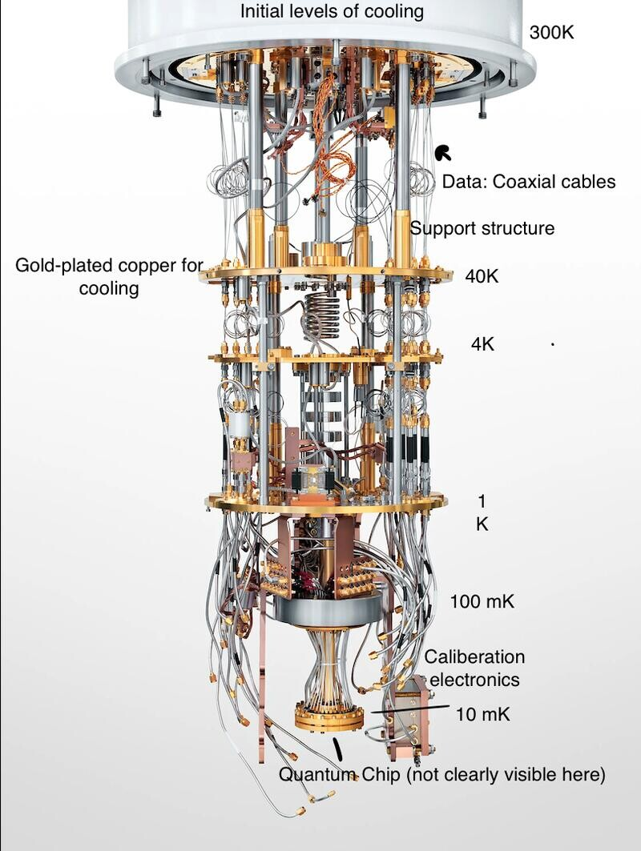

**Fig 1**

**Structure of Quantum Computer**

Quantum mechanics delves into the behavior of microscopic particles under low energy conditions. Its foundational principle is encapsulated in the Schrödinger equation. Yet, there are instances where the equation is not directly utilized, and only operators and wave functions are applied. Interestingly, quantum communication and quantum computing transcend traditional mathematical tools, leveraging unique quantum phenomena instead. Quantum communication is underpinned by the quantum no-cloning theorem, ensuring secure data transfer, while quantum computing capitalizes on the principle of quantum state superposition to process information in unprecedented ways.

The rise of quantum information science has not only expanded our understanding of quantum mechanics but also led to significant practical applications in modern technology. Quantum communication, with its ability to provide unbreakable security using the no-cloning theorem, is a major breakthrough in safeguarding sensitive data in an increasingly digital world. Similarly, quantum computing, through principles like superposition and entanglement, has the potential to revolutionize problem-solving in fields such as cryptography, artificial intelligence, and complex system modeling. These advancements underscore the relevance of quantum mechanics beyond theoretical physics, shaping the future of science and technology.This report aims to explore the various aspects of VLSI in quantum computing, highlighting its significance in the development of practical quantum processors. We will examine its evolution, working principles, applications, challenges, and future trends in the field.

**2 . EVOLUTION**

The journey of revolutionizing communication with quantum computing began with the foundational principles of quantum mechanics, such as superposition and entanglement. These principles introduced the possibility of transmitting data in entirely new ways, leveraging the unique properties of qubits for secure and efficient communication. In its early stages, quantum communication relied on proof-of-concept experiments, but practical implementation was hindered by technological challenges, including noise, scalability, and qubit control. These limitations restricted its adoption to small-scale experimental setups, yet they laid the groundwork for exploring the potential of quantum networks and cryptography..

The evolution gained momentum with the advent of quantum key distribution (QKD), which uses the no-cloning theorem to ensure secure data transmission. This breakthrough marked a turning point, as it allowed for the development of encryption methods that were theoretically unbreakable. Over time, innovations in quantum hardware, such as the integration of superconducting qubits and cryogenic environments, provided the stability required to scale up quantum communication systems. These advances addressed many of the initial bottlenecks, enabling researchers to transition from theoretical models to real-world applications of quantum communication technology..

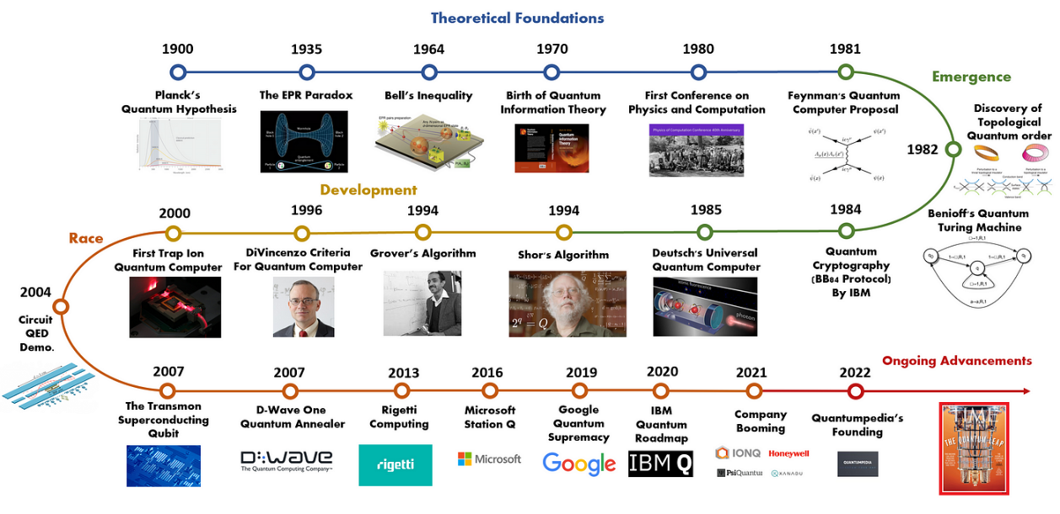

**Fig 2. Evolution of quantum computing**

As the field advanced, the concept of the quantum internet emerged—a network designed to leverage quantum mechanics for secure and high-speed communication. This vision has driven research into scalable solutions, such as entanglement swapping and error correction mechanisms, to ensure the reliability of quantum communication over large distances. Leading organizations and institutions have invested heavily in building prototypes for quantum networks, moving closer to realizing the dream of worldwide quantum connectivity.

Today, quantum communication continues to evolve with hybrid systems that integrate classical infrastructure with quantum technologies. These innovations are not only addressing current challenges but also opening the door to applications like secure cloud computing, advanced encryption for sensitive data, and real-time global collaboration. By reshaping how data is transmitted and protected, quantum computing stands at the forefront of revolutionizing communication for the future.

**3. QUANTUM COMMUNICATION**

Quantum communication is a groundbreaking field that leverages the principles of quantum mechanics, such as superposition and entanglement, to securely transmit information. Unlike classical communication methods, quantum communication ensures data integrity through the no-cloning theorem, which prevents an eavesdropper from duplicating quantum information without being detected. This unique feature has made quantum communication a leading contender in addressing the increasing challenges of data security in an interconnected world.

One of the most significant advancements in quantum communication is quantum key distribution (QKD). QKD uses entangled particles to establish encryption keys between two parties, ensuring that any interference during the key exchange is immediately noticeable. Popular protocols like BB84 have demonstrated the potential of QKD to create theoretically unbreakable encryption methods, marking a significant step forward in the development of secure communication technologies.

The concept of quantum teleportation is another transformative aspect of quantum communication. Quantum teleportation uses entangled particles to transmit the quantum state of a particle from one location to another without physically moving the particle itself. This phenomenon has profound implications for future technologies, including the creation of a quantum internet that enables instantaneous and lossless communication over vast distances.

Long-distance quantum communication remains a technical challenge due to the fragility of quantum states. To address this, researchers have developed quantum repeaters, which extend the range of quantum communication by maintaining entanglement over larger distances.

The future of quantum communication lies in hybrid systems that integrate quantum technologies with classical infrastructures. These systems aim to enhance efficiency, reliability, and scalability, creating a robust foundation for applications such as secure cloud computing, encrypted satellite communications, and real-time collaboration. With continued advancements, quantum communication promises to redefine the way information is exchanged, ensuring unparalleled security and speed.

**Summary**

Quantum communication is revolutionizing the way data is transmitted by utilizing the principles of quantum mechanics for ultra-secure communication. From quantum key distribution to teleportation and the development of quantum repeaters, this field continues to overcome challenges and push boundaries. As hybrid systems emerge, quantum communication is set to transform global connectivity and information security in unprecedented ways.

**4.WORKING PRINCIPLE**

Quantum communication relies on the unique properties of quantum mechanics to achieve secure and efficient data transmission. Key working principles include:

1. **Quantum Entanglement**: Entangled particles share a connection, such that the state of one particle instantly reflects in its partner, regardless of the distance. This property is essential for creating secure communication channels and forms the backbone of quantum communication.
2. **Quantum Key Distribution (QKD)**: QKD uses the no-cloning theorem, which states that quantum states cannot be copied, to securely exchange encryption keys. Protocols like BB84 ensure that eavesdropping attempts are detectable, making data transmission highly secure.
3. **Quantum Teleportation**: Leveraging entangled particles, quantum teleportation enables the transmission of quantum states without physical movement. This is pivotal for building quantum networks and ensuring instantaneous and lossless data exchange.
4. **Quantum Repeaters**: To extend communication distances, quantum repeaters are used to preserve entanglement across long ranges, ensuring reliable communication even across continents.

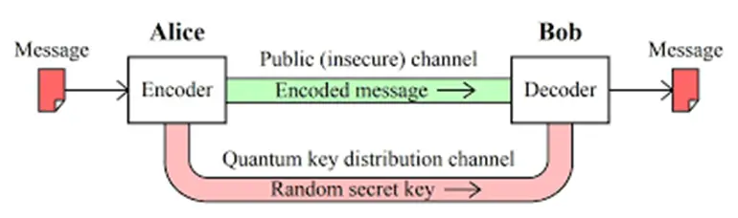

**Fig 3. Working of quantum communication**

By combining these principles, quantum communication enables groundbreaking advancements in data security and global connectivity.

**5.CHALLANGES AND SOLUTIONS**

Despite its transformative potential, quantum communication faces several challenges:

1. **Fragility of Quantum States**: Quantum states are highly sensitive to environmental disturbances, making long-distance communication difficult. **Solution**: Use of quantum repeaters and error correction mechanisms to maintain entanglement over large distances.
2. **Scalability**: Integrating quantum communication into existing infrastructures remains challenging. **Solution**: Hybrid quantum-classical models are being developed to bridge the gap.
3. **Cost and Complexity**: Quantum technologies require specialized equipment like cryogenic systems, making implementation expensive. **Solution**: Ongoing research is focused on making quantum communication systems more affordable and accessible.
4. **Global Standards**: Establishing uniform protocols for quantum communication is necessary for worldwide implementation. **Solution**: International collaborations and standardization efforts are underway.

These challenges, while significant, are being addressed through innovation and global cooperation.

### 6. FUTURE IMPLICATIONS

The future of quantum communication is incredibly promising, with potential applications across multiple domains:

1. **Quantum Internet**: A global network leveraging quantum entanglement to enable secure and instantaneous communication across the world.
2. **Secure Cloud Computing**: Quantum encryption ensures data stored and transmitted in the cloud is virtually unhackable.
3. **Advanced Cryptography**: Quantum-resistant encryption will protect critical systems, such as government databases and financial networks, from future quantum attacks.
4. **Real-Time Global Collaboration**: Quantum communication can enable instantaneous collaboration between researchers, businesses, and governments, transforming the way global problems are solved.

As quantum communication continues to evolve, it will redefine global connectivity, making it faster, more secure, and highly efficient.

### 7. CASE STUDY: Quantum Communication in Financial Security

**Background**

The financial sector is under constant threat from cyberattacks, with sensitive customer data and transactions requiring robust protection. Traditional cryptographic techniques are increasingly vulnerable, especially with the anticipated rise of quantum computers capable of breaking classical encryption. To address these challenges, a global financial institution partnered with a leading quantum technology research group to deploy a pilot quantum-secured communication system.

**Objective**

To implement a highly secure communication channel using quantum key distribution (QKD) for encrypted data exchanges between the institution's headquarters and a major branch. The goal was to achieve tamper-proof communication while testing the scalability of quantum communication technologies for future global deployment.

**Implementation**

1. **Technology Used**:
   * The pilot employed QKD, utilizing the BB84 protocol to securely exchange encryption keys over a fiber-optic network.
   * Entangled photon pairs were used to transmit quantum keys, ensuring that any eavesdropping attempt would disrupt the quantum state and be immediately detectable.
2. **System Integration**:
   * A hybrid quantum-classical infrastructure was set up, where quantum-secured channels worked alongside the institution's existing IT systems for seamless integration.
   * Post-quantum cryptographic algorithms were deployed to complement quantum security for added robustness.
3. **Network Deployment**:
   * A fiber-optic network connected the headquarters and a branch over a secure 50-kilometer distance.
   * Quantum repeaters were installed to extend the range and maintain the integrity of the quantum keys across the network.

**Results**

* **Enhanced Security**: The QKD system proved effective in protecting encryption keys, providing a level of security unattainable by classical means.
* **Eavesdropping Detection**: During testing, simulated interception attempts were detected instantly, showcasing the robustness of quantum communication.
* **Scalability Potential**: The pilot demonstrated the feasibility of scaling the quantum-secured network to other branches, paving the way for broader implementation.

**Challenges**

* **Cost of Infrastructure**: The deployment required significant investment in quantum hardware, such as photon detectors and repeaters.
* **Technical Expertise**: The IT team required specialized training to operate and maintain the quantum communication system.
* **Distance Limitations**: Despite quantum repeaters, the fiber-optic setup faced challenges in scaling over very long distances.

**Conclusion**

This case study highlights how quantum communication can revolutionize the financial sector by offering unparalleled security for sensitive data. While challenges remain, the success of the pilot project underscores the transformative potential of quantum technologies, marking a critical step toward secure global communication networks.

### 8. CONCLUSION

Quantum computing is ushering in a paradigm shift in communication technology by leveraging the principles of quantum mechanics to achieve unprecedented levels of security, efficiency, and scalability. As classical systems face growing challenges with data protection and the demand for global connectivity, quantum communication offers solutions that go beyond the limitations of traditional methods. Technologies such as quantum key distribution (QKD), quantum teleportation, and entanglement-based networks have already demonstrated the ability to create secure and instantaneous communication channels, laying the foundation for a quantum internet.

The advancements in quantum communication have significant implications across industries, from enhancing cybersecurity for sensitive governmental and financial data to facilitating real-time global collaboration. While there are hurdles such as infrastructure costs, scalability challenges, and technical expertise gaps, the relentless innovation in quantum technologies is gradually addressing these obstacles. As hybrid quantum-classical models and international collaborations progress, the integration of quantum communication into existing systems becomes more feasible and impactful.

Quantum computing and communication together represent a transformative force that could redefine how data is exchanged and protected on a global scale. The potential for ultra-secure communication, especially in an era of increasing cyber threats, underscores its relevance for the future. By continuing to invest in research and infrastructure, quantum communication stands to become a cornerstone of modern connectivity, revolutionizing the way we interact, collaborate, and secure information in a rapidly advancing technological world.

**9. REFERENCE**

• Bennett, C. H., & Brassard, G. (1984). Quantum Cryptography: Public Key Distribution and Coin Tossing. Proceedings of IEEE International Conference on Computers, Systems, and Signal Processing.

• Nielsen, M. A., & Chuang, I. L. (2010). Quantum Computation and Quantum Information. Cambridge University Press.

• Pirandola, S., et al. (2020). Advances in Quantum Cryptography. Nature Photonics.

• IBM Research. (n.d.). Advancing Quantum Communication with Qiskit. Retrieved from IBM Quantum Website.

• Google AI Blog. (2019). Sycamore: Demonstrating Quantum Supremacy. Retrieved from Google AI Blog.

• Wehner, S., Elkouss, D., & Hanson, R. (2018). Quantum Internet: A Vision for the Road Ahead. Science Magazine.

• European Union Quantum Flagship. (2022). Roadmap for Quantum Communication. Retrieved from Quantum Flagship Website.