🛡️ Cybersecurity Internship – Task 5 Report

Task Title: Capture and Analyze Network Traffic Using Wireshark  
Intern Name: Golla  
Date: October 3, 2025

*🎯 Objective*

*To capture live network traffic using Wireshark, identify key protocols, and analyze packet behavior for cybersecurity awareness and documentation.*

*🧰 Tools Used*

* *Wireshark v4.4.9*
* *Windows Command Prompt (ping google.com)*
* *Web Browser (for generating HTTP/DNS traffic)*

*📝 Steps Followed*

1. *Installed and launched Wireshark.*
2. *Identified active network interface using ipconfig.*
3. *Started live capture on the correct interface.*
4. *Generated traffic by:*
   * *Running ping google.com (ICMP)*
   * *Browsing websites (HTTP/DNS)*
5. *Stopped capture after 2 minutes.*
6. *Applied filters: icmp, dns, http, tcp*
7. *Saved capture as task5_capture.pcapng*

*🔍 Protocols Observed*

|  |  |  |
| --- | --- | --- |
|  |  | *ping google.com* |
|  |  | *google.com* |
|  |  |  |
|  |  | *example.com* |

*📸 Screenshots*

*(Insert screenshots here showing filtered packets and expanded packet details. You can*

*label them like “Figure 1: ICMP Packet”, “Figure 2: DNS Query”, etc.)* 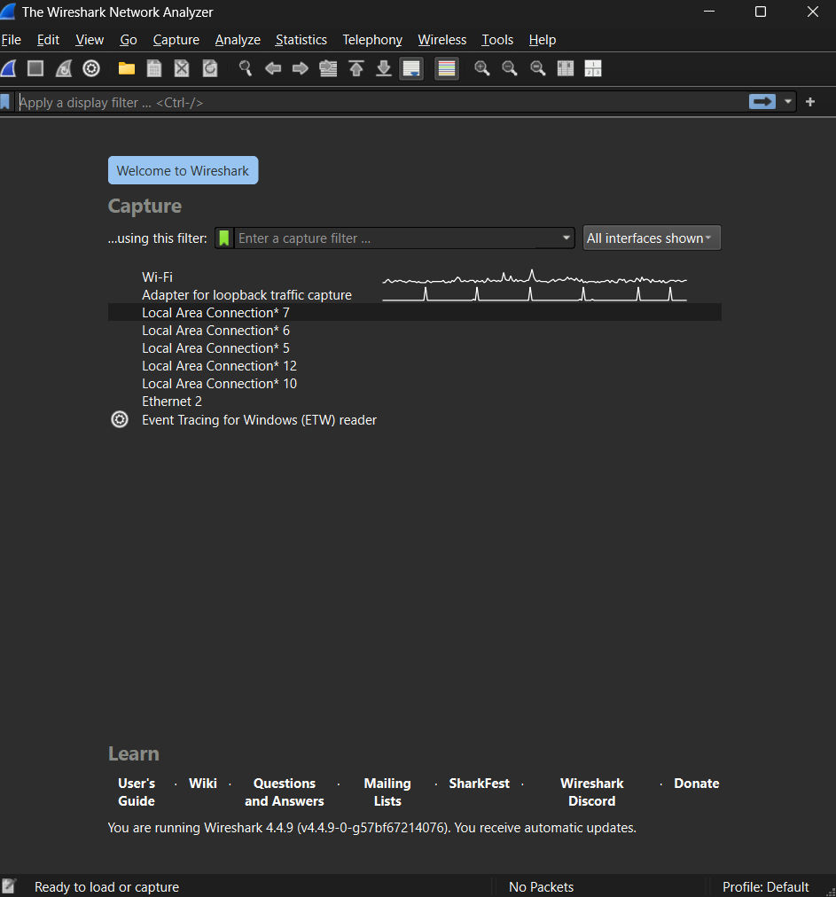

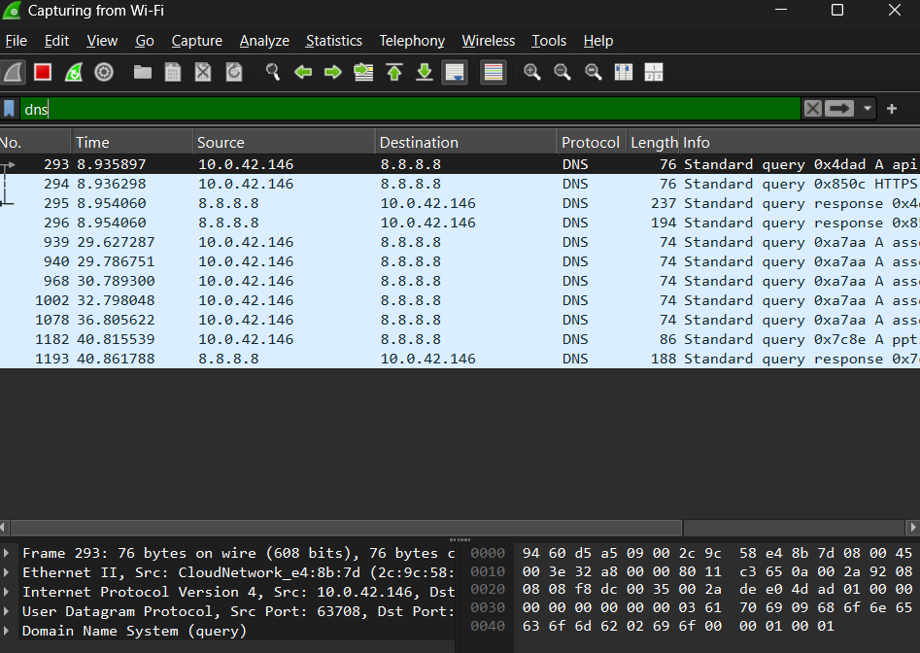

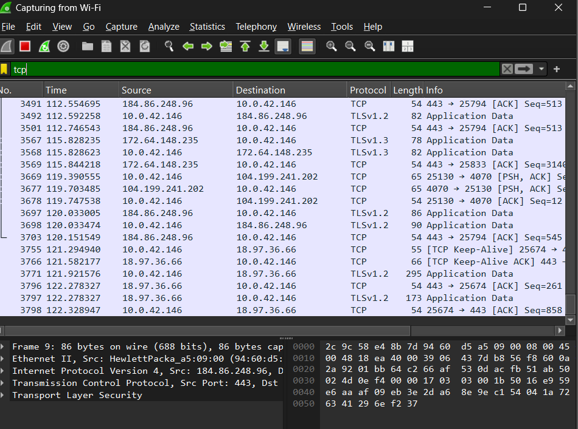

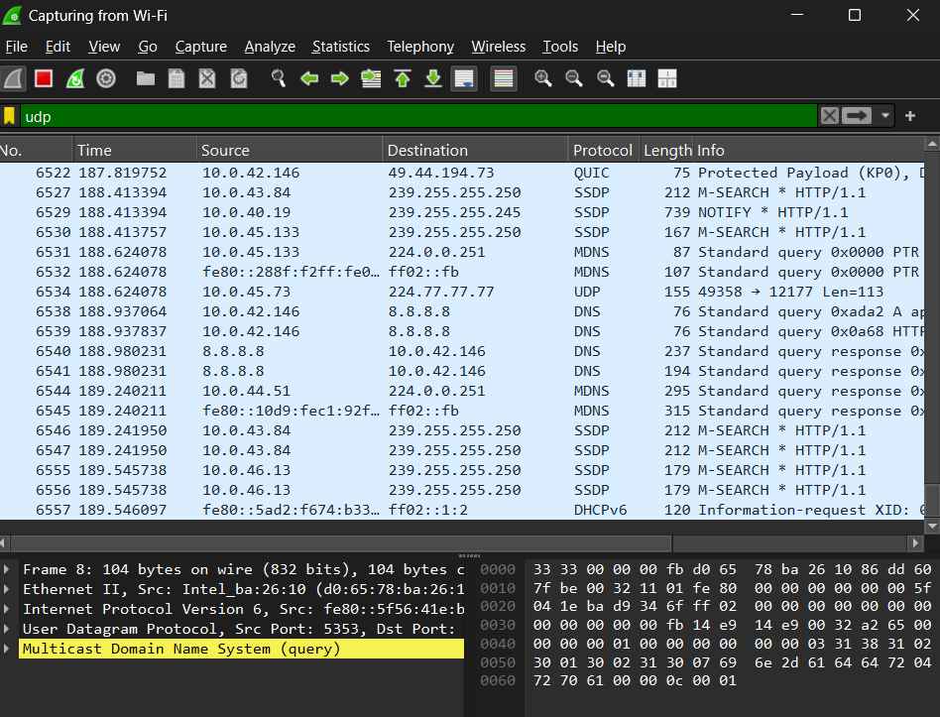

*🧠 Key Learnings*

* *ICMP packets matched ping results with TTL and round-trip times.*
* *DNS queries revealed how domain names are resolved.*
* *TCP packets showed handshake and data flow.*
* *HTTP packets displayed GET requests and responses.*

*🌟 Bonus Insight*

*Wireshark is like* ***Hanuman*** *in Ramayana—carrying packets safely across the network jungle! 🐒✨  
Understanding protocols is like decoding the language of the internet—each packet tells a story.*

*✅ Conclusion*

*This task provided hands-on experience in packet analysis and protocol behavior. Wireshark proved essential for visualizing and understanding network traffic, making it a powerful tool for cybersecurity diagnostics.*

*Once you paste this into Word or Docs and add your screenshots, export it as a PDF and upload it to your GitHub repo. Want help writing the GitHub description or README next? I’m ready!*