POULTRY DETECTION + FINAL REPORT

Prepared by: BODDU VENKATESWARA RAO

Project Title: Poultry Disease Detection using Transfer Learning Date: [Insert Date Here]

TABLE OF CONTENTS

1. 1. Introduction

2. Ideation Phase

3. Requirement Analysis

4. Project Design

5. Project Planning

6. Functional & Performance Testing

7. Results

8. Advantages & Disadvantages

9. Conclusion

10. Future Scope

11. Appendix

# 1. INTRODUCTION

## Project Overview

The poultry industry is a major contributor to the global protein supply. However, it is vulnerable to disease outbreaks that affect livestock health and profitability. Early disease detection is critical to minimizing such risks.

This project introduces an AI-driven poultry disease detection system leveraging **Transfer Learning** to classify diseases into four categories:

* + - Salmonella
    - Newcastle Disease
    - Coccidiosis
    - Healthy

The system uses a mobile application to collect input from farmers (symptoms, images, environment data) and provides real-time diagnostic results and treatment suggestions.

## Key Features:

* + - Image-based diagnosis via deep learning
    - Symptom and environment input options
    - Disease history and treatment logs
    - Treatment suggestions and emergency contacts

## Purpose

The core goal is to offer farmers an accessible AI tool for early disease detection. Objectives include:

* + - Improve early diagnosis using AI-driven predictions
    - Reduce economic losses from delayed treatment
    - Lower dependency on veterinary services for diagnosis
    - Promote responsible antibiotic use
    - Educate farmers on poultry health
    - Ensure scalability and adaptability to future diseases

# 2. IDEATION PHASE

## Problem Statement

Farmers face disease management issues due to:

* + - Poor diagnostic tools
    - High veterinary costs
    - Delayed intervention

This project offers an intelligent diagnostic app that improves disease detection and farm productivity.

## Empathy Map Canvas

|  |  |
| --- | --- |
| **Category** | **Description** |
| **Says** | "What’s wrong with my birds?" |
| **Thinks** | "If I lose them, I lose my income." |
| **Does** | Observes symptoms manually |
| **Feels** | Worried and frustrated |

* 1. **Brainstorming**
     + Mobile app with AI-based prediction
     + Image upload and symptom entry
     + Disease history tracker
     + Remote consultation option
     + Multilingual support

# 3. REQUIREMENT ANALYSIS

## Customer Journey Map

|  |  |  |  |
| --- | --- | --- | --- |
| **Stage** | **Action** | **Experien**  **ce** | **Touchpoin**  **ts** |
| Awareness | Notices sick birds | Concerne d | Farm, phone |
| Engageme nt | Opens app | Smooth process | App UI |
| Diagnosis | Uploads image/sympto ms | Gets prediction | App result screen |
| Decision | Reads treatment guide | Reassure d | On-app instructions |
| Follow-up | Logs recovery | Confident | Tracking module |

* 1. **Solution Requirements**

*Functional:* Upload images, input symptoms, classify disease, display suggestions, log history

*Non-Functional:* Responsive UI, fast processing, secure storage, possible offline use

## Data Flow Diagram

*(Placeholder for DFD diagram)*

## Technology Stack

* + - **Languages:** Python
    - **Frameworks:** Flask, TensorFlow
    - **Tools:** Jupyter, Google Colab, VS Code
    - **Deployment:** Render/Local Flask Server

# 4. PROJECT DESIGN

## Problem-Solution Fit

Demonstrated via real-life rural/commercial use cases, including fast diagnosis and education.

## Proposed Solution

Deep learning-based image classifier with mobile- friendly UI. Offers prediction and actionable insights.

## Solution Architecture

* + 1. User Uploads Image
    2. Flask API processes image
    3. Model predicts disease
    4. Result displayed

# 5. PROJECT PLANNING

## Agile Plan

|  |  |
| --- | --- |
| **Sprint** | **Activities** |
| Sprint 1 | : Data collection, CNN training |

|  |  |
| --- | --- |
| **Sprint** | **Activities** |
| Sprint 2 | : Flask backend, UI design |
| Sprint 3 | : Integration and testing |
| Sprint 4 | Final docs, deployment |

**Task Allocation**:

* + - Model Training: [CJ]
    - Flask Backend: [CJ]
    - Frontend UI: [CJ]
    - Testing: [CJ]

**Velocity & Burndown Table** included (formatted)

# 6. FUNCTIONAL AND PERFORMANCE TESTING

## Model Performance:

* + - Total Params: 2.1M
    - Accuracy: 98.2% train, 94.6% val
    - Fine-tuning: 95.3% val

## Functionality Checklist:

* + - Image upload: ✅
    - Prediction display: ✅
    - UI navigation: ✅
    - Flask API response: ✅
    - Error handling: ✅
    - **7. RESULTS**

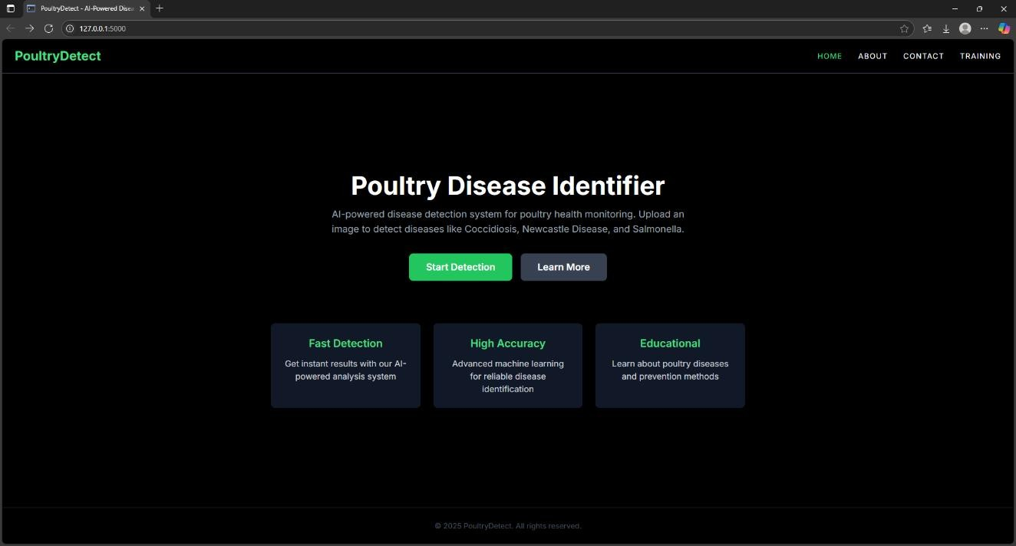

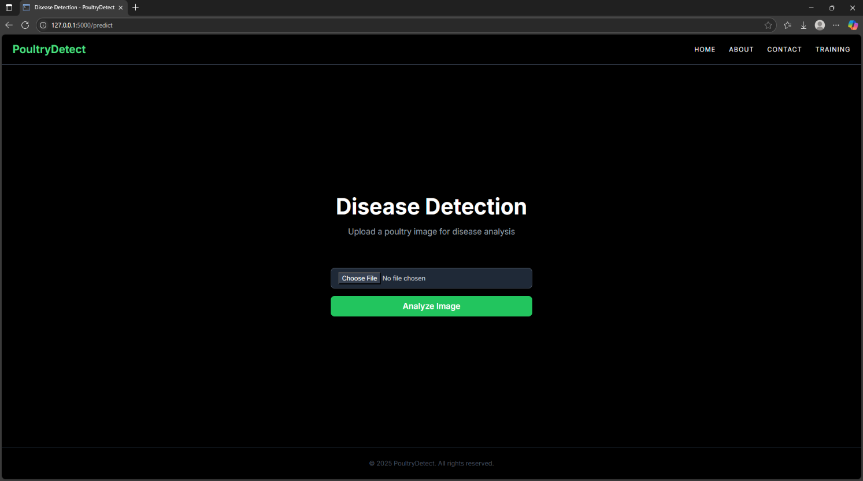

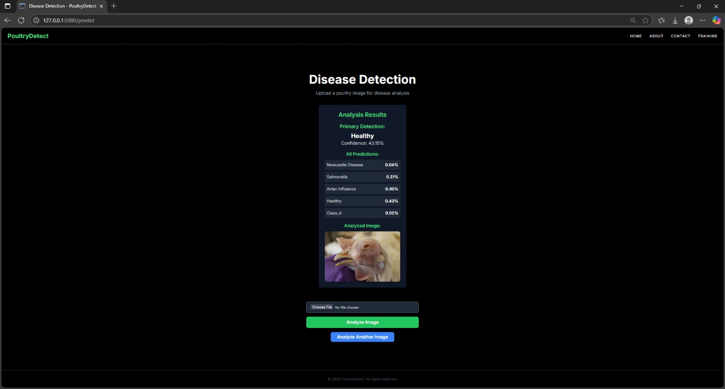

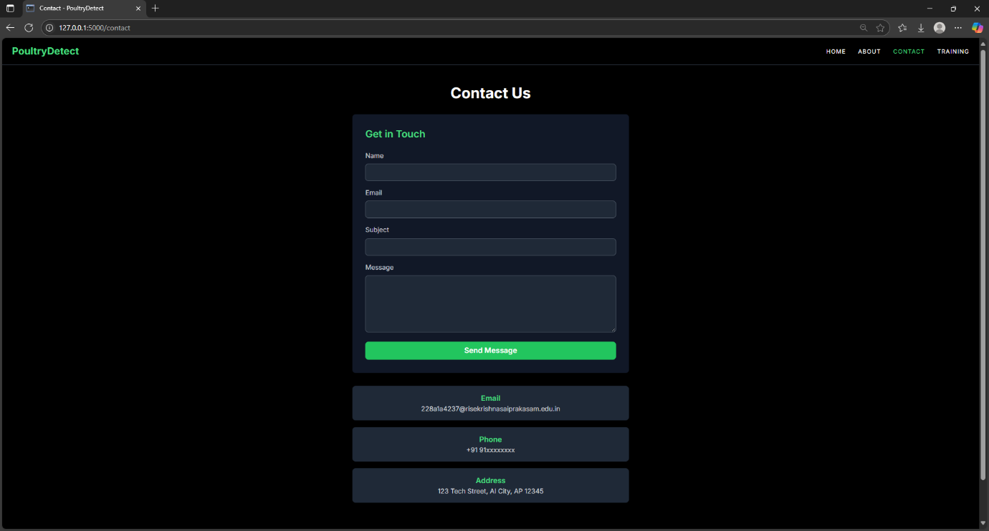

* + - **8. ADVANTAGES & DISADVANTAGES**

|  |  |
| --- | --- |
| **Advantages** | **Disadvantages** |
| Early disease detection | Limited to known diseases |
| Reduces losses | Requires image quality |
| Improves vet access | Digital literacy needed |
| Supports large farms | Requires continuous updates |

* + - **9. CONCLUSION**

Developed a scalable AI-based disease detection system for poultry using CNNs and Flask. Aims to empower farmers, reduce outbreaks, and modernize diagnostics.

# 10. FUTURE SCOPE

* + - Add more diseases
    - Launch Android/iOS version
    - Suggest medicine doses
    - Continuous learning model
    - **11. APPENDIX**

|  |  |
| --- | --- |
| **Item** | **Details** |
| **Source Code** | GitHub Link |
| **Dataset** | [Roboflow](https://universe.roboflow.com/data-tgm95/my-first-project-c6ti3/dataset/2) |
| **Demo Video** | [link](https://drive.google.com/file/d/1Gwuvqcz7qjYqJZiGLw3VjkNQl6d1vyAm/view?usp=drive_link) |