## Problem Set A:

1. Draw an inheritance hierarchy for classes **Quadrilateral**, *TRapezoid*, *Parallelogram*, *Rectangle* and *Square*. Use **Quadrilateral** as the base class of the hierarchy. Make the hierarchy as deep as possible.

The diagrams should include the state and behavior for each class.

Name the document as PA1_Quadrilateral.doc

Example Image for Inheritance is given below:

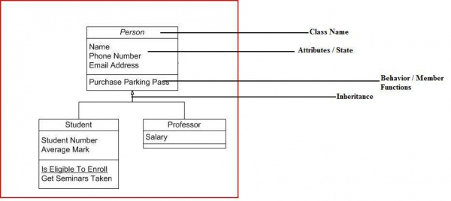

Name the document as : PA1_Quadrilateral.doc