Venkatesh Mogili


(MERN Stack Developer)

3+ years’ Experience

Email: mogilivenkatesh3@gmail.com
Mobile: +918328664336

OBJECTIVE

To work in a globally competitive environment and taking the challenging assignments that shall benefit the job satisfaction and professional growth.
Seeking a quality environment where my knowledge and experience will be shared and enriched by continually learning new things.

EDUCATIONAL QUALIFICATION
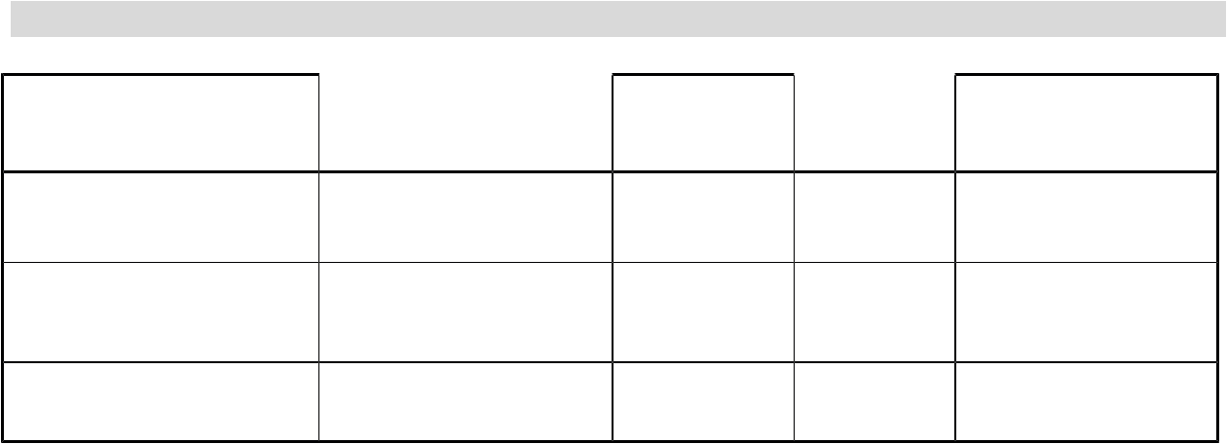

Degree/ Examination | Institute/University | Year | CGPA% | Remarks
B.Tech (CSE) | RGUKT- NUZVID | 2015-2019 | 7.57 | First Class
Pre University Course | RGUKT- NUZVID | 2013-2015 | 8.35 | Distinction
Secondary School(SSC) Z.P.P.HIGH SCHOOL |  | 2012-2013 | 10.0 | Distinction

Work Experience (2+ years)

TheRightDoctors (May 2018-Nov 2018) - Internship

Xelpmoc Design and Tech Ltd., (Dec 2019-July 2020) - Internship

AiKnow Labs Pvt Ltd., (July 2020 – Nov 2020) - Fulltime
Doodleblue Innovations Pvt Ltd., (Dec-2020 – present) - Fulltime

TECHNICAL SKILLS

Programming Skills: HTML, CSS, JavaScript, Bootstrap, ReactJS, ReactNative, NodeJS,
Angular2+, Socket.IO, SQL, Git, Google Cloud, AWS, Twilio, Stripe.

Operating Systems: Windows, Linux

Educational Software: VS Code, Xampp, Android Studio, MySQL.

PERSONAL SKILLS

Hardworking & Self-confidence Dedication towards work
Adaptable to new environment

Always enthusiastic to learn new things

ACADEMIC PROJECTS

- B. Tech(1st Year) University Project: E-Crush Website Time-line: 1st June 2015 to 30th October 2015

Team Size: 3, Role: Full Stack Developer
Used Technologies: HTML,CSS,JS,BOOTSTRAP,PHP,SQL.
Description:

This Website provides tutorials to improve communication skills, personality development through various features like Daily Topic to communicate, Daily Motivational Videos and shares general knowledge like Daily Fact, Daily Innovation etc.,

Link: shorturl.at/jmpEI
–------------------------------------------------------------------------------------------------------------------

- B. Tech(2nd Year) Convocation Project: Education+ Android App Time-line: 4th December 2016 to 10th December 2016
Team Size: 1, Role: Full Stack Developer

Used Technologies: Android
Description:

This Android Application is used to help for the students who are not able to take career decisions for higher studies after 10th, Inter, Engineering etc. Experts in each particular field will help to the students to clear their doubts.

Link: shorturl.at/anEJY
–--------------------------------------------------------------------------------------------------

3.B. Tech(2nd Year) University Project: Avagahana Website
Time-line: 1st September 2016 to 30th September 2016

Team Size: 1 , Role: Full Stack Developer,
Used Technologies: HTML,CSS,JS,BOOTSTRAP,PHP,SQL
Description:

Avagahana is a voluntary job with a motto - "Let's be aware of our ignorance - Let's become enlightened" has been initiated to impart certain focal points required to meet the challenges in every student life. Well, it gives an immense pleasure to bring the awareness on various academic issues.

Link: shorturl.at/gGRXY

–------------------------------------------------------------------------------------------------------------------

4.B. Tech 3rd year (Mini Project): CareerStar Website
Time-line: August 1st, 2017 to October 1st, 2017)
Team Size: 4, Role: Team Leader and Full Stack Developer.

Used Technologies: HTML,CSS,JS,BOOTSTRAP,PHP,SQL
Description:

This website gives the information about the companies that are Offering Jobs and other Internships that are related to the computer science department.
Link: shorturl.at/cdlpQ

5.B. Tech Final Year (Major Project): VChat Offline Messenger Android App
Time-line: December 10th, 2018 to April 10th, 2019

Team Size: 1, Role: Full Stack Developer
Used Technologies: Android, Wifi Peer to Peer connections.
Description:

VChat Offline Messenger is used to communicate with friends/colleagues within the short distance like classrooms, hotels, mess, offices within the distance of Wifi range. It’s main goal is to share files,text,images,videos offline along with Chat.

INDUSTRIAL PROJECTS

6. Project Name: AgriBook Ionic App Time-line: December 14th, 2017 to March 16th, 2018 Company: UCBerkeley Andhra Pradesh Smart Villages Team Size: 1, Role: Ionic App Developer Used Technologies: Ionic, Angular2+, NodeJS Description:

AgriBook is an Application using Ionic Framework. It is a great platform for the farmers to get know the latest farming techniques and to interact with the experts to solve the various crop diseases.
Link: shorturl.at/adfp5

–---------------------------------------------------------------------------------------------------------

7.Project Name: Digitial Patient Management System MEAN Application

Time-line: May 10th, 2017 to November 10th, 2018
Company: TheRightDoctors

Team Size: 5, Role: Full Stack Developer

Used Technologies: Angular2+, NodeJS, Google Cloud, Git, Firebase, Twilio, PAYTM,Facebook OAuth.

Description:

Digitial Patient Management System(DPM) is a great platform to contact doctors online at any time and from anywhere. You can take appointments, advices etc.,

Link: https://dpmp.therightdoctors.com , https://therightdoctors.com

- Project Name: ERP (Enterprise Resource Planning) Time-line: December 20th, 2019 to March 20th, 2020 Company Name: Xelpmoc Design & Tech Limited. Team Size: 5, Role: Team Lead and Full Stack Developer Used Technologies: Angular2+, Laravel, Propel, Git, AWS.

Description:

Enterprise Resource Planning application developed for a Mumbai based restaurant company(Speciality Restaurants) for managing the food items, employees,
company details, finance details etc.,
–--------------------------------------------------------------------------------------------------

9. Project Name: Intranet

Time-line: December 20th, 2019 to February 10th 2020
Company Name: Xelpmoc Design & Tech Limited.

Team Size: 2, Role: Full Stack Developer

Used Technologies: ReactJS, ReactNative, NodeJS, Laravel

Description:

Intranet application used to maintain Xelpmoc employees, salary payslip details, project

management, employee work tracker etc.,
–----------------------------------------------------------------------------------------------------------

10. Project Name: Pencil

Time-line: March 20th, 2020 to June 20th 2020
Company: Xelpmoc Design & Tech Limited.

Team Size: 4, Role: Full Stack Developer

Used Technologies: Angular2+, Laravel

Description:

Pencil is writing platform to publish your own books and you can sell your books. You can buy both Ebooks and physical book copies.

Link: https://thepencilapp.com/

–----------------------------------------------------------------------------------------------------------

- Project Name: Foodie React Native App Time-line: March 20th, 2020 to June 20th 2020
Project Type: Freelancing Project,

Team Size: 1, Role: Full Stack Developer

Used Technologies: ReactNative, NodeJS

Description:

Foodie is a simple food delivery application used to sell/buy foods online.

- Project Name: Covid19 Tracker React App Time-line: April 10th, 2020 to April 11th 2020 Project Type: Own Project,

Team Size: 1, Role: Full Stack Developer

Used Technologies: ReactJS, REST API

Description:

Covid19 Tracker is MERN Application used to track the Covid19 affected,recovered and

deaths details analysis with graph Globally and Country wise.

Link: https://covid19tracker-a4811.web.app/

–----------------------------------------------------------------------------------------------------------

- Project Name: Task Hacker MEAN App Time-line: June 1st 2020 to June 7h 2020

Project Type: HackerEarth StackHack 1.0 Challenge

Team Size: 1, Role: Full Stack Developer

Used Technologies: Angular2+, NodeJS

Description:

Task Hacker is a simple and powerful todo management application used to keep track of tasks, it’s progress and detailed weekly analysis of completion rate and pending tasks.

Link: https://www.youtube.com/watch?v=iePQZOc30VI https://www.hackerearth.com/challenges/hackathon/stackhack-v1/

–----------------------------------------------------------------------------------------------------------

14. Project Name: Messenger 1.0

Time-line: June 21st 2020 to June 28h 2020

Project Type: Freelancing Project

Team Size: 1, Role: Full Stack Developer

Used Technologies: React Native (Gifted Chat), NodeJS, Socket IO

Description:

Messenger 1.0 is a simple realtime online messenger which supports one-to-one text mes-saging with image and video support, online, offline, typing status, recent messages, last seen, search for chats and contacts.
Link: shorturl.at/eCHQU

15. Project Name: SBI Remit

Time-line: July 7th 2020 to August 31st 2020
Project Type: AiKnow Labs Pvt Ltd

Team Size: 1, Role: Full Stack Developer

Used Technologies: React Native, NodeJS

Description:

SBI Remit is a Japan Based Bank Project which contains transactions, payment history, customers details, admin users, agency users. This project contains 4 separate applications.

Link: shorturl.at/bsEFI

- Project Name: Task Management using React Hooks Time-line: September 1st 2020 to September 1st 2020 Project Type: Own Project

Team Size: 1, Role: Full Stack Developer

Used Technologies: React, JsonPlaceholder

Description:

Task Management Application is simple React application used to manage your task list and can be used for learning the react hooks and API integrations for beginners.

Link: https://venkateshmogili.github.io/todoApp-React-Hooks/build

- Project Name: Task Management using Vue Time-line: September 18th 2020 to September 18th 2020 Project Type: Own Project

Team Size: 1, Role: Full Stack Developer

Used Technologies: Vue, JsonPlaceholder

Description:

Task Management Application is simple Vue application used to manage your task list and can be used for learning the Vue fundamentals and API integrations for beginners.

Link: https://venkateshmogili.github.io/todo-vue-app/home/#/

- Project Name: Qutrix Staff Management
Time-line: December 24th 2020 to Present
Project Type: Doodleblue Innovations Pvt Ltd.,

Team Size: 1, Role: React Frontend Developer

Used Technologies: ReactJS, React Native, Redux, Redux-saga

Description:

Qutrix is work management application used to manage different types of users like admin, co-admin,staff, agency, client. In these applications, I worked on staff portal part.

Link: N/A

EXTRA – CURRICULAR ACTIVITIES & ACHIEVEMENTS

- Won StackHack 1.0 challenge conducted in HackerEarth contest.
- Got best performer award for delivering the project on time at Xelpmoc Design and Tech Ltd.,
- Delivered a messenger app using React Native and NodeJS within 4 days as a freelancing project.
- Got 1st prize among 1500 students in branch level Template Design Competition organised by Technostart2k18 of RGUKT-Nuzvid, Department of CSE.
- Participated in 2 days National Level Technical Festival conducted by RGUKT-Nuzvid (TeckZite2k18) and won 1st Prize in Template Design.
- Actively Participated in Technical Festival conducted by CSE Department in RGUKT-Nuzvid (TechnoStart 2k15,2k16) and won 1st Prize in Android Event (AppOn) and Template Designing.
- Actively Participated in Technical Festival of Saradhi College and Won 1st Prize in Web Designing in 2015.
- Worked as a Web Developer in E-Crush , Student Mitra and Avagahana Organizations in RGUKT-Nuzvid.

PERSONAL INFORMATION
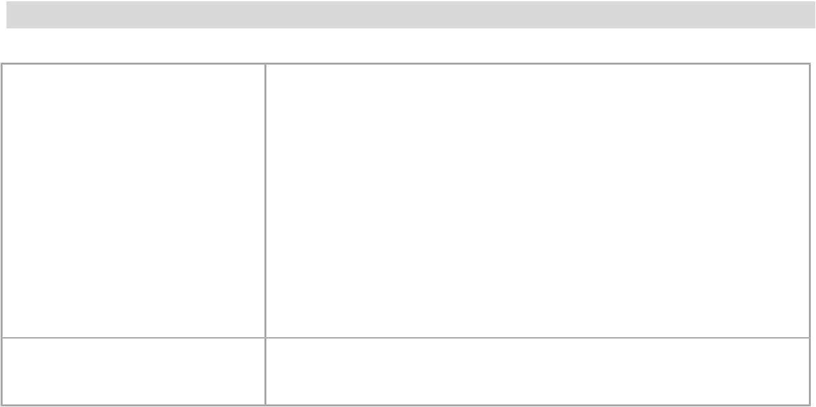

Name |  | Venkatesh Mogili
Date of Birth | 06-08-1998
Father name |  | APPARAO
Mother name |  | RAMALAKSHMI
Languages |  | Telugu, English
Nationality |  | Indian
Hobbies |  | Exploring new applications, Web and Mobile Applica-
 |  | tion Development, reading technical news, Listening
 |  | to music, Playing Cricket and Video Games.
Permanent address |  | R.Chandram Palem, Samalkot Mandal, East Godavari
 |  | District, Andhra Pradesh, Pincode: 533450.

DECLARATION

I, Venkatesh Mogili, hereby declare that the above-mentioned information is corrected up to my knowledge and I bear the responsibility for the correctness of the above-mentioned particulars.

Date : 25-04-2022

Place : R.Chandram Palem

Signature

(M.Venkatesh)

