110 argument over hazards

# Overview

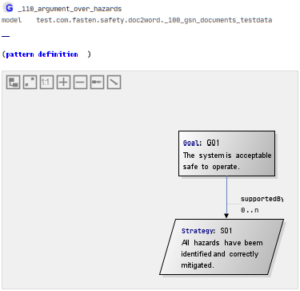

This is one of the most widely used top level arguments.