Vim /etc/ansible/ansible.cfg

Uncomment the inventory, sudo_user and host_key_checking

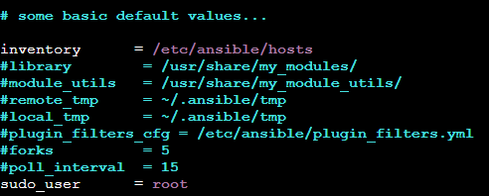



Adding the ansible user in main server and nodes

*Useradd ansible*

*Passwd ansible*

*Visudo* /add ansible user to root/

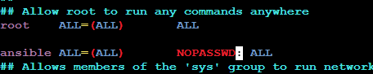

*Vi /etc/ssh/sshd_config* /change password authentication to yes/

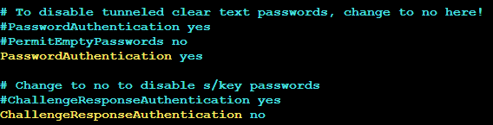

Perform the above two steps in nodes too

Specifying the node private id with node username and password

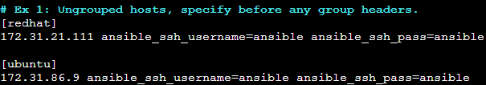

Checking the connection status of the nodes with below commands

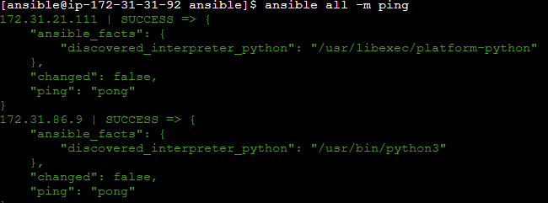

Installing Git tree docker and httpd in redhat server in task.yml playbook

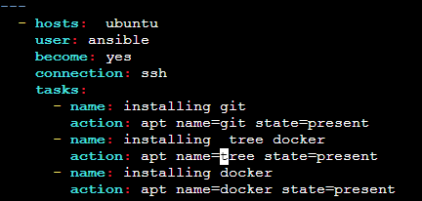

Checking the installed packages in redhat server

