**Java Installation**



**Python**

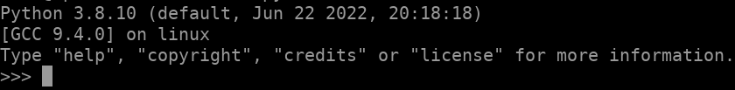

**Nodejs**

**Arango DB**

**PERCONA MySQL**

**Mongo DB**

