**UK Borough-Level Grocery Demand & Nutrient Analysis**

# **Objective**

The primary objective of this project was to perform a full-cycle data analysis on borough-level grocery transactions in the United Kingdom using Excel, SQL, and Power BI. The goal was to identify consumption patterns, evaluate nutritional trends, and provide actionable insights for public health policy and retail strategy. By drilling down to the borough level, we aimed to uncover hidden behavioural differences that national averages typically obscure.

# **Problem Statement**

Grocery consumption data in the UK is often analysed at a national or regional level. However, such aggregation overlooks significant behavioural variation across boroughs. Local councils, healthcare providers, and grocery retailers need granular insights to improve outcomes—from stocking healthy foods to designing health interventions. This project bridges that gap by analysing borough-level grocery demand and nutrient breakdown, thereby highlighting areas of concern, such as high sugar consumption or a low intake of fruit and vegetables.

# **Methodology**

The analysis followed a structured 5-stage pipeline:

## **Data Cleaning (Excel):**

The raw datasets were first reviewed for consistency and accuracy. Null values were removed to ensure data completeness, and column names were standardised to improve readability. Data types were converted to the appropriate formats to support numerical and categorical analysis. An essential part of this stage involved converting Area_id codes into readable borough names using official ONS mappings, enabling easier interpretation across stakeholders. For instance, E09000020 was identified as Harrow. This transformation ensured that insights could be linked directly to geographic locations, improving the practical application of findings in retail and policy contexts.

**Descriptive Analysis (Power BI):**

The goal of this phase was to explore and summarise borough-level grocery data through visual representation. Key Performance Indicators (KPIs) such as total number of boroughs analysed, estimated grocery spend, and calculated health scores were extracted and presented using Power BI cards. A stacked bar chart was employed to visualise the distribution of product categories across boroughs, highlighting consumption patterns such as high intake of fruit, vegetables, and grains. Additionally, a donut chart was used to isolate and present the top five food categories by weight. These visual insights formed the foundation for deeper, borough-specific diagnostic analysis.

## **Diagnostic Analysis (SQL):**

This stage focused on identifying borough-specific nutritional concerns and consumption behaviours. Structured queries were written in SQL to calculate key indicators such as sugar per transaction, and boroughs were ranked based on their aggregated scores. By comparing these indicators with calculated health scores, boroughs with poor nutritional trends were identified. For instance, Kingston upon Thames registered high transaction volumes yet reflected a suboptimal health score. This discrepancy highlighted the need to evaluate consumption quality alongside quantity. Boroughs were further categorised by prevalence of unhealthy product categories to pinpoint priority areas for intervention.

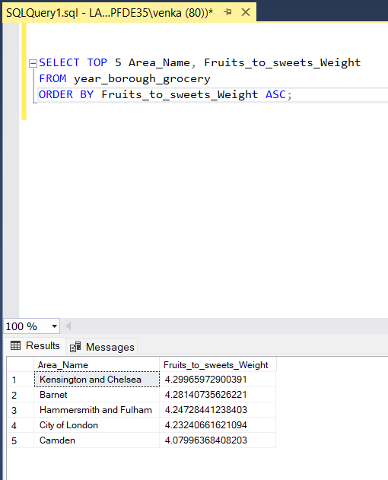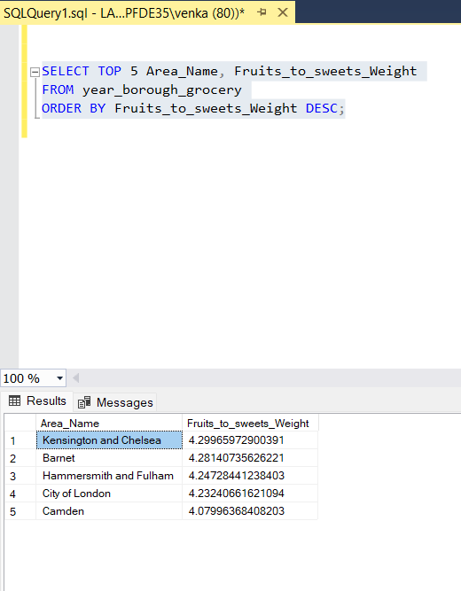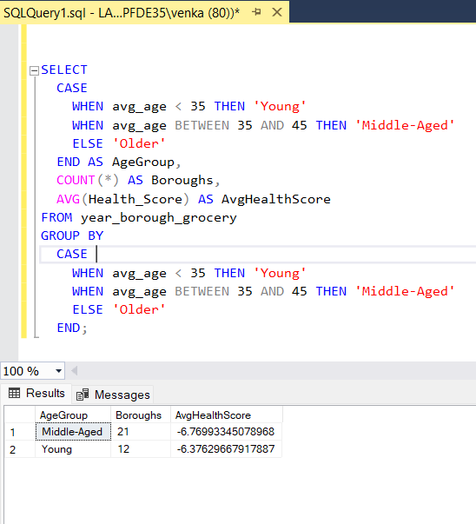

## **Prescriptive Suggestions (SQL + Power BI):**

Recommendations were developed based on insights derived from SQL queries and diagnostic trends. Boroughs that exhibited a high dependency on processed or sugary foods were flagged for intervention. For example, areas with elevated readymade meal or sweets weight were recommended to increase shelf presence of healthier options such as whole grains or fresh produce. Boroughs with particularly low fruit_veg_weight were prioritised for nutritional awareness initiatives. These findings were visualised using thematic mapping and slicers in Power BI, allowing stakeholders to interact with borough-specific solutions aligned with local consumption behaviours.

## **Dashboard Development (Power BI):**

A four-page interactive dashboard was developed using Power BI to consolidate and communicate findings effectively. The layout employed modern design principles, including consistent themes, slicers for interactivity, and clear labelling to enhance usability across a range of stakeholders.

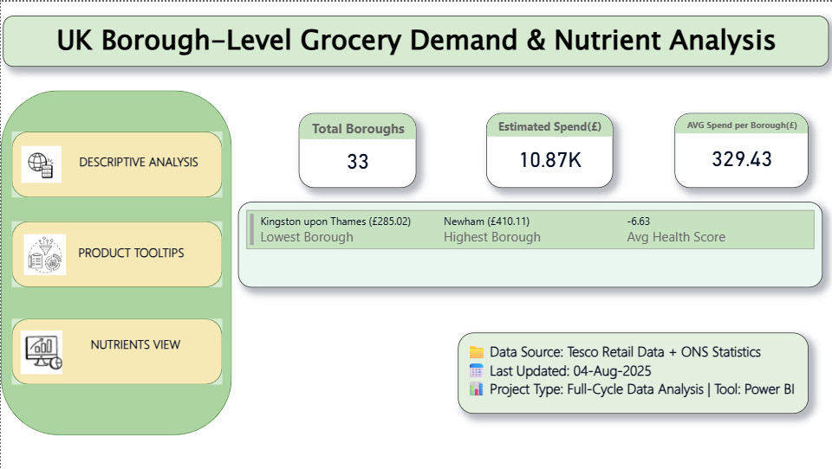

Page 1 presented headline KPIs such as total transactions, borough count, and average health score.

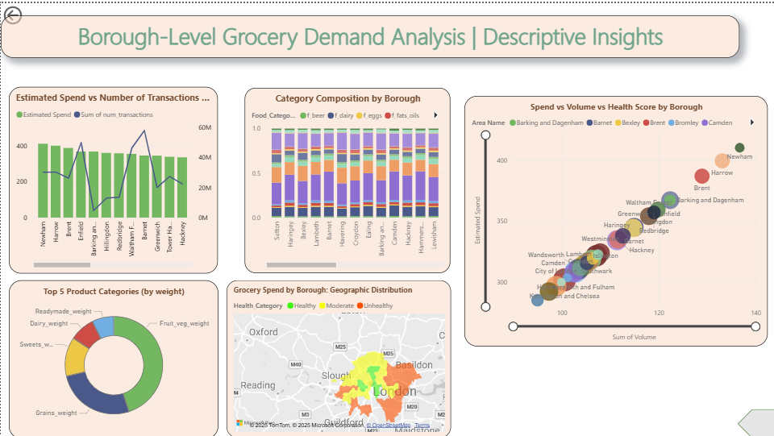

Page 2 showcased detailed visuals, including stacked bar charts and donut charts for category analysis.

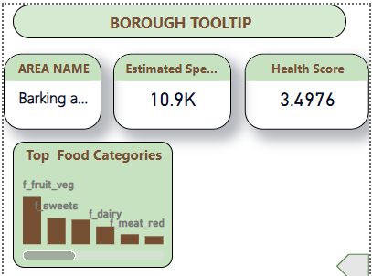

Page 3 introduced tooltip-enabled views to provide borough-level drilldowns upon hover interaction

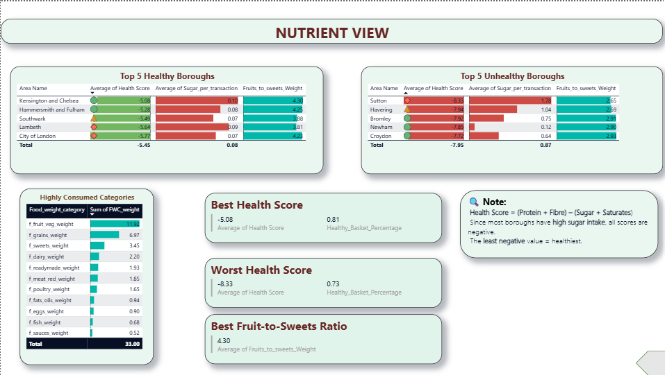

Page 4 featured ranked tables displaying the five healthiest and unhealthiest boroughs based on product composition.

### **Key Findings**

Analysis revealed that all 33 boroughs studied recorded negative health scores, indicating a widespread trend of poor nutritional balance across London boroughs. Harrow emerged as the borough with the least negative health score (-5.08), suggesting relatively better consumption behaviour, although still suboptimal. Kingston upon Thames recorded the highest number of transactions (137 units), which, when analysed further, revealed a disconnect between the quantity of groceries purchased and their nutritional quality. This gap between volume and health highlights the necessity of examining not just how much is consumed, but what types of foods dominate those transactions.

Further analysis of category-wise consumption showed that fruit and vegetables contributed the most by weight in most boroughs, followed by grains and dairy. However, a significant share of consumption was attributed to sweets, readymade meals, and soft drinks. These categories, often high in sugar and saturated fats, were consistently among the top five by weight, indicating the dominance of convenience-based eating habits, especially in densely populated or commercially active boroughs.

Using SQL, boroughs were ranked by sugar per transaction, revealing hotspots with exceptionally high sugar consumption relative to transaction volume. Additionally, boroughs with low fruit_veg_weight scores were flagged for having insufficient diversity in healthy food intake. These trends were further validated through visual analysis in Power BI, particularly via donut charts and stacked bar graphs. The visuals confirmed that sugary and processed food categories occupied significant proportions of the consumption mix, raising long-term concerns related to obesity, diabetes, and other chronic conditions if left unaddressed.

## **Solutions & Recommendations**

### **Retail Strategy:**

Retailers should consider increasing shelf space and promotions for healthy food categories in boroughs where processed food consumption dominates. Borough-specific product placement can drive healthier buying decisions.

### **Policy Interventions:**

Boroughs such as Kingston upon Thames and Croydon should be prioritised for community-based nutrition programmes. Awareness campaigns, healthy food subsidies, and collaboration with schools can improve local dietary behaviour.

**Data-Driven Monitoring:**

Power BI dashboards can be used by councils and health organisations to continuously track changes in dietary patterns and assess the impact of interventions in real time.

**Policy Development:**

Government bodies should consider integrating borough-level consumption data into national health planning. This level of granularity allows for the development of more targeted and effective nutritional policies.

### **KPI Monitoring:**

Use dashboards to monitor shifts in consumption over time.

## **Dashboard Overview**

**Page 1:** KPI summary with borough and national metrics.

**Page 2:** Interactive visuals – category composition and health scores.

**Page 3:** Tooltip visualisation page for hover-based analysis.

**Page 4:** Ranking tables of the top 5 healthiest and unhealthiest products.

All pages use a modern, clean Power BI theme with slicers for interactivity.

# **Limitations**

* No real-time price data, so economic analysis is limited.
* Health Score was estimated using static nutritional assumptions.
* Lack of demographic data limited deeper behavioural segmentation.

# **Future Work**

* Integrate NHS dietary guidelines to benchmark consumption.
* Include seasonal trends and promotional sales impact.
* Overlay population density, income, and age demographics.
* Train ML models to predict borough health classification.

# **Conclusion**

This project demonstrates the value of granular, borough-level analysis in understanding grocery consumption trends and their nutritional implications. By applying Excel for data preparation, SQL for diagnostic insights, and Power BI for visual storytelling, the analysis translated complex datasets into actionable intelligence. The insights derived from borough-specific trends enable local councils, retailers, and health authorities to collaborate on targeted interventions that promote healthier communities. While limitations exist in terms of price data and demographic integration, the framework provides a scalable model for future research and public health applications.