A Machine Learning approach in estimation of optimal power distribution in Non-Orthogonal Multiple Access.
E S Gopi, Venkatesh T K, Mukesh Gandhi
¹ National Institute of Technology, Tiruchirappalli, Tamil Nadu, India
Abstract. This paper proposes a method to estimate the power distribution of users in Non-Orthogonal Multiple Access(NOMA),maximizing total capacity and meeting the minimal guaranteed quality of service for each user. We generate dataset by the particle swarm optimization algorithm. We propose a state of art machine learning algorithm to regress power distribution given the total power used and channel characteristics.
Keywords: NOMA, MIMO, particle swarm optimization
- Introduction
  - Non – orthogonal Multiple Access
NOMA is a method in which the power domain is used for the multiple access rather than the other methods like OFDM, etc that use either time/frequency/code domain. In downlink NOMA network, as in figure 1, the base-station transmits the combined message signal S, which is the combination of the multiple users input with varying power of the message. The power distribution of the messages depends upon the channel co-efficient of the link between the user and base-station, user with a bad channel has more power allotted and vice-versa. Therefore, ensuring the transmission of the message signals to multiple users.
The transmitted signal from the base station is the combination of the individual user message signal $X_i$ with power $P_{i}$ allocated to it. The signal Y is represented as,
$S=\sum_{i=1}^{N}{\sqrt{P_{i}}}X_{i}$ (1)
where N is the total number of users and the power are ordered as $P_{1}<P_{2}<P_{3} …. <P_{N}$ , when the channel co-efficients are assumed to be ordered as ${\left|h_{1}\right|}^{2}>{\left|h_{2}\right|}^{2}>{\left|h_{3}\right|}^{2} …. >{\left|h_{N}\right|}^{2}$, where $h_{i}$ is the channel co-efficient between $i^{th}$ user and the base station. Thus, the received signal $Y$ at $i^{th}$ user is as,
$Y_{i}=h_{i}\sum_{i=1}^{N}{\sqrt{P_{i}}}X_{i}+ n_{i}$ (2)
where $n_{i}$ is white Gaussian noise in the channel with $σ^{2}$ variance.

  - SINR and detection of message signals
The detection process at the receiver’s end is achieved by Successive Interference Cancellation (SIC). In SIC, the receiver detects and eliminates message signals stronger than it’s required message until the required message signal power is detected, other signals which are less power than the required message act as interference. Therefore, the SINR (signal to interference noise ratio) of ${ i}^{th}$ user can be calculated from equation 2 as,
${SNIR}_{i}=\frac{{\left|h_{i}\right|}^{2}P_{i}}{\sum_{j=1}^{i-1}{{{\left|h_{j}\right|}^{2}P}_{j} + σ^{2}}}$ (3)
where the channel co-efficient are assumed to be ordered as ${\left|h_{1}\right|}^{2}>{\left|h_{2}\right|}^{2}>{\left|h_{3}\right|}^{2} …. >{\left|h_{N}\right|}^{2} ,$the numerator is the power of the required signal and the denominator is the power of the signals acting as interference and noise power $σ^{2}$.

  - Channel Capacity
The channel capacity of a received signal can be calculated from SNIR by Shannon–Hartley theorem as,
$C=\log_{2}(1+SNIR)$ (4)
where C is the channel capacity, bit rate is assumed to be 1. Thus, the total channel capacity of downlink NOMA is the sum of the individual channel capacity of the message signals,

$C_{T}= \sum{C_{i}= \sum_{i=1}^{N}{\log_{2}(1+{SNIR}_{i})}}$ (5)

where $C_{i}$ is the channel capacity of the message signal $X_{i}$.
- Motivation
To each user we need to provide a minimal guaranteed quality of service, therefore we need to ensure that channel capacity of received signal is more than the requirement of the user. Also, we need the total channel capacity to be maximum from the base station. We see that power distribution plays a major role in channel capacity. In this paper, given total power and channel characteristics, we regress the power distribution using neural networks, such that total channel capacity is maximized and meeting the minimal guaranteed quality of service for each user.

- Analysis and Dataset Generation

  - Analysis of constraints
Let’s assume the following scenario, there is one base station and 4 users. The channel link between ${ i}^{th}$ user and base station is $h_{i}$. We assume the following order of channel characteristic co-efficient $\left|h_{2}\right|>\left|h_{3}\right|>\left|h_{1}\right|>\left|h_{4}\right|$ . As power distribution is inversely proportional to the strength of the channel link , power order should be $\left|P_{2}\right|<\left|P_{3}\right|<\left|P_{1}\right|<\left|P_{4}\right|$ . Since we need to provide minimal guaranteed quality of service to user , not only the required message signal channel capacity should more than a minimum, but to remove the signals that are stronger than it , we need to detect it first .Thus at each user end the channel capacity of the required signal and signals stronger than it should have a bare minimum. For the above scenario and using equation 2 and 5, we have the following channel capacity constraints,

$$C_{1}=\log_{2}\left(1+\frac{ {\left|h_{1}\right|}^{2}P_{1}}{{\left|h_{1}\right|}^{2}P_{3}+{\left|h_{1}\right|}^{2}P_{2}+1}\right)>1$$

$$C_{2}=\log_{2}\left(1+{\left|h_{2}\right|}^{2}P_{2}\right)>1$$

$$C_{3}=\log_{2}\left(1+\frac{ {\left|h_{3}\right|}^{2}P_{3}}{{\left|h_{3}\right|}^{2}P_{2}+1}\right)>1$$

$$C_{4}=\log_{2}\left(1+\frac{ {\left|h_{4}\right|}^{2}P_{4}}{{\left|h_{4}\right|}^{2}P_{3}+{\left|h_{4}\right|}^{2}P_{2}+{\left|h_{4}\right|}^{2}P_{1}+1}\right)>1$$

where minimal guaranteed quality of service to user is assumed to be 1 and the variance of noise $σ^{2}$ is assumed to be 1. For detecting required signal at user 2, we need to detect higher power signals $X_{4}$,$X_{1}$and $X_{3}$. Therefore, the channel capacity of $X_{4}$ at user 2 end is,

$$C_{1}^{2}=\log_{2}\left(1+\frac{ {\left|h_{2}\right|}^{2}P_{4}}{{\left|h_{2}\right|}^{2}P_{3}+{\left|h_{2}\right|}^{2}P_{2}{ + \left|h_{2}\right|}^{2}P_{1}+1}\right)>1$$

Similarly, at user 2 we detect $X_{1}$ and $X_{3}$ , therefore,

$$C_{2}^{2}=\log_{2}\left(1+\frac{ {\left|h_{2}\right|}^{2}P_{1}}{{\left|h_{2}\right|}^{2}P_{3}+{\left|h_{2}\right|}^{2}P_{2}+1}\right)>1$$

$$C_{3}^{2}=\log_{2}\left(1+\frac{ {\left|h_{2}\right|}^{2}P_{3}}{{\left|h_{2}\right|}^{2}P_{2}+1}\right)>1$$
where $C_{i}^{j}$ is the channel capacity of ${ i}^{th}$ signal detected at ${ j}^{th}$ user end.
Similarly, at user 1 and 3 (not user 4 as it is the signal first detected), we get the following constraints,

$$C_{1}^{1}=\log_{2}\left(1+\frac{ {\left|h_{1}\right|}^{2}P_{4}}{{\left|h_{1}\right|}^{2}P_{3}+{\left|h_{1}\right|}^{2}P_{2}+{\left|h_{1}\right|}^{2}P_{1}+1}\right)>1$$

$$C_{1}^{3}=\log_{2}\left(1+\frac{ {\left|h_{3}\right|}^{2}P_{4}}{{\left|h_{3}\right|}^{2}P_{3}+{\left|h_{3}\right|}^{2}P_{2}+{\left|h_{3}\right|}^{2}P_{1}+1}\right)>1$$

$$C_{2}^{3}=\log_{2}\left(1+\frac{ {\left|h_{3}\right|}^{2}P_{1}}{{\left|h_{3}\right|}^{2}P_{3}+{\left|h_{3}\right|}^{2}P_{2}+1}\right)>1$$

Therefore, on total we have 10 channel capacity constraints to be met and one total power constraint. Keeping these 11 constraints to be true, total channel capacity at base station should be maximized.

  - Generating dataset
Dataset has been generated by running Monte-Carlo simulation, using Particle Swarm Optimization (PSO) algorithm. Channel characteristics and total power are taken as input, and power distribution is output of PSO algorithm. For the sake of simplicity and with no loss of generality, the dataset has been created for some fixed values of total power. Using Monte-Carlo simulation, we randomize the input channel characteristics for fixed values of total power. The generated input is given to constrained Particle Swarm Optimization (PSO) algorithm(reference), it maximizes total channel capacity by varying power distribution, without violating the above constraints. The channel characteristics generated is Gaussian distributed with variance 1, 2, 3 and 4 for $h_{1},h_{2},h_{3} and h_{4} ,respectively.$The dataset collected has only those input and output data that gives no outage for any of four users.

- Training of Neural Network
The dataset consists of the channel co-efficient for Rayleigh flat channel for various users and total power as input and power allocated per user for optimum performance as output. The data was trained using a neural network with 2 hidden layers consisting 20 neurons and a SoftMax activation function. Further the network was trained using Bayesian regularization algorithm. Batch-normalization was incorporated to prevent the model from overfitting. The model was trained for 1000 epochs. The test loss logged was decreasing at the earlier stages of training indicating that the model was generalized and was not subjected to overfitting and underfitting.

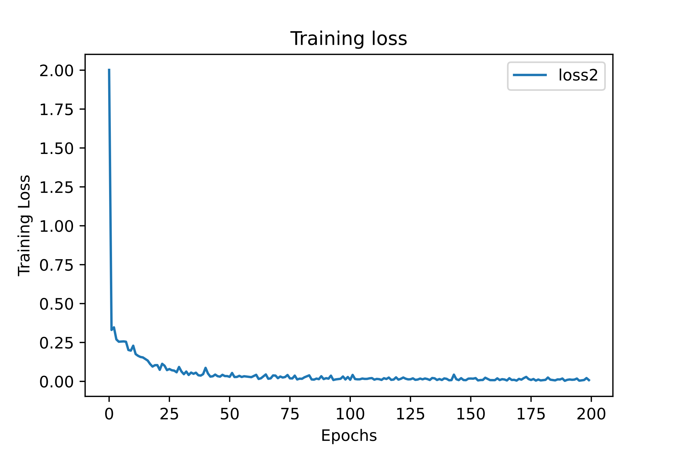
The network used SoftMax activation function because the sum of normalized allotted power to various users should be unity, indicating that there is no wastage of energy during the optimum allocation.

Fig “ “ Training loss during training

The error histogram reveals that the overall error 0.03 for 90% of the sample data and the least mean square error obtained was 0.07 which is very negligible compared to the average error.
- Probability of outage
The performance of the designed neural network was validated in terms of probability of outage for various users with varying power and channel co-efficient with a fixed variance. Probability of outage is defined as the probability of data rate of a user being less than the minimal required rate . Data rate less than the minimal rate results in an erroneous transmission. The outage probability was estimated as the average outage occurring in the network output for 1000 trials. The data rate of each user was calculated as mentioned in (3) and the probability of outage was calculated for every user.

Equation (?)

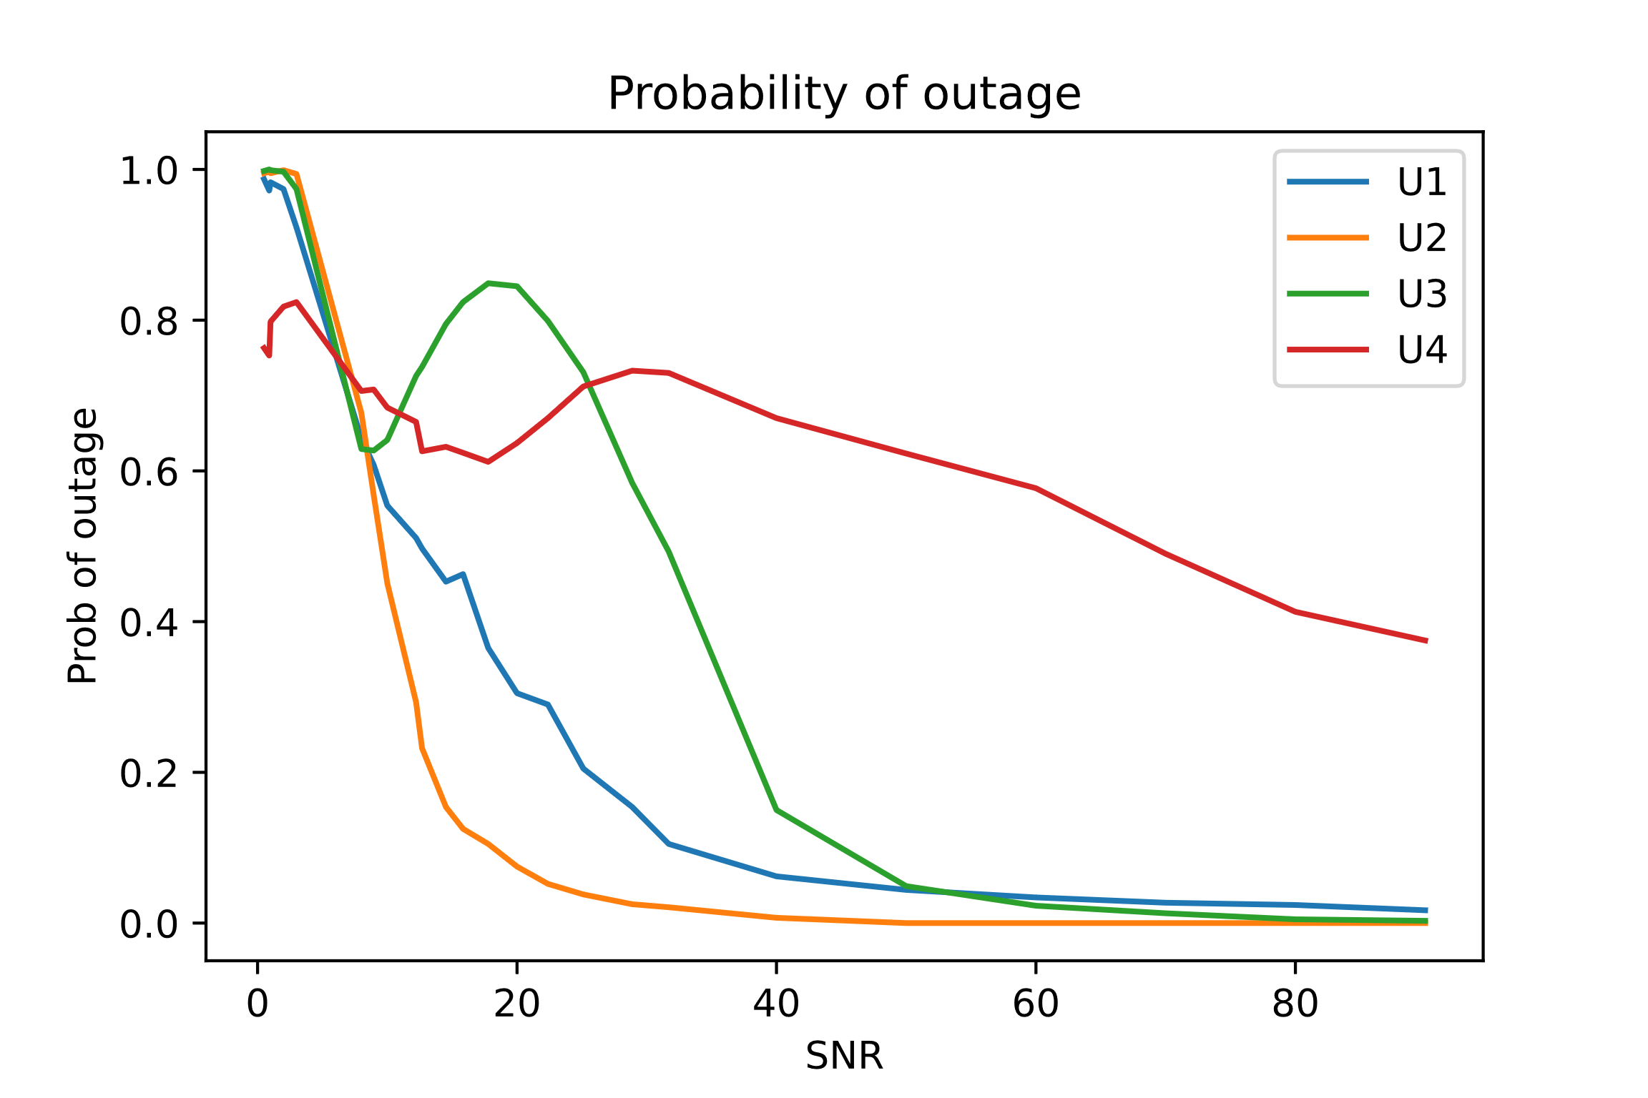
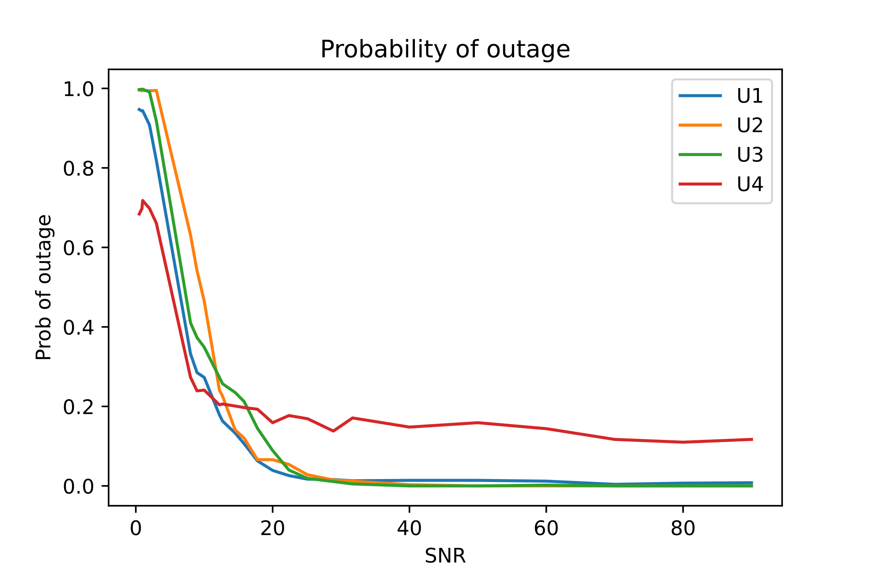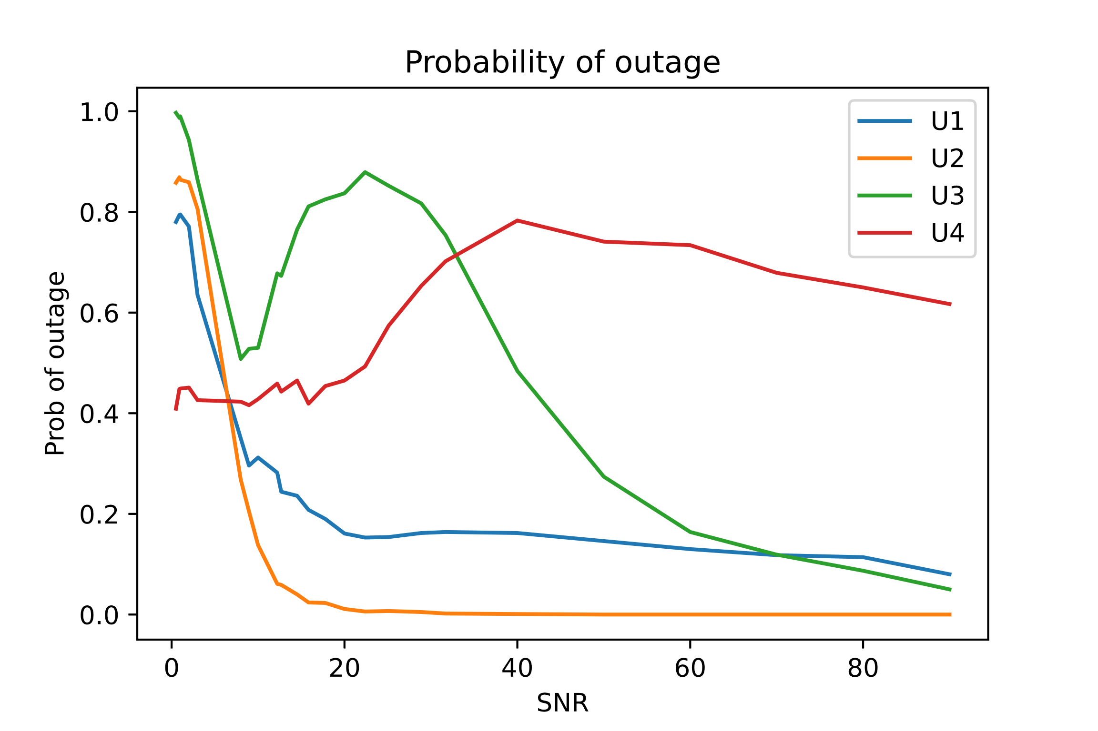
Plot abc

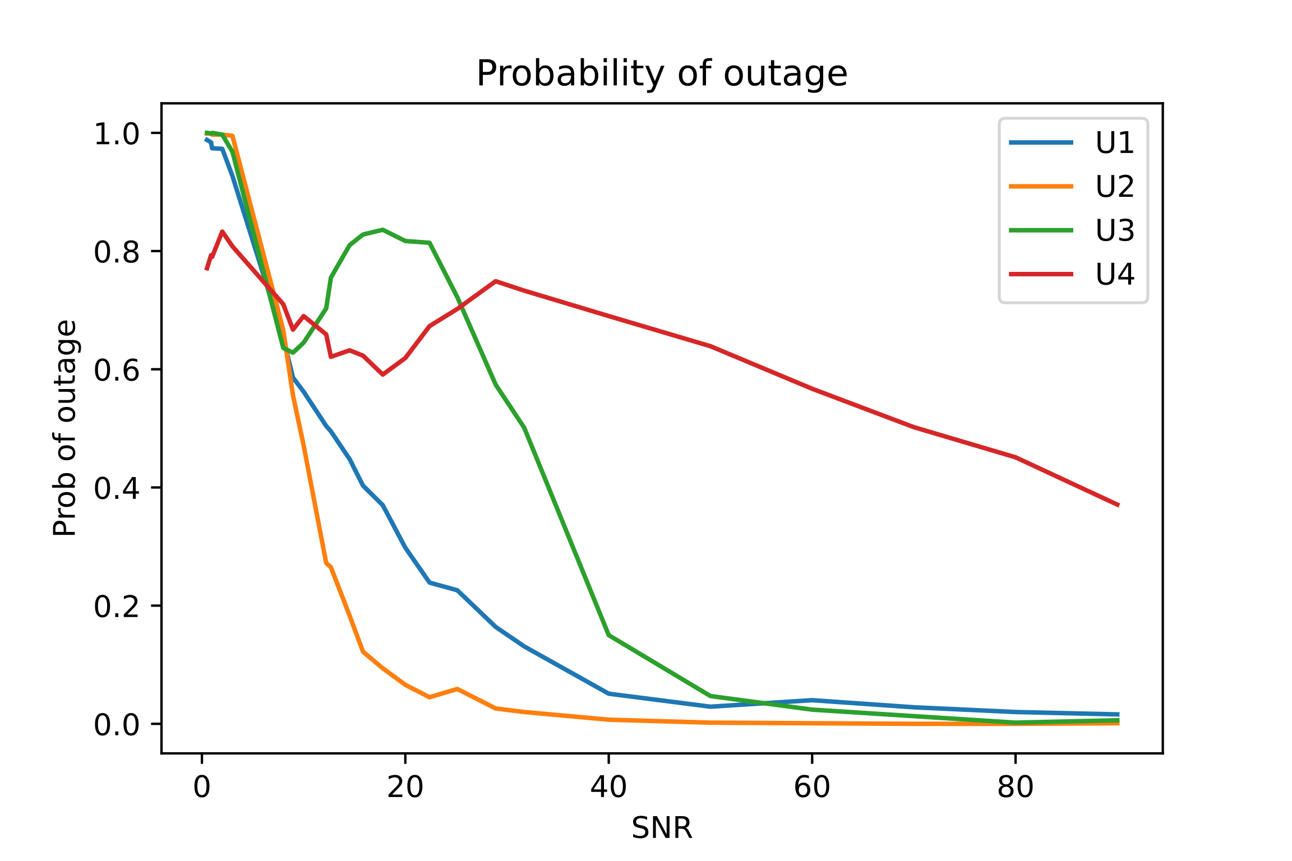
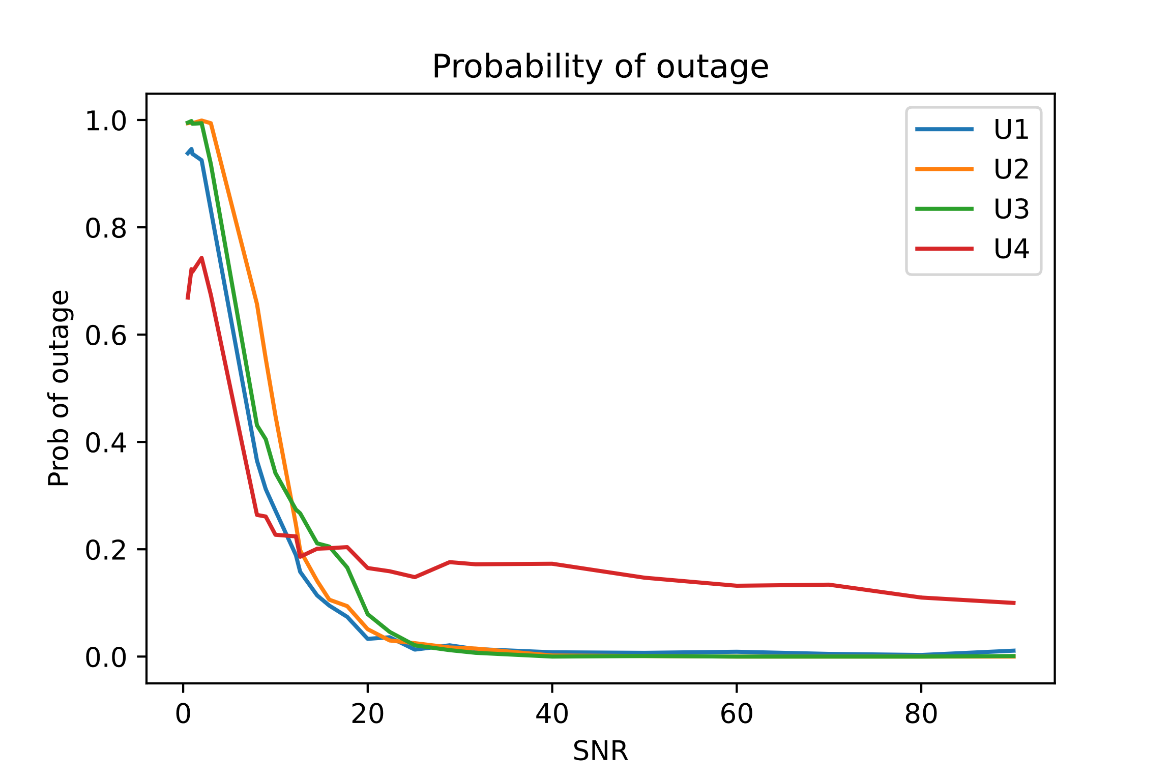
The plots in figure ?? were obtained by changing the variance of the user links. The figure ? shows that with increased variance in channel the probability of outage is higher than that with the lesser variance. User 4 was assumed to have the worst condition link and hence the probability of outage is higher for user 4 in most of the cases. As the SNR is increased the probability of outage decreases as expected.
Plot bcd

The plots in the figure were obtained for minimal normalized rate 0.9 and 1 . the probability of outage was less than 0.3 for most of the SNR indicating that the optimum power allocation had lesser chances of getting outage.

