**DAILY ONLINE ACTIVITIES SUMMARY**

|  |  |  |  |  |  |  |  |
| --- | --- | --- | --- | --- | --- | --- | --- |
| **Date:** | | **22nd May 2020** | | | | | |
| **Name of the Faculty** | | **VENKATESH** | | | | | |
| **No. of Students Allotted for monitoring** | | | | | **27** | | |
| **Progress** | | | | | **Good** | | |
| **Whether collected report from all the allotted students** | | | | | **26** | | |
| **Online Test Summary** | | | | | | | |
| **Subject** |  | | | | | | |
| **Semester** |  | | | **Duration** | |  | |
| **No. of students Taken** | | |  | **Passing %** | |  | |
| **Certification Course Summary** | | | | | | | |
| **Course** | | **Computer Networking – Digital Network Security** | | | | | |
| **Certificate Provider** | | **Alison** | | | **Duration** | | **3 Hours** |
| **Coding Challenges** | | | | | | | |
| **Problem Statement: Write a C Program to implement various operations of Singly Linked List Stack.** | | | | | | | |
| **Status: Total 35 Students were solved.** | | | | | | | |
| **Uploaded the report in Github** | | | | | **Yes** | | |
| **If yes Repository name** | | | | | <https://github.com/Venkateshbhat2007/Online-Daily-Activities> | | |
| **Uploaded the report in slack** | | | | | **Yes** | | |

Certification Course: **Computer Networking – Digital Network Security**

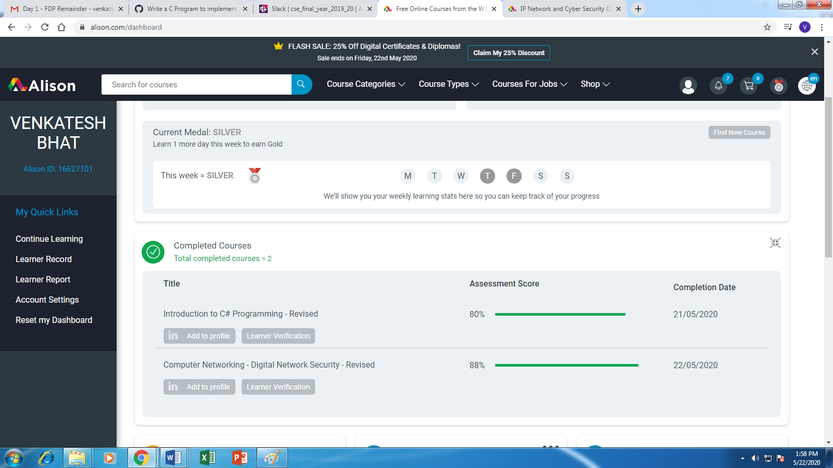

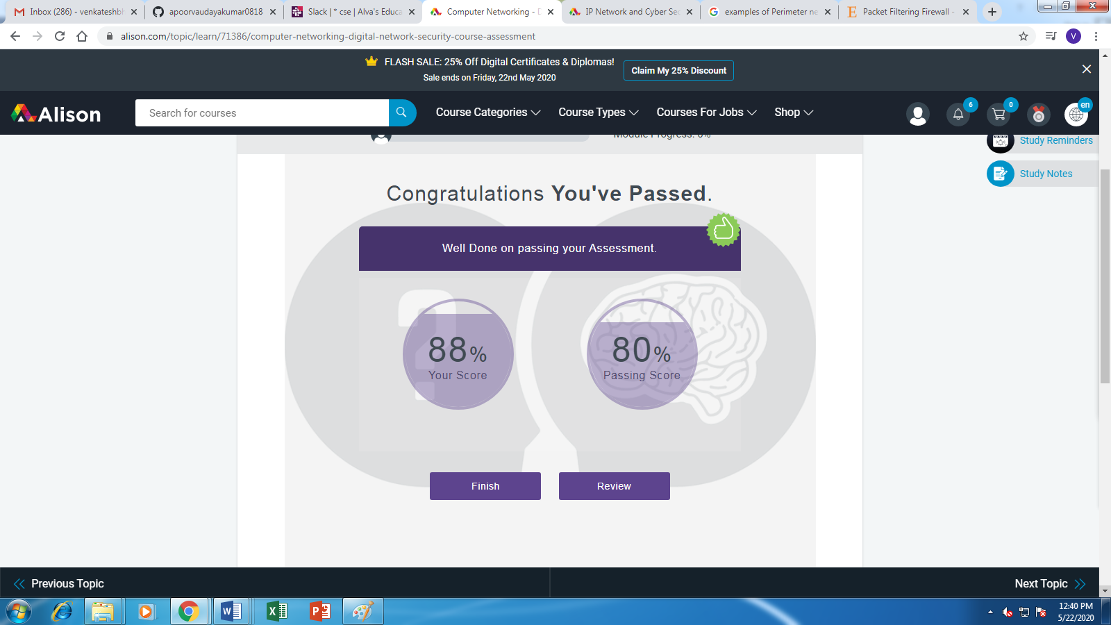

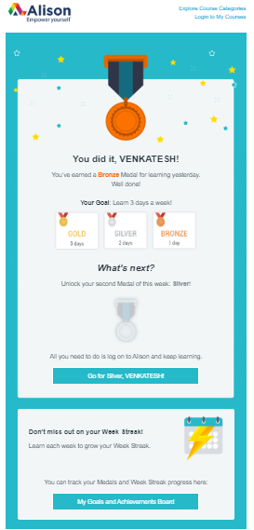

Webinar Attended:

***"IOT and Cyber Security - an Industry Perspective".***

**Conducted By:**

**Department of Computer Science and Engineering,**

**Cambridge Institute of Technology,**

