**DAILY ONLINE ACTIVITIES SUMMARY**

|  |  |  |  |  |  |  |  |  |
| --- | --- | --- | --- | --- | --- | --- | --- | --- |
| **Date:** | | **31st May 2020** | | | | | | |
| **Name of the Faculty** | | **VENKATESH** | | | | | | |
| **No. of Students Allotted for monitoring** | | | | | **27** | | | |
| **Progress** | | | | | **Good** | | | |
| **Whether collected report from all the allotted students** | | | | | **27** | | | |
| **Online Test Summary** | | | | | | | | |
| **Subject** |  | | | | | | | |
| **Semester** |  | | | **Duration** | |  | | |
| **No. of students Taken** | | |  | **Passing %** | |  | | |
| **Certification Course Summary** | | | | | | | | |
| **Course** | | 1. **Internet of Things and the Cloud – Revised** 2. **Webinar on Big Data & Data Science by Pantech** | | | | | | |
| **Certificate Provider** | | 1. **Alison** 2. **Pantech** | | | | | **Duration** | 1. **3 Hours** 2. **2 Hours** |
| **Coding Challenges** | | | | | | | | |
| **Problem Statement:** | | | | | | | | |
| **Status: Total 35 Students were solved.** | | | | | | | | |
| **Uploaded the report in Github** | | | | | **Yes** | | | |
| **If yes Repository name** | | | | | [https://github.com/Venkateshbhat2007/](https://github.com/Venkateshbhat2007/Online-Daily-Activities) | | | |
| **Uploaded the report in slack** | | | | | **Yes** | | | |

**Internet of Things and Cloud Revised – by Alison**

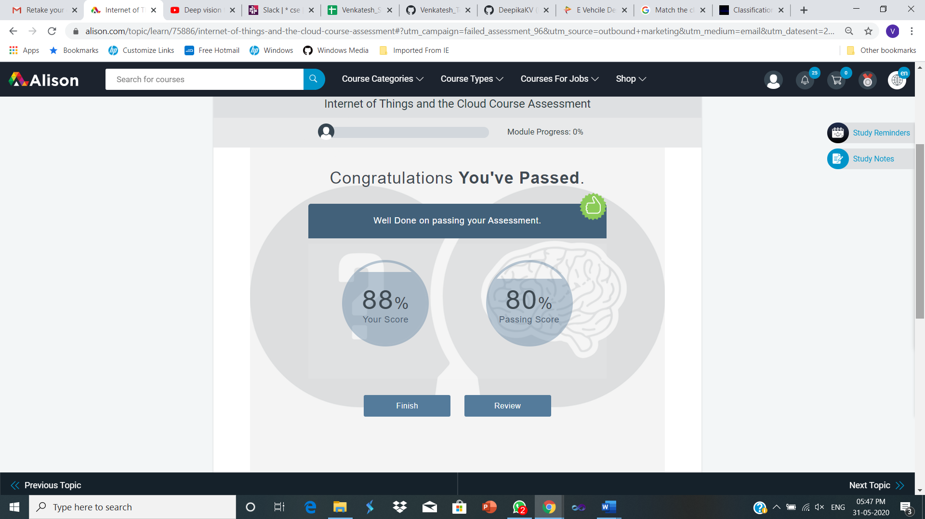

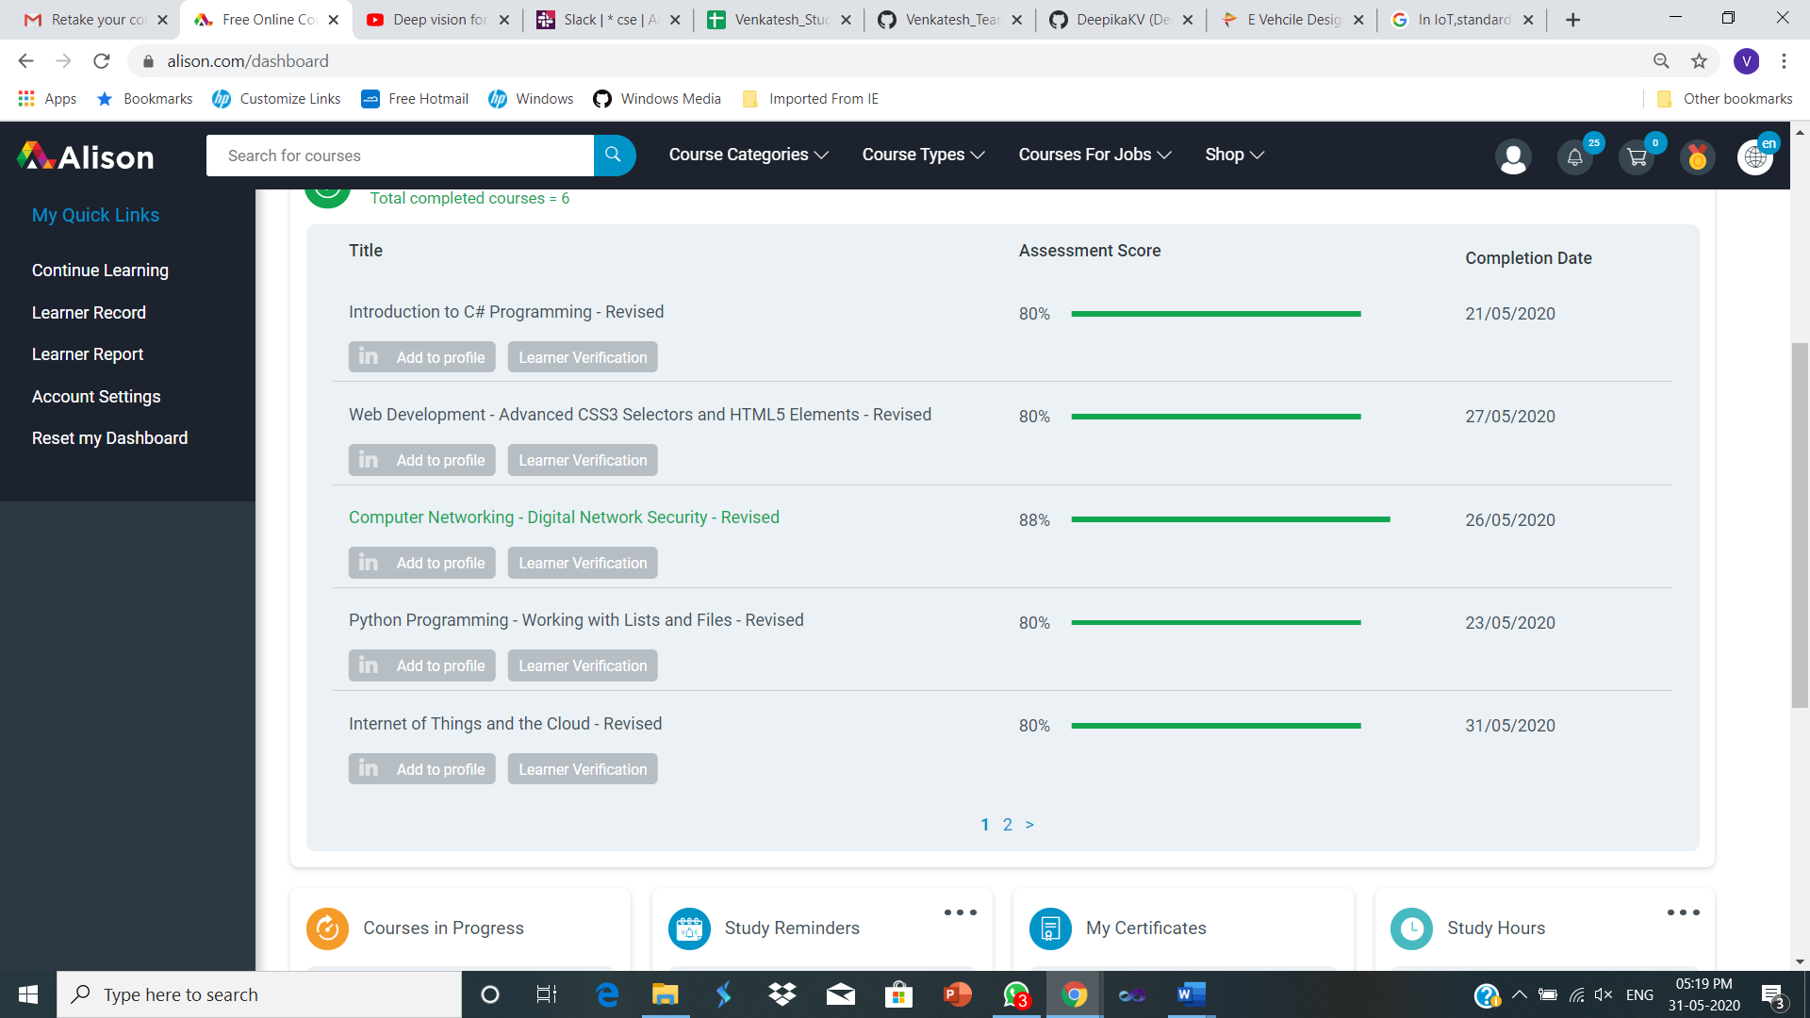

**Webinar on Big Data & Data Science by Pantech – Screenshots**

